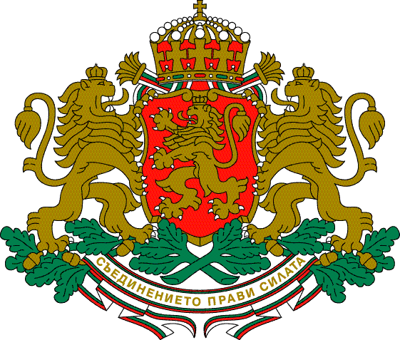

Republic of Bulgaria
Ministry of transport, information technology and communications

The Ministry of transport, information technology and communications (MTITC) has opened a Concession Granting Procedure for service for „Plovdiv Civil airport for public use”.
The Notice for the procedure has been published on the web site of the Bulgarian State Gazette: http://dv.parliament.bg/DVWeb/index.faces under № 1 as of 13.04.2016 and on the web site of the MTITC: http://www.mtitc.government.bg/ under the section „Current Concessions”.

