NATIONAL PROGRAMme
“DIGITAL BULGARIA 2015”

September 2012
Summary
The Information and Communication Technology (ICT), as well as the Internet drive the establishment of a competitive economy based on knowledge and innovation, to ensure high quality of life for all citizens. The policy of the ICT sector is defined as a horizontal policy since the effects and the impact of its implementation expand over all socio-economic sectors.
The ICT priorities at a European level are outlined in Europe 2020 - a strategy for smart, sustainable and inclusive growth aimed at preparing the EU economy for the challenges of the next decade. Its goal in particular is to accomplish one of its flagship initiatives - known as the Digital Agenda for Europe (DAE), which is directly linked to the problems in the field of Information Technology and the Internet.
The main objective of the Digital Agenda for Europe is to get sustainable economic and social benefits from the establishment of the digital single market based on the use of fast and ultra fast internet, as well as interoperable applications. This process will pave the way to maximizing the social and economic potential of ICT mainly through the use of the Internet, which is considered vital for economic and societal activities, such as: doing business, working, playing, communicating and self-expressing freely. The successful implementation of the Digital Agenda will speed up innovation, economic growth and improvement of the daily life of both the citizens and the business circles. Wider deployment and more effective use of digital technologies will allow Europe to cope with its major problems and it will ensure better living conditions to the Europeans - for instance, by means of improved health care, safer and more efficient transport solutions, cleaner environment, new media opportunities and easier access to public services and cultural content.
In this respect, the Digital Agenda for Europe identifies seven interrelated priority areas:

- A vibrant digital single market;
- Interoperability and Standards;
- Trust and Security;
- Fast and Ultra-fast Internet Access;
- Research and Innovation;
- Enhancing Digital Literacy, Skills and Inclusion;
- ICT-enabled Benefits for EU Society;
International Aspects of the Digital Agenda.

Bulgaria, being a full member of the European Union (EU) has the obligation to develop national strategic objectives that are consistent with the priorities and strategic goals outlined in the EU fundamental documents, the implementation of which will ensure their accomplishment.
The aim of the "Digital Bulgaria 2015" National Programme (the Programme) is to define the parameters (key actions, responsible institutions, deadlines, budget) of the Information Society (IS) development in Bulgaria, as well as to support the implementation of the EU guidelines and tasks formulated in the Digital Agenda for Europe (DAE) taking into account the social and economic potential of the Information and Communication Technologies (ICT) and the Internet by 2015.
The "Digital Bulgaria 2015" National Programme has been developed by the Subgroup to 31 Working Group "Europe 2020". Its purpose is to identify the measures and tasks that the Bulgarian authorities have to pursue until 2015.
The Programme arises the basic assumption that each authority is responsible for the administrative and financial implementation of the measures under the Programme, in accordance with DAE commitments and duties. Various sources of individual project funding such as targeted funding by the state budget, as well as grants under the European programs etc. are available to assure its inplementation.
The document is in compliance with the methodological guidelines for strategic planning in Bulgaria, and the conclusions of the public discussions with all stakeholders (universities, NGOs, business groups and citizens) which have been held at a national level. It presents the strategic goals and directions according to DAE which have to be included, so that the socio-economic structural reform in Bulgaria would be carried out successfully. The purpose of the latter is to meet on a national scale the EU requirements for the development of Information Society in Europe within the next four years.
The document provides legal, technological, economic and social guidelines for the development of an Information Society in Bulgaria. Within this context the Information and Communication Technologies continue to be the driving force for improving the quality of life to all citizens. The program promotes innovation and reflects the new role of the Internet as a crucial infrastructure and essential media for carrying out various economic and social activity.
The "Digital Bulgaria 2015 National Programme " relies on the following generally accepted principles, based on the experience and knowledge in the field which underpin the overall development process of the Information Society in Bulgaria:
1. People focused. The suitability of any program, project and activity on IS building should be measured by the input and the benefits provided to the citizens in the Republic of Bulgaria as end-users. Any program, project and activity must respect the rights of the citizens, including the right to privacy.
2. Accessibility. Taking into account the social nature of IS, the State shall invest in services and activities aimed at economically disadvantaged people in certain regions, which may have strong economic and social potential in the future. The services which demonstrate genuine business potential should be reoriented according to the business areas.
3. Full compatibility with the European Union policy. The Information Society building in Bulgaria should follow the European Union aquis. It should also be consistent with the policies of the International Telecommunication Union, the Council of Europe and other international organizations, taking into account the national circumstances and the level of development.
4. National ICT resources integration. Improving the efficiency of public investment in ICT resources based on integration and centralization of data and full compatibility among the building systems. In this respect, it is of utmost importance that a centralized approach signified by a single coordinating body steering the development of the Information Society is applied.
5. Trust and security of networks and information. The State shall implement a system of norms, sanctions and resources to ensure the security of data and ICT systems. All efforts undertaken in the IS field should follow the recognized principles and safety standards to raise no extra conditions that might compromise or encroach on one’s own, or third party data. These include identification and authentication, data protection, protection against cyber crime, intellectual property protection, consumer protection, etc.
6. Effectiveness and efficiency. The development of the Information Society must be implemented by means of projects which support the goals and priorities of the State Policy, defined on strategic national, regional and local level by the most effective and efficient use of scarce resources.
7. Digital content quality. Any activity, project or initiative, leading to the creation of digital content, especially characterized as being of national significance, should be supported and structured as a part of the national digital heritage system.
8. Co-operation. Public Private Partnerships (PPP). In its activities the State shall rely on the knowledge, competence and flexibility of the Bulgarian ICT business, the universities and NGOs for the efficient development of the Information Society in Bulgaria.
9. Technological neutrality. The State should apply the principle of technological neutrality in the regulatory activities related to the development of the Information Society, in order to protect the interests of citizens and consumers.
The national program is ambitious to establish a new mechanism, aimed at coordination and action within which the development of the Information Society in Bulgaria will not be construed as a goal or a task of an internal department or administrative unit, but as a shared objective of all stakeholders, such as the public sector, academies, NGOs, civil society and private organizations. Following the pattern of the European agenda, the Programme clearly shows which areas need concerted efforts in the coming years and where the public sector, academies and other key economic players should be fully involved.
Main Guidelines
On the basis of the ‘Digital Bulgaria 2015’ National Programme, guidelines for action have been set out. These are consistent with the national objectives formulated in the National Reform Programme with the trends reflected in the Digital Agenda for Europe. The guidelines are oriented mainly towards wider application and implementation of the Information and Communication Technologies and the Internet tools, which are expected to result in innovative eco-systems:
• Developing advanced electronic communications infrastructure and providing efficient electronic services to achieve optimal conditions for establishin a competitive digital single market and improving the quality of life;
•Strengthening modern education and achieving highly efficient research and development sector, based on the latest technological inventions;
•Creating and promoting a favorable business environment for innovative entrepreneurship aimed at developing high-tech competitive economy.
Programme Objectives
The Programme objectives, the implementation of which shall ensure the fulfilment of the above mentioned directions must overlap completely with the areas of operation and the objectives of the Digital Agenda for Europe; the objectives are set in accordance with the specific features of the business environment, as well as the economic framework in Bulgaria:
• Creating conditions for construction and development of a vibrant digital single market;
• Improving interoperability and encouraging better usage of standards;
• Increasing confidence in ICT by strengthening the network and information security policy;
• Providing fast and ultra-fast Internet access;
• Stepping in efforts to improve the effectiveness of research and innovation activities and to stimulate ICT innovation by exploiting the opportunities of the Single Market;
• Bridging the digital divide by increasing digital literacy and skills for the use of ICT;
• Enhancing the benefits of ICT for society by raising their importance for environmental protection to ensure sustainable health, to promote cultural diversity and the creation and distribution of content; encouraging their application for the development of e-governance and for the construction of intelligent transport systems to improve mobility;
• International aspects of the Programme - to promote Internet Governance internationally and to foster global cooperation with the purpose of preserving the stability of the Internet based on the multistakeholders’ model.

I. Conclusions and recommendations on the analysis of the National Program for Accelerated Development of Information Society 2008-2010 (Program 2008-2010) Implementation in the Republic of Bulgaria

The "Digital Bulgaria 2015" National Programme is a new strategic document that reflects the leading strategic guidance for the development of the Information Society in Europe up to 2015. The biggest challenge is to ensure rapid adoption and implementation of measures necessary to meet the envisaged targets. Thus, at the very beginning, the document is analyzed in the context of previous strategic initiatives, which have been taken regarding the development of the Information Society in Bulgaria. The analysis is focused on systematic problems, which could jeopardize the successful implementation of "Digital Bulgaria 2015".

Strategic documents and operational normative framework
Over the past two years in Bulgaria a number of strategic and program documents have been developed or are under development in relation to the policy of ICT in line with the priorities and strategic goals of the EU program documents, the implementation of which is to ensure the achievement of these objectives .
National Reform Programme
The Action Plan of the National Reform Programme of Bulgaria (2012-2020) sets out specific measures that are related to the widespread deployment and use of ICT which could be grouped by priority as follows:
▪ Development of e-Health
▪ Development of e-Government
▪ Broadband development
▪ Promoting investments aimed at creating new jobs in high-tech industries and knowledge-based services (education, R & D, ICT, etc.).
▪ ICT for Energy Efficiency
▪ ICT to improve the Education system
Other strategic planning documents that have sections with policies in ICT are:

National Strategy for Scientific Research 2020
It defines ICT as one of the three key priorities, which shall support research and technological development. The other two are technology, health, environmental and energy-saving technologies, which also include ICT. In accordance with the Digital Agenda for Europe, the main emphasis should be made on supporting research and technological development in the fields of research, ICT infrastructure, e-Government, online health, smart home, digital skills, security in cyber-space.
Innovation Strategy of Bulgaria,
The Innovation Strategy, completed in 2006, should be updated according to the 2020 horizon .At the Ministry of Economics, Energy and Tourism (MEET) a thematic working group is established with the assistance of consultants from the World Bank in orger to develop a strategy for smart specialization concerning the innovations. Currently an Innovation Act is under preparation, which should create the legal base for fostering innovation, a key priority in the EU strategic planning documents. The establishment of a State Enterprise "Bulgarian Innovation Fund" is invisaged, in order to provide financial support for innovation in line with the governmental policy in this area.

National Strategy for Broadband Access Development
An updated and expanded National Strategy for Development of Broadband Access, as well as a National Operational Plan for its implementation are developed. They define a new medium and long-term strategic objectives in line with the new higher standards and objectives set out in the Digital Agenda for Europe, which determine the new trends in this area. The updated strategy is focused mostly on the fourth priority of the Digital Agenda for Europe associated with providing fast and ultra-fast internet to all EU citizens. Both documents are public, being coordinated inter-departmentally and submitted to the Development Council at the Council of Ministers.
In accordance with the preconditions of Annex IV in the draft Regulation laying down common rules for the funds covered by the Common Strategic Framework, Bulgaria is committed to develop by the end of 2013 a National Programme for Development of broadband access networks of next generation (NGA).
Common Strategy for e-Government Development 2011-2015
adopted in December 2010. According to the main priorities of the strategy the general dimension of e-Government development in the country is updated. The stated measures will accelerate the implementation and integration with the pan-European electronic governance system. Electronic governance is an effective anti-crisis tool. The main objectives of the strategy are as follows:

▪ Minimizing uncoordinated and sporadic actions in connection with e-Government establishment;
▪ Creating conditions for the widespread application of ICT in public administrations engaged in parallel with the implementation of organizational changes and the acquisition of new knowledge to improve public services and democratic processes, as well as to facilitate the elaboration and implementation of a State policy to achieve:
▪ Modernization of public administration;
▪ Building an information society, which leads to economic growth and improving quality of life;
▪ Developing a model of e-Government, taking into account the specific issues of the public sector as a whole.

ICT is widely recognized as a key driving force for possible stimuli, creating innovation and shaping the information society. One-quarter of the GDP growth in the EU is created in the ICT sector, so that investment and innovation in ICT contribute to productivity growth in the EU by 45%.
The progress which has been observed in the field of ICT throughout the country in recent years is unsatisfactory. Bulgaria is still far from the average level in the European Union regarding the access to broadband infrastructure and services, so that it lags behind in terms of the indices for the development of information society and innovation.
The Ministry of Transport, Information Technologies and Communications (MTITC) and the Executive Agency "Electronic Communication Networks and Information Systems", (the latter being Second Level Spending Unit to MTITC), are the main institutions of the Executive authority involved in the implementation of the State policy in the field of Information Technology and Communications . The efforts of both institutions are aimed mainly at developing the necessary legal framework, in order to ensure efficient environment for business communication, building and maintaining advanced electronic communications infrastructure for the needs of public administration and e-Government, flexible spectrum management to promote the development of mobile connectivity, development and delivery of electronic services to businesses and individuals in the frames of e-governance, providing a high degree of interoperability, network and information security.
In pursue of the key priorities listed above a number of preparatory and implementation measures are performed in accordance with the information provided by the representatives of the institutions participating in the Sub -group.
II.Information Society Projects and Initiatives Implementation Analysis
1. Strengthening the single market for electronic communications services;
2.Spectrum harmonization in Bulgaria in compliance with the European Legislation;
3. Fast and ultra-fast internet access;
4.Electronic governance;
5. Improving transport connectivity and market access;
6. Draft Law on Innovation;
7. Achieving high quality of education;
8. Implementation of cross-border electronic services in the environment area - particularly by means of advanced sensor networks;
9. Transposition of the VAT Directive, ensuring equal treatment between electronic and paper invoices;
10. Unified Geographic Information System (GIS);
11. Child safety online.

Conclusions from the Analysis:
1. Generating a critical mass (ICT infrastructure and services), allowing rapid development of the Information Society and faster completion of the European targets can only be achieved through the efforts of the private sector and a good regulatory framework. That's why, financial governmental intervention is necessary.
2. Achieving the desired outcomes and their sustainability and ensuring the monitoring process can become difficult, if the policy tools as a set of ICT measures and actions in the various national strategy documents remain financially unprovided.
3. A major problem encountered in policy development of the IS in Bulgaria remains the current decentralized approach to public services management of IS and IT, which does not generate positive economic and social effects. The implementation of centralized IT management across the country would not take the rights of local communities, independent authorities and organizations executing public functions to make their own decisions regarding the implementation of IT projects including ICT components.

ІІІ. DAE Monitoring and Implementation Assessment Guidelines

The basic guidelines set out in the Digital Agenda for Europe are used, as well as the measures and activities foreseen to be implemented in each of the directions, being commitment of the European Commission and the relevant institutions of the Member States.

Direct obligations for the Member States of the European Union
Member States (MS) of the EU have obligations on these specific tasks implementation, but also commitment to other tasks that are governed by the European Commission:

IV. Mechanism for assessing DAE implementation
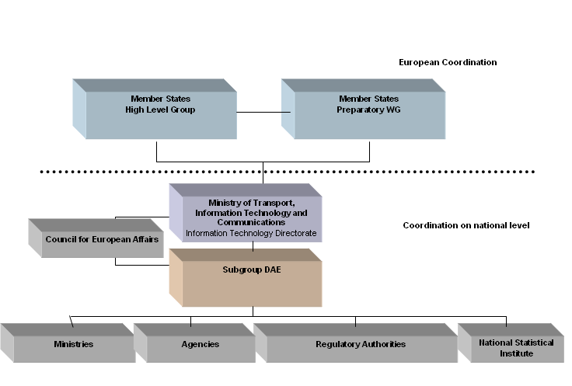
The IS development policy is horizontal and the common purpose of the State that in terms of decentralized IT management requires a well-functioning coordination mechanism involving all government levels.
The implementation of DAE is a responsibility of all state structures. It is regularly monitored and reported by the ‘DAE’ Sub-group, which prepares statements and submits them for approval to the Council of European Affairs via WG 31 "Europe 2020." The approved opinions are provided to the "Information Technology" Directorate experts in MTITC, participating in the Preparatory Working Group and to experts participating in the High Level Group on DAE at the European Commission . Furthermore the European management mechanism of DAE is activated:

The table, which reports the DAE implementation is given in Annex 1.
V. Guidance, Management and Control
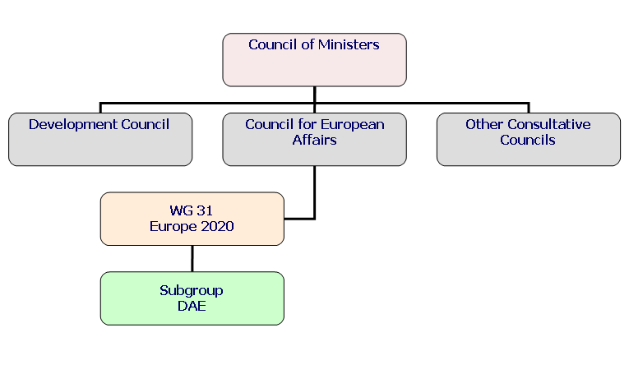
The mechanism of control, coordination and supervision of the Program is a part of a national coordinating mechanism on EU matters. The Decision, taken at the 230th meeting of the Council of European Affairs (CEA) as of 17 January 2011 has approved the formation of a Sub-group at Working Group № 31 "Europe 2020", in order to coordinate the work related to the implementation of a Digital Agenda for Europe, with the leading role of the Ministry of Transport, Information Technologies and Communications and the co-chairman of the Financial Ministry. The Sub-group Secretariat is expected to be in the Ministry of Transport and Communications. The Ministry of Transport, Information Technology and Communications and the Ministry of Finance are responsible.
Participants in the Program
The IS formation requires special attention to be paid by public institutions. They should set conditions to accelerate the processes of active involvement of the private sector and the public to discuss new regulations (public consultations), as well as the implementation and monitoring.
State institutions keep a leading role in terms of:
• Legislation governing the IS with minimum regulation in the public interest and protection regarding the rights of citizens;
• Developing policies to stimulate significant activities and the realization of projects with national importance;
• Participation in inter-governmental agreements to achieve an unified global provisions/regulations in the information sphere/area and also to combat international crime.
Governmental institutions should encourage the private sector and the NGOs to participate in educational and awareness campaigns for the implementation of public scrutiny in terms of openness and transparency, as well as the direct decision making for the development of different IS areas.
In legislation and in practice on its implementation it is necessary to clearly define the trend of the state withdrawal from executing political control over the information area.
Particularly important for the state is to set prerequisites, so that the private sector itself should take action to:
- design technological foundations of IS;
- Participate actively in the standardization process.
In the process of transition to IS, it is necessary to include the general public, and in particular non-government organizations and institutions. Their role is expected to provide:
- Presentation of projects and participation in public discussions on legislation;
- participation in joint bodies with representatives of state institutions and the private sector to solve the important issues of Information Society;
- supporting the implementation of educational projects and explaining the positive effects and risks associated with ICT applications;
- initiatives to mitigate the harmful effects of ICT applications undertaking;
- Program implementation monitoring .

VI. Action Plan
The plan is exposed in Annex 2 of this document

VII.Annexes
1.DAE Implementation Table
2. “Digital Bulgaria 2015” Action Plan

A Digital Agenda for Europe, COM(2010)245, adopted 19 .05. 2010, EC
Methodology for Strategic Planning in the Republic of Bulgaria, April 2010

