SEERA-EI: South East European Research Area for eInfrastructure
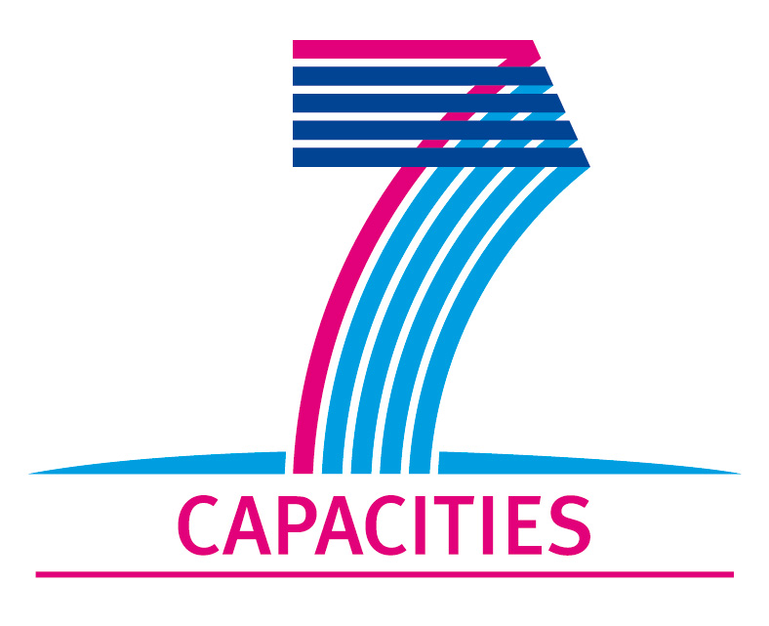 |  | 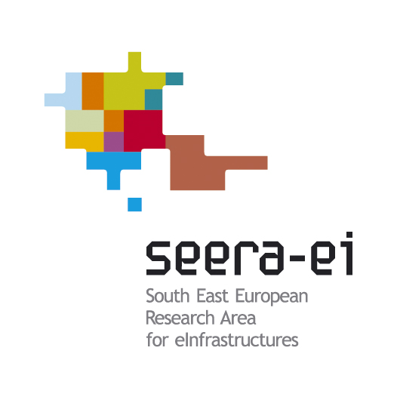
SEERA-EI Open Workshop
Grand Hotel Sofia, May 12, 2010
This document provides the agenda for the SEERA-EI Open Workshop, hosted by IPP and EA ECNIS and held in Sofia on May 12th, 2010.

 Copyright by the SEERA-EI Consortium. The SEERA-EI Consortium consists of:
Greek Research and Technology Network | Greece
General Secretariat for Research and Technology, Greek Ministry of Ministry of Education, Life Long Learning and Religious Affairs | Greece
Ministry of Education and Science | Albania
Polytechnic University of Tirana | Albania
Ministry of Communications and Transport | Bosnia-Herzegovina
EA ECNIS | Bulgaria
Institute for Parallel Processing – Bulgarian Academy of Sciences | Bulgaria
Ministry of Information Society | FYR of Macedonia
Macedonian Academic and Research Network | FYR of Macedonia
Academy of Sciences of Moldova | Moldova
RENAM | Moldova
Ministry of Education and Science | Montenegro
University of Montenegro | Montenegro
National Authority for Scientific Research | Romania
RoEduNet | Romania
Ministry of Science | Serbia
University of Belgrade – RCUB | Serbia
Scientific and Technological Research Council of Turkey | Turkey
ULAKBIM | Turkey

Agenda
Start time | Planned duration | Item description | Presenter
SESSION 1: THE INTERNATIONAL VIEW
09:30 | 20 min | Welcome | Parvan Rusinov - Deputy-Minister of Transport, Information Technology and Communications (MTITC); with activity field information technology and communications, Bulgaria
09:50 | 25 min | Workshop context, regional vision | Ognjen Prnjat, GRNET, Greece
10:15 | 30 min | Regional and national infrastructures: current status | Burcu Ortakaya, ULAKBIM, Turkey
10:45 |  | Coffee
11:15 | 45 min | Regional programmes: overview | Paul Gasner, ROEDUNET, Romania
12:00 | 30 min | EC RI strategy | Wim Jensen, European Commission, Information Society and Media Directorate-General GÉANT & eInfrastructures
12:30 |  | Lunch
SESSION 2: THE NATIONAL VIEWS
13:30 | 45 min | Bulgarian eInfrastructure-related programmes | Georgi Prangov – senior expert in directorate ”Information Tehnologies”, MTITC, Bulgaria  Hristo Hristov – Head of department in directorate ”Information Technologies”, MTITC, Bugaria
14:15 | 45 min | Bulgarian eInfrastructure: status and vision | Emanouil Atanassov, IPP-BAS, Bulgaria
15:00 |  | Coffee
15:30 | 30 min | Case study: Romania | Sorin Zgura, ANCS, Romania
16:00 | 30 min | Case study: Serbia | Dragan Domazet, Ministry of Science, Serbia
16:30 | 30 min | Case study: Moldova | Prof. Andrei Andries, RENAM Association, Moldova
17:00 | 15 min | Workshop wrap-up and conclusions | M. Nikolova, MTITC, Bulgaria
17:30 |  | Close

Participants
 | Name | Position | Institution
1 | Mimoza AGOLLI |  | Ministry of Education and Science, MoEs, Albania
2 | Andrei ANDRIES | Project staff, General Director | Research and Educational Networking Association of Moldova, RENAM, MD
3 | Emanouil ATANASSOV | Project staff,  Assoc. Professor | Institute for Parallel Processing - Bulgarian Academy of Sciences, IPP-BAS, Bulgaria
4 | Kiril BOYANOV | Director | IPP-BAS, Bulgaria
5 | Musa CAGLAR | Assistant Expert | Scientific and Technological Research Council of Turkey, TUBITAK, TR
6 | Umut Yilmaz CERTINKAYA | Project staff | ULAKBIM, Turkey
7 | Tryfon CHIOTIS | Chief Technical Officer | GRNET, Greece
8 | Igor COJOCARU | Director | Information Society Development Institute of Academy of Sciences of Moldova, ASM, Moldova
9 | Deyan DANESHKI | Executive Director | Executive Agency for Electronic Communications Network and Information Systems, EA “ECNIS”, Bulgaria
10 | Saso DIMITRIJOSKI | State counselor | Ministry of Information Society, MoIS, Macedonia
11 | Dragan DOMAZET |  | Ministry of Science and Technological Development, MSTD, Serbia
12 | Vlatko DRMIC | Advisor | Ministry of Communications and Transport, MoCT, Bosnia&Herzegovina
13 | Neki FRASHERI | Head of R&D Center for IT | Polytechnic University of Tirana, PUoT, Albania
14 | Paul GASNER | Project staff, expert | Agency for Administration of National Research and Education Network, RoEduNet, RO
15 | Vasil GRANCHAROV | Director of Directorate | EA “ECNIS”, Bulgaria
16 | Todor GUROV | Project staff,  Assoc. Professor | IPP-BAS, Bulgaria
17 | Emil Horozov | Director of NSF | National Scientific Fund, NSF, Bulgaria
18 | Hristo HRISTOV | Head of Department | MTITC, BG
19 | Mihaela IACOB | Vice-minister | Ministry of Information Technologies and Communications, MITC, Moldova
20 | Sasa IVANOVIC | Adviser for international cooperation in science | Ministry of Education and Science, MoES, Montenegro
21 | Wim JANSEN | Project Officer | European Commission, Information Society and Media Directorate-General GÉANT & eInfrastructures
22 | Aneta KARAIVANOVA | Project staff,  Assoc. Professor | IPP-BAS, Bulgaria
23 | Zeljko KNEZEVIC | Assistant of minister | Ministry of Communications and Transport, MoCT, Bosnia&Herzegovina
24 | Margita  KON-POPOVSKA | Professor | University SsCyril and Methodius, Macedonia
25 | Darko KOVACEVIC | Head of ICT Department | Ministry of Education and Science, MoES, Montenegro
26 | Milan KUZELKA | Management Associate | University of Belgrade – RCUBm UoB-RCUB,RS
27 | Vladimir MAKARIEV | Director of Directorate | MTITC, Bulgaria
28 | Dobromir MALAMOV | Expert, Assoc. Professor | National Science Fund, Bulgaria
29 | Sadi MATAR | Advisor | Ministry of Communications and Transport, MoCT, Bosnia&Herzegovina
30 | Margarita NIKOLOVA | Head of Department | EA “ECNIS”, Bulgaria
31 | Radule NOVOVIC | Deputy Minister | Ministry for Information Society of Montenegro, Montinegro
32 | Burcu ORTAKAYA | Project staff, senior researcher | TUBITAK/ULAKBIM, TR
33 | Georgi PRANGOV | State expert | MTITC, Bulgaria
34 | Smiljana PRELEVIC | Adviser for basic research | Ministry of Education and Science, MoES, Montenegro
35 | Ognjen PRNJAT | Project coordinator, European and Regional Grid Management | Greek Research and Technology Network, GRNET, Greece
36 | Aleksandra RADULOVIC | Project staff, system engineer | University of Montenegro, UoM, ME
37 | Silviu ROMAN | senior counselor | National Authority for Scientific Research of Romania, Romania
38 | Parvan RUSINOV | Deputy Minister | Ministry of Transport, Information Technology and Communications, MTITC, Bulgaria
39 | Kalin SHUTILOV | State expert | EA “ECNIS”, Bulgaria
40 | Eleni STAVRIANOUDAKI | Scientific officer | General Secretariat for Research and Technology, Greek Ministry of Education, LifeLong Learning and Religious Affairs, GSRT, Greece
41 | Greta STOYCHEVA | Chief expert | EA “ECNIS”, Bulgaria
42 | Diana VASILEVA | Senior expert | EA “ECNIS”, Bulgaria
43 | Sokol YMERI | Head od E-Education Sector | Ministry of Education and Science, MoEs, Albania
44 | Ion-Sorin ZGURA | Expert | National Authority for Scientific Research, ANCS, Romania

