CONCEPT

for
Development and Render for Maintenance and Operation
of Regional Broadband Access Networks
in Less Urbanized and Rural Areas

BULGARIA
2010

TABLE OF CONTENTS

І. GENERAL INFORMATION 3

Broadband penetration in the Republic of Bulgaria

ІІ. STRATEGY 8
Social and economic goals
Technological objectives - connectivity, networks, infrastructure
Financial resources:

III. CONCEPT FOR REALIZATION OF THE INVESTMENT PROJECT 11

1. Concept Implementation Plan 11

  - Coordination measures 11
  - Selection of areas for inclusion in the pilot project 13

  - Organizational model of the project according to its revenue 18

  - Technical framework for realization of the investment project 18

1.4. Models for management of the newly constructed infrastructure 28

І. GENERAL INFORMATION – DEMAND AND SUPPLY

The European indexes and analyses for broadband development are clearly affirming that Bulgaria is still lagging behind in comparison with the other EU member-states, both by connectivity and application of technologies by business and consumers and by usability.

As of January 2010 broadband penetration rate in Bulgaria was 13% compared to 24.8% EU average which ranked us last with regard to this index and taking into account the lack of broadband access in rural areas.
This conclusion clearly indicates that the market is not able to ensure the necessary level of broadband penetration, especially in regions considered as unprofitable from economics viewpoint.
Therefore, state intervention is compulsory for overcoming this negative trend and for enhancing the catalytic effect on our economy.

As a result, several studies and analyses have been conducted by using information from various institutions involved in the said matter. Amongst them are the following: Communications Regulation Commission (CRC), Ministry of Regional Development and Public Works, Ministry of Economy, Energy and Tourism, Ministry of Education, Science and Youth and the National Statistics Institute (NSI). Studies done by some ICT organizations have been used, as well. The mentioned organizations are as follows: ICT Cluster, non-governmental organizations such as Association for Information Systems, Territorial Planning, Ecology, Consultation and Qualification and Applied Research and Communications Fund. The latter has dealt with inquiring by towns and villages.

Furthermore, a working group has been established consisting of representatives of the afore-mentioned institutions in order to conduct a specialized study and analysis of the gathered data.

Broadband penetration in the Republic of Bulgaria by towns and villages, number of Internet service providers and state intervention

By the end of 2008, the number of undertakings which notified the CRC for starting activity for provision of data transmission and Internet access services reached 636 in total.

The economy of broadband services provision shows that from market viewpoint investing in such services is not always profitable.
In general, differences in population density indicate that development of broadband networks shall be more profitable where there is more and more concentrated potential demand i.e., densely inhabited areas. Similarly, some areas exist where there could be profitable only for a single provider to deploy a network and not for two or more. Under certain conditions state aid measures could be more effective mechanisms for achieving goals of general interest.

Towns and villages/number of Internet Service Providers

The division of towns and villages in the Republic of Bulgaria is based on administrative regions (28) and in particular, on built-up areas (city, village).
According to NSI’s data taken from the last population counting, out of 7 605 000 people totally in the country, cities’ population represents 71,1% of the whole population and is aged 40.1 on the average while people living in villages reach 28.9% and are averagely aged 45,4.

Cities
Across Bulgaria’s territory there are totally 253 cities. In 126 cities, there are more than two providers where Sofia ranks first with its 93 providers, followed by Varna with 36 ones, Plovdiv with 26, Bourgas with 21 etc. There are 81 towns having two providers and 38 more served by one Internet provider. There is not a single Internet provider in 8 towns (Figure 1).
Figure 1

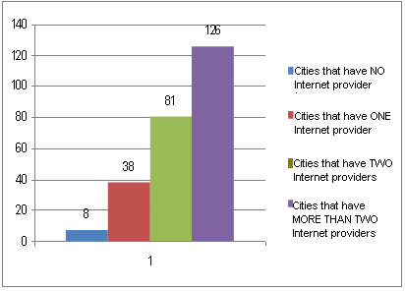

Source: Data provided by CRC for the purposes of the study

Villages
In total, there are 5049 small settlements (villages) on the territory of the country. 116 of them are characterized by more than two Internet service providers, 228 villages have two Internet providers, 708 have a single Internet provider and 3997 have no Internet providers at all (Figure 2).
Figure 2

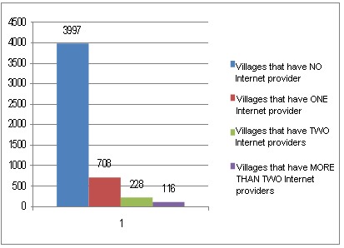

Source: Data provided by CRC for the purposes of the study

Data give idea of broadband coverage by settlements based on number of Internet providers. This allows for identification of regions where state aid is admissible.

On the map, areas marked in green have Internet access with relatively high speeds and provide wide range of communication services. Those are regional centers (big cities) and municipality centers (mid-sized towns) and their surrounding territories, tourist and economic developed regions, as well.

Small villages and smaller towns are marked in red and situated in areas where based on official data there is no Internet. They are situated in mountainous, bordering and remote agricultural areas and are also included as constituent towns and villages within a particular municipality (264 in total). Population in those towns and villages is characterized by relatively low or thoroughly missing awareness of ICTs and Internet benefits and hence, the lack of readiness for Internet use and electronic communication services. As a result, private companies are not interested to invest in the said areas.
Therefore, state intervention encouraging private operators to introduce their communication services in such settlements is fully justified in the context of the
ambitious goal set by the European Commission in the Digital Agenda for Europe and Strategy i2020.

Another very important argument in this direction is the provision of technological irrevocable commitment of the state to provide electronic administrative services within the context of e-government in these areas. This is a key factor for encouraging the demand, a condition for promoting the benefits of the Internet and electronic services and skills in this area, which in turn creates prerequisites for integration and welfare of citizens and businesses.

In this regard it is of great importance to increase the number of people who use computer equipment and mobile telephony as alternative opportunities for the use of electronic services, including administrative ones.
Данни от изследване на НСИ в тази насока показват следното: Data from the study, conducted by NSI along these lines show the following:
- every fourth household in Bulgaria have had internet access;
- с 6 процентни пункта е нараснал относителният дял на населението, което има достъп до интернет, а 43% от лицата в България използват компютър ;by 6 percentage points increased the proportion of the population that has Internet access, and 43% of the people in Bulgaria use a computer;
- една трета от населението в България използва интернет всеки ден или поне веднъж седмично, като най-активна е възрастовата група на подрастващото население от 16 до 24 години - 29%, следвана от лицата между 25 и 34 години, които представляват 27% от населението, което редовно използва интернетone third of the population in Bulgaria uses Internet every day or at least once a week as the most active age group is this of the young population from 16 to 24 years – 29 %, followed by those between 25 and 34, representing 27 % of the population who regularly uses Internet.
On the other hand, According to the 15th Progress report on the single european electronic communications market (2009) the penetration rate of mobile telephony for Bulgaria is 139%.according to the 15th Progress report on the single european electronic communications market (2009) the penetration rate of mobile telephony in Bulgaria is 139%. On the
The above mentioned data shows an upward trend which, although still not on the desired by us rate (except for the mobile penetration), is to improve the level of usage of ICT and as a result of electronic services.
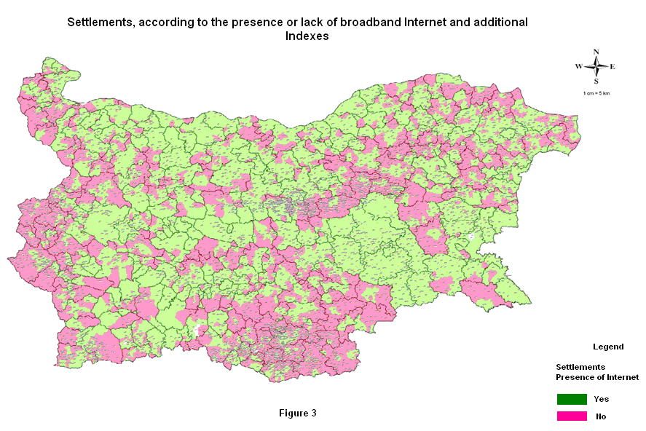

ІІ. STRATEGY
As a first step in solving the above described problems was the development of a National Strategy for Development of Broadband Access in the Republic of Bulgaria which was approved by the Council of Ministers on 25 November 2009.
The national strategy presents a single approach for development of broadband access in order to achieve sustainable strategic results.

Social and economic goals

- To develop and optimize accessibility, quality and scope of services (in the fields of education, health, administrative services etc.) by use of broadband access in all regions of the country.
- To boost social cohesion by providing access to online services to people living in rarely populated and remote areas and thus, overcoming trends for “digital divide” with this part of the society.
- To improve competitiveness of the Bulgarian economy which will lead to increasing employment and welfare of people by ensuring a research and innovations platform and thus, increasing the GDP.
- To increase trust in the Internet by imposing security and behavior rules corresponding to business standards.
- To facilitate and stimulate the use of broadband access by business for the needs of implementing new business strategies and providing new services to end-users.

Technological objectives: connectivity, networks, infrastructure:

Connectivity in the regional and major cities:
- by 2013: the population should have broadband access with speed above 20 Mbps within a built-up area;
- to provide wireless broadband access in public places;
- by 2013: to develop a broadband infrastructure connecting health centers and hospitals in the country;
Connectivity in mid-sized towns:
- by 2013: up to 90% of the population should have access to broadband with speed above 10 Mbps;
- to provide wireless access in public places but at least in municipalities buildings and town-halls;
- by 2013: to provide opportunity for optical fibre connectivity of up to 80% of the households nearby their houses;
Provision of broadband access in remote and underdeveloped areas:
- by 2013: up to 50% of the population should have fixed and wireless access within a built-up area;
- by 2010: the population of the country should have access to computer and the Internet as close as possible to its home.

As per Pyramid Research forecasts for broadband access penetration in Bulgaria will increase up to more than 28 % by the end of 2013. The information is quoted in CRC’s analysis on our market situation.

Financial resources:

The main resources for financing the measures identified in the National Strategy, aimed mainly for the construction of communication infrastructure are:

- Financing equal to EUR 20 mln. is laid down in Operational Programme “Regional Development”, second priority, Operation 2.2 “Information and Communication Network” for the programme period 2007-2013;
- Financing for investment purposes from the MTITC budget in accordance with the economic situation in the country;
- Financing from private investors involved in different forms of public-private partnership.

In order to increase the efficiency of investment will be carried out a number of accompanying events and activities in order to promote the benefits of Internet use and broadband digital services and trainings to acquire skills in this area. In organizing these activities will be involved the joint efforts of local authorities and a number of institutions - Ministry of Education, Youth and Science (MEYS), Ministry of Labor and Social Policy (MLSP), Ministry of Agriculture and Food (MAF).
For this purpose, may be used additional financial resources from the following sources:

- Rural Development Programme (RDP) - to build informational centers in towns and villages in the selected areas;
- Operational Programme "Administrative Capacity";
- Operational Programme "Human Resources - training and strengthening the administrative capacity of local administration officials.

The financial resources requisite in order to secure the above mentioned activities will be an integral part of the National Programme for implementing the National Strategy for the development of broadband in the Republic of Bulgaria, which is under development.

The national strategy will be implemented gradually, taking into account the available financial resources aimed at achieving the objectives set out in it. The initial phase covers the period 2010-2011. In 2010 a pilot project will be started for three selected low urbanized areas, totaling EUR 7.5 mln. In 2011 new projects will be launched involving between five and eight areas estimated to EUR 12.5 mln or more in case of successfully fulfilled models of public-private partnership.

III. CONCEPT FOR REALIZATION OF THE INVESTMENT PROJECT

The current concept has been developed in relation to the forthcoming implementation of an investment project by the Ministry of Transport, Information Technology and Communications and more precisely by the Executive Agency “Electronic Communications Networks and Information Systems” (EA “ECNIS”) as a direct beneficiary of the Operational Programme Regional Development, Operation 2.2. "ICT Network” equaling in total to EUR 20 mln.

The indicative support activities are as follows:

- Construction of broadband connections to urban periphery and less urbanized areas and rural areas;

- Development of critical, secure, safe and reliable public infrastructure.

1. Concept Implementation Plan

The organisation of the implementation of the concept for realization of the investment project includes the following activities:

- Coordination measures;
- Definition of regions for the pilot projects. Preparation of methodology. Selection of areas. Conduct of advice and approval;
- Conduct feasibility studies. Determination of the nature of the project
according to its revenue. Determination of the subsidy;
- Definition of the technical framework for building of the communication
infrastructure;
- Management of the existing infrastructure. Formulation of model management according to revenue of the project.

1.1. Coordination measures

An expert working group on broadband issues has been established as per Minister’s order. It consists of experts with necessary competencies from ICT organizations– Bulgarian Association of Information Technologies (BAIT), Association Telecommunications, Law and Internet Foundation, etc.; non-governmental organizations – Applied Research and Communications Fund, ICT Cluster as well as professors from universities and the Bulgarian Academy of Sciences.
The working group has been assigned with the following tasks:
  - To elaborate an assessment methodology and conduct a state-of-play analysis on broadband access in order to ensure reasonable selection of towns and villages to be included in pilot projects;
  - In a methodological way, to assist work related to elaboration of a National Programme for Goals Fulfillment of the National Strategy for Development of Broadband Access 2010-2013 (the National programme is under elaboration);
  - In a methodological way, to assist work related to preparation of concepts and project proposals directed to fulfillment of pilot projects included in the Framework Investment Programme for Tasks Fulfillment aiming at broadband access development;
  - To analyze and offer models of public-private partnership in fulfilling tasks ensuing from the National Strategy for Development of Broadband Access.

The most important developments and decisions taken on the basis of an expert working group should then receive the sanction and approval of the Advisory Board to the Minister of Transport, Communications and Information Technology. The Advisory Board includes eminent representatives of various organizations - public, industry, research and NGOs, related to ICT.

In order to ensure the success of the project for development of broadband access in less urbanized areas and rural areas, it is provided the conclusion of a Memorandum of institutional cooperation with the municipal administrative authorities to ensure that the contractor of the infrastructure and the service providers have a system for effective construction of the urban part of the infrastructure. Furthermore, they must secure an adequate technological facilities in the municipal or other public buildings in order to build local network centers in which the active equipment to be installed and to be terminated the connections of the network infrastructure and of the operators, providing services.

The concept in question was discussed repeatedly in the past four months with representatives of industry and NGOs in the Working Group, was presented to the major mobile operators (M-Tel, Globul and Vivacom) and was discussed in several publications in press as well as workshops on projects "B3 Regions" and "SEERA-EI", held in Sofia. Furthermore it was presented to three scientific and practical conferences:
1. Bulgarian Economic Forum
2. 7th National Conference (01.04.10) – “Telecom market – a partner platform for operators and business clients”
3. ASTEL Conference 2010 (27.04.10) "access without barriers."
The concept was discussed and a workshop held in the regional center of Haskovo with local authorities elected by the first inclusion in the project area.

1.2. Selection of areas for inclusion in the pilot project
Each of the selected areas consists of three or four municipalities and the settlements within them, without Internet, i.e.,within these settlements where no broadband infrastructure exists. In order to ensure them broadband network coverage, government support is required.

The selection of appropriate areas among more than 15 potential ones is done by a selection methodology which contains the following assessment criteria:

- Total number of residents in towns and villages included in the assessed area;
- Availability of public institutions as a prerequisite for active public and social relationships (schools, hospitals or health centers, community centers etc.);
- Availability of economic activity or prerequisites for initiating one in the given town and village (undertakings, tourist spots, farms, small and medium enterprises, hotels, restaurants, snack bars etc.);
- Availability of prerequisites for increased demand and use of broadband services:
- percentage of active population (more than 50%);
- availability of developed and used administrative services in municipality
centers and municipalities part of the assessed area.

The afore-mentioned methodology and its calculation formula is shown on the site of EA “ECNIS” (http://www.esmis.government.bg).

Selected areas

Region 1: Covers Parvomai Municipality (Plovdiv Region),
Dimitrovgrad Municipality (Haskovo Region),
Mineralni Bani Municipality (Haskovo Region)

Population to be covered: between 19 800 and 22 000 people

Note: The bigger figure is based on the assumption that constituent settlements in municipalities will be connected with wireless technology. On this ground and depending on terrain relief and network topology there is a growing possibility to cover also dispersed towns and villages having population below 500 (the respective lands are in white colour on the maps).

Figure 4

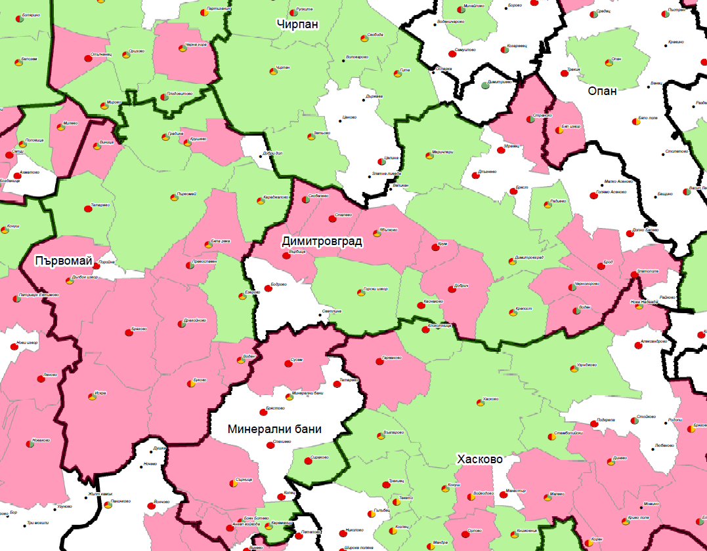

Region 2: Covers Veliki Preslav Municipality (Shoumen Region),
Varbitsa Municipality (Shoumen Region),
Smiadovo Municipality (Shoumen Region),
Dalgopol Municipality (Varna Region).

Population to be covered: between 20300 and 21000 people

Figure 5

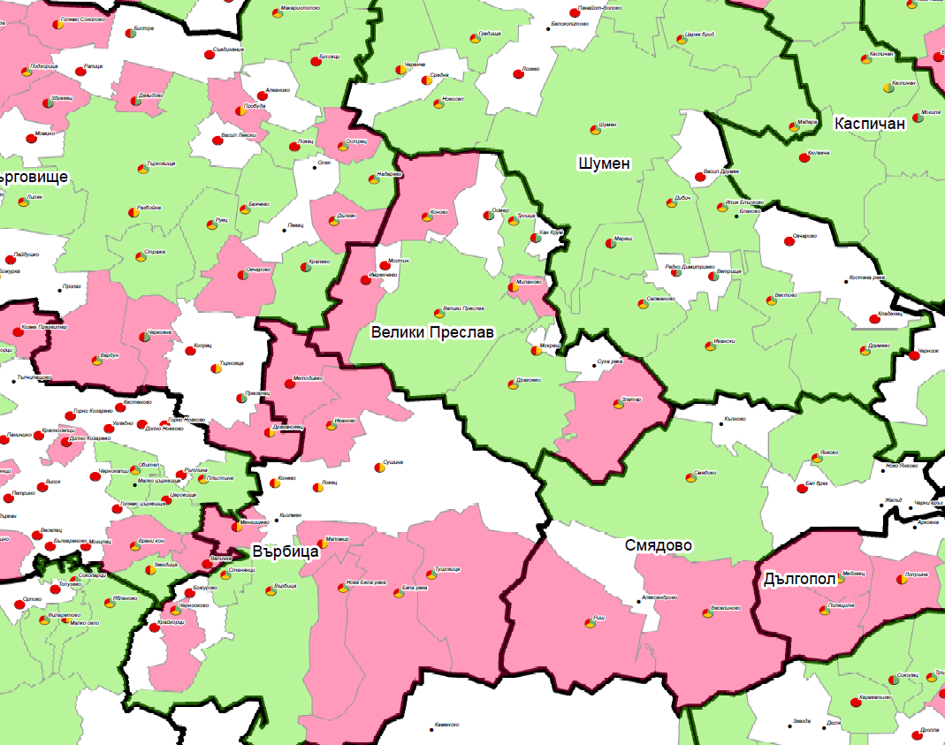

Region 3: Covers Loznitsa Municipality (Razgrad Region),
Samuil Municipality (Razgrad Region),
Venetz Municipality (Shoumen Region),
Hitrino Municipality (Shoumen Region)

Population to be covered: between 17000 and 18800 people

Figure 6

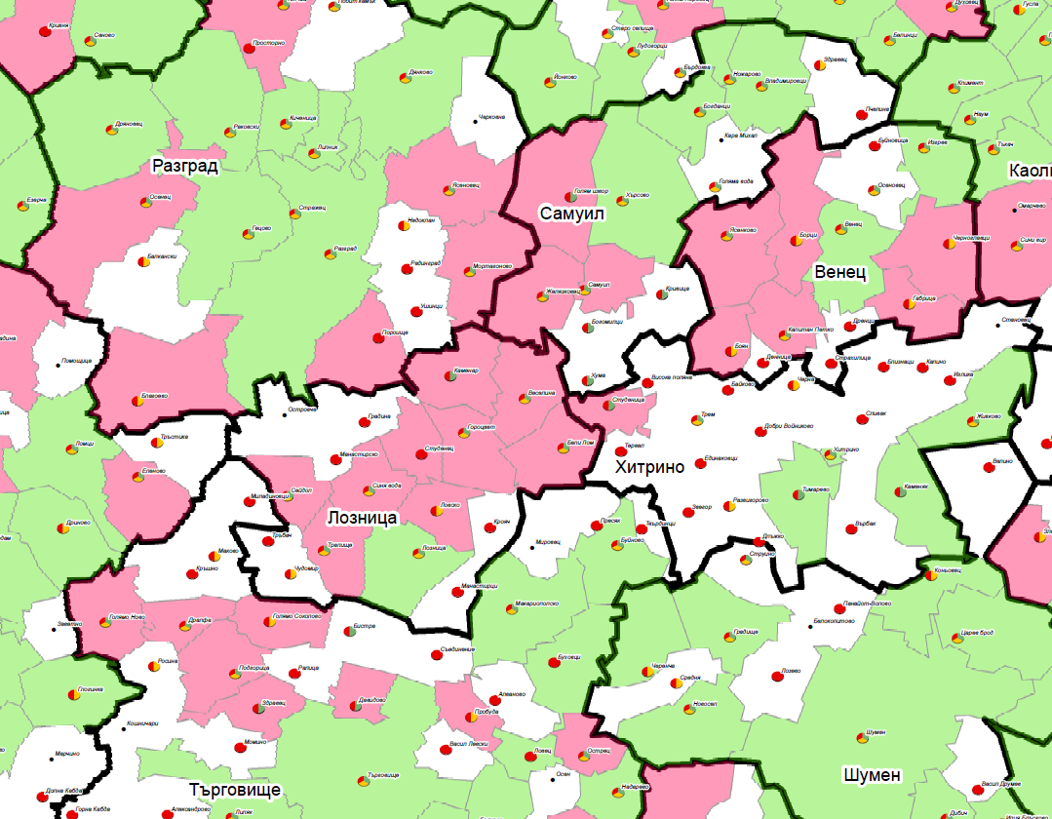

The above-mentioned working party and the Advisory Council on ICT issues to the MTITC Minister have approved the elaborated selection methodology and also the selected areas under it for their inclusion in the pilot project (Report No.3/12.03.2010 of the Advisory Board).
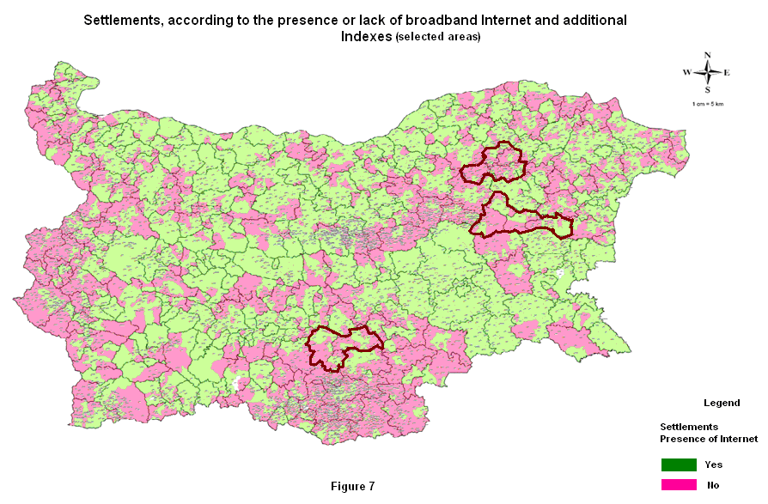
1.3. Organizational model of the project according to its revenue

Before starting the investment project and in order to apply for grants under the OPRD there must be conducted Pre-investment study. The Pre-investment study includes a description of the scope of the project, preliminary feasibility study; including research on alternative technologies applicable to its implementation; a survey of existing communications infrastructures as for this purpose a card should be made. It is crucial to evaluate the potential use of broadband services in selected areas through the method of interview with specially designed questionnaires. It is especially important to be prepared the appropriate analysis required (cost-benefit analysis of financial and economic analysis of all relevant technology solutions tested in feasibility studies, sensitivity analysis), quantity-value accounts, description of the actions set out in the project with relevant indicators. On the basis of the analysis of cost-benefit will be set the amount of the subsidy. Regardless of the sound objective - 50% of households to employ Internet and electronic communications services, preliminary studies indicate that the specifics of the population in these areas, consumption, respectively, revenues from fees may not ensure the financial resources necessary to maintain the newly built infrastructure, ie project will most likely be non profitable.

The conduct of these preparatory activities and the preparation of the Medium-term investment program framework with project fiches (each with financial analysis) and an indicative budget of the project and other necessary accompanying documents, will enable EA “ECMIS” as a direct beneficiary to apply to the Managing Authority of Operational Programme "Regional Development" and this would ensure successful opening of Operation 2.2. of the OPRD

This will allow the launch of an open tender procedure for render of a procurement contract for design and construction (complete engineering) of communication infrastructure, representing regional networks for open access, providing broadband access in three predefined areas.

1.4. Technical framework for realization of the investment project

In essence, the concept envisages the creation of regional networks with open access to provide broadband Internet access in pre-selected less urbanized and rural areas. This will be done as EA “ECNIS” as a beneficiary of OP “Regional Development” will hold an open procurement procedure for design and construction (complete engineering) of these networks.

Network with open access (Open Access Network - OAN) is network architecture and business model that separates physical access to the network and management and provision of the services. In order to create a competitive environment for all comers, telecom operators (service providers) are ensured equal access to the network. Maintenance, management and provision of the services provided by the Network with Open Access (OAN) are performed by EA “ECNIS” as a beneficiary or a company selected by competition. The access to the network resources will be maintained in regulation with predefined quality assurance services.

The present concept makes provision the regional OAN network to be built on three levels:

- Distributive level - Combines the network traffic from municipal centers, linking them to one or two regional network centers, where they interact with telecommunication service providers. Devices on that level are multi-functional routers with high reliability.;
- Aggregate level - Combines the network traffic in urban centers, linking them with one or two municipal network centers. Devices of this layer are high-performance Ethernet switches with low latency;
- Level of access – Aggregates the traffic from end users as they connect to the network center in town. Access to the subscribers is provided by retail providers.
In the framework of the investment project, the regional network must connect the supporting communication network (backbone) of one of the leading telecom operators in the point of presence in the regional network center, situated in the district town with network centers situated in local municipal cities in the region through high-speed optical Ethernet connection. On the next level municipal network centers should be linked to the local network centers in the targeted remote settlements without Internet access, with more than 500 people through high-speed optical Ethernet connection or point-to-point radio connection.

Fig. 8 Organization of a regional network with open access
In order to enable the provision of electronic administrative services within the e-government concept, alongside with the retail services, provided by the private operators to end-users, separate optical fibers will be planed between the distribution and aggregate level.

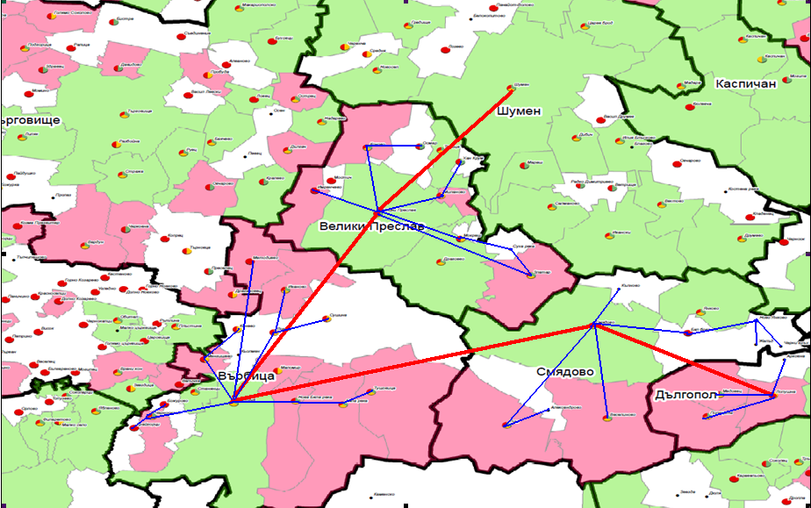

Fig. 9 Example connectivity in one area

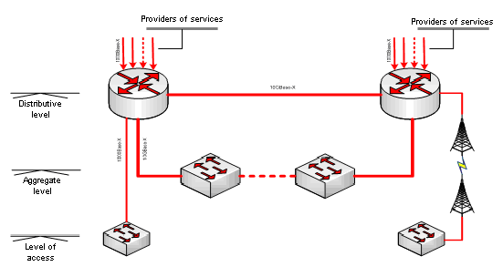

Fig. 10 - levels of regional network with open access

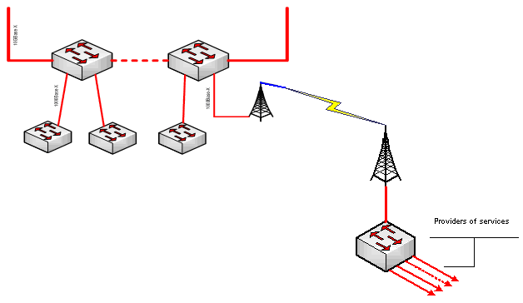

Fig. 11 - aggregate level and level of access

The Local network centers will be located in municipal buildings in the city centers and remote locations. Public institutions (schools, hospitals, municipal agricultural offices, police departments, community centers, etc.) must be connected to the local network centers in the relevant locality. The network centers are the points of connection to the telecommunication service providers, which declared interest. With that end in view in the local network center in the municipality of each remote location, a device for access to the network is installed (radio equipment, optical switch and / or other). This device allows telecommunication operators, providing retail communication services, using different technologies for access to end customers, to provide a wide range of communication services with guaranteed performance and quality.

In order to take advantage of the opportunities provided by the infrastructure, subject to this investment project, communication operator should invest in building connectivity to the point of presence in the district center and in construction of the “last mile”.

The proposed infrastructure must be scalable, flexible and oriented towards the delivery of advanced services. In order to meet the contemporary business requirements, the infrastructure should be able to ensure the operation of existing services and to quickly implement new ones in the future. The network must support all services equally. The proposed infrastructure must meet the following functional requirements:

- ToIt must be able to ensure the provision of multimedia services;
- The provision of services must be independent of the used transport-related technologies like optical fiber or point-to-point radio;
- M It ust allow retail suppliers to use different technologies for access to end customers, such as Ethernet, xDSL, 3G, WiMAX, DOCSYS and others.
The chosen solution for active equipment should meet the following principles:

- -Support of Ethernet connectivity - 100 Mbit / s Ethernet, 1Gbit / s Ethernet, 10Gbit / s Ethernet;
- Transparent provision of pre-defined services with guaranteed quality;
- Opportunities for management and real-time monitoring of the network as a whole and the network nodes via a standard interface protocols adopted in industrial administration of telecommunications networks. Easy location of the damage;

For this purpose a center will be built to monitor the network in one of the regional network centers, as it is provided the appropriate hardware and software. This requirement would be included in the technical assignment to the tender documentation for open tender procedure for the design and execution (complete engineering) of regional networks for broadband Internet access. Furthermore, it makes provision to be developed web GIS application for monitoring and analyzing the network in selected areas, as part of overall planning and monitoring of the broadband Internet coverage in the country.
- The active network equipment must provide the following services to licensed service providers who wish to lease;
- ETHERNET LINE (E-LINE) PHASE 2 SERVICE TYPE (point to point);
- ETHERNET LAN (E-LAN) SERVICE TYPE (multipoint to multipoint); ETHERNET TREE (E-TREE) SERVICE TYPE (point to multipoint);
(The definition of Ethernet services is under the Metro Ethernet Forum MEF 6.1 Ethernet Services Definitions - Phase 2. )
- -The active equipment must be able to ensure the parameters of quality of maintenance of Ethernet services.;
- European standards for safety and electromagnetic compatibility.

A roadmap for events and the preparation and implementation of the pilot investment project in 2010 is shown in fig.12

Fig. 12 Road map 2010
Combined effect

Along with the activities, outlined in the Roadmap project, there are planned and carried out additional activities as part of the National Program (under development) for the implementation of the Strategy for development of broadband in Bulgaria. These additional activities include conducting research and working discussions, related to the identification of coordinated actions with other institutions committed to the introduction of ICT in municipalities in order to achieve more efficient investment. These are Ministry of Education, Youth and Science (MEYS), Ministry of Labor and Social Policy (MLSP), which in the frame work of Operational Programme Administrative Capacity might assist the process of promoting broadband Internet and electronic communications services and promote their use. Another such administration is the Ministry of Agriculture and Food, which is the Managing Authority of Rural Development Programme (RDP).Within this collaboration is expected to assign with funding from RDP a study and analysis of the potential use of Internet and broadband services from population, business and public authorities (regional and local) in different regions of the country since that would benefit greatly the future planning of broadband development, requisite for the purposes of subsequent projects. With that end in view, there is stipulated the development of GIS application and database which should be updated periodically. Furthermore, the joint efforts of both institutions would encourage local authorities in municipalities in the selected areas to apply for funding under RDP for building information centers in the settlements.

It is envisaged to conduct series of specialized training courses for individual groups of the population:

- different age groups, minority groups, in order to acquaint the population in pre - selected area with the possibilities of Internet and information and communication technologies and their sphere of application in daily live, as well as the creation of necessary skills in this area;
- local government officials in order to increase administrative capacity in the context of improving administrative services, offered to the population and businesses within the e-government concept.

In order to realize these active forms of education and training, it is necessary to use all the possibilities offered by the equipped computer cabinets in the local schools or suitable municipal halls in the selected settlements.

For this purpose, may be used additional financial resources from the following sources:

- Operational Programme "Administrative Capacity";
- Operational Programme "Human Resources - training and strengthening the administrative capacity of local administration officials.

The financial resources requisite in order to secure the above mentioned activities will be an integral part of the National Programme for implementing the National Strategy for the development of broadband in the Republic of Bulgaria, which is under development.

Thus will be stimulated and increased the demand of communications services in the selected areas, which will reconsider the investment in infrastructure and will significantly enhance its effectiveness.

Targets

Supply side

In the tender documentation for this open procedure should be set clear measurable outcomes of the pilot projects tailored to the anticipated effects and results set out in the National Strategy for Broadband:
- To enable provision of retail broadband services with clearly defined minimum parameters and quality;
- 100 % connectivity to schools and medical facilities in the settlements in the selected areas;
- first year – 30% of the households will be customers, second year – 50 %.
Demand side
The expectations and the outlined goals, regarding the penetration of broadband Internet and the usage of computer equipment and electronic services for the three selected areas, are set as follows:
- level of broadband penetration (%) – EU average;
- computer equipment (%) – BG average;
- level of service penetration (%) – 50 % BG average;
- mobile and fixed devices, as an alternative opportunity for the use of administrative services – increase by 30 %.
In regard to the level of service penetration, it is to be expected more aggressive penetration of double (cable TV and high-speed Internet) and triple play services (cable TV, fixed voice telephony service and high-speed Internet) by cable operators as is the tendency for the whole country.

1.5. Models for management of the newly constructed infrastructure
Admission (Approval), maintenance and operation of the newly constructed infrastructure
The investment project should be completed by establishment of a broadband infrastructure in the three selected areas and the admission (approval) of projects in accordance with the existing legislation and requirements of the Operational Programme “Regional Development”. After obtaining permission for the operation of the broadband infrastructures in the three areas the following maintenance and operations scenarios are applicable:

A. The project is not profitable
The preliminary calculations show that according to expectations the project will not be profitable taking into account the economic situation and characteristic of the selected regions. In this case financial provision of the activities for maintenance and management of the established infrastructure will be secured from the budget of the Executive Agency.
1. Model 1
As a direct beneficiary under the Operational Programme “Regional Development”, Executive Agency “Electronic Communication Networks and Information Systems” is responsible for the maintenance of the established infrastructure. The Executive Agency will conduct an open competition procedure for rendering the established regional electronic communications infrastructure with obligation for managing and provision of open access.
The selected company (contractor) is obliged to provide a non-discriminatory access to all telecommunication operators and service providers which have declared such an intention.
Fees collected from telecommunication operators and service providers by the contracting company (contractor) should be consistent with fees collected for similar services in such areas in order not to distort competition.
Revenues from the said fees, supplemented with funds from the budget of the Executive Agency will allow the latter to provide necessary financial resources for execution of the maintenance and management functions of the regional networks obliged to provide open access.
2. Model 2
Executive Agency “Electronic Communication Networks and Information Systems” shall conduct an open competition procedure for selection of a company designated to perform maintenance and management functions of the regional electronic infrastructure obliged to provide open access.
The selected company (contractor) is obliged to provide a non-discriminatory access to all telecommunication operators and service providers which have declared such an intention.
Fees collected from telecommunication operators and service providers by the contracting company (contractor) should be consistent with fees collected for similar services in similar areas in order not to distort competition.
Revenues from the said fees, supplemented with funds from the budget of the Executive Agency will allow the latter to provide necessary financial resources for execution of the maintenance and management functions of the regional networks obliged to provide open access.

B. The project is profitable
In this case is applied the principle of a free competitive initiative.
- Model 3
The state shall conduct an open competition procedure for rendering (concession procedure or other appropriate form of rendering) of the established infrastructure for maintenance and management for a period of at least seven years. For the mentioned period the ownership of the infrastructure should not be changed in accordance with the requirements of the Operational Programme “Regional Development”.
All market players may participate in the open competition procedure, including the company which designed and constructed the project site.
The selected contractor (company) maintains and manages the regional infrastructure with open access in accordance with the conditions laid down in the contract while being obliged to provide a non-discriminatory access to all telecommunication operators and service providers which have declared such an intention.
Fees collected from telecommunication operators and service providers by the contracting company (contractor) should be cost-oriented in order not to distort competition.
Revenues from the said fees will allow the provision of necessary financial resources for the execution of the maintenance and management functions of the regional networks having obligation for provision of open access and payment of concession fees, as well.
- Model 4

As a direct beneficiary under the Operational Programme “Regional Development”, the Executive Agency “Electronic Communication Networks and Information Systems” maintains and manages the regional electronic infrastructure obliged to provide open access for a period of at least seven years. For the mentioned period the ownership of the infrastructure should not be changed in accordance with the requirements of the Operational Programme “Regional Development”.
Executive Agency “Electronic Communication Networks and Information Systems” is obliged to provide a non-discriminatory access to all telecommunication operators and service providers which have declared an intention thereof and which shall be bound to provide said retail services at pre-determined limited price.
Fees collected from telecommunication operators and service providers by Executive Agency “Electronic Communication Networks and Information Systems” should be cost-oriented in order not to distort competition.
Revenues from the said fees will allow provision of necessary financial resources for the execution of the maintenance and management functions of the regional networks having an obligation for provision of open access.

After the expiry of the period where one of the above-mentioned models is applied, the established infrastructure could be rendered for disposition of the respective municipalities’ the lands of which it occupies or to associations of these municipalities.

