FINAL REPORT

from

Investigation of railway accident – derailment of locomotives within occurred side collision, serviced DFT № 20691 and DFT № 20698, in Iliyantsi station on 21.01.2022

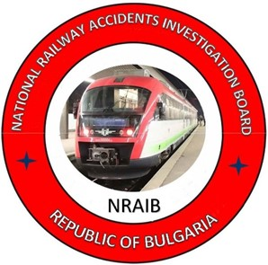

2022
OBJECTIVE OF INVESTIGATION AND EXTENT OF RESPONSIBILITY
The National Air, Maritime and Railway Transport Accidents Investigation Board (NAMRTAIB), which is an independent body performs the investigation of significant accidents, accidents and incidents. The National Board is within the Council of Ministers (CM) of the Republic of Bulgaria, and aims to find the circumstances and causes that led to the accidents and incidents occurrence in order to improve the safety and to avoid such in future. The investigation of accidents and incidents does not include the determination of fault and responsibility in no circumstances.
The investigation is performed in accordance with the requirements of DIRECTIVE (EU) 2016/798 of the European Parliament and of the Council of 11 May 2016 on railway transport safety, the Railway Transport Act (RTA), Ordinance No59 dated 5.12.2006 on the rail transport safety management, and Ordinance No Н-32 dated 19.09.2007 on the coordination of the activities and information exchange during the railway accidents and incidents investigation, as well as per Agreement dated 17.04.2018 on the interaction during investigation of accidents and incidents in the air, maritime and railway transport between the Prosecutor's Office of the Republic of Bulgaria, Ministry of Interior, and the Ministry of Transport, Information Technology and Communications.
The Investigation reports follow the requirements of REGULATION (EU) 2020/572 of the Commission dated 24 April 2020 on the reporting structure for railway accident and incident investigation reports.

TABLE OF CONTENTS
№ | Title of section | Pg.
 | Summary | 5
 | Investigation | 9
 | Description of the event | 13
 | Analysis of the event | 27
 | Conclusions | 43
 | Safety recommendations | 44

ABBREVIATIONS, USED IN THE REPORT
BDZ PS Ltd. – ,,BDZ-Passenger Services“ Ltd. – state carrier for passenger services
,,Bulmarket Rail Cargo“ Ltd. – licensed railway undertaking for freight traffic services
SE NRIC – State enterprise „National railway Infrastructure Company “(railway infrastructure manager)
NAMRTAIB – National Air, Maritime, and Railway Transport Accidents Investigation Board (Independent Specialized National Investigation Body)
RAEA – Railway Administration Executive Agency
MoI – Ministry of Interior
SDoI – Sofia Directorate of Interior
WIS – Wagon inspection section
MAD – Main air duct (depending on the context)
km – kilometre along the railway infrastructure
OCL – Overhead contact line (catenary)
ECM – Entity in Charge of Maintenance
IDFT – International Direct Freight Train
RRI WSSB type– Route-relay interlocking (German type)
DFT – Direct freight train
RTA – Railway Transport Act
Ordinance № 59 – Ordinance on the rail transport safety management
TF – Task Force
RRS – Rail Rolling Stock
TOMR – Train operation management and reporting (in real time)
SMS – Safety Management System
TMWI – Technician-mechanic wagon inspector
DCCM – Device for communications, connections and messages
SABS – Semi-automatic block system

- Summary
  - Brief Description of the Event.
On January 21, 2022, at Iliyantsi station on the eighth track was composed DFT № 20691, towed (headed) by auxiliary locomotive № 91522086001-8, driven by locomotive driver first-person, and locomotive driver second-person, and a train locomotive № 91520085005-4, by locomotive driver first-person, followed by two more inoperable locomotives № 91520087025-0, accompanied by locomotive instructor and locomotive № 91520087009-4 accompanied by locomotive driver. The train consisted of 24 wagons, 648 tons, assigned for movement by NRIC on 20.01.2022 with direction Iliyantsi - Ruse marshalling yard.
On the ninth track in Iliyantsi station, was composed DFT № 20698, towed by locomotive №91522086005-9 consisting of 10 wagons, 108 tons. The train was assigned by NRIC on 20.01.2022 with route Ruse marshalling yard - Iliyantsi - Svetovrachene - Kremikovtsi - Yana - Pirdop. A complete test "A" was performed on the train by TMWI, an employee of the railway undertaking ,,Bulmarket Rail Cargo“ Ltd. that performed the transport.
At 03:13 a.m. (according to the data taken from the diaries of the traffic manager on-duty) from the eighth acceptance-departure track at Iliyantsi station departed DFT № 20691 in direction Kurilo station to Ruse marshalling yard with an open exit signal and an order for departure by the traffic manager on-duty second person at the station. The locomotive driver second-person accepted the departure order and informed the locomotive driver first-person.
At 03:13 a.m. from the ninth track at Iliyantsi station departed DFT № 20698 without a permitting indication of the signal from the ninth track in direction Svetovrachene station to Pirdop. During the departure, the locomotive driver first-person was alone in the locomotive control cabin. At that time, the locomotive driver second-person was in the engine compartment of the locomotive to download data on electricity consumption. When the locomotives of the two trains entered contemporarily, switch № 39 collided laterally and derailed to the left and right of the railway switch with all the wheel-sets (Fig. 1.1).

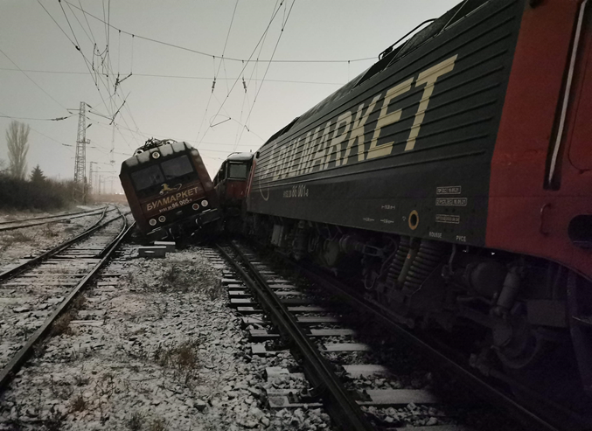
Fig. 1.1. Derailment of the locomotives of the two trains
Locomotives and staff of the railway undertaking for freight services „Bulmarket Rail Cargo“ Ltd. served the two trains.
Because of the derailment, the fixing rope of the catenary broke and the same hung down. At 04:50 a.m. the voltage in the catenary was switched off from the fifth to the tenth track to repair the damage. At 05:50 a.m. the voltage in the catenary and the movement of the trains on the fifth track was restored.
At 10:46 a.m., the bodies of the pre-trial proceedings and the head of the investigation of the NAMRTAIB gave written permission to the manager of the railway infrastructure to start emergency recovery works on the railway infrastructure and derailed rolling stock.
Because of the derailment, no staff was injured from the locomotives serving the two trains, as well as staff from the station. Serious damages were caused to the derailed two locomotives and minor damages to the non-derailed train locomotive of DFT 20691.
Damages were caused to the signalling equipment, the catenary network (overhead contact line) and on the rail track, and the facilities.
The movement of trains through switch № 39 on the eighth and ninth tracks was restored at 17:00 p.m. on 22.01.2022.
  - Location and time of the event occurrence.
In Iliyantsi station on 21.01.2021 at 03:13 a.m. with a permitting indication for the signalling DFT № 20691 departed from the 8-th towed by auxiliary headed locomotive № 91522086001-8, at that moment from the 9th acceptance-departure track DFT № 20698 departed without permitting signalling indication, towed by locomotive № 91522086005-9. The locomotives of both trains entered at switch №39 at the same time and a side collision followed, from which both locomotives derailed with all the wheel-sets away from the railway switch. Railway switch № 39 in Iliyantsi station is on the left with a radius of R = 300 m, and a profile in the uphill of 1.20 ‰ (Fig. 1.2).
Fig. 1.2. Scale sketch of the accident.
  - Factors determining and contributing the event.
The determining factor for the accident is the departure of DFT № 20698 from the ninth track in the direction of Svetovrachene station at 03:05:03 a.m. (according to the speedometer installation of locomotive № 91522086005-9), without checking the clock, without permitting indication at the exit semaphore and without an order for departure from the traffic manager on- duty at Iliyantsi station.
A contributing factor to the accident is the parallel location of the exit semaphores on the 8th and 9th tracks (ground in the left curve), the geometry of the permanent way on both tracks and adverse weather conditions (rain mixed with snow) in the dark part of the day.
  - Direct causes and consequences of the event.
It was found that the 9th track of Iliyantsi station is located to the right of the 8th track in the direction of increasing mileage, and from South to North most of the 9th track is parallel to the 8th, with wheelbase 4.83 meters, after which the 9th track deviates to the right with a right curve and a left counter-curve, due to which the wheelbase between the two tracks increases to 6.58 meters.
The Investigation Commission found that when looking from the driver's cab at the location of locomotive № 91522086005-9, it is quite possible that the locomotive driver misunderstood the 8th track permit of the exit semaphore for the DFT № 20691 (Fig.1.3).
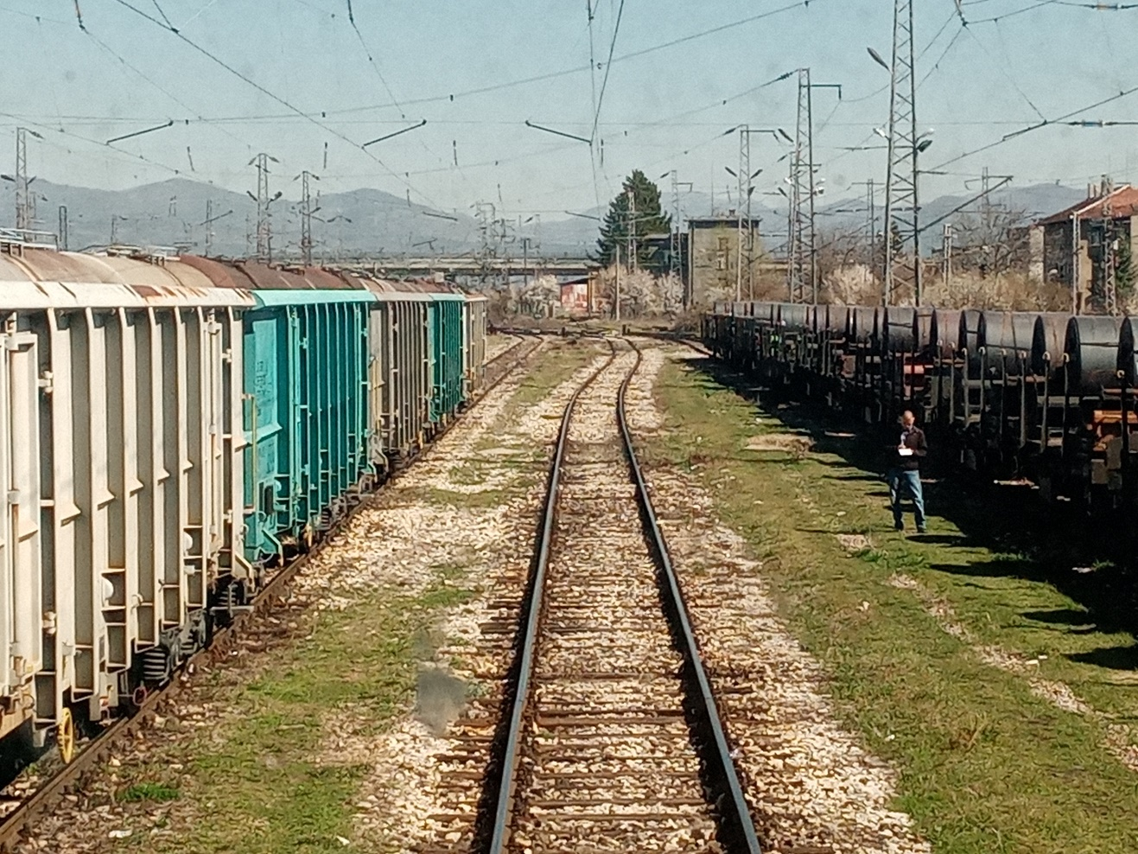
Fig. 1.3. Location of the locomotive of DFT № 20698 on 9-nth track.
The circumstance cannot be considered as the main cause for the accident, as the normative documents and the technology of Iliyantsi station forbid the locomotive driver to leave the station only on the permitting indication of the exit semaphore, but it probably had impact to some extent
It remains unclear why the locomotive driver of locomotive № 91522086005-9 undertook departure, given that the locomotive was loaded with maximum or almost maximum traction - something that cannot be done accidentally. It is known that the locomotive can be set in motion (even more so in traction mode) only after specific actions have been performed by the locomotive driver, in a strictly defined sequence.
Therefore, the direct cause for the accident can be considered that DFT № 20698 left the ninth track without meeting the regulatory requirements for sending trains from Iliyantsi station.
  - Safety recommendations and addressees to which they are addressed.
In order to prevent other similar accidents that could have serious consequences for the railway infrastructure and rolling stock, the Investigation Commission proposes to the National Safety Authority RAEA safety recommendations related to Bulmarket Rail Cargo EOOD and SE NRIC.
- Recommendation 1 proposes that SE NRIC and Bulmarket Rail Cargo EOOD shall acquaint the interested staff with the content of this report.
- Recommendation 2 proposes Bulmarket Rail Cargo EOOD to assess the psychological human factor of the locomotive staff in order to improve teamwork in a positive atmosphere.
- Recommendation 3 proposes Bulmarket Rail Cargo EOOD to hold periodically interviews with the locomotive staff in the presence of a psychologist to discuss the development and promotion of collective good practices.
- Recommendation 4 proposes RAEA to assess the functioning of the Safety Management Systems with regard to the performance of pre-shift briefings and checks on alcohol and other intoxicants of locomotive staff in railway undertakings carrying freights and passengers and, at its discretion and need to restore the points for carrying out pre-travel medical examinations.
- Recommendation 5 proposes in case when assessing the functioning of the Safety Management Systems of the railway undertakings, discrepancies or omissions are established regarding compliance with the requirements of item 4.2 Competence, item 4.6 Integration of the human and organizational factor from Annex 1 of Commission Delegated Regulation (EU) 2018/762, RAEA to issue mandatory instructions to railway undertakings to organize training of staff on the formation of mechanisms such as resilience to stress, personal stability and dynamic balance of psychological state, building and playing a subjective sense of control.
- Recommendation 6 proposes RAEA to carry out an inspection regarding the type of signalling at Iliyantsi station and together with SE NRIC to take action to comply with the requirements of Art. 305 of Ordinance № 58.

- Investigation
  - Decision for starting the investigation.
The decision to initiate the investigation was taken by the member of the Management Board of the NAMRTAIB in the Republic of Bulgaria, leading the investigation of railway accidents and incidents given the severity of the accident and its impact on railway transport safety. The investigation will be mainly focused on the analysis and organization of the human factor, which aims to prevent such accidents, which in similar circumstances could lead to serious consequences.
  - Motives for the decision to initiate the investigation.
The Decision to initiate the investigation is taken by the Commission at NAMRATIB based on art. 20, paragraph 2, (а) and (c) of Directive (EU) 2016/798, art. 115к, paragraph 1, item 2 of RTA, and art. 76, par. 1, item 2 of Ordinance No 59 dated 5.12.2006.
  - Scope and restrictions of the investigation.
The scope of the investigation examines and analyses the human factor (the locomotive staff who drove the locomotive of DFT № 20698), the violations of the regulations related to safety and the training of the staff.
For the purposes of the ongoing investigation, the Chairperson of the Investigation Commission recruited an external expert to the Investigation Commission to conduct human factor analyses.
Given the caused damages, the investigation is focused on the circumstances that led to the accident - derailment of locomotives in a subsequent side collision, serviced DFT № 20691 and DFT №20698 at Iliyantsi station, which in slightly different circumstances could lead to human casualties and significant material damages.
  - Competences of the persons, involved in the investigation.
The Deputy President of the Management Board of the NAMRATIB, head of railway transport field headed the Investigation Commission. The composition of the commission includes external independent experts - habilitated persons from the scientific circles and experts with free profession with qualification and professional orientation in fields of activity – human factor, railway infrastructure, and rail rolling stock.
  - Communication and consultations with the persons and entities, involved in the event.
The Commission defined the parameters of the investigation and coordinated its actions with the Task Force, which includes representatives of the entities involved in the accident. The Task Force collected all documents and samples, written testimony of the staff of the entities, records from the recording devices of locomotive № 91522086001-8, towing DFT №20691 and locomotive №91522086005-9, towing DFT № 20698, as well as recordings from the camera front wall of locomotive № 91522086005-9. The materials and documents were handed over to the Chairperson of the Investigation Commission at the NAMRATIB. The chairperson of the Investigation Commission conducted the first on-site interview with all the involved in the accident. The entities were requested and provided information on the maintenance of the rail track and the facilities of the signalling equipment at Iliyantsi station, information on the repair and maintenance of the locomotives of the two trains. The expertise of the locomotive personnel who underwent the medical and psychological examinations was also required. Interviews were conducted with the safety authorities of the two entities and with the management of the railway company Bulmarket Rail Cargo EOOD and the railway infrastructure manager SE NRIC. The locomotive personnel involved in the accident was tested for alcohol use in the presence of the Chairperson of the Investigation Commission and the Task Force.

  - Degree of cooperation from the participating entities.
During the investigation, the managers of the railway company Bulmarket Rail Cargo EOOD and SE NRIC, fully cooperated and provided complete access to the Investigation Commission at NAMRATIB as well as to all the collected materials and documents.
In addition, interviews were conducted with the locomotive staff, the shift staff at Iliyantsi station and the management team of the entities. Full access to rolling stock and railway infrastructure elements was provided.
  - Methods and techniques of investigation and analysis.
On 21.01.2022 at 03:45 a.m. the member of the Board of NAMRATIB with competence to investigate railway accidents received an oral notification by mobile phone at 04:06 a.m. followed by a written notification by SMS from the on-duty officials of the railway infrastructure manager for realized accident. The member of the Management Board of NAMRATIB with competence to investigate railway accidents analysed the received information, notified the two entities (SE NRIC and Bulmarket Rail Cargo EOOD) not to take other actions until his arrival on the spot.
At 04:30 a.m. the member of the Board of the NAMRATIB with competence to investigate railway accidents arrived at the place of the accident at Iliyantsi station. He undertook primary inspections and prepared photographic material on the state of the station interlocking, RRI type WSSB, which registered the moment of the accident with light and sound notification of the accident. After the derailment of the locomotives, switch № 39 remained in a cut position, visibly indicated on the control panel of the station interlocking. Through the control panel of the station interlocking it was established that the route was arranged and locked with a permissive indication of the output signal and given ready by the traffic manager on-duty second person from the 8th track for departure of DFT № 20691 in the direction of Ruse marshalling yard.
A discrepancy was found in the type of signalling (high-speed and conventional) which is a possible factor introducing additional confusion for locomotive drivers, described in detail in item 3.1.4.2.
At 05:00 a.m., after the completion of the inspection of the station interlocking, permission was given by the head of the investigation of the NAMRATIB for restoration and preparation of a Statement of findings for its technical condition. In the office at Iliyantsi station, the officials of the Task Force carried out tests with the interlocking, which were reflected in the Statement of findings for the technical condition of the signalling equipment.
The availability and integrity of all seals on the prepared and locked route, as well as the permitting indication of the 8th track exit signal were established.
It was established that the traffic manager on-duty first person at the Iliyantsi station had properly manipulated the station interlocking and it was working normally at the time of the accident.
During the first inspections of the railway infrastructure it was found that due to the derailed locomotives one of them with the pantograph broke the fixing support rope of the catenary between poles 53 ÷ 60 and the traffic was interrupted from the 5th to the 10th track. The rope has sagged and the catenary voltage has not been switched off so far. From 04:50 a.m. the voltage in the catenary was switched off from the fifth to the tenth track and was switched on at 05:50 a.m. after the completion of the repair.
After the inspection, permission was given by the investigating body - NAMRATIB for its restoration and drawing up a Statement of findings for the technical condition of the catenary.
The location of the two locomotives derailed with all the wheel-sets on both sides of the switch was determined on switch № 39. On locomotive № 91522086005-9 of DFT № 20698 on the 9th track, the first bogie had dug into the ballast prism between the 9th and 10th tracks, and the second bogie was trapped in the first bogie of the second (non-derailed) train locomotive on 8th track. The locomotive was lying to the right at a 45 ° angle. The first locomotive № 91522086001-8, towing DFT № 20691, derailed to the left on switch № 39 with all the wheel-sets. The buffers of locomotive № 91522086001-8 and №91520085005-4 were jammed with each other in a horizontal plane transverse to the rail track axis.
The “Safety Procedure SP 2.09” part of the SMS of SE NRIC was not observed due to the late notification received, around 06:30 a.m. on the national telephone number 112 about the occurred accident.
At around 07:30 a.m., the pre-trial bodies from the SDIM - Sofia, investigating police officers arrived at Iliyantsi station. The head of the investigation from the NAMRATIB on the spot with the bodies of the pre-trial proceedings set up an organization for follow-up and exchange of information. A re-inspection was carried out jointly with the investigative bodies in the pre-trial proceedings of the SDIM - Sofia. According to a report by the investigating police officers, the Sofia District Prosecutor's Office has instituted pre-trial proceedings to establish the circumstances and causes that led to the accident and to establish the guilty officials. An organization for follow-up actions and exchange of information was established between the bodies of the pre-trial proceedings from SDIM - Sofia and the head of the investigation from NAMRATIB.
An interview was conducted on the spot with the staff of the railway infrastructure (first and second person traffic managers on duty, switchman at post № 1 at Iliyantsi station).
In the light part of the day, repeated inspections of the derailed locomotives on switch 39 were performed, documented with photographic material.
Inspections were performed for the visibility of the readings of the exit signals on the 8th and 9th tracks. The exit signals of the two tracks, although they are terrestrial (ground), the perception of their readings is possible and guaranteed after an established measurement at a distance of 200 meters from them.
After lifting and moving the derailed locomotives, inspections were performed on switch № 39. From the inspections and the condition of the station interlocking, it was established that the switch after the accident passed in a cut position. The following damages were found along the switch: displacement along the axis of the point, intermediate and crossing part; broken switch wooden sleepers and fasteners, broken rails on both tracks after the end of the switch.
During the inspection of the catenary, a broken fixing rope from the 5th to the 10th acceptance-departure tracks was found.
The inspection of the locomotives revealed damage to three of the locomotives on their running gear: № 91522086005-9, towed DFT № 20698 from the 9th track and two locomotives on the 8th track, auxiliary head № 91522086001-8 and train № 91520085005-4, towed DFT № 20691.
Damage to the electric turn signal apparatus of switch № 39 caused by derailed locomotives was found.
At 10:46 a.m. on 21.01.2022, after the completion of the on-site inspections, in order to restore quickly the movement and capacity of the railway infrastructure, the Investigation Commission of the NAMRATIB and the pre-trial body of SDIM - Sofia gave written permission to the railway infrastructure manager to start emergency recovery activities.
On 03.02.2022 in the city of Ruse on the territory of "Express Service" Ltd. the Task Force, together with representatives of the two entities inspected and measured the locomotives of DFT 20691 № 91520085005-4 and № 91522086005-9 and locomotive 91522086001-8 of DFT № 20698, and Statements of findings for their technical condition have been drawn up. Express Service OOD is a certified ECM and under a contract with the railway company Bulmarket Rail Cargo EOOD, is responsible for the maintenance and technical condition of the locomotives.
On 04.02.2022, the Chairperson of the Investigation Commission in the NAMRATIB received from the head of the Task Force in RI "Transport Safety" - Sofia collected materials, documents and physical evidence (including photos) about the railway accident - derailment of two locomotives in the event of a side collision at switch № 39, served DFT № 20691 and DFT № 20698 at Iliyantsi station on 21.01.2022.
On April 6, 2022, the Investigation Commission of the NAMRATIB conducted an experiment to clarify the circumstances at Iliyantsi station with the location of the two locomotives located on the 8th and 9th tracks. The aim of the experiment was to determine the visibility of the exit signal from the cab of the locomotive on the 9th track (ground), which was positioned 193 meters from it. DFT № 20698 is composed on the 9th track and in front of the locomotive the rail track to the exit signal is in a straight line with a length of 77 m, followed by a right curve with radius R = 3846 m and length 56 m, straight with a length of 25 m and after it a left curve with radius R = 303 m and length 59 m. The exit signal (ground) for the 9th track is with normal visibility from the locomotive cab (at the time of the accident it was in a prohibited position). The experiment was conducted in the light part of the day in clear weather and excellent visibility. The probability that the locomotive driver mistakenly perceived the open exit signal on the 8th track for DFT № 20691 in the dark part of the day is very probable.
  - Difficulties faced during the investigation.
During the investigation, the Investigation Commission of the NAMRATIB did not encounter any difficulties. Representatives of the Task Force and the safety authorities of the Railway Infrastructure Manager and the Railway Undertaking provided full cooperation to the Investigation Commission. The activities for the reconstruction of the railway infrastructure and the rolling stock started after a written permission from the investigative structures of the pre-trial proceedings and the Investigation Commission of the NAMRATIB.
  - Interaction with the judicial authorities.
In accordance with the Agreement on Interaction between the bodies of the pre-trial proceedings and the Investigation Commission of the NAMRATIB in force from 17.04.2018, information, documents and materials were exchanged between the parties during the investigation. The pre-trial authorities from SDIM - Sofia on 21.01.2022, at about 12:30 p.m., tested the locomotive staff of all locomotives for the use of alcohol and other intoxicants.
The pre-trial authorities, through the "Drug Test" (field test), established that the locomotive driver of locomotive № 91522086005-9 from DFT № 20698 (left without a permit from track 9) had used narcotics (Benzodiazepines). The tested locomotive driver categorically denied the use of alcohol, drugs and other intoxicants on the day of duty. On 21.01.2022, at 14:20 p.m., a blood sample and urine were taken for examination in a specialized laboratory of the Military Medical Academy - Sofia, to establish the use of narcotics.
As can be seen from the Forensic Chemical Toxicological Expertise prepared on 11.04.2022, it was established that the provided biological samples taken by the locomotive driver of locomotive №91522086005-9 did not contain alcohol and drugs/narcotics.
  - Other important information for the investigation context.
From the testimony of the locomotive drivers, confirmed by the decipherment of locomotive №91522086005-9, towing DFT № 20698 from the 9th track, it became clear that from the place of departure until the moment of the subsequent collision, about 200 meters, the locomotive has developed a speed of about 33 km/h, and locomotive № 91522086001-8 towed DFT № 20691 from the place of departure until the moment of the subsequent collision, about 110 meters has developed a speed of about 19 km/h.
- Description of the event
  - Information on the event and the context.
    - Description of the event type.
On 21.01. 2022, at 02:38 a.m., DFT № 20698 arrived at Iliyantsi station, consisting of 17 wagons, 68 axles, 717 tons, with locomotive № 91522086005-9, driven by locomotive driver first-person and locomotive driver second-person. The train was assigned to operate with a schedule from SE NRIC on 20.01.2022 in the direction Ruse marshalling yard - Iliyantsi - Pirdop (Fig. 3.1). A shunting with DFT №20698 was carried out at Iliyantsi station, a group of seven wagons of the train was reduced. The new locomotive crew of locomotive № 91522086005-9 with locomotive driver first person and locomotive driver second person parked again the locomotive from the ninth track side of Sofia North station to the ninth track side of Svetovrachene station. After coupling the locomotive of DFT № 20698, which consists of 10 wagons, 108 tons, a full test "A" was performed by TMWI, an employee of the railway undertaking "Bulmarket Rail Cargo" EOOD, performing the transport
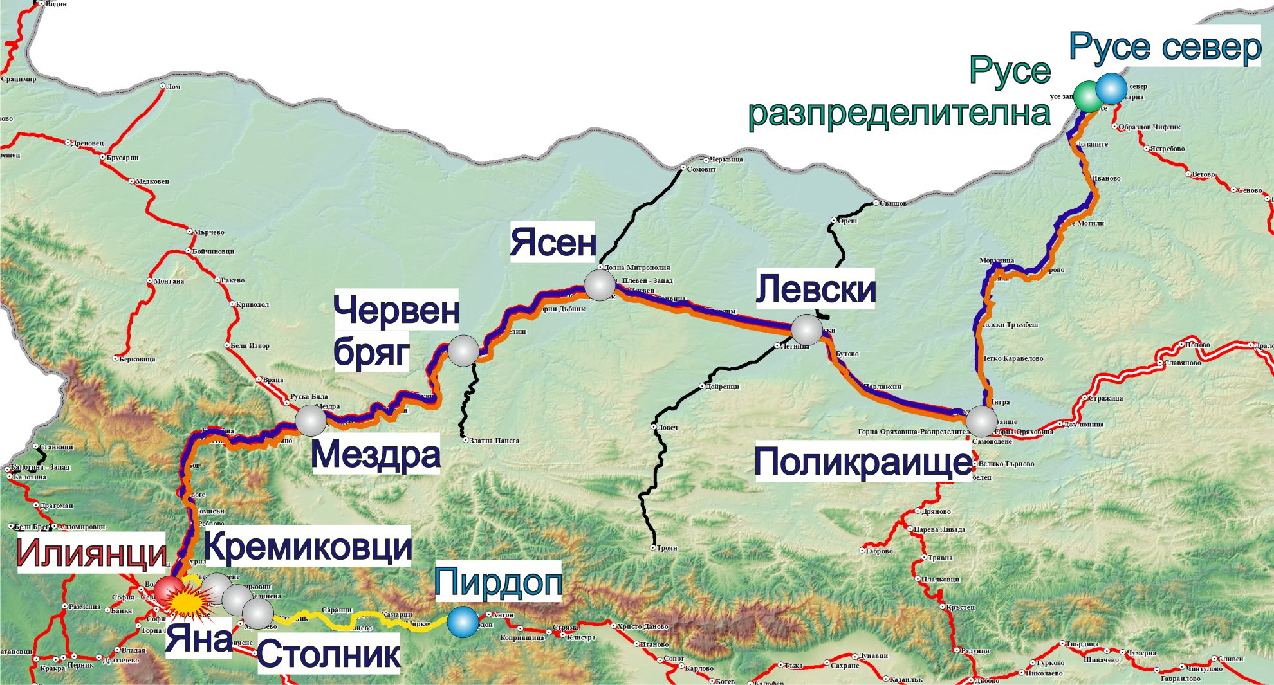
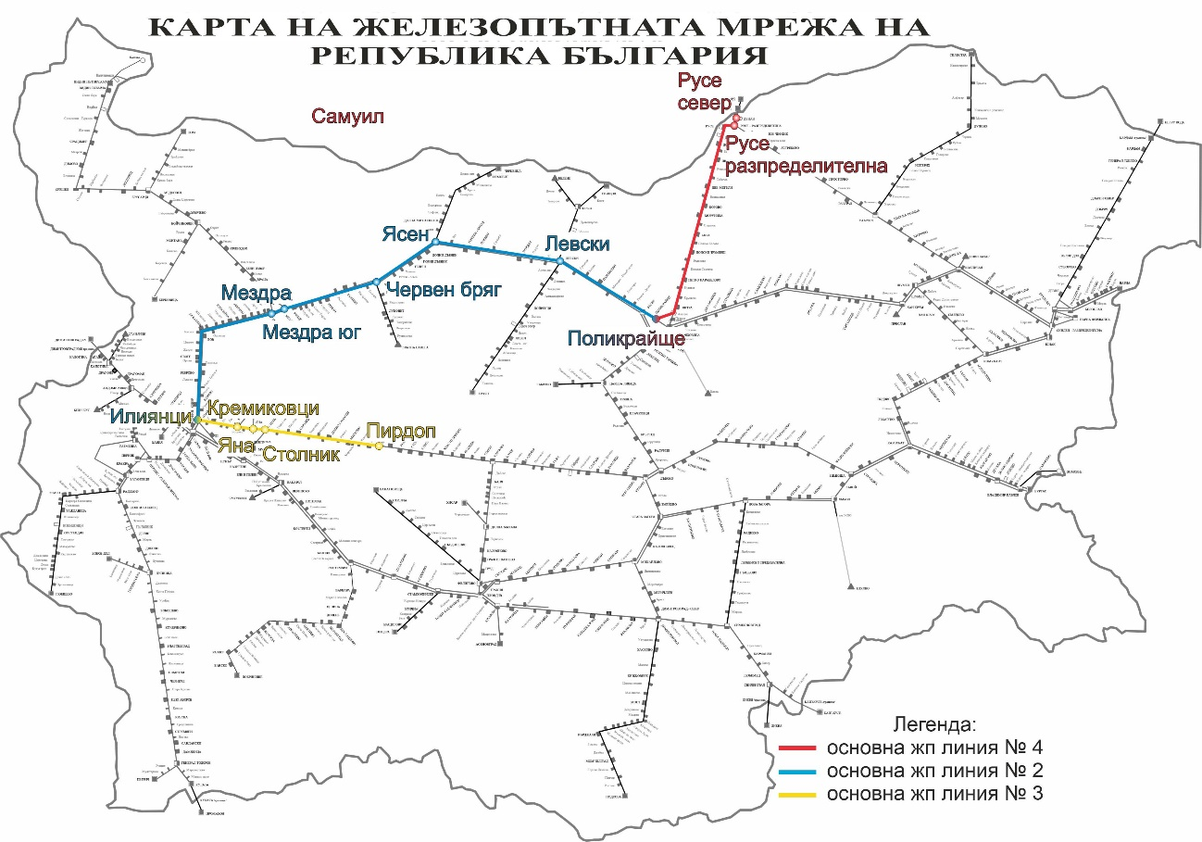
On 21.01.2022 in Iliyantsi station at eight acceptance-departure track was composed DFT №20691, towed by auxiliary locomotive № 91522086001-8 at the head, with locomotive driver first person, and locomotive driver second person, and train locomotive № 91520085005-4 with locomotive driver first person. After it, in the train composition were included two locomotives in non-working condition № 91520087025-0, accompanied by locomotive instructor, and locomotive № 91520087009-4, accompanied by a locomotive driver. After them, composition of 24 wagons, 88 axles, 648 tones. SE NRIC assigned the train for movement on 20.01.2022 scheduled in direction Ilyiantsi – Mezdra – Gorna Oryahovitsa – Ruse North (fig. 3.2). TMWI, employee of the railway undertaking “Bulmarket Rail Cargo” EOOD, which was performing the transport, carried out test „А” to DFT № 20691.
Fig. 3.1. Routes of movement of DFT № 20691 and № 20698
- Origin station of movement of DFT № 20698 (Ruse marshalling yard);
- Main stations on the two trains’ alignment;
- End destination station for the movement of DFT № 20698 (Pirdop station) and of DFT № 20691 (Ruse North station);
- Origin station of DFT № 20691 and station, in which DFT № 20698 changes the direction of movement (Iliyantsi station);
- Place, where the accident occurred;
- Track that DFT № 20698 passed;
- Track that DFT № 20698 was about to pass;
- Track that DFT № 20691 was about to pass;
Fig. 3.2. Map of the routes of transport of DFT № 20691 and 20698
At 03:13 a.m. (under downloaded data from the records of the traffic manager on-duty) from 8th acceptance-departure track in Ilyiantsi station DFT № 20691 departed to Ruse North station. The train was composed at approximately 110 m from the exit semaphore, which is ground, and departed with permitting indication of the exit signal and given order for departure by the traffic manager on-duty second person in the station. The locomotive driver second person received the departure order and submitted it to the locomotive driver first person. At the time of the collision, the train was with speed 19 km/h.
According to the data from the registration video camera of locomotive № 91522086005-9, after 30 seconds from the 9th acceptance-departure track, DFT № 20698 set off in the direction of Svetovrachene station to Pirdop. The train was composed 193 m from the exit semaphore, which landed with a prohibitory indication of the signal and departed without a departure order from the traffic manager on-duty. The speed of the train at the time of collision was 33 km/h. When entering in switch № 39 (connecting the 8th and 9th tracks), the locomotives of the two trains collided laterally and derailed with all the wheel-sets to the left and right of the rail track. Because of the derailment of the two locomotives of the catenary, the transverse fixing rope was broken and the movement was interrupted from the fifth to the tenth track. From 04:50 a.m. to 05:50 a.m., the catenary was repaired and the movement of trains was restored on the fifth track. Three hours after the occurrence of the event, at 06:30 a.m. a notification was submitted to the national telephone number 112 about the railway accident at Iliyantsi station.
At 07:30 a.m. the bodies of the pre-trial proceedings arrived on the spot, and together with the head of the investigation from the NAMRATIB the whole accident was inspected.
At 10:46 a.m. written permission was given to the railway infrastructure manager by the pre-trial authorities and the head of the NAMRATIB investigation for starting emergency and recovery work on the railway infrastructure and derailed rolling stock.
3.1.2. Description of the event location:
3.1.2.1. Date, punctual time and location of the event.
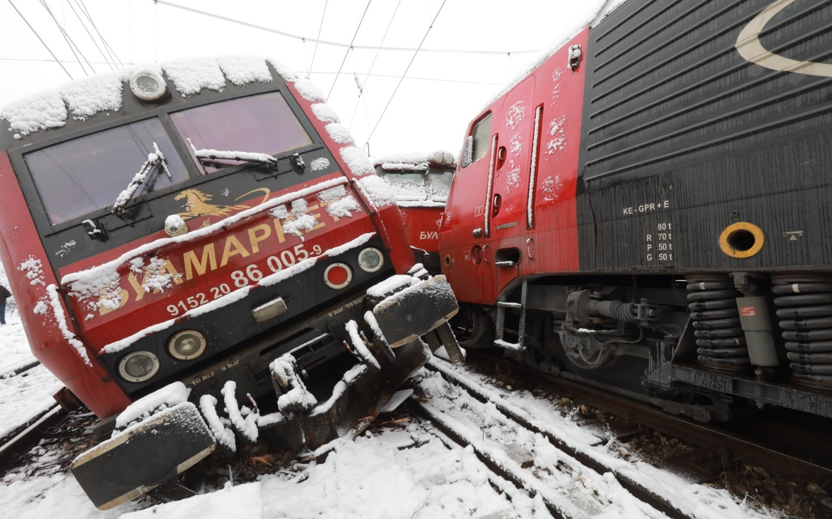
The railway accident occurred at Iliyantsi station at 03:13 a.m. on switch № 39 (according to data taken from the diaries of the traffic manager on-duty). DFT № 20691 was composed on the 8th track, which departed according to the permitting indication of the signalling at the station and the duty traffic manager gave an order. On the 9th track, a DFT № 20698 was composed, which started without a permitting indication from the station signalling. When the two trains entered at the same time, switch № 39 was followed by a side collision of the two locomotives, which derailed both with all the wheel-sets out of the rail track. Given the distances of the trains from the end of switch № 39, the locomotive with the train from the 8th track for 110 m developed speed of 19 km/h, and the locomotive with the train from the 9th track for 193 m developed speed of 33 km/h so far of the subsequent collision between them (Fig. 3.3)
Fig. 3.3.
      - Location of the place of the accident.
The railway accident occurred in Ilyiantsi station on switch № 39, after followed side collision between the locomotives of the two trains on the switch, departed from 8th to 9th track. The two tracks, 8th is in left curve with radius R=400 m, and 9th track in left curve with radius R=303 m, the tracks are in profile 1,20 ‰ in uphill in the direction of movement. The rail switch, connecting the two tracks is with radius R=300 meters, deviation 1:9, length 33 m, left, in profile 1,20 ‰ in uphill.
Ilyiantsi station is a junction station with directions for main railway lines № 2, № 3 and № 6. The railway lines are conventional with movement speeds up to 130 km/h (fig. 3.2).
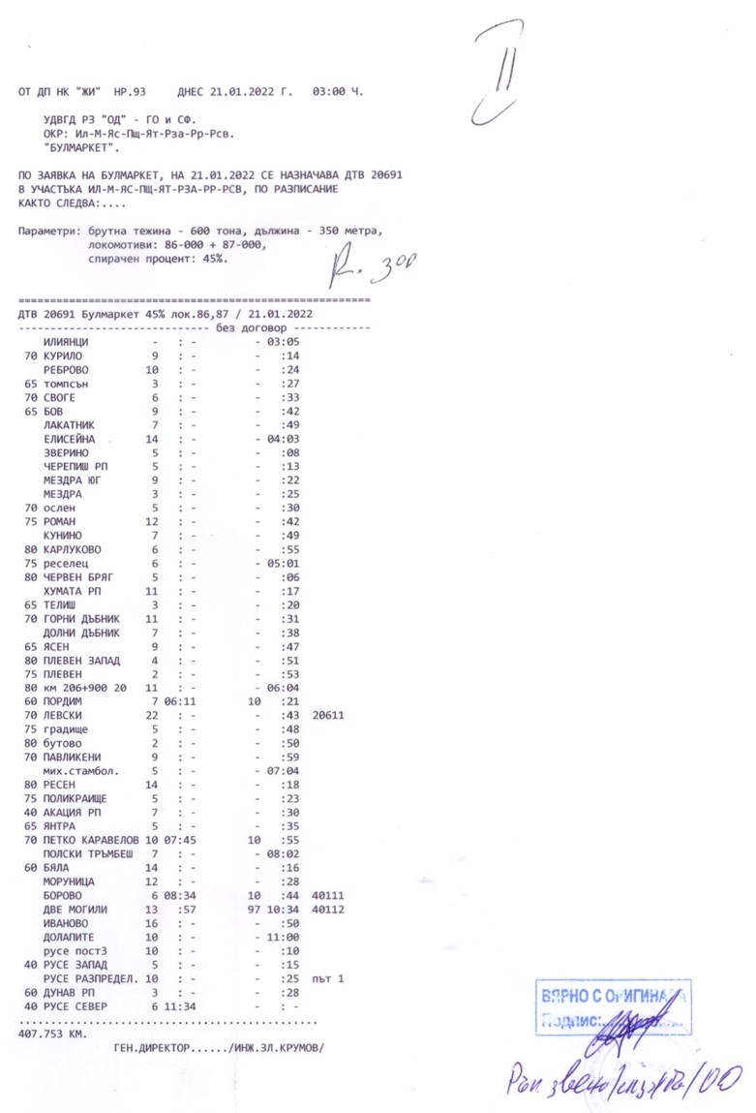
DFT № 20691 moves under schedule, shown in figure 3.4.
Фиг. 3.4. Разписание на ДТВ № 20691.
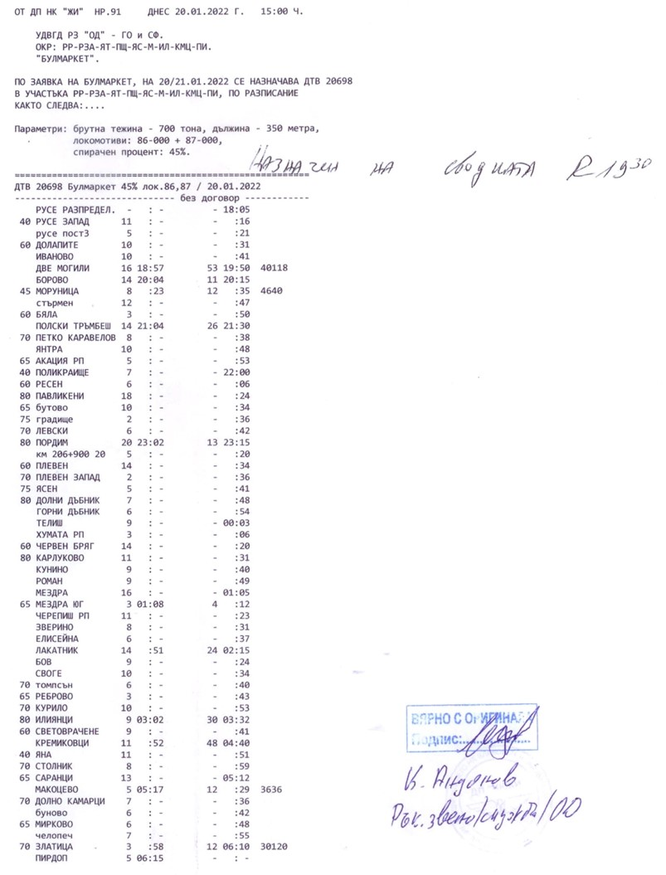
DFT № 20698 moves under schedule shown in fig. 3.5.
Fig. 3.5. Schedule of DFT № 20698.
The prepared schedules of the two trains DFT № 20691 and DFT № 20698 were taken from the control cabins of the two locomotives. In view of this, the locomotive drivers of the two trains were informed in advance on the train schedules.
      - Meteorological and geographical condition at the time of the event.
- In the dark part of the day – 03:13 a.m. (under taken data from the diaries of the traffic manager on-duty);
- Air temperature: -10ºС;
- Wind direction speed around 3 km/h, Western;
- Weather – cloudy, with rains and snowing with normal visibility of the signals;
      - Performance of construction activities on the site or in vicinity.
Not applicable.
      - Fatalities, injuries and material damages:
      - Employees of the railway infrastructure manager or railway undertaking.
None.
      - Other persons officially connected with the location of the event.
None.
      - Passengers.
None.
      - External persons.
None.
      - Cargo, luggage or other property.
None.
      - Environment.
None.
      - Rolling stock.
• Serious damages, caused to the running gears of the derailed two locomotives № 91522086001-8 and № 91522086005-9, and lighter damages to the train non-derailed locomotive № 91520085005-4.
• Financial account presented by Bulmarket Rail Cargo EOOD for caused damages amounting to 169 151,96 BGN.
      - Railway infrastructure.
• Financial account for the damages caused to the rail track and rail switch because of the derailment, amounting to 10 952,46 BGN in Ilyiantsi station;
• Financial account for the damages caused to the signalling equipment because of the derailment, amounting to 767,52 BGN in Ilyiantsi station;
• Financial account for the damages caused to the catenary because of the derailment amounting to 415,48 BGN in Ilyiantsi station;
• Total costs for damages: 181 287,42 BGN.
    - Description of other consequences, including the event impact on the usual activity of the participants.
In the period 14.12 ÷ 15.12.2021, for the reconstruction of the railway infrastructure the manager of the railway infrastructure and the railway undertakings have generated additional costs for changing the train schedule.
• Deviated trains of the railway undertakings – none;
• Cancelled trains of the railway undertakings – 1 592,95 BGN;
• Appointed trains of the railway undertakings – none;
• Delayed trains of the railway undertakings – none;
• Costs for rehabilitation means – 3 981,14 BGN;
• Total costs: 5 574,09 BGN.
    - Identity of the participants and their functions.
      - Railway infrastructure:
- SE National railway infrastructure company has Safety Authorization № BG 21/2018/0001 valid from 01.07.2018 until 30.06.2023.
SE NRIC personnel, involved in the accident:
- Traffic manager on-duty, first person in Ilyiantsi station;
- Traffic manager on-duty, second person in Ilyiantsi station;
      - Railway undertaking:
Bulmarket Rail Cargo EOOD has:
    - License for performing railway transport services;
    - Safety Certificate part А BG, valid until 30.12.2023;
    - Safety Certificate part B BG, valid until 30.12.2023;
Bulmarket Rail Cargo EOOD involved in the accident:
- Locomotive driver first person of locomotive № 91522086001-8 of DFT № 20691;
• Locomotive driver second person of locomotive № 91522086001-8 of DFT № 20691;
• Locomotive driver first person of locomotive № 91520085005-4 of DFT № 20691;
• Locomotive driver first person of locomotive № 91522086005-9 of DFT № 20698;
• Locomotive driver second person of locomotive № 91522086005-9 of DFT № 20698;
    - Description of the respective parts of the railway infrastructure and signalling system:
      - Type of the track, railway switch, rail crossing etc.
At Iliyantsi station, the 8th acceptance-departure track in plan - left curve with radius R = 303 m with profile 1.20 ‰ in uphill and the 9th acceptance-departure track in plan - left curve R = 400 m with profile 1, 20 ‰ in the uphill, the tracks are connected with switch № 39, left with a radius R = 300 m.
      - Interstation block system, station installation, type of signalling.
The Iliyantsi - Kurilo interstation is equipped with a SABS;
The Iliyantsi - Svetovrachene interstation is equipped with a SABS;
Iliyantsi station is equipped with Route-relay interlocking (MRC) type WSSB.
Type of signalling:
- In the direction of Sofia North station - the exit semaphores are on the conventional signalling;
- In the direction of Kurilo and Svetovrachene stations - the exit semaphores are on the speed signalling.
According to Art. 305 of Ordinance № 58 is not allowed to use semaphores of different types of signalling in one station. The found discrepancy in the type of signals may be a factor that further confuses locomotive drivers.
      - Train protection systems.
Iliyantsi station does not have a train protection system. The station is equipped with a train dispatch radio connection (VDRV), with the help of which the locomotive driver makes a radio connection with a train dispatcher, with separate stations, with the trains in the respective section.
The locomotives № 91522086001-8 and № 91522086005-9 are equipped with an active vigilance device and an electronic recorder type Program vizualizare inregistrari IVMS, Version 1.0.0.25132, SC Softronic Craiova.
    - Other information referring the event.
The train documents „Way-bill“, „Brake mass certificate and „Nature sheet“ (fig. 3.6 ÷ 3.13) correspond to the hours of the actual movement of the two trains under the presented data of the TOMR and the locomotives encryption.

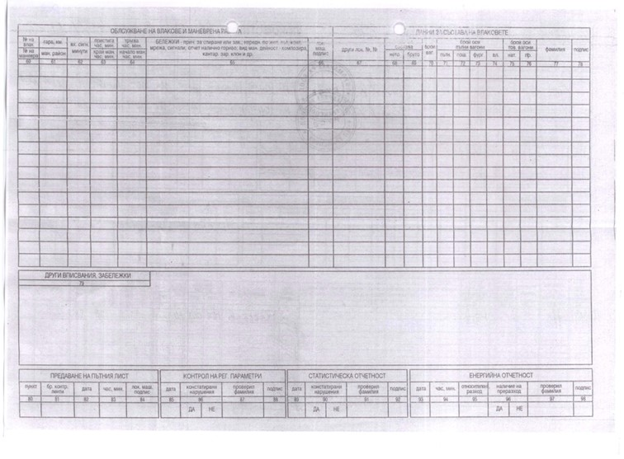
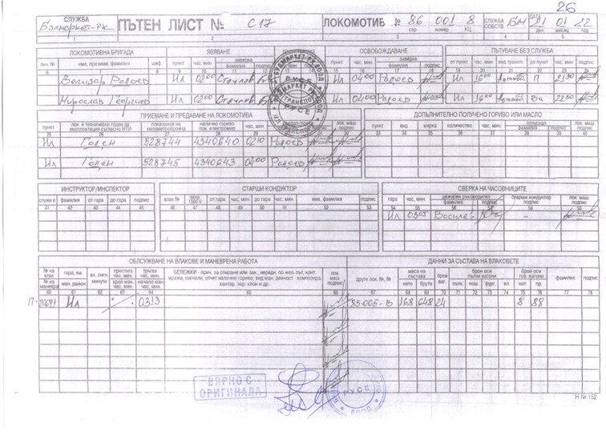
Fig. 3.7. Way-bill of locomotive № 91522086001-8 of DFT № 20691 rear part.
Fig. 3.6. Way-bill of locomotive № 91522086001-8 of DFT № 20691 front part.
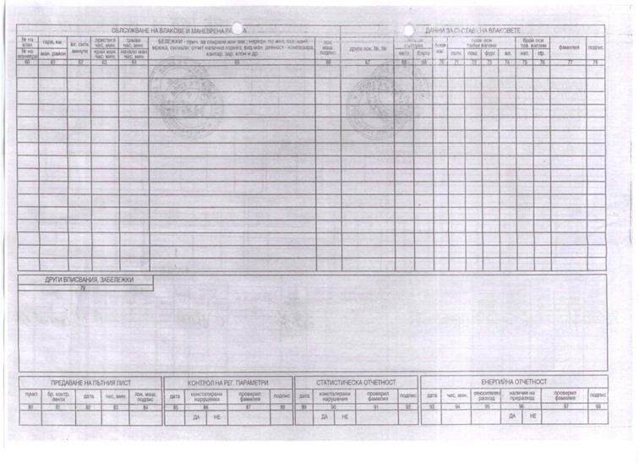
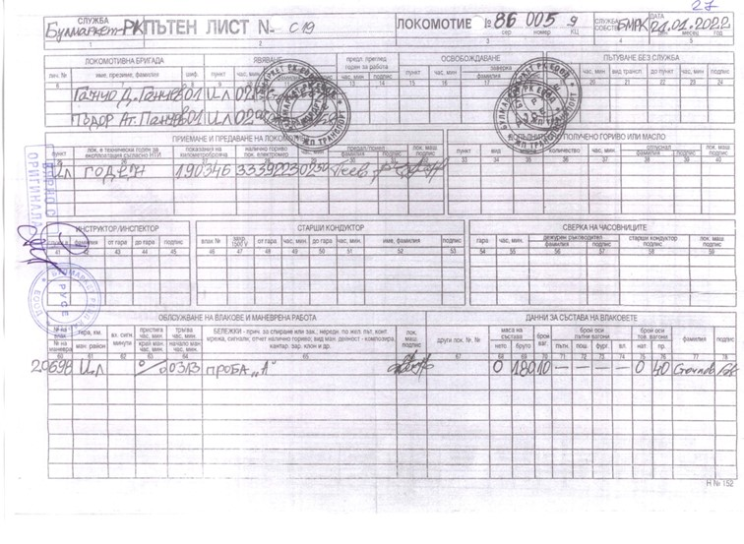
Fig. 3.9. Way-bill of locomotive № 91522086005-9 of DFT № 20698 rear part.
Fig. 3.8. Way-bill of locomotive № 91522086005-9 of DFT № 20698 front part.
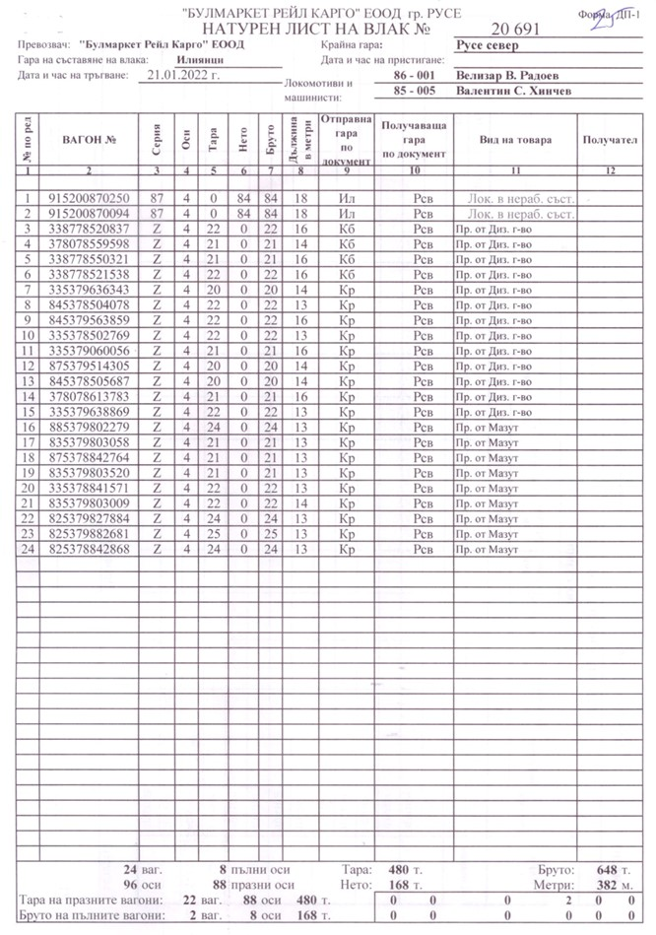
Fig. 3.10. Nature Sheet of DFT № 20691.
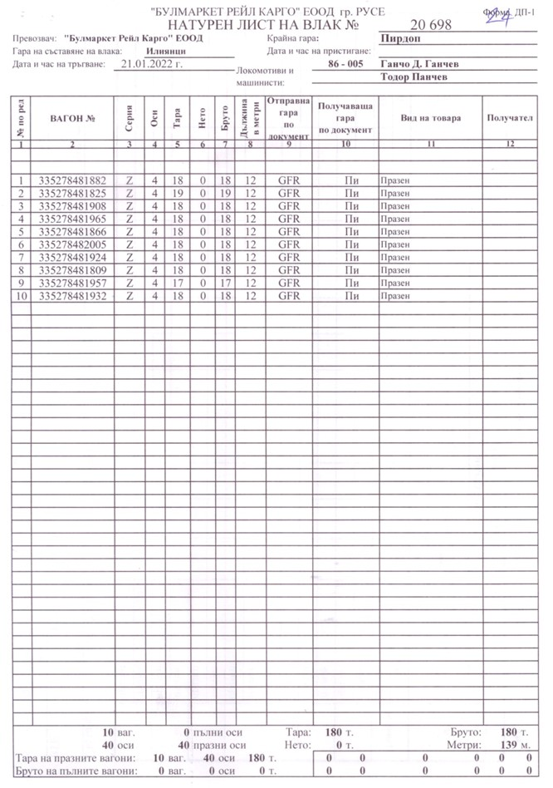
Fig. 3.11. Nature Sheet of DFT № 20698.
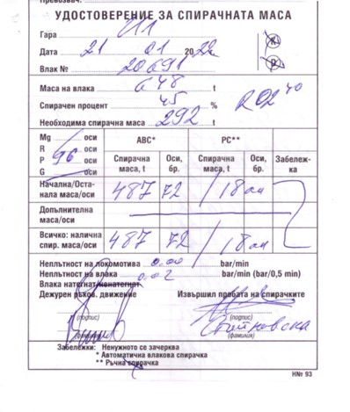
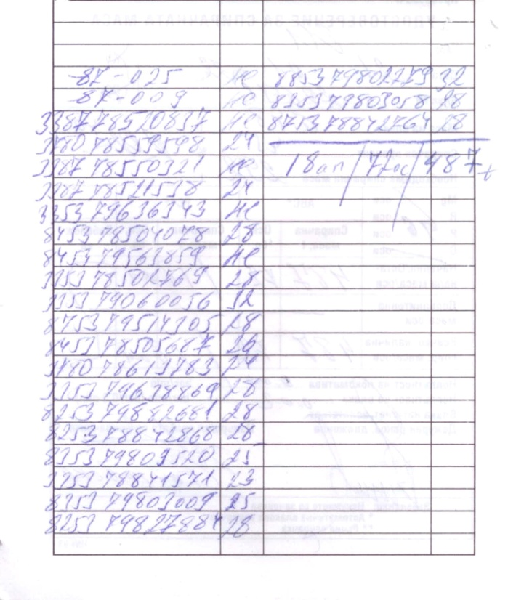
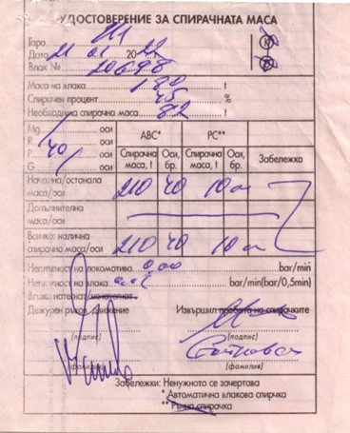
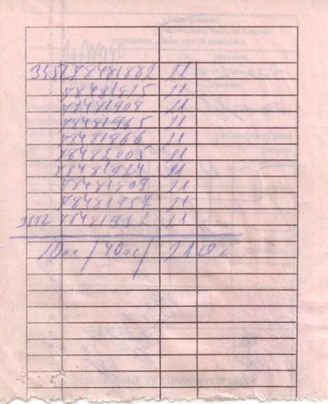
Fig. 3.12. Brake Mass Certificate of DFT № 20691.
Fig. 3.13. Brake Mass Certificate of DFT № 20698.

  - Factual description of the occurred.
    - Immediate sequence of events that led to the accident, including:
      - Actions that the involved in the event persons undertook.
On 21.01.2022 from Kurilo station in Iliyantsi station arrived DFT № 20698 at 02:38 a.m. in composition of 17 wagons, 68 axles, 717 tons, towed by locomotive № 91522086005-9 with locomotive crew - locomotive driver first person and locomotive driver second person. The train was moving in the direction of Ruse marshalling yard - Pirdop. The train was scheduled to run by SE NRIC on 20.01.2022. A group of seven full wagons from the train on the ninth track has been reduced from the composition of DFT № 20698. The new replacement of locomotive № 91522086005-9 with a locomotive driver first person and a locomotive driver second person moved the locomotive from the ninth trackside of Sofia North station to the ninth track side of Svetovrachene station to Pirdop. DFT № 20698 was composed of 10 wagons, 40 axles, 108 tons. A TMWI performed a complete test "A" on the train.
On 21.01.2022 in Iliyantsi station on the eighth track DFT № 20691 was drawn, towed with auxiliary head locomotive № 91522086001-8 with locomotive driver first person and locomotive driver second person and train locomotive № 91520085005-4 with locomotive driver first person after that the two locomotives in non-working condition locomotive № 91520087025-0 accompanied by a locomotive instructor and locomotive № 91520087009-4 accompanied by a locomotive driver, followed by a train of 24 wagons, 88 axles, 648 tons. The train was scheduled to run by SE NRIC on 20.01.2022. The train is moving in the direction Iliyantsi - Ruse north. TMWI performed a test "A" to DFT № 20691.
At 03:13 a. m. DFT № 20691 departed from Iliyantsi station to Ruse North station with an open exit signal and an order for departure from the traffic manager on-duty second person in the station. The locomotive driver second person accepted the departure order and handed over to the locomotive driver first-person.
At 03:13 a.m., without checking the clock, without allowing an exit signal and without an order for departure from the traffic manager on-duty in Iliyantsi station, DFT № 20698 departed from the ninth track in the direction of Svetovrachene station to Pirdop. After passing 193 m at a speed of 33 km/h when entering in switch № 39, the locomotive of DFT № 20698 collided sideways with the locomotive of DFT № 20691, and also entered in switch № 39. The locomotives derailed with all the wheel-sets to the left and right of the rail track. Because of the derailment of the locomotives, the fixing rope of the catenary was broken and the voltage was interrupted from the fifth to the tenth tracks.
At 03:15 a.m., after the collision and stopping of the two trains, the locomotive drivers inspected and found that the two leading locomotives of the two trains derailed with all the wheel-sets, as the locomotive on the 9th track laid to the left and bounced with the running gear of the train locomotive on the 8th track, which did not derail on the rail track.
From 04:50 a.m. to 05:50 a.m. the voltage in the catenary was switched off to restore the integrity of the catenary.
At 05:50 a.m., the movement of the trains on the fifth track was restored.
At 04:10 a.m. the Sofia Rehabilitation Service and the Mezdra Rehabilitation Service were notified.
At 06:30 a.m. an employee of the railway infrastructure manager notified the bodies of the Ministry of Interior.
At 10:46 a.m. a permit was given for the start of emergency recovery works.
      - Rolling stock and technical facilities functioning.
Until the accident, the rolling stock, incl. the locomotives of the two trains: on the 8th track DFT № 20691 and on the 9th track DFT № 20698 were in good working order and functioning normally.
The station interlocking and the catenary at the time of the accident were in good condition.
The rail track on the 8th and 9th tracks, incl. and switch № 39, at the time of derailment were technically sound in norms, as evidenced by the measurements of the parameters of the rail track at the time of derailment, reflected in the Statement of Findings of the Task Force.
      - Operational system functioning.
The operational system of the train control in Iliyantsi station was in good condition and was functioning normally at the time of the accident.
    - Sequence of events from the beginning of the accident to the end of the rescue services actions.
Not applicable.
      - Undertaken measures for protecting and guarding the event location.
After the arrival of the bodies of the Regional Directorate of the Ministry of Interior - Sofia and clarification of the situation, the region was not restricted for access to external persons and representatives of the participating entities. The bodies of the pre-trial proceedings, the head of the investigation of the NAMRATIB and the interested officials for conducting inspections and follow-up actions were on site.
Access to the media was limited.
      - Actions of the emergency rescue services.
Not applicable.
      - Actions of the emergency rehabilitation services.
On 21.01.2022, the railway infrastructure manager established an organization, and two specialized UNIMOG rehabilitation vehicles from the Mezdra Rehabilitation Service and the Sofia Rehabilitation Service were directed to Iliyantsi station, as well as two railway cranes EDK 300 / 5-50 tons from Sofia station.
At 12:20 p.m., locomotive № 91522086005-9 was lifted onto the rail track.
At 14:06 p.m. locomotive № 91522086001-8 was lifted on the rail track.
At 17:00 p.m. on 22.01.2022 the movement of trains through switch № 39 and on the eighth and ninth tracks was restored.

- Analysis of the event
  - Participation and responsibilities of the entities, involved in the event
    - Railway undertaking.
The analysis of the movement is made on the basis of the data from the recording devices of locomotives № 91520085005-4 and № 91522086001-8 from the composition of DFT 20691 and of locomotive № 91522086005-9 from the composition of DFT № 20698, as well as the recording of the on-board camera mounted on locomotive № 91522086005-9 (Fig. 4.1).
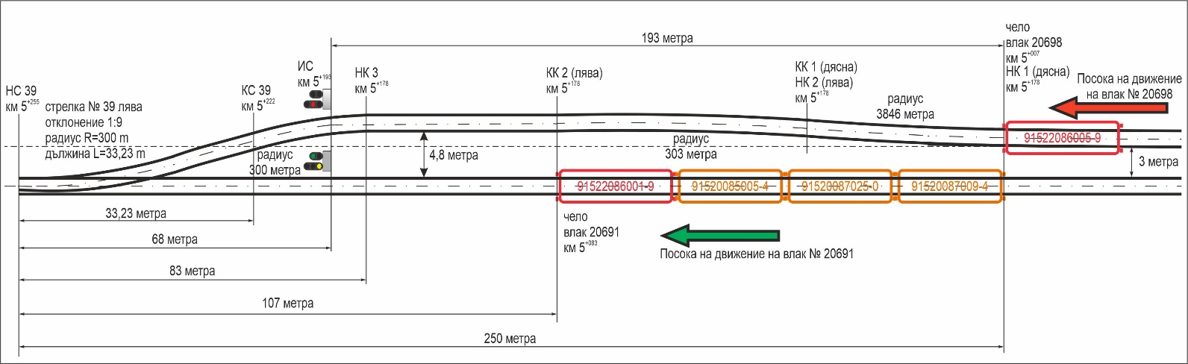
Note: The time of the DVR does not coincide with the exact astronomical time. The electronic recording speedometers of all three locomotives also do not record the parameters of the locomotives synchronously with the exact astronomical time.
Fig. 4.1. Scheme of the mileage location of the two trains before the accident

      - Analysis of the movement of DFT № 20691.
DFT № 20691 was composed on the 8th track at Iliyantsi station and was expected to depart in the direction of Kurilo station to Ruse North station (Fig. 4.1).
According to the data from the electronic recorder of locomotive № 91522086001-8 DFT № 20691 departed at 03:05:46 a.m. on the clock of the locomotive recorder, gradually accelerated, travelled 165 meters and after 1 minute and 15 seconds at 03:07:00 a.m. developed maximum speed of 19 km/h (Fig. 4.2, pos. 1). At 03:07:02 a.m. after passing 175 meters (Fig. 4.3) the pressure in the main air duct started to decrease - initially smoothly, then steeper and after another 35 meters reached a value of 0.0 bar and the speed also decreased to 0 km/h, which shows that the locomotive driver delayed with the automatic train brake initially ex officio and then emergency, reducing the pressure in the main air duct to 0.0 bar (Fig. 4.2, item 2). The printout of the tabular form of the locomotive recorder (Fig. 4.4) confirmed the data.
To confirm the obtained results, an analysis of the movement of locomotive 91520085005-4 was performed. The locomotive departed at 02:12:35 on the clock of the locomotive recorder (Fig. 4.5, Fig. 4.6), gradually increased the speed and at 02:14:04 a.m. reached a maximum speed of 18.5 km/h, after passing 179 meters in 1 minute and 29 seconds (Fig. 4.6, pos. 1, Fig. 4.7). At 02:14:06 a.m. the pressure in the main air duct initially gradually, then sharply began to decrease and at 02:14:11 a.m. after passing another 19 meters reached a value of 0.0 bar (Fig. 4.5, pos. 2). After lowering the pressure in the main air duct, the speed also began to decrease and at 02:14:13 a.m. also reached a value of 0 km/h, passing
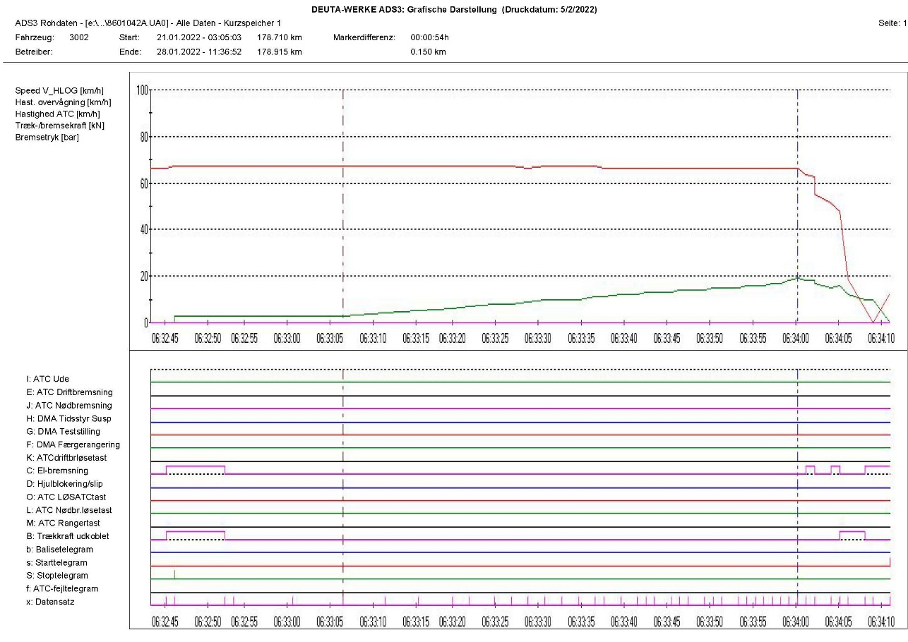
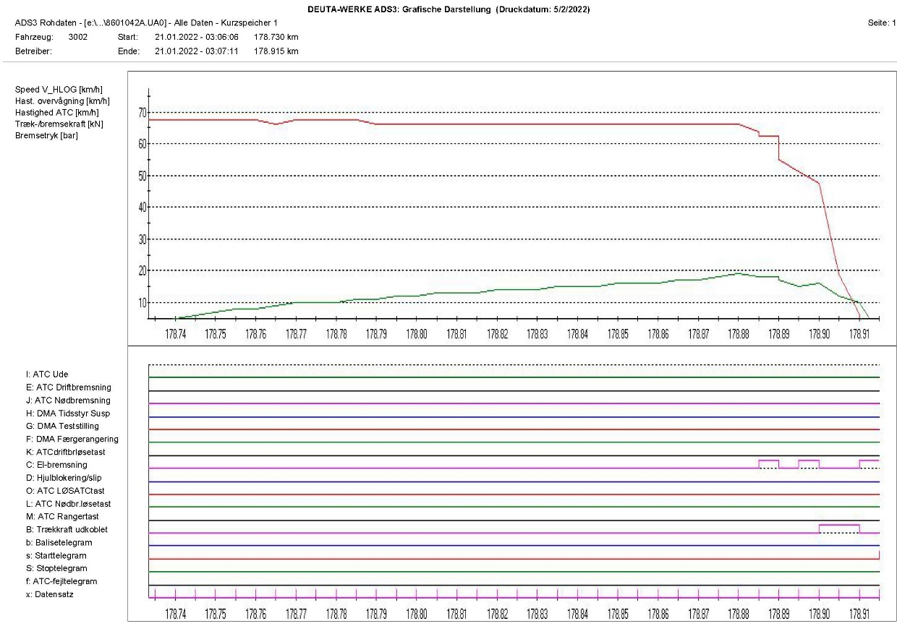
another 20 meters (fig. 4.5, fig. 4.8).
Fig. 4.2. Diagram of the movement speed of locomotive № 91522086001-8
03:05:46
V=3 km/h
V=19 km/h
1
2
Fig. 4.3. Diagram of passed movement track of locomotive № 91522086001-8
03:05:46

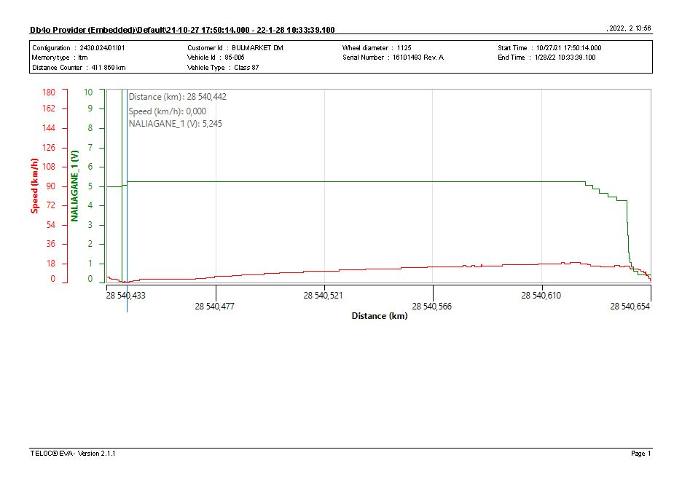
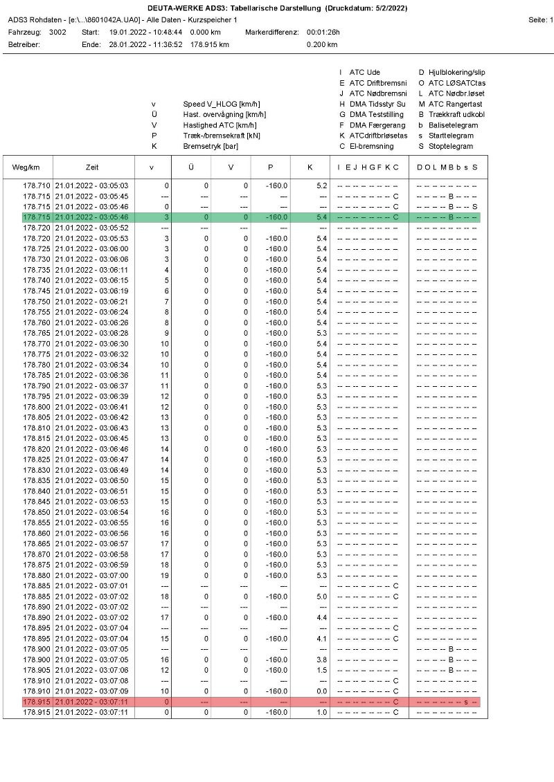
Fig. 4.5. Diagram of passed track of locomotive № 9152208005-4
1
2
Fig. 4.4. Table of movement data of locomotive № 91522086001-8
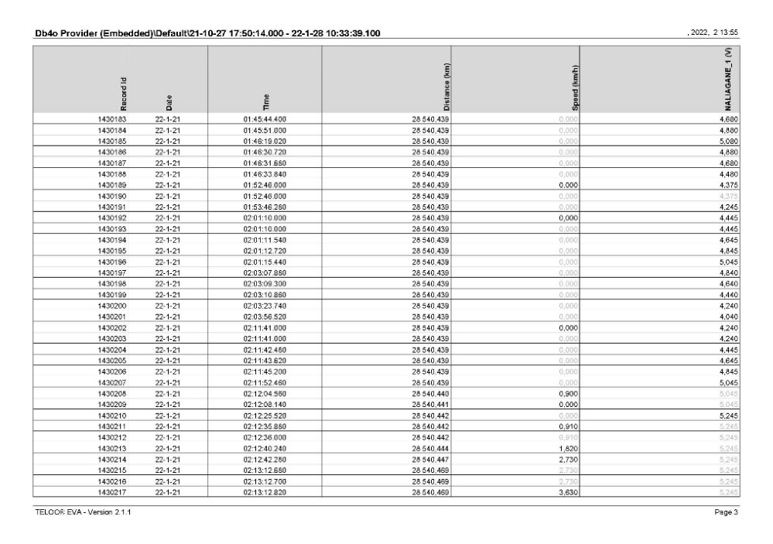
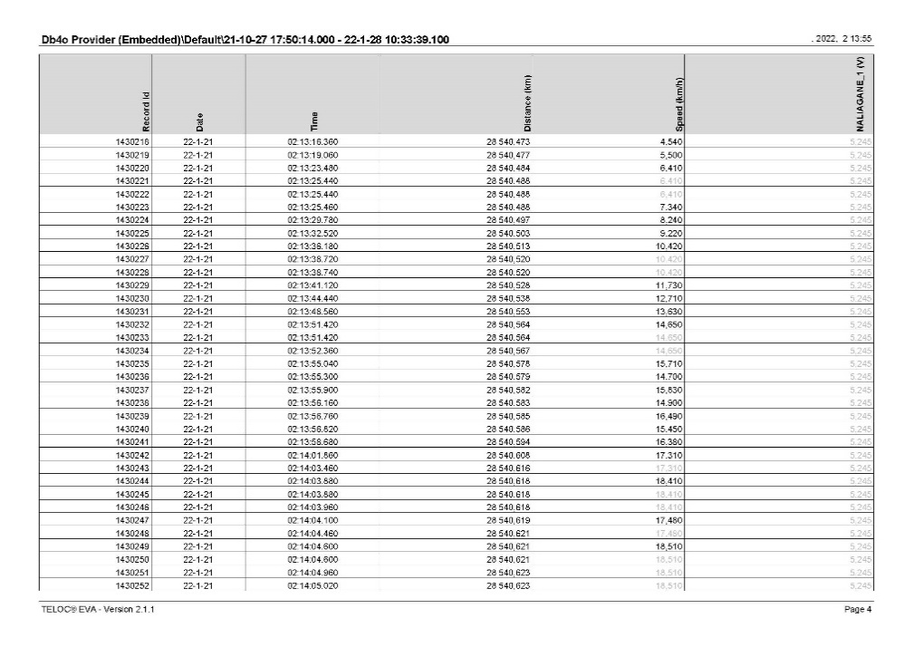
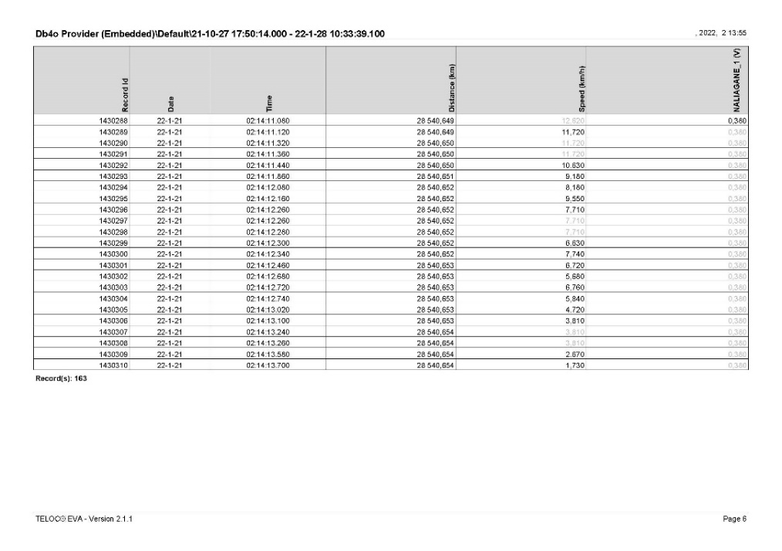
Fig. 4.6. Table of movement data of locomotive
№ 91520085005-4 at the moment of departure
Fig. 4.7. Table of movement data of locomotive
№ 91520085005-4 at maximum speed
Fig. 4.8. Table of movement data of locomotive
№ 91520085005-4 at the moment of stopping
      - Analysis of the movement of DFT № 20698.
The analysis of the movement of train locomotive № 91522086005-9 for DFT №20698 was also performed according to the data from the recording device of the locomotive, the time being registered by its clock.
The locomotive departed at 03:05:03 a.m., and travelled a distance of 215 meters in 44 seconds, reaching a speed of 33 km/h (Fig. 4.9, pos. 1, Fig. 4.10). The data show that the speed gradient was significantly greater than that of the locomotives of DFT № 20691. At 03:05:44 a.m. the locomotive driver applied the automatic train brake in fast (emergency) braking mode, reducing the pressure in the main air duct up to 0.0 bar (Fig. 4.9, pos. 2, Fig. 4.10, Fig. 4.11). For 8 seconds the speed decreased from 33 to 0 km/h, during which time the train travelled 45 meters (Fig. 4.11). The locomotive located on site at 03:05:52 a.m. after a total distance of 260 meters in 49 seconds (Fig. 4.11). The graph in the line reading the pressure in the main air duct shows some fluctuations in the values due to the shocks received in the locomotive due to the derailment (Fig. 4.9, pos. 3).
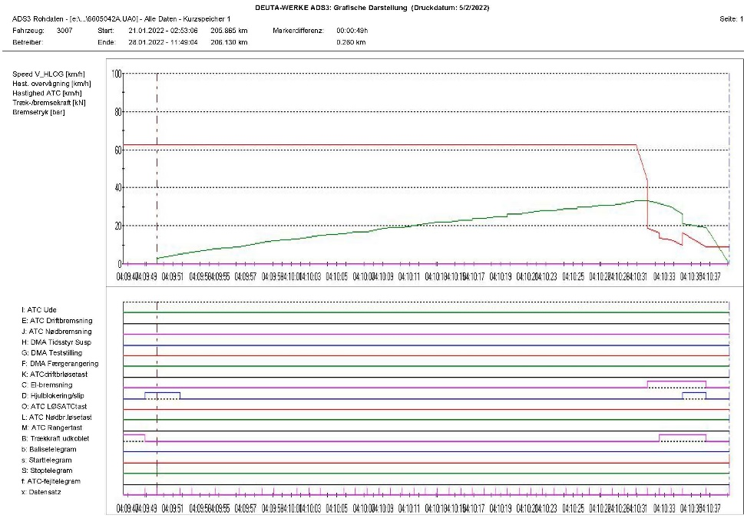
Fig. 4.9. Chart of passed track of locomotive № 91522086005-9 under time
1
2
3

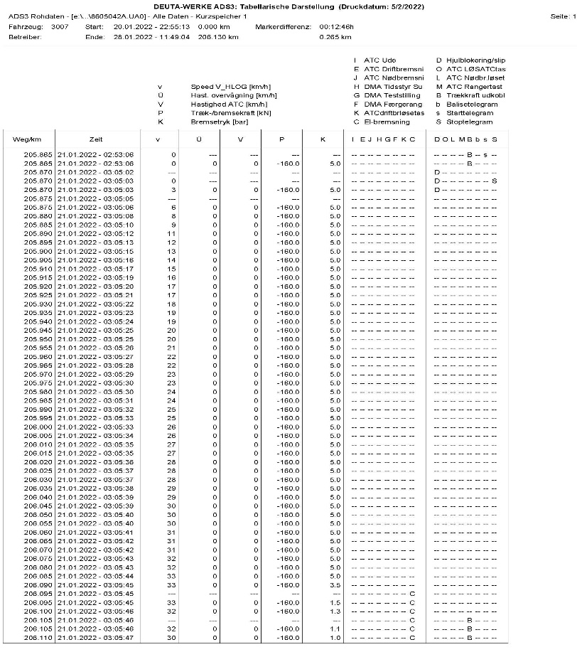
Fig. 4.10. Table with data for movement of locomotive
№ 91522086005-9 at the time of departure (green), reaching maximum speed and fast stopping (yellow)
Fig. 4.11. Table of movement data of locomotive
№ 91522086005-9 at the time of final stopping
The presence of recording cameras on both front sides of the locomotive № 91522086005-9 provides additional information about the movement of the two trains and presents visually the events leading up to the accident. The analysis of the recording of the CAM 3 camera for the locomotive movement shows that the two trains were established/settled respectively: DFT № 20691 on the 8th track and DFT № 20698 on the 9th track at Iliyantsi station, as the locomotive of DFT № 20698 is at the same level with the first wagon of the DFT № 20691, i.e. all DFT № 20691 locomotives were ahead of it. At 03:28:03 a.m. on the clock of the recording camera, a permitting indication was given at the exit ground semaphore for the 8th track. At 03:28:56 a.m. the composition of DFT № 20691 moved slightly forward, then relaxed backwards - movements that show that the locomotive driver of the leading locomotive № 91522086001-8 made several attempts to start and "stretch" the train and at 03:29:28 a.m. DFT № 20691 finally started, gradually to increase its speed.
At 03:30:02 a.m., on the DFT clock, the locomotive driver of locomotive № 91522086005-9 turned on the searchlight and at 03:30:04 a.m. left without receiving a permit from the exit semaphore, and an order to leave from the traffic manager on-duty in Iliyantsi station. At 03:30:19 a.m., 17 seconds after departure, locomotive № 91522086005-9 reached a speed of 6.2 km/h, catching up with the speed of DFT № 20691, currently moving on the 8th track. In that way, DFT № 20698 reached a speed of 32.5 km/h in 55 seconds, measured by the DVR. The speed and acceleration of the train, resulting from the high traction of the locomotive, allowed DFT № 20698 to catch up with the moving at a lower speed on the 8th track DFT № 20691 and in the area of switch № 39 oversized locomotive № 9152208600 -9 hit a rib of locomotive № 91522086001-8, as a result of which both locomotives derailed.
      - Analysis of the human factor of the locomotive staff.
The surveyed locomotive staff has many years of experience in this position, with no evidence of disciplinary violations in terms of compliance with the traffic safety rules. Compared to the psychological research conducted in 2019, there is no decline and deficits in terms of the studied indicators and professionally significant qualities.
1. Social factors.
It was established negative impact of unhealthy climate in the team during the shifts, conflicts with colleagues, lack of character compatibility, which increases the risk of emergencies or mistakes.
The two-year period of living in a COVID pandemic may have triggered a subconscious accumulation of negative emotional stress due to fear of growing sick and dead, as well as the loss of loved ones from the disease. There is no information about family conflicts.
2. Professional factors, which have a direct impact on the work.
Sufficiently high level of professionally important cognitive processes and abilities to make sense of the conditions in the work environment.
Sufficiently high level of emotional and volitional stability for the performed professional activity.
Sufficiently high level of physical qualities and motor skills that are professionally important for the activity.
The negative impact of the poor organization of the work regime and unfavourable conditions for rest and meal;
Lack of established good practices for establishing and maintaining contacts in business and personal terms between the locomotive staff in the railway undertaking.
Long-term exposure to threshold factors accompanying the activity: noise, vibration, electromagnetic radiation, vestibular loads;
- Psychological factors that have impact on the professional qualities.
Lack of established practices for creating team compatibility between locomotive crews in the preparation of work schedules, often having to work with colleagues who have conflicting characters and behaviour, which leads to the accumulation of emotional hostility.
Wrong decisions are explained by momentary distraction, distraction and overconfidence in the profession.
The disorganization of behaviour in this case manifested itself as a situational loss of acquired skills that were brought to automatism (routine). The objectivity and critical thinking were violated, both in terms of their own actions and in assessing the adequacy of the actions of station staff.
It is always possible to have a breakdown in parameters such as self-control, clarity of perception and assessment of what is happening, performing actions and operations appropriate to the situation, and the factors that cause them cannot be objectively determined. Such situations can be avoided if staff training is organized on the formation of mechanisms such as resilience to stress, development of personal stability and dynamic balance of the state, building and playing a subjective sense of control.
- Personal sphere.
Stable extrovert, no evidence of impulsivity, conflict and unsociality, no psychopathological tendencies. He has high self-esteem and confidence in his own professional skills. Realistically and self-critically assesses the circumstances of the accident. Self-control is aimed at finding the causes of mistakes in oneself instead of shifting the focus to external circumstances, people professionally related to the accident.
From a psychological point of view, short-term distraction and inadequate assessment of the situation can be explained by factors from everyday life, such as work overload, social contacts, family relationships, illness etc.
Psychological research is prognostic for the professional behaviour of the studied locomotive staff and gives conclusions about the presence or absence of certain professionally significant qualities, but is not a guarantee of their unconditional functioning and availability in the work process.
According to the surveyed locomotive staff, the head of transport to the company, who brought the documents of DFT № 20698 on the 9th track, did not say that the two trains were at their railway undertaking and were ready to leave, which would sharpen their attention. The train, composed on the 8th track, obstructed visibility to the platform and the building station.
4.1.2. Infrastructure manager.
      - Analysis of the rail track in and around the area of derailment.
The technical condition of the rail track on the 8th and 9th tracks, as well as on switch № 39 at the time of the accident are in accordance with the requirements of the technical norms for superstructure of the rail track.
The signalling equipment at Iliyantsi station at the time of the accident was technically sound.
    - Entities in charge of the technical maintenance.
Not applicable.
4.1.4. Manufacturers or providers of rolling stock and railway products.
Not applicable.
    - National Safety Authority.
Railway Administration Executive Agency is the National Safety Authority for railway transport in the Republic of Bulgaria.
4.1.6. Нотифицирани органи или органи за оценка на риска.
Not applicable.
    - Certifying bodies of the entities in charge of maintenance.
The Railway Administration Executive Agency as the National Safety Authority for railway transport performs certification of the entities in charge of the vehicles maintenance (ECM) in accordance with Directive 2004/49/EC and Regulation (EU) 445/2011, as per Ordinance No 59 on the railway transport safety management and on the maintenance functions in accordance with Directive 2004/49/EC and Regulation (EU) 445/2011.
From June 16, 2020 the RAEA performs certification of the ECM as per the Commission Implementing Regulation (EU) 2019/779 of 16 May 2019 laying down detailed provisions on a system of certification of entities in charge of maintenance of vehicles pursuant to Directive (EU) 2016/798 of the European Parliament and of the Council and repealing Commission Regulation (EU) No 445/2011.

    - Persons or entities involved in the event, documented or not in the respective safety management systems or indicated in register.
Not applicable.
  - Rolling stock and technical facilities:
    - Factors, deriving from the design of the rolling stock, railway infrastructure or technical facilities.
Not applicable.
    - Factors deriving from the installation and placing into service of the rolling stock, railway infrastructure and technical facilities.
Not applicable.
    - Фактори, дължащи се на производители или друг доставчик на железопътни продукти.
Not applicable.
    - Factors deriving from manufacturers or another provider of railway products.
Not applicable.
    - Factors due to the entity in charge of the technical maintenance, workshops for technical maintenance and other technical maintenance service providers.
Not applicable.
    - Other factors or consequences considered as involved within the investigation objectives.
      - Loading of the wagons.
  - Human factor:
    - Individual human characteristics:
      - Training and development, including skills and experience.
Railway undertaking:
• Locomotive driver first person of locomotive № 91522086005-9 - Diploma № 24129 specialty "Railway equipment - electric locomotives", acquired qualification for "Locomotive driver of electric locomotives", conducted training in the period 20.08.1988 ÷ 17.08.1991. issued by VNVTU "Todor Kableshkov" - Sofia;
Locomotive driving license BG 71 2018 1826 issued by RAEA;
Certificate № 79 for holding the position of “Locomotive driver” in “Bulmarket Rail Cargo” EOOD dated 02.09.2019.
Additional certificate № 000000024129 from Bulmarket Rail Cargo EOOD for rolling stock for which the driver is allowed to drive - series 85.000, 86.000 and 87.000 from 28.09.2021 on the national railway infrastructure of the Republic of Bulgaria until 28.09.2030.
• Locomotive driver second person of locomotive № 91522086005-9 - Diploma № 000600 specialty "Railway equipment - electric locomotives", acquired qualification for "Locomotive driver of electric locomotives", conducted training in the period 30.08.1993 ÷ 03.08.1996. , issued by VNVTU "Todor Kableshkov" - Sofia;
Locomotive driving license BG 71 2018 1647 issued by RAEA;
Certificate № 92 for holding the position of assistant locomotive driver in Bulmarket Rail Cargo EOOD dated 23.08.2021.
Additional certificate № 000000000600 from Bulmarket Rail Cargo EOOD for rolling stock for which the driver is allowed to drive - series 85.000, 86.000 and 87.000 from 28.09.2021 on the national railway infrastructure of the Republic of Bulgaria until 28.09.2030.
• Locomotive driver first person of a locomotive № 91522086001-8 - Certificate of competency № 1583 acquired license for "Locomotive driver of electric locomotives", conducted training in the period 01.07. ÷ 24.09.2004, training institution VNVTU "Todor Kableshkov" - Sofia, issued by RAEA;
Locomotive driving license BG 71 2016 0063 issued by RAEA;
Certificate № 61 for holding the position of “Locomotive Driver” in Bulmarket Rail Cargo EOOD dated 01.09.2015.
Additional certificate № 000000001583 from Bulmarket Rail Cargo EOOD for rolling stock for which the driver is allowed to drive - series 42.000, 43.000, 44.000, 85.000, 86.000 and 87.000 from 13.03.2019 on the national railway infrastructure of the Republic of Bulgaria until 14.12.2024.
• Locomotive driver second person of a locomotive № 91522086001-8 - Certificate of competency № 21144 acquired qualification for “Locomotive driver”, conducted training in the period 01.08. ÷ 19.10.2018
Locomotive driving license BG issued by RAEA;
Certificate № 244 for holding the position of assistant locomotive driver in Bulmarket Rail Cargo EOOD dated 12.11.2021.
Additional certificate № 000000021144 from Bulmarket Rail Cargo EOOD for rolling stock for which the driver is allowed to drive - series 85.000, 86.000 and 87.000 from 28.12.2018 on the national railway infrastructure of the Republic of Bulgaria until 28.12.2027.
• Locomotive driver first person of locomotive № 91520085005-4 - Certificate of competency № 19772 acquired license for "Locomotive driver of electric locomotives", conducted training in the period 15.02 ÷ 10.07.2017 training institution PTC at BDZ, issued by RAEA;
Locomotive driving license BG issued by RAEA;
Certificate № 223 for holding the position of “Locomotive Driver” in Bulmarket Rail Cargo EOOD dated 18.05.2021.
Additional certificate № 000000019772 from Bulmarket Rail Cargo EOOD for rolling stock for which the driver is allowed to drive - series 85.000, 86.000 and 87.000 from 28.09.2021 on the national railway infrastructure of the Republic of Bulgaria until 28.09.2030.
Railway infrastructure:
• Traffic manager first person at Iliyantsi station - Diploma № 000121, specialty “Railway traffic manager”, conducted training in the period 20.10.1999 ÷ 01.03.2003, issued by VTU “Todor Kableshkov - Sofia;
Certificate № 4818 for holding the position of Traffic Manager in TOSAMD - Sofia from 20.08.2018.
• Traffic Manager second person at Iliyantsi station - Certificate of competency № 8995, acquired competency for “Traffic Manager”, conducted training in the period 22.10 ÷ 13.05.2008, training institution TPC at NRIC, issued by RAEA;
Certificate № 2004 for holding the position of Head of Traffic in TOSAMD - Sofia from 07.07.2008.
      - Medical and personal circumstances, which influence the event, including the presence of physical and psychological stress.
Railway undertaking:
• Locomotive driver first person of locomotive № 91522086005-9:
Single-health dossier № 2739 dated 05.10.2021, issued by National Multi-profile Sofia Transport Hospital.
Conclusion: suitable for locomotive driver.
Psychological certificate № 880/26.06.2019, issued by the Psychological Laboratory - Railway Transport Gorna Oryahovitsa at the Sofia Multi-profile National Transport Hospital for a locomotive driver.
Conclusion: allowed for a period of 3 years.
• Locomotive driver Second-person of a locomotive № 91522086005-9:
Card for preventive medical examination from 20.08.2021, issued by the Labour Medicine Service.
Conclusion: suitable for locomotive driver.
Psychological certificate № 472 / 14.04.2021, issued by the Psychological Laboratory at the Sofia Multi-profile National Transport Hospital for a locomotive driver.
Conclusion: allowed for a period of 1 year.
• Locomotive driver first person of the locomotive № 91522086001-8:
Card for preventive medical examination from 17.05.2021, issued by the Labour Medicine Service.
Conclusion: suitable for locomotive driver.
Psychological certificate № 676/29.07.2020, issued by the Psychological Laboratory at the National Multidisciplinary Transport Hospital Sofia for a locomotive driver.
Conclusion: allowed for a period of 5 years.
• Locomotive driver second-person of a locomotive № 91522086001-8:
Card for preventive medical examination from 12.11.2021, issued by the Labour Medicine Service.
Conclusion: suitable for locomotive driver.
Psychological certificate № 1108/05.12.2018, issued by the Psychological Laboratory at the Sofia Multi-profile National Transport Hospital for a locomotive driver.
Conclusion: allowed for a period of 5 years.
• Locomotive driver first person of the locomotive № 91520085005-4:
Card for preventive medical examination from 17.05.2021, issued by the Labor Medicine Service.
Conclusion: suitable for locomotive driver.
Psychological certificate № 1210 / 22.11.2021, issued by the Psychological Laboratory at the Sofia Multi-profile National Transport Hospital for a locomotive driver.
Conclusion: allowed for a period of 5 years.
Railway infrastructure:
• Traffic manager first person at Iliyantsi station:
Single-health dossier № 1469 dated 26.07.2021, issued by the Sofia Multi-profile National Transport Hospital.
Conclusion - suitable.
Psychological certificate № 177 / 06.02.2018, issued by the Psychological Laboratory - Railway Transport Sofia at the Sofia Multi-profile National Transport Hospital for traffic manager.
Conclusion: allowed for a period of 5 years.
• Traffic manager second person at Iliyantsi station:
Single-health dossier № 1850 dated 06.10.2021, issued by the Sofia Multi-profile National Transport Hospital.
Conclusion - suitable.
Psychological certificate № 1263/23.11.2021, issued by the Psychological Laboratory - Railway Transport Sofia at the Sofia Multi-profile National Transport Hospital for traffic manager.
Conclusion: allowed for a period of 5 years.
Fatigue.
Railway undertaking:
• Locomotive driver I-st person of locomotive № 91522086005-9:
Break/rest: from 20.01.2022 hour 01 minutes 40 to 21.01.2022 hour 02 minutes 00
Started work: 21.01.2022 hour 02 minutes 00 – (11h. and 20 min.)
• Locomotive driver II-nd person of locomotive № 91522086005-9:
Break/rest: from 20.01.2022 hour 01 minutes 40 to 21.01.2022 hour 02 minutes 00
Started work: 21.01.2022 hour 02 minutes 00 – (11h. and 20 min.)
• Locomotive driver I-st person of locomotive № 91522086001-8:
Break/rest: 20.01.2022 hour 14 minutes 40 to 21.01.2022 hour 02 minutes 00
Started work: 21.01.2022 hour 02 minutes 00 – (11h. and 20 min.)
• Locomotive driver II-nd person of locomotive № 91522086001-8:
Break/rest: 20.01.2022 hour 14 minutes 40 to 21.01.2022 hour 02 minutes 00
Started work: 21.01.2022 hour 02 minutes 00 – (11h. and 20 min.).
• Locomotive driver I-st person of locomotive № 91520085005-4:
Break/rest: from 20.01.2022 hour 14 minutes 40 to 21.01.2022 hour 02 minutes 00
Started work: 21.01.2022 hour 02 minutes 00 – (11h. and 20 min.).
Railway infrastructure:
• Traffic manager first person Iliyantsi station:
Break/rest: from 19.01.2022 hour 19 minutes 00 to 20.01.2022 hour 19 minutes 00
Started work: 20.01.2022 hour 19 minutes 00 – (12 h.)
• Traffic manager second person in Iliyantsi station:
Break/rest: от 17.01.2022 hour 07 minutes 00 to 20.01.2022 hour 18 minutes 50
Started work: 20.01.2022 hour 18 minutes 50 – (47 h. and 10 min.)
      - Motivation and attitudes related to the human factor.
Negative impact and unhealthy climate during a change of team with his colleague locomotive driver. There is a lasting negativity, tense and nervous atmosphere during the shifts, which is a factor in undermining the collegial relations and lowering the motivation to work. The testimony shows that the hasty departure of the train was caused by the constant dissatisfaction of the colleague that they are delayed and always return late.
    - Work related factors:
      - Tasks planning.
Bulmarket Rail Cargo EOOD performs rail freight transport under the Train Composition Plan, appointed in the Train movement schedule and additionally assigned trains for movement by the railway undertaking with requests to the Railway Infrastructure Manager to develop timetables in the Schedule of movement.
SE NRIC - Railway Infrastructure Manager for maintenance, repair and operation of railway infrastructure. Prepares schedules and timetables for requests submitted by railway undertakings/carriers for the movement of trains and vehicles on all main and secondary railway lines.
      - Constructive particularities of the facilities that influence the connection human-machine.
Not applicable.
      - Communication means.
Not applicable.
      - Practices and processes.
Not applicable.
      - Operation rules, local instructions, staff requirements, prescriptions for technical maintenance and applicable standards.
Application of national and internal normative acts and standards.
      - Working time of the involved personnel.
The staff involved in the accident of both entities works in shifts regime of 12-hour working shift. In accordance with the requirements of the normative acts - Labour Code and Ordinance № 50 of 28.12.2001 for the working hours of the managerial and executive staff, engaged in providing the transportation of passengers and freights in the railway transport.
Risk treatment practices.
• SE NRIC applies safety procedure SP 2.09 „Methods of evaluation, assessment and management of the risk „version 05 effective from 01.03.2019, which is part of the SMS.
• Bulmarket Rail Cargo EOOD applies the following procedures:
- SP-48 Methodology for risk analysis and assessment;
- SP-56 Safety Management;
- SP-39 Identification of risks related to external parties in relation to the railway system;
4.3.2.7. Context, machinery, equipment and indications for shaping the working practices
Not applicable.
    - Organizational factors and tasks:
      - Planning of the working force and the working load.
The work is planned in accordance with the requirements of the national regulations, developed methodologies and good European practices concerning the personnel directly related to the railway safety.
      - Communications, information and teamwork.
Not applicable.
      - Recruitment, staffing requirements, resources.
The staff in both entities is selected and appointed to the relevant position with proven legal capacity, professional qualifications and teamwork skills for the respective positions.
      - Implementation management and supervision.
Not applicable.
      - Compensation (remuneration).
The personnel involved in the accident by both entities, in accordance with the requirements of national regulations, have permanent employment contracts, which determine and regulate the relevant remuneration and compensation for each position.
      - Leadership, powers related issues.
Not applicable.
      - Organizational culture.
Not applicable.
      - Legal issues (including the respective European and national rules and provisions).
Not applicable
      - Regulatory framework conditions and safety management system application.
Railway undertaking.
- Directive (EU) 2016/798 of the European Parliament and of the Council of 11 May 2016 on railway safety;
- Commission Delegated Regulation (EU) 2018/762 of 8 March 2018 establishing common safety methods on safety management system requirements pursuant to Directive (EU) 2016/798 of the European Parliament and of the Council and repealing Commission Regulations (EU) No 1158/2010 and (EU) No 1169/2010;
- COMMISSION IMPLEMENTING REGULATION (EU) 2019/779 of 16 May 2019 laying down detailed provisions on a system of certification of entities in charge of maintenance of vehicles pursuant to Directive (EU) 2016/798 of the European Parliament and of the Council and repealing Commission Regulation (EU) No 445/2011;
- COMMISSION IMPLEMENTING REGULATION (EU) No 402/2013 of 30 April 2013 on the common safety method for risk evaluation and assessment and repealing Regulation (EC) No 352/2009;
- Railway Transport Act;
- ORDINANCE No 59 dated 5.12.2006 on the railway transport safety management.
Railway infrastructure.
- Directive (EU) 2016/798 of the European Parliament and of the Council of 11 May 2016 on railway safety;
- Commission Delegated Regulation (EU) 2018/762 of 8 March 2018 establishing common safety methods on safety management system requirements pursuant to Directive (EU) 2016/798 of the European Parliament and of the Council and repealing Commission Regulations (EU) No 1158/2010 and (EU) No 1169/2010;
- COMMISSION IMPLEMENTING REGULATION (EU) 2019/779 of 16 May 2019 laying down detailed provisions on a system of certification of entities in charge of maintenance of vehicles pursuant to Directive (EU) 2016/798 of the European Parliament and of the Council and repealing Commission Regulation (EU) No 445/2011;
- COMMISSION IMPLEMENTING REGULATION (EU) No 402/2013 of 30 April 2013 on the common safety method for risk evaluation and assessment and repealing Regulation (EC) No 352/2009;
- Railway Transport Act;
- ORDINANCE No 59 dated 5.12.2006 on the railway transport safety management.
    - Environmental factors:
      - Labour conditions (noise, illumination, vibrations).
Not applicable.
      - Meteorological and geographic conditions.
• In the dark part of the day – 03:13 a.m.;
• Air temperature in interval night -10º and day -4ºС;
• Wind speed and direction around 3 km/h;
• Weather – cloudy with raining/snowing with normal visibility of the signals;
• Iliyantsi station is geographically located in the Western part of the rail network.
      - Construction works, performed on the spot or in very proximity.
Not applicable.
    - Any other significant factor for the investigation objectives.
Not applicable.
  - Feedback and control mechanisms, including risk and safety management, as well as monitoring processes:
    - Regulatory framework conditions.
Commission Delegated Regulation (EU) 2018/761 of 16 February 2018 establishing common safety methods for supervision by national safety authorities after the issue of a single safety certificate or a safety authorisation pursuant to Directive (EU) 2016/798 of the European Parliament and of the Council and repealing Commission Regulation (EU) No 1077/2012
Commission Delegated Regulation (EU) 2018/762 of 8 March 2018 establishing common safety methods on safety management system requirements pursuant to Directive (EU) 2016/798 of the European Parliament and of the Council and repealing Commission Regulations (EU) No 1158/2010 and (EU) No 1169/2010
ORDINANCE No 59 dated 5.12.2006 on the railway transport safety management.
    - Processes, methods and results from the activities on the risk assessment and monitoring that the involved entities performed:
      - Railway undertakings.
Bulmarket Rail Cargo EOOD applies the following procedures, part of the SMS:
- SP 5.1.3 procedures for determining the level of risk;
- SP 5.2.3 procedure and method for determination the level of risk in case of significant changes;
- SP 5.3.3 safety management procedure through hazard register.
      - Railway Infrastructure.
SE NRIC applies Safety Procedure SP 2.09 "Methodology for identification, assessment and risk management" version 05 in force from 01.03.2019 which is part of the SMS.
      - Entities in charge of the technical maintenance.
SE NRIC and Bulmarket Rail Cargo EOOD are certified ECM.
SE NRIC applies Safety Procedure SP 2.09 "Methodology for identification, assessment and risk management" version 05 in force from 01.03.2019 which is part of the SMS.
      - Manufacturers and all other participants.
Not applicable.
      - Reports for independent risk assessment.
No assessment has been made by an Independent Assessor (AsBo) of any changes in operating conditions or factors relevant to the occurred accident.
    - Safety management system of the involved:
      - Railway undertakings.
The latest annual planned supervision over the SMS of Bulmarket Rail Cargo EOOD was performed in the period 27 ÷ 31.07.2020. In 2021 several specialized audits were performed - the latest one was in the period 08 ÷ 10.09.2021.
      - Railway Infrastructure.
The latest annual planned supervision of the SMS of SE NRIC was performed in the period from 19.10.2020 to 30.10.2020.
    - Safety Management System of the entities in charge of the technical maintenance.
Not applicable.
    - Results from the supervision, performed by the National Safety Authority.
The results from the performed audits and inspections referring the functionality of the Safety Management System of SE NRIC and Bulmarket Rail Cargo EOOD as per the requirements of Regulation (EU) 2018/761, Regulation (EU) No 1169/2010, Ordinance No 56 and Ordinance No 59 on respect of the specific requirements of the European legislation and national rules for design, maintenance and operation of the managed railway infrastructure demonstrate that the entities maintain SMS and are able to respect the requirements, envisaged in the respective normative documents.
    - Permits, certificates and assessment reports, provided by the National Safety Authority or other Conformity Assessment Bodies:
      - Safety certificates of the involved railway infrastructure managers
Safety Authorization No BG 21/2018/0001 valid from 01.07.2018 to 30.06.2023.
      - Сертификати за безопасност на участващите железопътни предприятия.
,Bulmarket Rail Cargo EOOD holds single Safety Certificate SIN № BG 1020200048, valid until 05.08.2025.
      - Safety certificates of the involved railway undertakings
Not applicable.
      - Entities in charge of the technical maintenance.
Bulmarket Rail Cargo EOOD has a Certificate of ECM for railway vehicles BG/31/0020/0005 valid until 11.12.2025;
SE NRIC is responsible for the repair, maintenance and operation of the national railway infrastructure.
    - Other system factors.
Not applicable.
  - Previous similar cases.
The NAMRTAIB has not investigated accidents of similar nature so far.
- Conclusions
  - Summary of the analysis for the event causes.
The Investigation Commission visited the place of the accident several times, got acquainted with the collected and provided documentation for the repair and maintenance of the locomotives, as well as examined the human factor of the locomotive staff in the railway undertaking.
The Investigation Commission took note of the documentation provided on the technical condition of the derailed locomotives № 91522086001-8 and № 91522086005-9.
The Investigation Commission got acquainted with the situation on the spot, made several detailed and careful inspections and measurements of the railway, the rolling stock, conducted an interview with the locomotive and station staff involved in the accident. The Commission analyzed thoroughly all the circumstances related to the accident and made a summary.
The accident occurred because of unauthorized departure of DFT № 20698 without meeting the regulatory requirements for sending trains, in adverse weather conditions in the dark part of the day.
  - Undertaken measures after the event occurrence.
The manager of the railway infrastructure undertook the restoration of the damaged section of the rail track, the railway switch № 39, the signalling equipment and the catenary in Iliyantsi station in the period 21 ÷ 22.01.2022.
The damaged locomotives, after their lifting of the rail track, were sent for repair and assessment of the damages to "Express Service" Ltd. Ruse, certified ECM, which under contract maintains the traction rolling stock of the railway company "Bulmarket Rail Cargo" EOOD. .
The Investigation Commission in the NAMRTAIB requested and performed control medical and psychological examinations in a specialized medical institution for the transport of the locomotive driver of a locomotive № 91522086005-9, departed from the 9th track without a permit signal.
Medical and psychological examinations and tests of the locomotive driver were performed at the National Multidisciplinary Transport Hospital "Tsar Boris III" - Sofia. The Commission received all the results of the specialized medical examinations and a report on the psychological tests performed. The Investigation Commission, together with the expert on the human and organizational factor, analyzed the results of the research and found that there were no deviations from the health norms for the position - locomotive driver.
5.3. Additional findings.
The Investigation Commission in NAMRTAIB ordered the entities involved in the accident on 03.02.2022 to perform measurements of the locomotives № 91522086001-8, № 91522086005-9, № 91520085005-4, servicing DFT № 20691 and DFT 20698. The measurements were performed in Express Service OOD, Ruse, from the submitted Statement of findings; the Commission found no deviations in the technical norms parameters.
- Safety recommendations
In order to improve the safety in the rail transport, the Investigation Commission at NAMRATIB proposes to the Railway Administration Executive Agency the following safety recommendations adapted to SE NRIC and Bulmarket Rail Cargo EOOD.
• Recommendation 1 proposes that SE NRIC and Bulmarket Rail Cargo EOOD shall acquaint the interested staff with the content of this report.
• Recommendation 2 proposes Bulmarket Rail Cargo EOOD to assess the psychological human factor of the locomotive staff in order to improve teamwork in a positive atmosphere.
• Recommendation 3 proposes Bulmarket Rail Cargo EOOD to hold periodically interviews with the locomotive staff in the presence of a psychologist to discuss the development and promotion of collective good practices.
• Recommendation 4 proposes RAEA to assess the functioning of the Safety Management Systems with regard to the performance of pre-shift briefings and checks on alcohol and other intoxicants of locomotive staff in railway undertakings carrying freights and passengers and, at its discretion and need to restore the points for carrying out pre-travel medical examinations.
• Recommendation 5 proposes in case when assessing the functioning of the Safety Management Systems of the railway undertakings, discrepancies or omissions are established regarding compliance with the requirements of item 4.2 Competence, item 4.6 Integration of the human and organizational factor from Annex 1 of Commission Delegated Regulation (EU) 2018/762, RAEA to issue mandatory instructions to railway undertakings to organize training of staff on the formation of mechanisms such as resilience to stress, personal stability and dynamic balance of psychological state, building and playing a subjective sense of control.
• Recommendation 6 proposes RAEA to carry out an inspection regarding the type of signalling at Iliyantsi station and together with SE NRIC to take action to comply with the requirements of Art. 305 of Ordinance № 58.
In accordance with the requirements of Art. 24 (2) of Directive (EU) 798/2016 and Art. 91, para. 3 of Ordinance № 59 of 5.12.2006, the Chairperson of the Investigation Commission in NAMRATIB, provides a final report containing information on the circumstances and causes that led to the accident with formulated safety recommendations.
The investigation aims to improve the railway safety and prevent accidents by giving priority to the prevention of serious accidents.
The Commission at NAMRTAIB, proposes a final report with safety recommendations on 31.05.2022.

Chairperson:
Dr. Eng. Boycho Skrobanski
Deputy President of the NAMRTAIB AB

