FINAL REPORT

from

Investigation of railway accident – derailment of locomotive
№ 91520087023-5, serviced international direct freight train № 48041, while entering in Belovo station on 11.06.2021

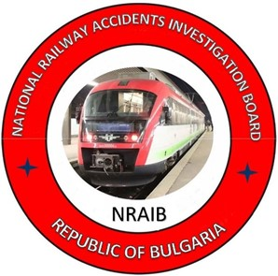

2021
OBJECTIVE OF INVESTIGATION AND EXTENT OF RESPONSIBILITY

The National Air, Maritime and Railway Transport Accidents Investigation Board (NAMRTAIB), which is an independent body performs the investigation of serious accidents and incidents. The National Board is within the Council of Ministers (CM) of the Republic of Bulgaria, and aims to find the circumstances and causes that led to the accidents and incidents occurrence in order to improve the safety and to avoid such in future, without searching personal fault and responsibility.
The investigation is performed in accordance with the requirements of Directive (EU) 2016/798 of the European Parliament and of the Council of 11 May 2016 on railway safety, which is transposed into the Railway Transport Act (RTA), Ordinance No 59 dated 5.12.2006 on the rail transport safety management, and Ordinance No Н-32 dated 19.09.2007 on the coordination of the activities and information exchange during the railway accidents and incidents investigation, as well as per Agreement dated 17.04.2018 on the interaction during investigation of accidents and incidents in the air, maritime and railway transport between the Prosecutor's Office of the Republic of Bulgaria, Ministry of Interior, and the Ministry of Transport, Information Technology and Communications.
The Reports follow the requirements of Regulation (EU) 2020/572 of 24 April 2020 on the reporting structure for railway accident and incident investigation reports.

TABLE OF CONTENTS
№ | Title of section | Стр.
 | Summary | 5
 | Investigation | 8
 | Description of the event | 11
 | Analysis of the event | 18
 | Conclusions | 33
 | Safety recommendations | 38

ABBREVIATIONS, USED IN THE REPORT
ABS – Automatic Block System
ALS – Automatic Locomotive Signalling
BRC EOOD – „Bulmarket Rail Cargo” EOOD – railway undertaking/operator
SE NRIC – State enterprise „National railway infrastructure company“ (railway infrastructure manager)
IDFT – International direct freight train
RAEA – Railway Administration Executive Agency
ECM – Entity in Charge of Maintenance
RRI МН-68 – Route Relay Interlocking type МН-68
NAMRTAIB – National Air, Maritime, and Railway Transport Accidents Investigation Board (Independent Specialized National Investigation Body)
TF – Task Force
RRS – Rail Rolling Stock

SMS – Safety Management System
DCCM – Device for communications, connections and messages
MRTO – Management and reporting of train operation
Ordinance № 59 – Ordinance on the rail transport safety management
MSL „Hook – bolt” – Manual switch locker Hook – bolt

1.Summary
  - Brief description of the Event.
On 11.06.2021 at 5:30 a.m. from the station Dimitrovgrad (ZhS) — the Republic of Serbia departed IFT No 48041, comprising 18 wagons, 72 axles, 486 tons, towed by electric locomotive No 91520087023-5 with locomotive crew. The train route was in the direction of the Republic of Serbia via the Republic of Bulgaria to the Republic of Turkey. In the section from station Dimitrovgrad ZhS to Belovo station, the train ran with the permitted section speed. The train arrived in Sofia station at 11:23 a.m. After changing the locomotive crew, the train departed at 11:40 a.m. from Sofia station. No irregularities were observed and found during the train movement and staying in the stations, either by the locomotive crew or by the staff of the stations in the section. The train passed through Kostenets station without stopping at 14:07 p.m. After the train locomotive entered in Belovo station on track No1, the right wheel of the third wheel-set of the locomotive (from the second bogie) fell from the inner side of the right rail and after 60 m derailed also the left wheel of the third wheel-set of the locomotive (from the second bogie). The derailed locomotive passed through switches No 2, No 10 and switch No 14 derailed with the four wheel-sets of the two bogies. In addition, the first wagon of the train derailed. The locomotive driver stopped the train with the train brake at 14:27 p.m. The locomotive crew after the inspection found that the locomotive had derailed with all the wheel-sets and the first wagon with the two wheel-sets of the first bogie.
The movement along Belovo — Kostenets interstation was interrupted for a day.
There was no injured personnel. There were caused damages to the locomotive and the first derailed wagon. The railway infrastructure also suffered damages.
After lifting the rolling stock and carrying out restoration works on the railway infrastructure, the train movement was restored at 14:30 p.m. on 12.06.2021 at a speed of up to 25 km/h
  - Location and time of the event occurrence.
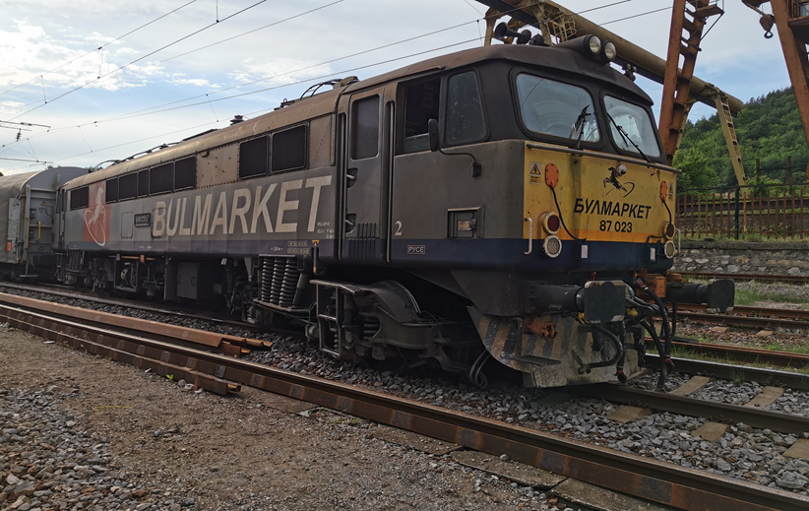

Fig. 1.1. Derailment of locomotive and first wagon of IDFT
№ 48041 in Belovo station
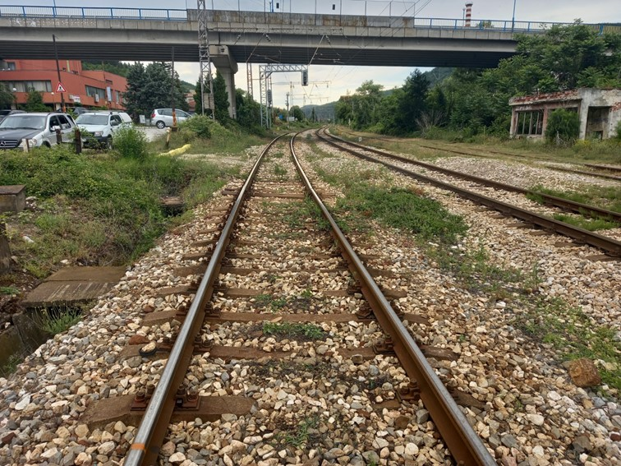
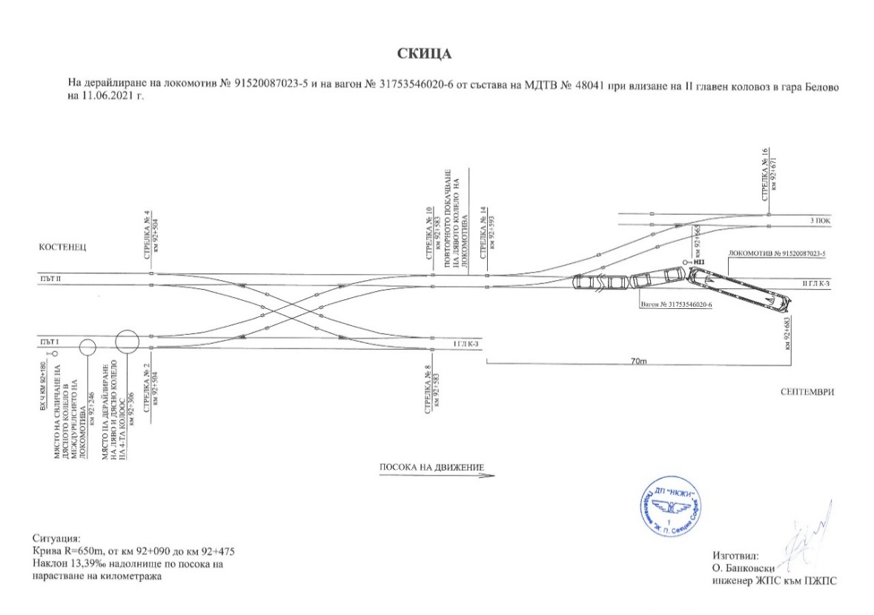
The derailment of locomotive No 91520087023-5 serving IFT No 48041 occurred in Belovo station at km 92⁺ ²⁴⁶ at 14:27 p.m., where the right wheel of the third wheel-set of the locomotive in the direction of the train movement derailed in the track gauge and after 60 m derailed the left wheel of the same locomotive wheel-set. When passing through switch No 14 in the station, the locomotive derailed with all the wheel-sets and the first wagon with the two wheel-sets of the first bogie (Figure 1.2)
Fig. 1.3. Photo from the end of the derailed train towards the entrance semaphore in Belovo station with benchmark of the falling point of the right wheel of the first wheel-set of the second bogie of the locomotive in its movement direction.
Fig. 1.2. Sketch of derailment of the locomotive and the first wagon, while entering of IDFT № 48041 in Belovo station

  - Factors determining the event.
The determining factor for the occurrence of the accident is the fatigue destruction of the wheel-set in a zone with a voltage concentrator (the transition from the middle part of the wheel-set to the sub-header part). A leading hypothesis for the rupture is the accumulation of fatigue in the axle material, given its long life cycle.
  - Direct causes and consequences of the event.
Direct cause for the accident occurrence is break (rupture) of the axle of the third wheel-set in the direction of movement of locomotive No 91520087023-5 in the area of the sub-header during the train running. This resulted in the derailment of the locomotive with a third wheel-set, and then about 350 metres on switch No 14 derailed with the four wheel-sets, followed by the first wagon with the first bogie with the two wheel-sets. Damage has been caused to the railway infrastructure (railway, switches, security equipment and signalling), both to the locomotive and to the first wagon.
  - Safety recommendations and addressees to which they are addressed.
The Investigation Commission proposes safety recommendations addressed to the National Safety Authority, the Railway Administration Executive Agency, and relevant to both entities involved in the accident.
• Recommendation 1 proposes that NRIC SE and Bulmarket Rail Cargo EOOD shall acquaint the interested staff with the content of this report.
• Recommendation 2 proposes Bulmarket Rail Cargo EOOD to correct and submit safety procedure SP-54 “Instruction for the operation of a locomotive instructor/receiver on the quality of the production processes”, by imposing duties of presence during the formation of wheel-sets with change of elements, as well as during the performance of non-destructive control (ultrasonic and penetrant defectoscopy), to characterise and accept the repair works with signature in the repair cards.
• Recommendation 3 proposes that Bulmarket Rail Cargo EOOD shall assign to the maintenance contractor to perform, in addition to the ultrasonic control a penetrant defectoscopy as well, when performing all types of repairs on the wheel-sets. This additional defectoscopy shall be recorded as an obligation in the Rules for Repair of Locomotives Series 87.000
- Investigation
  - Decision for starting the investigation.
The decision to initiate an investigation of the accident has been taken with respect to the seriousness and its impact on the safety. The investigation aims to prevent this type of accidents, which in similar circumstances could lead to significant accidents, including technical damages in the structural subsystems.
  - Motives for the decision to initiate the investigation.
The Decision to initiate the investigation is based on art. 20, paragraph 2, (а) and (c) of Directive (EU) 2016/798, art. 115к, paragraph 1, item 3 of RTA, art. 76, par. 1, item 2 of Ordinance No 59 dated 5.12.2006, and by Order of the NAMRATIB for assignment of Commission for investigation of the railway accident.
  - Scope and restrictions of the investigation.
Within the scope of the investigation there were considered and analysed the violations of the regulations implemented by the railway undertaking BRC EOOD in the operation, repair and maintenance of the locomotive.
In view of the damages suffered, the investigation is focused on the circumstances that led to the derailment of the locomotive and wagon of IDFT No 48041 in Belovo station.
  - Competences of the persons, involved in the investigation.
The composition of the commission includes external independent experts - habilitated persons from the higher scientific circles and experts with free profession with qualification and professional orientation in fields of activity – railway infrastructure, and rail rolling stock.
  - Communication and consultations with the persons and entities, involved in the event.
The Task Force, which includes representatives from both entities, was consulted during the investigation. The Task Force, appointed by Telegram No P-121/11.06.2021 from the Sofia RSI to SE NRIC, collected the documents and materials as well as the downloaded recordings of locomotive No91520087023-5. These have been submitted to the Chair of the Investigation Commission in the NAMRATIB. Interviews were conducted with the persons directly involved in the accident (the locomotive crew, which handled locomotive No91520087023-5 and the staff on shift in Belovo station). The entities were requested and provided with information on the maintenance of the railway track in Belovo station, as well as information on the last repair and maintenance of the derailed locomotive. Interviews were conducted with the safety authorities of both entities and with the managers of the railway undertaking Bulmarket Rail Cargo EOOD.
  - Degree of cooperation from the participating entities.
During the investigation, the railway undertaking — Bulmarket Rail Cargo EOOD and the railway infrastructure manager — SE NRIC, involved in the accident, cooperated with the Investigation Commission in the NAMRATIB. During the investigation and in agreement with the Chair of the Investigation Commission, the entities undertook re-measurements of the track as well as of the derailed rolling stock. Further requested documents and material were provided to the Commission to identify the causes for the accident.
  - Methods and techniques of investigation and analysis.
Following the notification by SE NRIC at 17:30 p.m. on 11.06.2021 of occurred accident, the member of the Management Board of NAMRATIB responsible for investigating railway accidents analysed the information, informed the two entities SE NRIC and Bulmarket Rail Cargo EOOD and departed immediately to the location of the accident with one expert.
On-the-spot talks were held with representatives of investigating authorities from the Ministry of Interior — Septemvri, as well as with authorities of the Pazardzhik District Prosecutor’s Office regarding their investigation and follow-up of the parties during the investigation.
After the inspections carried out on the spot and acquainted with the particularities of the accident, the Chair of the Investigation Commission took a decision to undertake an investigation, of which he informed the two entities involved in the accident on the spot. The proposal of SE NRIC, the remaining 17 wagons of the train composition to be withdrawn back to Kostenets station, was agreed. The derailed locomotive 91520087023-5 and the first derailed wagon No 31753546020-6 with the two wheel-sets of the first bogie remained in place. Initial inspections of the signalling equipment were carried out in Belovo station. Inspections were also carried out of the derailed locomotive and wagon in the composition of IFT No 48041, as well as of the track in the derailment zone. The Chair of the Commission requested that the recordings of the locomotive recording device be removed and that the locomotive passport be provided, as well as from the latest track measurements and repairs that were carried out.
The Task Force with representatives of SE NRIC and Bulmarket Rail Cargo EOOD carried out inspections and measurement of the track in the derailment area and drew up a statement of findings.
In order to avoid conflicts of interest, the Investigation Commission decided to carry out measurements of the parameters of the derailed locomotive and wagon at points outside the railway undertaking/carrier.
The Investigation Commission ordered, after lifting the derailed locomotive No 91520087023-5, the locomotive be moved to the Locomotive depot Plovdiv, where the parameters of the locomotive should be measured
The Investigation Commission ordered that after lifting the derailed wagon No 31753546020-6, it should be moved to the Wagon Plant, Kolovag EAD — Septemvri, where the parameters of the wagon should be measured.
On 21.06.2021, inspections, dimensioning of the derailed bogie of the wagon and measuring of the parameters of the wagon were carried out in the presence of the Investigation Commission and members of the Task Force in the Wagon Plant, Kolovag EAD — Septemvri, for which a Statement of findings was drawn up.
- To measure and download the geometric dimensions from the bogie, a robotic measuring arm FARO Arm, model Quantum-M with serial number w40-M2-18341, was used with a laser head mounted on it Neostar D150 FARO 2. The last calibration took place on 28.03.2021 (Figure 1.4).
- The robotic measuring arm uses the original measurement software FARO CAM 2 2019, version 2019.8.
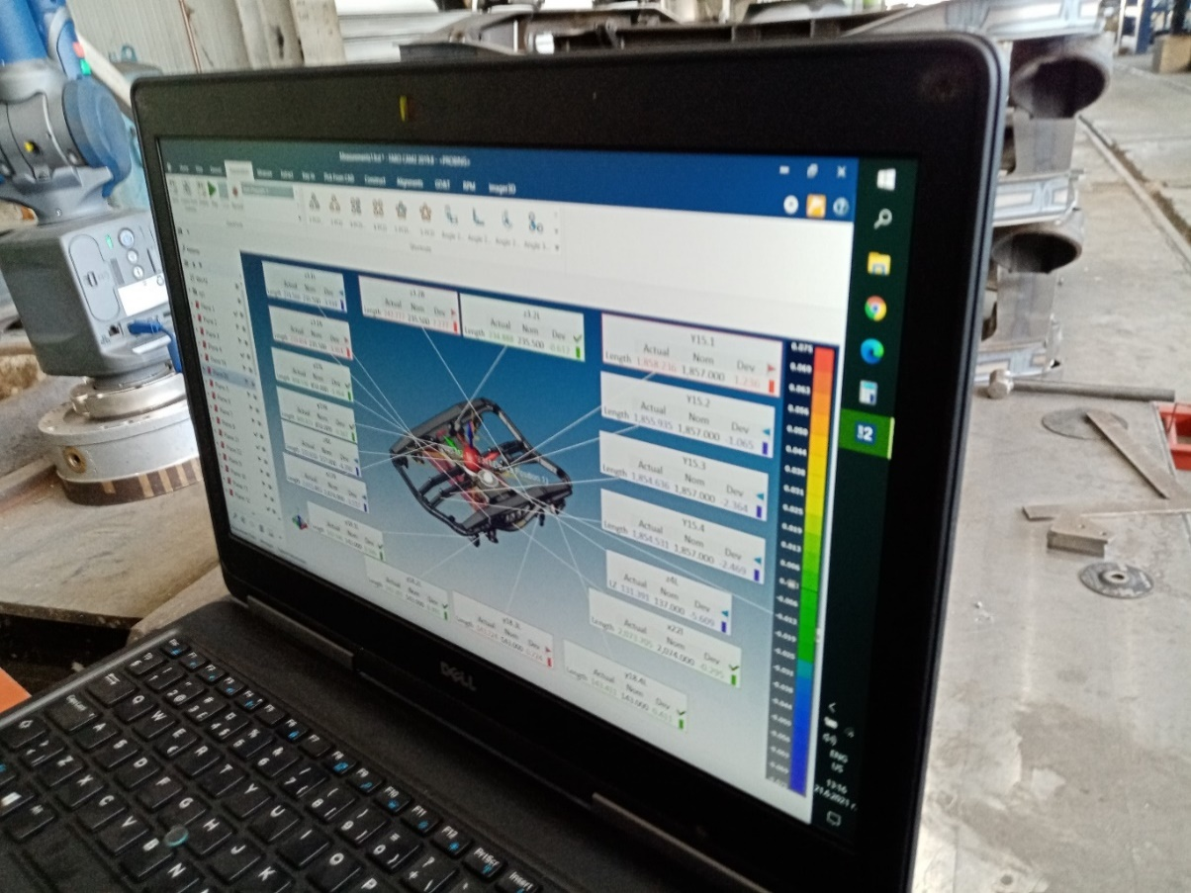
Inspections and measurement of the parameters of the locomotive were carried out in the period 23-25.06.2021 in the Locomotive Depot Plovdiv, in the presence of the Investigation Commission and members of the Task Force, for which a Statement of findings was drawn up. There was found a rupture of the third wheel-set of the locomotive in the direction of movement in the area of the rear part of the free side of the wheel-set. For the technical expertise preparation, the two parts of the break zone were requested.
Fig. 1.4. Measurement of the parameters of the derailed bogie of wagon № 31753546020-6.
In the period 23.06.-28.08.2021, correspondence was exchanged in due time regarding additional submission of documents and materials from the two entities involved in the accident. The railway undertaking/carrier insisted on re-measurement of the track parameters and required additional documents and materials relating to its maintenance to be submitted.
On 16.07.2021, in the presence of the Investigation Commission and representatives of the Task Force of SE NRIC and Bulmarket Rail Cargo EOOD, inspections and re-measurements of the track parameters in the derailment zone were carried out, for which a second Statement of findings was drawn up. The complete track measurements were carried out with a locomotive of the same 87.000 series provided by the railway undertaking/carrier. The track parameters were found to comply with the technical standards and requirements.
On 20.07.2021, the Task force, category II, submitted to the Investigation Commission the materials and documentation relating to the derailment of a locomotive and wagon of IFT No 48041 on 11.06.2021.
On 02.09.2021 in the Research Sector of the Technical University — Sofia, Department of Metal Science and Material Technology was prepared Expertise on the type of demolition of the axle of locomotive 91520087023-5.
  - Difficulties faced during the investigation.
During the investigation, communication between the Investigation Commission and representatives of the railway infrastructure manager and the railway undertaking/carrier was at the necessary level. The restoration activities of the railway infrastructure started after written authorisation from the investigative bodies of the pre-trial proceedings and the member of the management board of the NAMRATIB. The requirements of Article 89, par.2, item 1 of Ordinance No59 dated 5.12.2006 were complied with, when the investigation was carried out by the NAMRATIB, the head of the Task force coordinated the recovery activities with the member of the management board of the NAMRATIB with competence to investigate railway accidents.
  - Interaction with the judicial authorities.
In accordance with the Agreement on Interaction with the judicial authorities, following their inspections of the railway infrastructure and the derailed RRS, it was released from supervision and the Investigation Commission started its independent investigation.
  - Other important information for the investigation context.
After the withdrawal of the non-derailed 17 wagons from the composition of IFT No 48041 in Kostenets station, the derailed locomotive and the first wagon remained at the place of the accident. The railway infrastructure manager has set up an organisation for the restoration of railway infrastructure and capacity. The derailed wagon was lifted on the rails at 21:10 p.m., and the locomotive at 01:10 a.m. on 12.06.2021, the train movement through Belovo station was restored at 14:30 p.m. on 12.06.2021 with a speed of up to 25 km/h.
- Description of the event
  - Information on the event and the context.
    - Description of the event type.
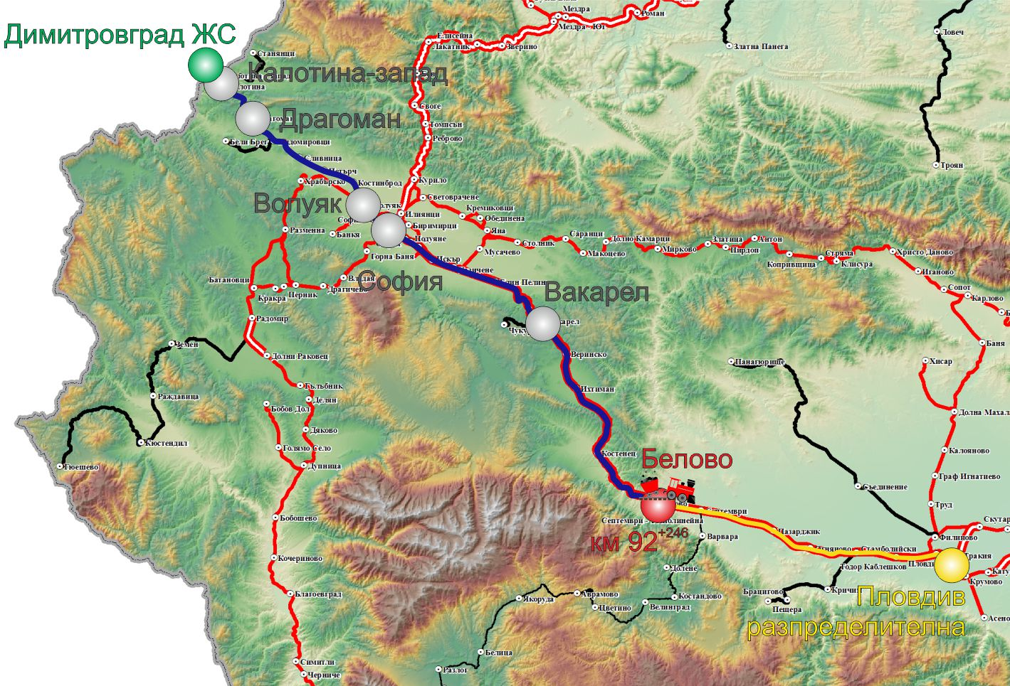
On 11.06.2021 at 05:30 a.m. from Dimitrovgrad station (ZhS) — the Republic of Serbia departed IDFT No 48041, comprising 18 wagons, 72 axles, 486 tons, towed by electric locomotive No 91520087023-5 with locomotive drivers first and second person. The train route was in the direction of Dimitrovgrad ZhS — Sofia — Plovdiv — Plovdiv Marshalling yard (Fig. 3.1)
Fig. 3.1. Route of movement of IDFT № 48041
- Origin station of the train movement;
- Main stations on the train alignment;
- End destination station for the train movement;
- Place, where the accident occurred;
- Track that the train passed;
- Track that the train did not succeed to pass.
Along the section Dimitrovgrad ZhS to Sofia station, the train operated with the allowed section speed, arrived in Sofia station at 11:23 a.m. After changing the locomotive crew, the train departed from Sofia station at 11:40 a.m. No irregularities were observed and found during the train movement and staying in the stations, either by the locomotive crew or by the staff of the stations in the section. The train passed through Kostenets station without stopping at 14:07 p.m. The traffic manager on duty at Belovo station has prepared the route for train No 48041 without stopping at the station. The train passed the entrance signal with the allowable indication and was diverted to the second main track. Switch No. 2 for the train route was locked with the MSL “Hook-Bolt” due to the performance of installation-construction works in the station of Belovo on the first main track. After the train entered the station from track 1 to km 92+ 246, the right wheel of the third wheel-set of the locomotive in the direction of traffic slide from the inner part of the right rail, thus traveling a distance of 60 m, then the left wheel of the same wheel-set slide into the track gauge. The train passed with the derailed wheel-set through switches No 2 and 10. On switch No 14, the locomotive derailed with all four wheel-sets of the two bogies, dragging the first wagon, which also derailed. When the the locomotive driver felt that the locomotive swayed, he stopped the train with the train brake. After the inspection by the locomotive crew, the locomotive was derailed with all the wheel-sets and the first wagon with the two wheel-sets of the first bogie. During the train’s running, the speed on the route from Dragoman station to Belovo station was observed and the operation was emergency-free.
    - Date, punctual time and location of the event.
The derailment of IDFT No 48041 occurred on 11.06.2021 at 14:27 p.m. while running at 41 km/h, after the entrance signal at Belovo station. First derailed the right wheel of the third wheel-set of the locomotive in the track gauge at km 92+ 246 and after 60 m derailed the left wheel. The place of derailment is in left curve with radius R=650 m, in profile 13.39‰, in downhill.
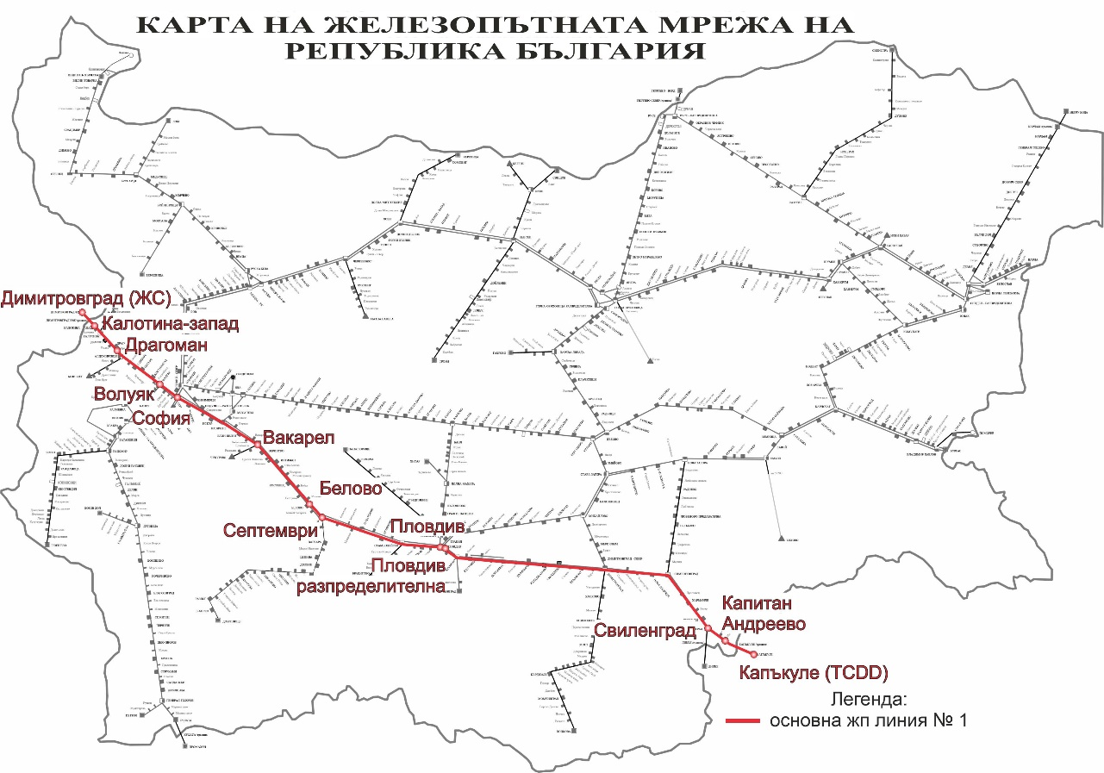
Belovo Station is located on the main railway line No 1 in the direction of the train movement Sofia-Plovdiv — Kapikule. The railway line is conventional double-track, electrified with running speed of up to 160 km/h (Figure 3.2).
Fig. 3.2. Scheme of main railway line № 1 for movement of IDFT № 48041

IDFT № 48041 run under schedule, shown on figure 3.3.
Fig. 3.3. РSchedule of IDFT № 48041
Evident from Appendix № 34 of Report, which Task force second category prepared on 05.07.2021 – Statement for movement of IDFT № 48041 from Sofia station to Belovo station on 11.06.2021, shown on fig.3.4

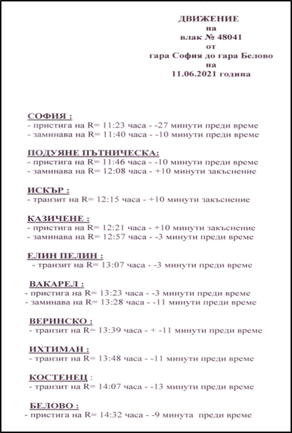
Fig. 3.4
      - Meteorological and geographical condition at the time of the event.
- in the daylight hours – 14:30 p.m.;
- Air temperature +26ºс;
- Wind speed 1 km/h;
- weather – clear, with normal visibility of the signals;
      - Performance of construction activities on the site or in vicinity.
In the period of the accident occurrence in Belovo station performed construction installation works on the track and on the structures.
    - Fatalities, injuries and material damages:
      - Employees of the railway infrastructure manager or railway undertaking.
None.
      - Other persons officially connected with the location of the event.
None.
      - Passengers.
None.
      - External persons.
None.
      - Cargo, luggage or other property.
None.
      - Environment.
None.
      - Rolling stock.
Damage were caused to the running gear part of the derailed locomotive No 91520087023-5 and to the running gear part of the derailed wagon No 31753546020-6.
Value accounts for damages by the railway undertaking/carrier are presented, amounting to: BGN 39 459.72 for the locomotive and BGN 23 475.51 for the wagon.
      - Railway infrastructure.
Damages to the railway infrastructure and the structures in Belovo station were caused because of the derailment of BGN 15 763.01.
Total damages: 78 698.24 BGN
    - Description of other consequences, including the event impact on the usual activity of the participants.
In the period 11.06.-12.06.2021, the railway infrastructure manager and the railway undertakings generated additional costs for modification of the train operation schedule.
      - Railway infrastructure:
- Deviated trains from the alignment: 2 846,67 BGN;
- Cancelled trains along the section: 3 764,76 BGN;
- Assigned trains in the section: 363,27 BGN;
- Costs for rehabilitation means: 1 647,00 BGN;
- Total costs: 8 621,70 BGN.
      - Delayed trains of the railway undertakings amounting to:10 740,05 BGN.
      - Costs for the railway undertaking BDZ-Cargo Ltd: 12 451,17 BGN
• Total costs: 23 191,22 BGN.
    - Identity of the participants and their functions.
      - Railway infrastructure:
- SE National railway infrastructure company has Safety Authorization No № BG 21/2018/0001 valid from 01.07.2018 until 30.06.2023.
SE NRIC personnel, involved in the accident:
- Traffic manager on-duty in Belovo station;
- Head of Belovo railway sections;
      - Railway undertaking:
- „Bulmarket Rail Cargo“ EOOD has:
    - License for performing railway transport services № 212 dated 14.05.2015;
    - Single safety certificate № BG 10 2020 0048 dated 06.08.2020 valid to 05.08.2025;
    - Certificate for entity in charge of maintenance for vehicles № BG/31/0020/0007 dated 11.12.2021 valid to 02.08.2025.
• Staff of „Bulmarket Rail Cargo“ EOOD, involved in the accident:
- Locomotive driver, I-st person of locomotive № 91520087023-5;
- Locomotive driver II-nd person of locomotive № 91520087023-5;
    - Description of the respective parts of the railway infrastructure and signalling system:
      - Type of the track, railway switch, rail crossing etc.
The route is a continuation of the current track No 1 for the 1st main track of Belovo station. Since the railway track of the 1-st main track in Belovo station was dismantled due to the performance of the construction installation works, the entering trains from Kostenets station on the current track No 1 were accepted in deviation in Belovo station on the second main track. The route of the entering trains in Belovo station passed through left curve with radius R=650 m with profile 13.39 ‰ in downhill, in deviation for the second main track.
Interstation block system, station installation, type of signalling.
The interstation Kostenets — Belovo is equipped with automatic block system (ABS) with pass signals;
Belovo Station is equipped with a route-relay interlocking MH-70, the switches in the station are turned electrically;
The overhead contact line in the interstation Kostenets — Belovo is looped, compensated;
Incoming and outgoing messages are performed with a Communications, Connections and Messages Device CCMD-8.
      - Train protection systems.
The Sofia-Plovdiv section is equipped with Automatic Locomotive Signalling (ALS). As of 4.12. 2019, an upgraded Control-Command and Signalling subsystem, ‘Train detection’ and ‘Train protection’ have been put into service in the Sofia-Plovdiv section as follows:
• Part “Train detection” in the railway section from the warning signals at the station of Septemvri, part Belovo to the entry signals of Plovdiv station, part Todor Kableshkov;
• Part “Train protection” in the railway section from the warning signals at Septemvri station, Belovo part to after the entry signals at Plovdiv station, part Todor Kableshkov;
• Part “Radio connection” in the railway section from the Central Railway Station Sofia to the railway station Plovdiv, including the building of the Head Office of SE NRIC;
• Belovo station is only equipped in relation to the “radio” part with GSM-R;
    - Other information referring the event.
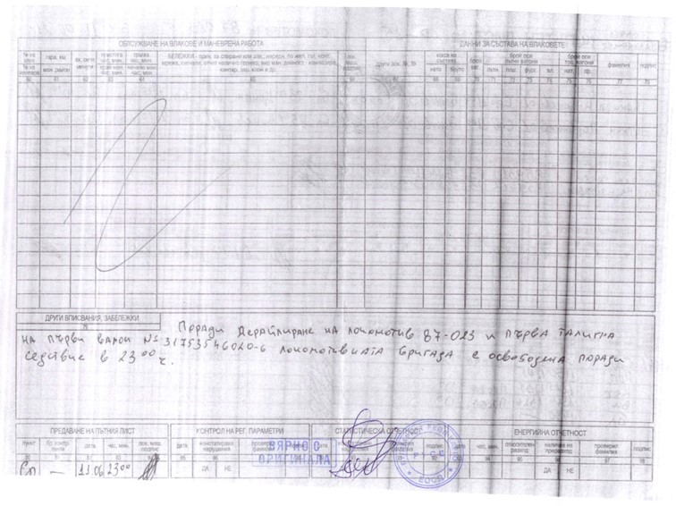
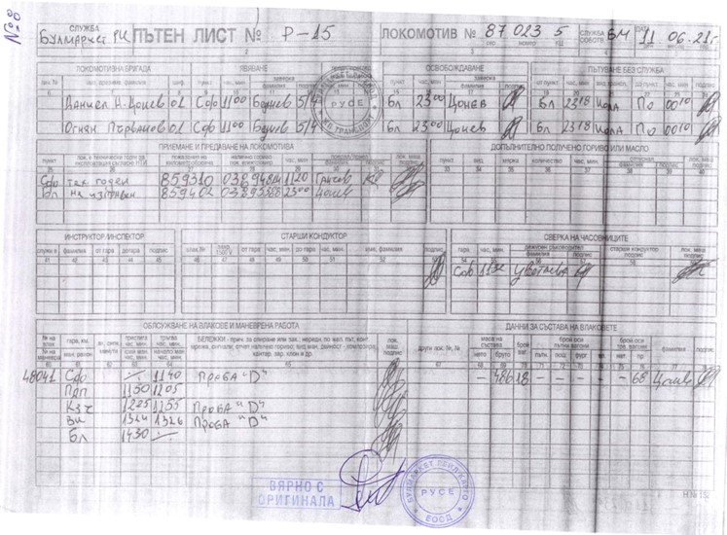
The train documents „Way-bill“, „Nature sheet“ and „Authorization for brake mass“ (fig. 3.5, 3.6, 3.7, 3.8) correspond to the hours of the actual movement of IDFT № 48041 according to the data presented by MRTO and the speedometer installation (tape) of the locomotive.
Fig. 3.6. Way-bill of locomotive № 91520087023-5 – rear part.
Fig. 3.5. Way-bill of locomotive № 91520087023-5 – front part.
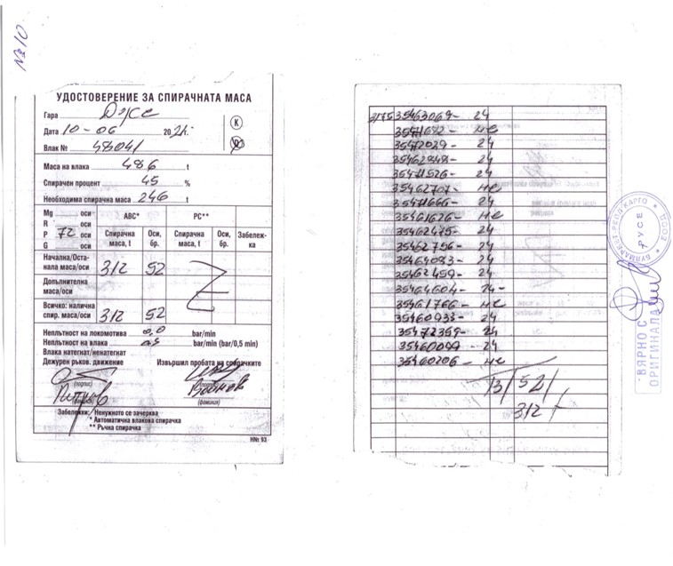
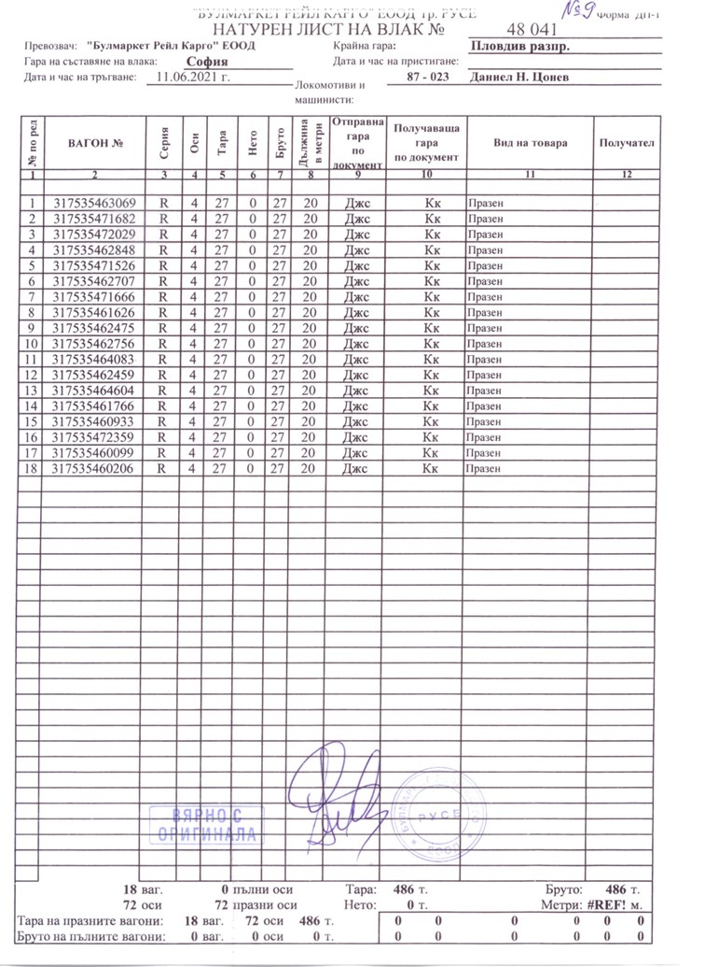
Fig. 3.8. Brake mass Authorization of IDFT № 48041 – front and rear part.
Fig. 3.7. Nature shit of IDFT № 48041.
  - Factual description of the occurred.
    - Immediate sequence of events that led to the accident, including:
      - Actions that the involved in the event persons undertook.
IDFT No 48041 passed through Kostenets station at 14:07 p.m. without stopping. The traffic manager on-duty tracked the train’s passage through the station and did not notice any damage to the rolling stock. When the train entered in Belovo station at 14:25 p.m. (according to the station records), the train travelled at about 40 km/h. The traffic manager on-duty exited on the platform to meet the incoming train and saw that the locomotive derailed at switch № 14 and stopped.
After the locomotive swung strongly at switch No 14, the train driver started to stop the train with the train brake and after 90 m the train stopped at 14:27 p.m.
After the train stopping, the locomotive crew inspected and found that the locomotive had derailed with all 4 wheel-sets and the first wagon of the train had derailed with the two wheel-sets of the first bogie.
      - Rolling stock and technical facilities functioning.
Until the moment of the accident, the rolling stock is regular and functions normally.
The track in Belovo station at the time of derailment was in good condition.
      - Operational system functioning.
The operational system is regular with proper functions.
    - Sequence of events from the beginning of the accident to the end of the rescue services actions:
The derailment of locomotive No 87023 serving IDFT No 48041 occurred at the station of Belovo at 14:27 p.m. at km 92⁺²⁴⁶, where the right wheel of the third wheel-set of the locomotive in the direction of the train fell into the track gauge and after 60 m derailed the left wheel of the same wheel-set. On switch, No 14 derailed the locomotive with all-wheel-sets and the first wagon with the two wheel-sets of the first bogie (Figure 1.2).
      - Undertaken measures for protecting and guarding the event location.
The authorities of the RO Ministry of Interior — Septemvri have segregated the area of the accident and the movement of external persons was restricted, apart from the representatives of the two entities involved in the accident, representatives of the TF — Pazardzhik and representatives of the Investigation Commission of the NAMRATIB.
      - Actions of the emergency rescue services.
No actions from the emergency rescue services were required/necessary.
      - Actions of the emergency rehabilitation services.
- Train movement between the stations Kostenets — Belovo — Septemvri was interrupted from 14:30 p.m. on 11.06.2021 to 14:30 p.m. on 12.06.2021;
- The last seventeen non-derailed wagons of IDFT No 48041 were withdrawn at Kostenets station at 21:30 p.m.;
- On 14.06.2021 from Kostenets station at 02:28 a.m., IDFT No 44141 departed on the route for Plovdiv Marshalling yard — Kapikule, Turkey, serviced by locomotive No 86005 of the railway undertaking Bulmarket Rail Cargo EOOD.
- To lift the derailed locomotive and wagon, the railway infrastructure manager sent recovery means from Sofia station and Plovdiv station.
- Wagon No 31753546020-6 was lifted at 21:09 p.m. on 11.06.2021;
- Locomotive No 91520087023-5 was lifted at 01:10 a.m. on 12.06.2021;
•Train movement between the stations Kostenets — Belovo — Septemvri was restored on 12.06.2021 at 14:30 p.m. with speed up to 25 km/h.
- Analysis of the event
  - Participation and responsibilities of the entities, involved in the event:
    - Railway undertaking.
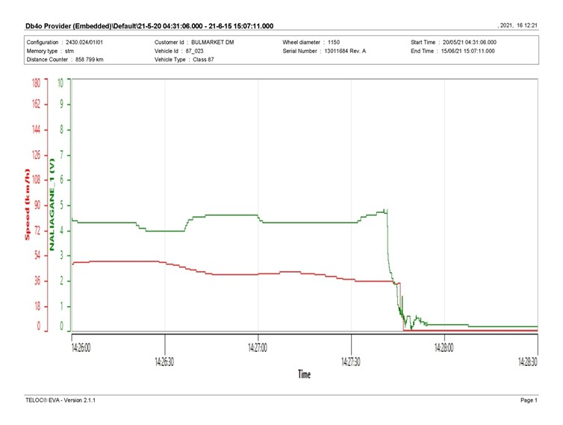
On the Figures.4.1.a and Figure.4.1.b below are shown diagrams with the movement parameters of IDFT No 48041, downloaded in graphic and tabular form from the locomotive’s speedometer installation (the first in a function of time and the second as a function of the odometer of locomotive No 91520087023-5).
Fig. 4.1.а.
The figure depicts the instantaneous speed diagrams with km/h (red) and the pressure in the main air duct of the train with dimension bar (green), as a function of the time parameter, between 14:26:00 p.m. and 14:28:30 p.m.
The graphic image is generated by the system software TELOC®EVA-2.1.1.

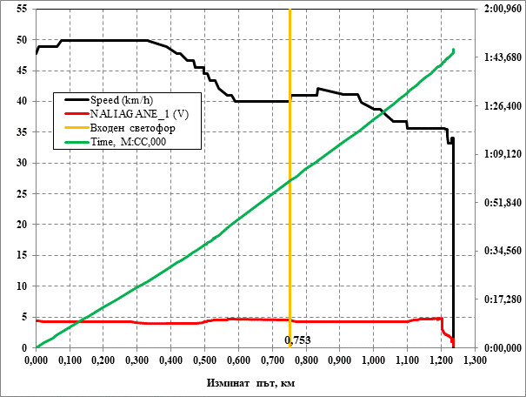
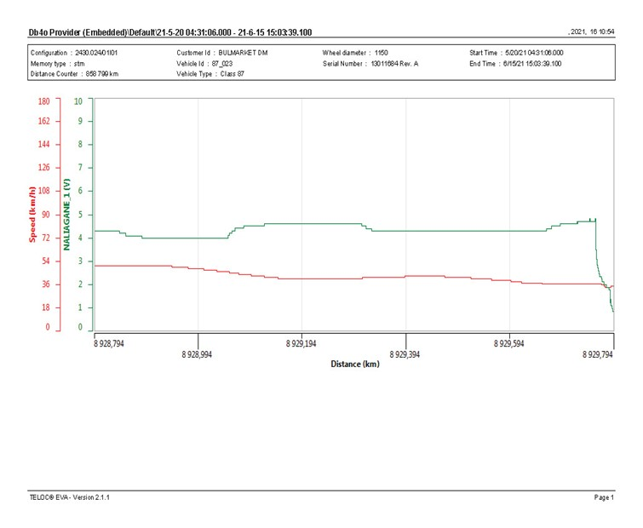
The following Figure 4.2.a shows diagrams of the parameters of speed, main air pressure of the train and time travelled (using the table data from the locomotive’s speed installation) as a function of the travelled track and, in Figure 4.2.b, the same parameters, but as a function of the locomotive odometer.
Fig. 4.2.а
Fig. 4.1.b.
Within maximum allowed speed of 50 km/h, there was not observed any over speed in the Kostenets — Belovo station.
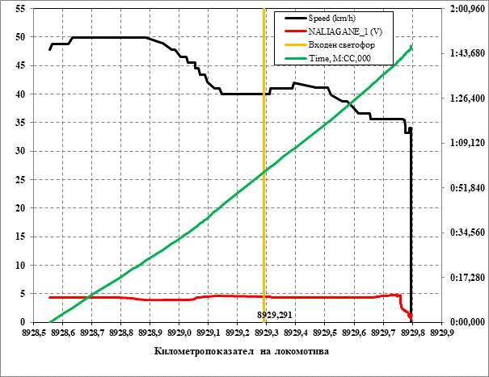
The following Figure 4.2.a shows diagrams of the parameters of speed, main air pressure of the train and time travelled (using the table data from the locomotive’s speed installation) as a function of the travelled track and, in Figure 4.2.b, the same parameters, but as a function of the locomotive odometer.
Fig. 4.2.b.
These diagrams are more viewable and convenient to analyse. The parameters are shown in the last about 1250 metres before stopping the train after derailment. The process took about 1 minute and 54 seconds.
    - Analysis of the track.
The accident occurred when running on a track in a round circular curve with the following parameters:
— Curve radius R= 650 m, which is composed of 2 transition curves of 115 m lengths and a round circular curve of 155 m.
— The total length of the curve from km 92+ 090 to km 92+ 475 is L= 385 m.
According to the Statement of findings of the Task Force on the condition of the track, the cant in the round circular curve is H=85 mm at a speed of 80 km/h H=80 mm. The rail track is with joints, rails type S49, rail length 25 m. From point 20 to point -4 the sleeper gird is wooden and from -4 to point -20 is reinforced concrete with fastening PAC-68I. The wooden gird has a “K” fastening. The place of derailment is in the downhill 13.39 ‰, according to the attached sketch.
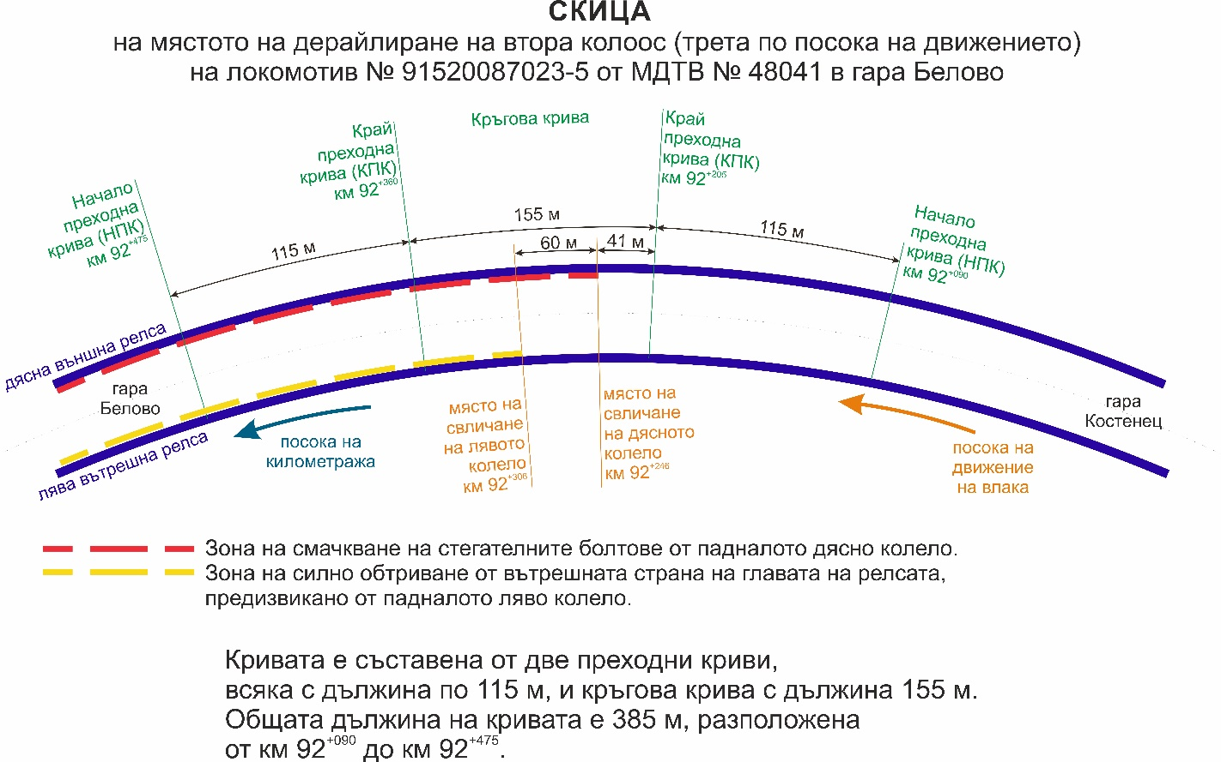
Point 0 at km 292+ 246 is the point of derailment after the axle break at a speed of 41 km/h.
Fig. 4.3. Sketch of the place of derailment of the second wheel-set of locomotive № 91520087023-5 (third in movement direction) of IDFT № 48041 in Belovo station Белово
      - Analysis of the rail track on level.
The analysis of the transverse level of the track was carried out 20 m before the derailment, as the track was not destroyed. To overcome the lateral accelerations and load uniformity of the two rail threads in the rail curves, a normal cant shall be set where trains can run at a speed of up to 120 km/h.
$$H_{H}=8x\frac{V^{2}max}{R}mm.=\frac{8x{80}^{2}}{650}=\frac{8 x 6400}{650}=80 mm.$$

With this cant the lateral acceleration is the following:
$$P= \frac{V^{2}}{13R}-\frac{H}{153}=\frac{{80}^{2}}{13 x 650}-\frac{80}{153}=\frac{6400}{8450}-\frac{80}{153}=0,24 m/s^{2}$$

With speed of 60 km/h; H = 80 mm.
$$P= \frac{V^{2}}{13R}-\frac{H}{153}=\frac{{60}^{2}}{13 x 650}-\frac{80}{153}=\frac{3600}{8450}-\frac{80}{153}=-0,10 m/s^{2}$$

$$Hmin= \frac{{11,8V}^{2}}{R}-100= \frac{{11,8 x 60}^{2}}{650}-100=120-100=-35 mm.$$
It is accepted that Н_{min} = 0 as per Table 3.7 from „Instruction on the current maintenance of the track and switches“.

Parameters of locomotive № 91520087023-5:
- Total length= 17 830 mm.
- Distance between the wheel-sets in the bogie = 3280 mm.
- Distance between the central bolts of the two bogies = 9982 mm.
Calculated transitions based on inter-axle distance in the bogies (bogie base).

А) Calculated parameters in the points before derailment:
т.0 = 84 mm, p.3 = 81 mm, Difference = 3 mm.
$$K= \frac{L}{H}= \frac{3280}{3}=1093:K=1:1093$$
B) Measured parameters in the points after derailment:
p.0 = 84 м.; p. -3 = 89 mm; Difference = 5mm.
$$K= \frac{L}{H}=\frac{3280}{5}=656:K=1:656$$

Calculated transitions based on distance between the central bolts of the bogies = 9982 mm.
А) Before derailment:
p.0 = 84 mm, point 10 = 82 mm, difference = 2 mm.
$K= \frac{L}{H}=\frac{10 000 мм. }{2 мм.}$ = 5000; к = 1:5000
B) After derailment:
p.0 = 84 mm; p. -10 = 90 mm; difference = 6 mm.
$$K= \frac{L}{H}=\frac{10 000 mm.}{6 mm.}=1666:K=1:1666$$

The calculated data confirm that the inclinations of the transitions for the two bases correspond to the ‘Instruction for current maintenance of the track and switches’.
In the case of a cant of H=85 mm, the minimum measured is 76 mm at point 17 and the maximum is 93 mm at -18. These values of the parameters do not exceed the threshold set out in the standards. There are no records in the Statement of findings on measurement of hidden failures (twists) due to unsubstantiated claims by the railway undertaking/carrier. It is apparent from the on-the-spot inspections that there is no hardened ballast prism, which may have caused hidden falls.
The cross-level data around the derailment point are shown in Figure 4.4, Diagram 1.
      - Analysis of the rail track under rail gauge.
The measured values recorded in the Statement of findings show that the maximum track gauge recorded is in point 0 and points 2 and 3, with values 1 459 mm and 1 460 mm, up to a maximum of 1 465 mm for first and second class railway lines.
The data are shown in Figure 4.4, Diagram 2.
      - Analysis of the rail track in plan (under axis).
The alignment of the curve is measured at 1 m with chord S = 20 m, as the curve is with R = 650 m.
The reports are shown in Fig. 4.4, Diagram 3.
Theoretical alignment:

$f= \frac{S^{2}}{8R}=\frac{{20}^{2}}{8 x 650}= \frac{400 x 1000}{5200}=77$mm.

At 5 m maximum alignment difference is between point 0 and point 5 = $f_{1}-f_{2}=\left|77-83\right|=6 mm under absolute value.$
At 10 m maximum alignment difference between point 10 and point 20 = $f_{1}-f_{2}=81-74=7 mm.$
The permitted thresholds for alignment differences at speeds of 60 km/h are 31 mm for alignment with chord 20 m and 15 mm for chord 10 m. For speeds up to 60 km/h are 48 mm for chord 20 m and 24 mm for chord = 10 m.
It is evident that the status of the track by axis is in the norm
      - Analysis of the rail fatigue – outer right to the train direction.
The Statement of findings records values of 0 mm for vertical wear of the rails and lateral 3 mm at the zero point, the maximum measured wear of 5 mm is laid down in points 18, 19 and 20, within allowed 13.5 mm.
It is apparent from the performed analyses and calculations that the track parameters are within the permissible thresholds.

    - Entities in charge of the technical maintenance.
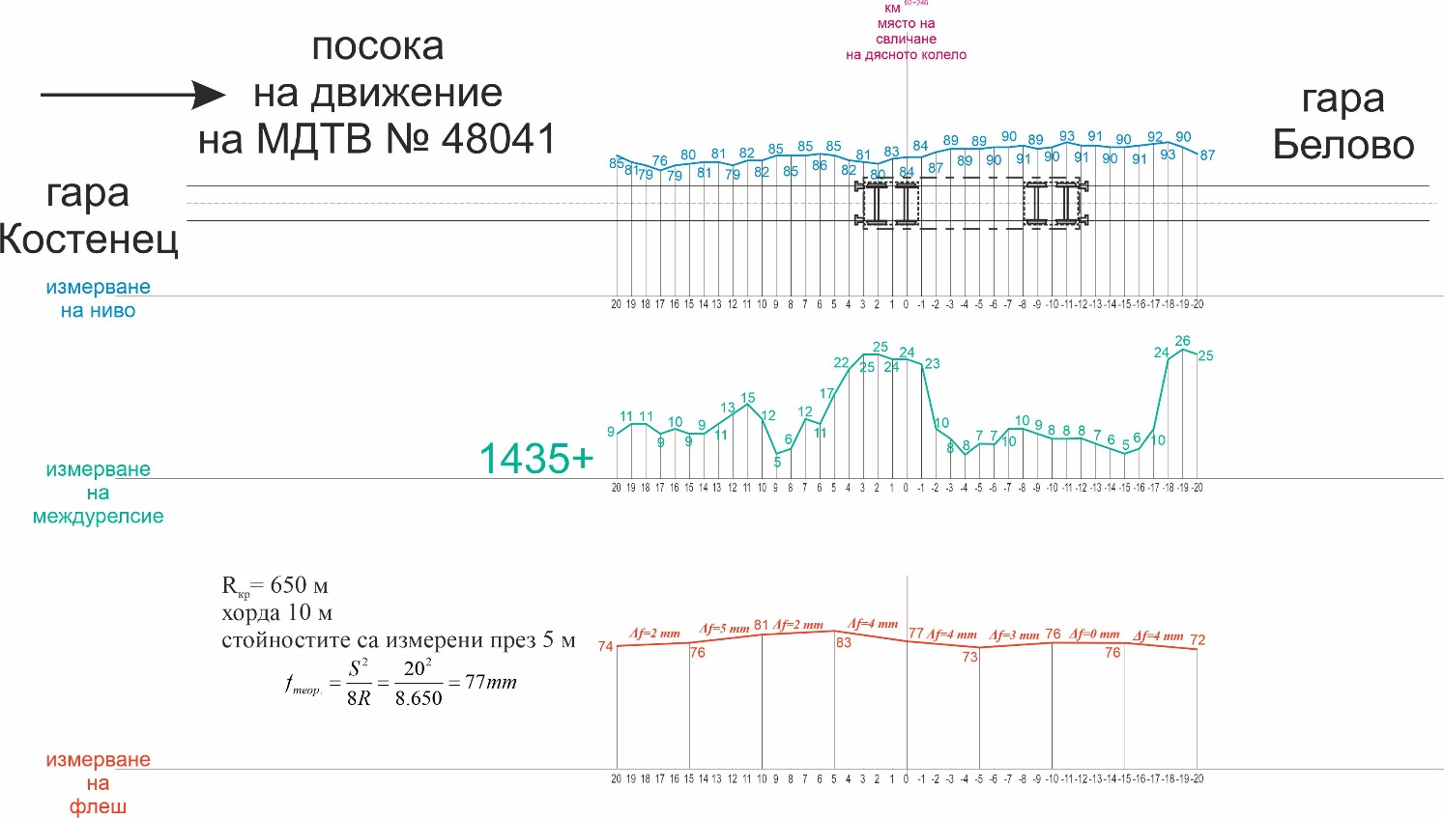
For the technical maintenance of the railway infrastructure, the responsible entity is SE NRIC.
Fig. 4.4. Schemes of the measured track
For the technical maintenance of traction rolling stock, the responsible entity is the railway undertaking/carrier Bulmarket Rail Cargo EOOD.
    - Manufacturers or providers of rolling stock and railway products.
Not applicable.
    - National Safety Authority.
Railway Administration Executive Agency is the National Safety Authority for railway transport in the Republic of Bulgaria.
    - Notified bodies or Risk assessment bodies.
Not applicable.
    - Certifying bodies of the entities in charge of maintenance.
The Railway Administration Executive Agency as the National Safety Authority for railway transport performs certification of the entities in charge of the vehicles maintenance (ECM) in accordance with Directive 2004/49/EC and Regulation (EU) 445/2011, as per Ordinance No 59 on the railway transport safety management and on the maintenance functions in accordance with Directive 2004/49/EC and Regulation (EU) 445/2011.
From June 16, 2020 the RAEA performs certification of the ECM as per the Commission Implementing Regulation (EU) 2019/779 of 16 May 2019 laying down detailed provisions on a system of certification of entities in charge of maintenance of vehicles pursuant to Directive (EU) 2016/798 of the European Parliament and of the Council and repealing Commission Regulation (EU) No 445/2011

    - Persons or entities involved in the event, documented or not in the respective safety management systems or indicated in register..
The railway undertaking/carrier Bulmarket Rail Cargo EOOD is a certified entity in charge of maintenance of vehicles (diesel and electric locomotives and freight wagons, including dangerous goods) and holds certificate No BG/31/0020/0007.
Bulmarket Rail Cargo EOOD has entrusted the performance of the maintenance function to “Express Service” OOD.
“Express Service” OOD holds certificate No FM/BGRA/2020/0003 as a person performing the function “Performance of maintenance” of vehicles (diesel and electric locomotives).
  - Rolling stock and technical facilities:
    - Factors, deriving from the design of the rolling stock, railway infrastructure or technical facilities.
Not applicable.
    - Factors deriving from the installation and placing into service of the rolling stock, railway infrastructure and technical facilities.
Not applicable.
    - Factors deriving from manufacturers or another provider of railway products.
Not applicable.
    - Factors, deriving from the technical maintenance and/or modification of the rolling stock or the technical facilities.
Not applicable.
    - Factors due to the entity in charge of the technical maintenance, workshops for technical maintenance and other technical maintenance service providers.
Not applicable.
    - Other factors or consequences considered as involved within the investigation objectives.
  - Human factor:
    - Individual human characteristics:
      - Training and development, including skills and experience.
Railway undertaking:
• Locomotive driver – I-st person License No 11416 for obtaining professional qualification „Locomotive driver of electric locomotives“, training performed within the period 14.09.÷19.11.2009, issued by Professional Training Center (PTC) of Bulgarian State Railways (BDZ).
Locomotive driving license BG 71 2016 0048 issued by RAEA;
License № 51 of position Locomotive driver at Bulmarket Rail Cargo EOOD from 01.09.2015
• Locomotive driver II-nd person – License № 257 for obtaining professional qualification „Locomotive driver of electric locomotives“, training performed within the period 01.10.2002÷02.02.2003 issued by Professional Training Center (PTC) of NRIC;
Locomotive driving license BG 71 2017 0895 issued by RAEA;
License № 92 of position Locomotive driver at Bulmarket Rail Cargo EOOD from 18.12.2017.
Railway infrastructure:
• Traffic manager in Belovo station – Certificate of qualification № 10895 for, Traffic manager“, training performed within the period 20.10.2008÷12.05.2009, issued by the Professional Training Center at NRIC;
Certificate № 3376 for position Traffic manager at TOSAD – Sofia from 14.08.2012.
• Head of rail track section Belovo – Certificate of qualification № 19928 for, Technician on maintenance and construction of railway lines“, training performed within the period 12.04.1979÷12.06.1982, issued by PRI “Todor Kableshkov” – Sofia.
Certificate № 64 for position Head of section – RS Sofia from 19.01.2021.
      - Medical and personal circumstances, which influence the event, including the presence of physical and psychological stress.
Railway undertaking:
• Locomotive driver I-st person:
Medical exam card dated 04.03.2021, issued by Plovdiv Multi-profile Transport Hospital– conclusion: suitable for locomotive driver.
Physiological exam No 361/22.03.2019, issued by Laboratory for physiological expertise at Plovdiv Multi-profile Transport Hospital for locomotive driver. Conclusion: accepted for a 5-year period.
• Locomotive driver II-nd person:
Medical exam card dated 04.03.2021, issued by Plovdiv Multi-profile Transport Hospital– conclusion: suitable for locomotive driver.
Physiological exam № 1326/20.11.2017, issued by Laboratory for physiological expertise at Plovdiv Multi-profile Transport Hospital for locomotive driver. Conclusion: accepted for a 5-year period.
Railway infrastructure:
• Traffic manager in Belovo station:
Single health dossier № 2209/07.06.2021 for periodical medical exams of traffic manager in SE NRIC, issued by Sofia Multi-profile Transport Hospital, conclusion – suitable for traffic manager.
Physiological exam № 729/02.05.2017, issued by Laboratory for physiological expertise at Sofia Multi-profile Transport Hospital for traffic manager.
Conclusion: accepted for a 5-year period.
• Head of Belovo railway section:
Medical obligatory periodical exam card dated 07.07.2020, issued by Sofia Multi-profile Transport Hospital, conclusion – suitable
      - Fatigue.
Railway undertaking:
• Locomotive driver I-st person:
Break/rest: from 02:40 a.m. on 10.06.2021 to 11:00 a.m. on 11.06.2021 (32 hours and 20 minutes);
• Locomotive driver II-nd person:
Break/rest: from 23:00 p.m. on 08.06.2021 to 11:00 a.m. on 11.06.2021 (84 hours and 00 minutes);
Railway infrastructure:
• Traffic manager in Belovo station:
Break/rest: from 19:00 p.m. on 09.06.2021 to 07:00 a.m. on 11.06.2021 (36 hours and 00 minutes);
• Head of railway section Sliven:
Full working time 40 hours a week.
      - Motivation and attitudes.
Not applicable.
    - Work related factors:
      - Tasks planning.
„Bulmarket Rail Cargo“ EOOD performs the freight traffic under a Plan for train composition and they are carried out as per the Train Operation Schedule.
      - Constructive particularities of the facilities that influence the connection human-machine.
Not applicable.
      - Communication means.
Not applicable.
      - Practices and processes.
Not applicable.
      - Operation rules, local instructions, staff requirements, prescriptions for technical maintenance and applicable standards.
Application of the national normative acts and internal standards.
      - Working time of the involved personnel.
In accordance with the requirements of the normative acts - Labour Code and Ordinance № 50 of 28.12.2001 for the working hours of the managerial and executive staff, engaged in providing the transportation of passengers and freights in the railway transport. The staff of both entities works in shifts/suspension (when servicing a train or a vehicle - with a variable start and different working hours), in which a summary calculation of the working time shift in a 12-hour work shift and full working week are applied.
      - Risk treatment practices.
SE NRIC applies safety procedure SP 2.09 „Methods of evaluation, assessment and management of the risk „version 05 effective from 01.03.2019, which is part of the SMS.
„Bulmarket Rail Cargo” EOOD applies a safety procedure:
SP-48 Methods of analysis and assessment of the risk;
SP-56 Safety management;
SP-39 Evaluation of risks, related to parties external for the railway system;
Context, machinery, equipment and indications for shaping the working practices
Not applicable.
    - Organizational factors and tasks:
      - Planning of the working force and the working load.
As per the requirements of the normative documents and best practices.
      - Communications, information and teamwork.
Not applicable.
      - Recruitment, staffing requirements, resources.
Recruitment and selection of staff with regulated professions related to railway safety in both entities shall be carried out in accordance with the approved procedures and rules, which are part of the safety management system.
      - Implementation management and supervision.
Not applicable.
      - Compensation (remuneration).
Not applicable.
      - Leadership, powers related issues.
Not applicable.
      - Organizational culture.
Not applicable.
      - Legal issues (including the respective European and national rules and provisions).
Not applicable.
      - Regulatory framework conditions and safety management system application.
Railway undertaking.
- Directive (EU) 2016/798 of the European Parliament and of the Council of 11 May 2016 on railway safety;
- Commission Delegated Regulation (EU) 2018/762 of 8 March 2018 establishing common safety methods on safety management system requirements pursuant to Directive (EU) 2016/798 of the European Parliament and of the Council and repealing Commission Regulations (EU) No 1158/2010 and (EU) No 1169/2010;
- COMMISSION IMPLEMENTING REGULATION (EU) 2019/779 of 16 May 2019 laying down detailed provisions on a system of certification of entities in charge of maintenance of vehicles pursuant to Directive (EU) 2016/798 of the European Parliament and of the Council and repealing Commission Regulation (EU) No 445/2011;
- COMMISSION IMPLEMENTING REGULATION (EU) No 402/2013 of 30 April 2013 on the common safety method for risk evaluation and assessment and repealing Regulation (EC) No 352/2009;
- Railway Transport Act;
- ORDINANCE No 59 dated 5.12.2006 on the railway transport safety management.
- TOR and TOSAR.
Railway infrastructure.
- Directive (EU) 2016/798 of the European Parliament and of the Council of 11 May 2016 on railway safety;
- Commission Delegated Regulation (EU) 2018/762 of 8 March 2018 establishing common safety methods on safety management system requirements pursuant to Directive (EU) 2016/798 of the European Parliament and of the Council and repealing Commission Regulations (EU) No 1158/2010 and (EU) No 1169/2010;
- COMMISSION IMPLEMENTING REGULATION (EU) 2019/779 of 16 May 2019 laying down detailed provisions on a system of certification of entities in charge of maintenance of vehicles pursuant to Directive (EU) 2016/798 of the European Parliament and of the Council and repealing Commission Regulation (EU) No 445/2011;
- COMMISSION IMPLEMENTING REGULATION (EU) No 402/2013 of 30 April 2013 on the common safety method for risk evaluation and assessment and repealing Regulation (EC) No 352/2009;
- Railway Transport Act;
- ORDINANCE No 59 dated 5.12.2006 on the railway transport safety management.
- TOR and TOSAR.
    - Environmental factors:
      - Labour conditions (noise, illumination, vibrations).
Not applicable.
      - Meteorological and geographic conditions.
Not applicable.
      - Construction works, performed on the spot or in very proximity.
The railway section Kostenets — Belovo — Septemvri is part of the first main, double-track railway line. Since May 2021, the project “Modernisation of the Kostenets — Septemvri railway section” has been implemented in Belovo station, which is part of the projects financed under the Connecting Europe Facility, Transport Sector (CEF). With the start of the first stage of the construction works, three tracks were dismantled at the station: 4th, 6th and 1st main, which is a continuation of the current track No 1, connecting the stations Kostenets — Belovo — Septemvri. Switches No 8, 12 and 18 adjacent to the tracks were also dismantled in the station. Current track No 1 in Belovo — Septemvri is also dismantled in connection with the implementation of the construction works. The movement of trains at the station is carried out bi-directionally on a single railway line on current track No 2. In this regard, the route of the incoming trains from Kostenets station on track No 1 in the station of Belovo are routed to the second main track and continue on the rights of the current track No 2 for the station of Septemvri. The deadline for completion of the works and implementation of the project is 11.08.2024.
    - Any other significant factor for the investigation objectives.
Not applicable.
  - Feedback and control mechanisms, including risk and safety management, as well as monitoring processes:
    - Regulatory framework conditions.
Commission Delegated Regulation (EU) 2018/761 of 16 February 2018 establishing common safety methods for supervision by national safety authorities after the issue of a single safety certificate or a safety authorisation pursuant to Directive (EU) 2016/798 of the European Parliament and of the Council and repealing Commission Regulation (EU) No 1077/2012;
ORDINANCE No 59 of 5.12.2006 on the railway transport safety management.
    - Processes, methods and results from the activities on the risk assessment and monitoring that the involved entities performed:
      - Railway undertakings.
„Bulmarket Rail Cargo” EOOD applies a safety procedure:
SP-48 Methods of analysis and assessment of the risk;
SP-56 Safety management;
SP-39 Evaluation of risks, related to parties external for the railway system;
Railway infrastructure.
SE NRIC applies a safety procedure SP 2.09 „Methods of risk evaluation and assessment „version 05 effective from 01.03.2019, which is a part of SMS.
      - Entities in charge of the technical maintenance.
SE NRIC and “BDZ-Cargo” Ltd. are certified ECM.
SE NRIC applies a safety procedure SP 2.09 „Methods of risk evaluation and assessment „version 05 effective from 01.03.2019, which is a part of SMS.
„Bulmarket Rail Cargo” EOOD applies a safety procedure:
SP-48 Methods of analysis and assessment of the risk;
SP-56 Safety management;
SP-39 Evaluation of risks, related to parties external for the railway system;
Manufacturers and all other participants.
Not applicable.
      - Reports on independent risk assessment.
There have not been performed an assessment by independent Assessment Body (AsBo) on changes/modifications performed in operational conditions and factors that refer to the occurred accident.
    - Safety Management System of the involved:
      - Railway Undertakings.
The last annual planning supervision of Bulmarket Rail Cargo EOOD was carried out in the period 27-31.07.2020. In 2021, several specialised audits were carried out — the last one was in the period 08-10.09.2021.
      - Railway Infrastructure.
The latest annual planned supervision of the SMS of SE NRIC was performed in the period from 19.10.2020 to 30.10.2020.
    - Safety Management System of the entities in charge of the technical maintenance.
Not applicable.
    - Results from the supervision, performed by the National Safety Authority.
The results from the performed audits and inspections referring the functionality of the Safety Management System of SE NRIC and Bulmarket Rail Cargo EOOD as per the requirements of Regulation (EU) 2018/761, Regulation (EU) No 1169/2010, Ordinance No 56 and Ordinance No 59 on respect of the specific requirements of the European legislation and national rules for design, maintenance and operation of the managed railway infrastructure demonstrate that the entities maintain SMS and are able to respect the requirements, envisaged in the respective normative documents.
    - Permits, certificates and assessment reports, provided by the National Safety Authority or other Conformity Assessment Bodies:
      - Safety certificates of the involved railway infrastructure managers.
Safety Authorization No BG 21/2018/0001 valid from 01.07.2018 to 30.06.2023.
      - Safety certificates of the involved railway undertakings.
    - Single safety certificate № BG 10 2020 0048 dated 06.08.2020 valid to 05.08.2025;
      - Authorizations for placing in service of permanently fixed equipment and permits for placing on the market of vehicles.
Not applicable.
      - Entities in charge of the technical maintenance.
Bulmarket Rail Cargo EOOD holds ECM Certificate for Railway Vehicles No BG/31/0020/0007 of 11 December 2021 valid until 02.08.2025.
SE NRIC is responsible for the repair, maintenance and operation of the national railway infrastructure.
Express Service Ltd. holds ECM Certificate for Railway Vehicles No FM/BGRA/2020/0003 valid until 16.06.2025;
The railway undertaking “Express Service” Ltd. as a certified person responsible for vehicle maintenance function (diesel and electric locomotives). Performs the function of “Performance of maintenance” under a contract with Bulmarket Rail Cargo EOOD for repair and maintenance of traction rolling stock. In September 2019, all 8 wheels of the locomotive were replaced due to the expired resource of the old ones (repair by necessity). After releasing the four axles from the wheels, an ultrasound defectoscopy was performed with a defectoscope Type USN 50 with a B2SN streak; WB35-N2; WB45-N2; WB70-N2. Defective axis defects have not detected any defects on them. Once the wheels have been crimped to the axle by heat-pressing technology, each wheel is checked for the quality of crimping by force, for which a computer printout is presented, to assess the quality of the crimping.

    - Other system factors.
Not applicable.
  - Previous similar cases.
A similar case of a torn axle of the 86.000 locomotive series, which axles are structurally hollow, in similar circumstances in the Pirdop station area, was investigated. The investigation was concluded with a final report in a form appropriate to the type and severity of the accident, which also formulated safety recommendations.

- Conclusions
  - Summary of the analysis for the event causes.
According to the Technical Passport of locomotive No 91520087023-5, it was manufactured and put into service at the British Railways in 1974 and since 01.01.2013 it has been assigned to Bulmarket DM OOD — Ruse.
The Investigation Commission has established that the Fabre axis. No m6 5751 worked almost continuously from the time it was manufactured in 1973 until it was broken.
From the theory, it is well known that each axle is subjected to a multi-cyclic variable load from bending during its rotation during operation. It is also known that the highest values of bending voltages occur in the middle of the wheel-set. The question arises why the wheel-set break is in the transition area to the sub-header on the free side of the wheel-set (and not on the side of the large gear of the wheel reducer).
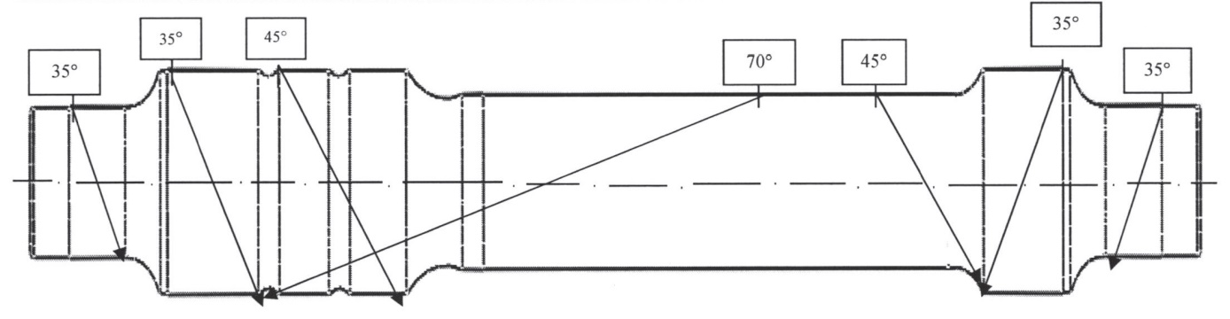
Fig. 5.1. The wheel-set with indicated section of the break

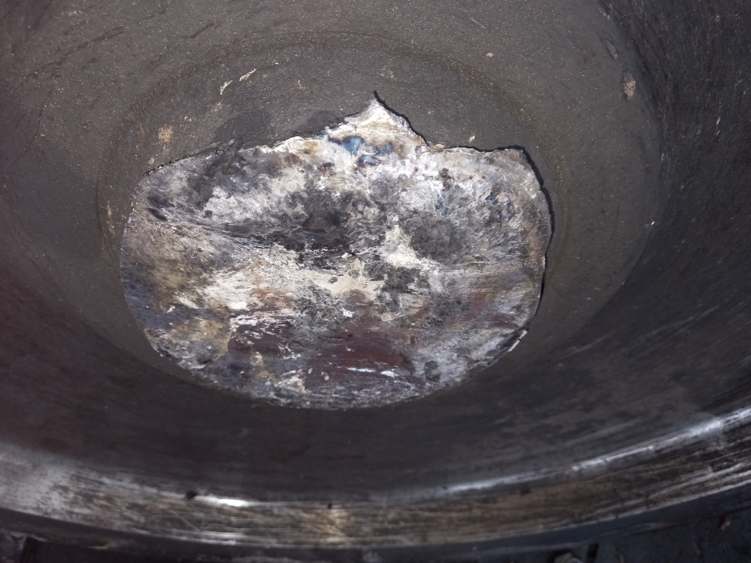
Fig. 5.2. Photo of the surface of the transition in the sub-header part of the wheel

As can be seen from the above figure, the plane of the surface is perpendicular to the axis of the wheel-set, i.e. the ‘break’ of the wheels is not the result of a transmission of an engine to the wheels that loads the axle with a twisting moment (in such cases the surface would be below 45°).
An equivalent vertical wheel-set load diagram is shown in Figure 5.3.
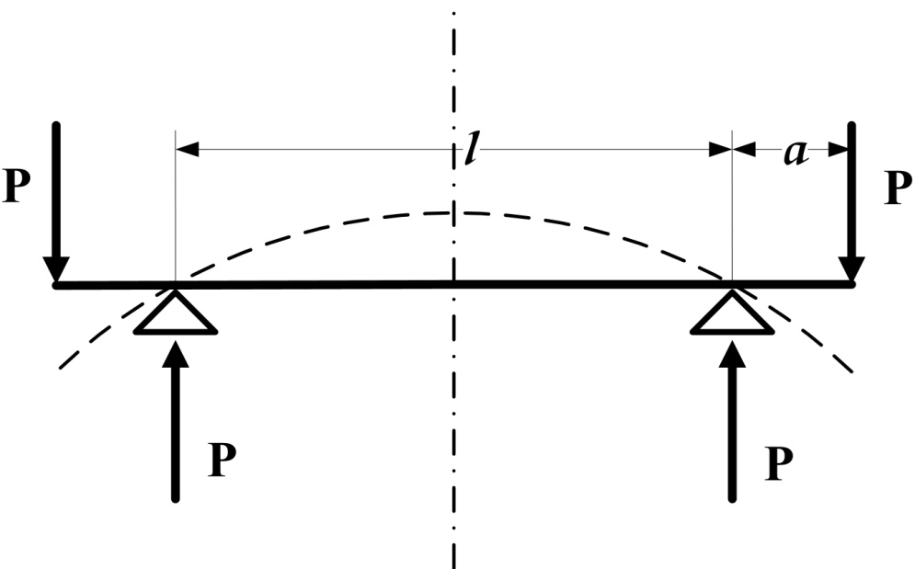
Fig.5.3.

The bending moment in the track gauge (length of dimension l) is М_{ОГ}=P.a=Const.

In the applicable standard BDS EN 13260:2021, Railway equipment. Wheel-sets and bogies. Product requirements, the original text of the standard states that “The components of the wheelset can be shrink-fitted or press-fitted to the axle”, i.e. the formation of the wheel-set can be performed by means of a heat squeeze (so-called heat-press assembly with wheel heating up to 250 °C) or by compression to the axle (so-called cold-press assembly).
In the case of the cold press formation of the wheelset, the standard sets out clear requirements for control of the assembly based on the ‘force-movement’ diagram shown in Figure 5.4.
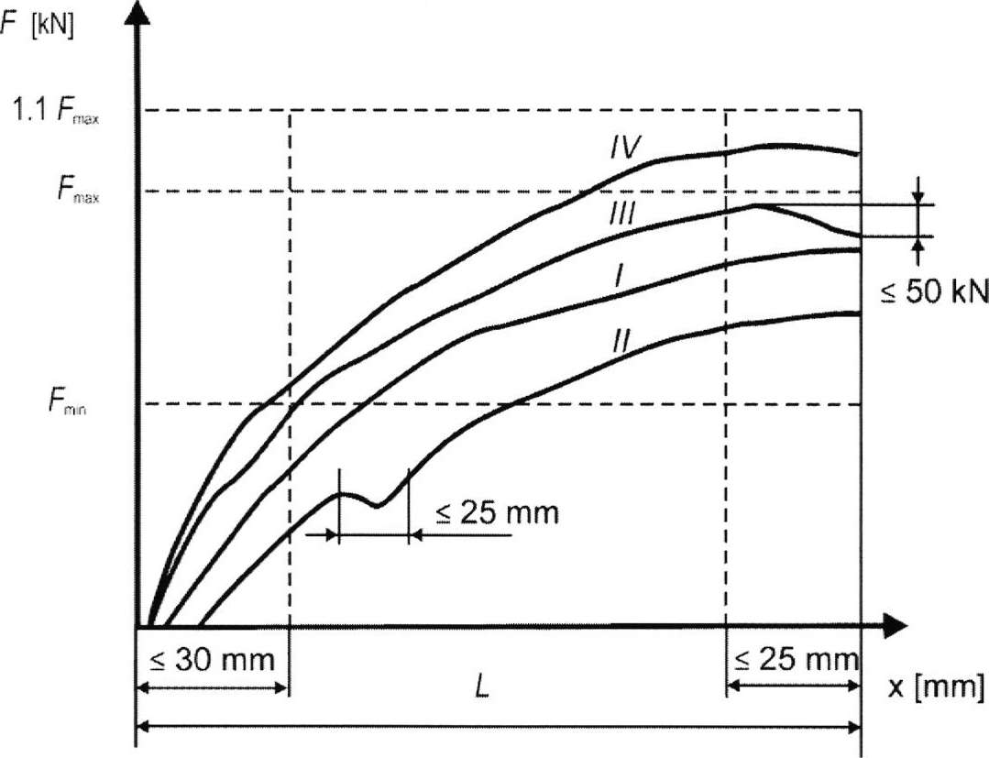
Fig. 5.4. Sample diagrams of crimping and eligibility limits
According to „Complete Report No 3 of full certification of the wheel-set” issued by Express Service OOD on 17.04.2017:
- ‘point 2 Check results of the wheel-set and its individual components’: no record in the report;
- ‘point 3 Wheel-repression/pressure and drive gear supports’: there are no records in nine of the fields, and only in the field ‘maximum crimping force, kN’ is written the number 1020;
- “point 4 Ultrasonic defection of the axle of the wheel-set” — the type of defectoscope “Krautkramer”, USN 50, No 05296 used, chapters WVB 35-2, WB 45-2 and WB70-2 are indicated. It is concluded that the ultrasound defects performed do not indicate the presence of cracks.
- “point 5 Penetrant/magnetic/............. defective” - no record in the report, i.e. not conducted;
- ‘point 7 Conclusion’ states that ‘the wheel complies with the requirements of BDS EN 15313:2010, Regulation No 58 of the MTITC, UIC-Codex and may be installed in the running gear part of locomotive No 91520087017-7’.
It is also unclear the type of diagrams attached on pages 3 and 4 (called “Diagram of Breakdown”). Most likely, these are diagrams for checking the quality of the axle-wheel assembly, but then the force-moving diagrams, after exhaustion of the emptiness, should show a zero displacement and a vertical increase in force that is not visible on the diagrams presented.

The TU-Sofia’s expert report concluded that “The examined surface has the specific form of fatigue demolition”! It is also stated, "The most characteristic of the development of the tiring crack is that it takes a leap. Under the increase of the microscope on the fatigue surface, the so-called fatigue lines — grooves corresponding to the successive positions of the crack front occupied during its movement are well visible. Each of them can be formed for a single load cycle, but in some cases their width does not correspond to the average cyclic displacement of the crack.’
In summary of the above, the most likely cause for the accident is the fatigue destruction of the wheel-set in a zone with a voltage concentrator (the transition from the middle part of the wheel-set to the sub-header). A leading hypothesis for breaking is the accumulation of fatigue in the wheel-set material, given its long life cycle. It is possible that the ultrasound defectoscopy of the wheel-set did not reveal the presence of a crack and the probability of checking the heat-press assembly of the wheel (according to the load diagram 1020 kN) may have appeared/developed the crack, is not high (but cannot be excluded).
  - Undertaken measures after the event occurrence.
In the period 08-10.09.2021 the Railway Administration Executive Agency carried out an extraordinary supervisory and on-the-spot audit in Ruse in connection with a railway accident — derailment of locomotive No 91520087023-5 in Belovo station on 11.06. 2021 for the implementation of the activities of Bulmarket Rail Cargo EOOD as a railway carrier and certified person responsible for maintenance of railway vehicles (diesel and electric locomotives) and of the production base “Express service” OOD in Obraztsov Chiflik, as a certified person performing the function of railway vehicles maintenance (diesel and electric locomotives).
In the course of the inspection, experts of the Railway Administration Executive Agency reviewed the overall documentation relating to the technical condition and repairs of locomotive No 91520087023-5. According to the maintenance file for locomotive No 91520087023-5, on 28.04.2020, the locomotive bogies were changed and the locomotive’s mileage to date was 724 080 km. From the time the bogies were installed until the moment of derailment, the locomotive had travelled 135 332 km. Following an analysis of the documents, it was found that there were no discrepancies
According to the register of adverse events (accidents and incidents register) of Bulmarket Rail Cargo EOOD of the company’s safety system, it was found that this was the first case of wheel-set break since the acquisition of this series of locomotives. Locomotive No 91520087023-5 was manufactured in 1974, with wheel-set No m6 5751 being manufactured in 1973. At the time of acquisition of the locomotive on which the said wheel-set was fitted in 2012, it was not known how many times the wheels had been replaced and how many kilometres the wheel-set had previously travelled. Since the acquisition in 2012, a detailed account has been kept of the mileage and the cycle of formation with new wheels on each axle of that locomotive, with full traceability. Wheel-set No m6 5751 was last formed with a mono-block on 03.10.2019, according to the submitted complete report for the wheel-set. On 18 September 2019, in Express Service Ltd. was carried out USD on wheelset No m6 5751, after which the wheel-set was left to stand in reserve — for use if necessary. The wheel-set was in stock until it was incorporated and installed in a lock. No 91520087023-5 on 30.04.2020, according to the passport data. The wheelbase after installation is about 142 x km. The maintenance control is carried out by the receiver of the company, on site at the factory of “Express Service” Ltd., according to the presented instructions for its work. The receiver shall sign a transfer protocol, certifying the performed controls and measurements. When performing operations for the replacement of wheel-sets, as well as when performing the USD, he does not sign the documents. Bulmarket Rail Cargo EOOD and Express Service OOD have confirmed that the process of stretching the wheel-set was carried out under the supervision of the receiver of Bulmarket Rail Cargo EOOD. The protocols for full certification of wheel-sets were drawn up on 24.07.2019.
The evidence attesting the legal capacity of the person carrying out the USD and the document certifying the calibration of the defectoscope are:
- Control certificate No 21-126-001/07.09.2021 for the verification of ultrasound defectoscope Krautkrämer USN 50, No 05296-602302;
- Protocol for the control of ultrasonic defectoscope to certificate No 21-126-001/07.09.2021;
- Certificate No 464-1 of 07.10.2016 of the defectoscope in “Express Service” OOD, carrying out SD, issued by the Certification Centre for Non-Demolition Control Staff of the National Scientific and Technical Society for defectoscopy;
- A sample from a logbook of ultrasonic non-destructive testing of wheel-sets for the period 05.09.2019-09.10.2019;
No irregularities and non-compliances were found on the documents. When performing a defectoscopy, a reference wheel-set is used to adjust the defectoscope.
The formation of the wheel-sets has been found to be performed by means of a hot-press assembly between the axle and the wheels. The method used is unconventional for the rail sector. According to the wheel-sets passports, on 02.10.2019 a check was carried out with an extrusion effort of 1.02 MN.
As a result of the audit carried out by the National Safety Authority, the overall conclusion is:
- No critical discrepancies were found in the processes for carrying out USD and formation of wheel-sets of locomotives series 87.00 in “Express Service” Ltd. The management system shall be implemented correctly and in accordance with the written internal rules. One non-compliance was found: “Express Service” Ltd. uses a form of protocol for USD, different from the model of the Instruction of “Express Service” Ltd., with which “Express Service” Ltd. is familiar with on-site through a statement of findings;
- For locomotives series 87.00, used by Bulmarket Rail Cargo EOOD, this is the first case of a broken wheel-set for this series;
- With regard to locomotives series 87.00, given their period of operation, the Railway Administration Executive Agency found that their maintenance could be improved.

5.3. Additional findings.
There are no any.

- Safety recommendations
In order to improve the safety in the rail transport, the Investigation Commission at NAMRATIB proposes to the Railway Administration Executive Agency the following safety recommendations adapted to SE NRIC and „Bulmarket Rail Cargo“ EOOD.
• Recommendation 1 proposes that NRIC SE and Bulmarket Rail Cargo EOOD shall acquaint the interested staff with the content of this report.
• Recommendation 2 proposes Bulmarket Rail Cargo EOOD to correct and submit safety procedure SP-54 “Instruction for the operation of a locomotive instructor/receiver on the quality of the production processes”, by imposing duties of presence during the formation of wheel-sets with change of elements, as well as during the performance of non-destructive control (ultrasonic and penetrant defectoscopy), to characterise and accept the repair works with signature in the repair cards.
• Recommendation 3 proposes that Bulmarket Rail Cargo EOOD shall assign to the maintenance contractor to perform, in addition to the ultrasonic control a penetrant defectoscopy as well, when performing all types of repairs on the wheel-sets. This additional defectoscopy shall be recorded as an obligation in the Rules for Repair of Locomotives Series 87.000.
With reference to the requirements of art. 91, paragraph 3 and art. 94 par. 1 and par. 4 of Ordinance No 59 dated 5.12.2006, the NAMRTAIB Investigation Commission provides a final report, which contains information from the conducted investigation with recommendations for improving the safety in railway transport.
The member of the Management board at NAMRTAIB, proposes a final report with safety recommendations on 01.12.2021.

Chair:
Dr. Eng. Boycho Skrobanski
Deputy President of the NAMRTAIB AB

„shrink-fitting”
„shrink-fitting”
Repressing means removing the wheel from the wheelset.

