REPUBLIC OF BULGARIA
MINISTRY OF TRANSPORT,
INFORMATION TECHNOLOGIES AND COMMUNICATION

9, Diakon Ignatiy Street, 1000 Sofia bskrobanski@mtitc.government.bg
тел: +359 2 940 9317 mail@mtitc.government.bg
факс: +359 2 940 9350

SPECIALIZED UNIT FOR INVESTIGATIONS OF ACCIDENTS AND INCIDENTS IN RAILWAY TRANSPORT AT MTITC

FINAL REPORT

from

investigation of a railway accident – fire occurred
in a fast train № 8613 coach at Konyovo station on March 30, 2018

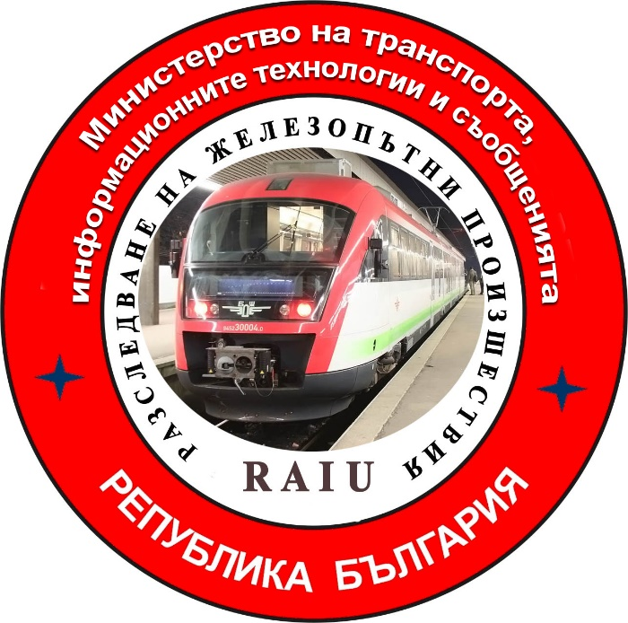

2018

FINAL REPORT

Purpose of the investigation and degree of responsibility

The Investigation of serious accidents, accidents and incidents is carried out by an independent investigation authority of the Republic of Bulgaria - "Specialized Unit for Investigation of Accidents and Incidents in Railway Transport" in the "Ministry of Transport, Information Technologies and Communications" (MTITC) and it aims:
To identify the circumstances and the reasons that led to their implementation with a view to improve safety and prevent from others without seeking personal responsibility and guilty.
The investigation is carried out in accordance with the requirements of Directive 2004/49 / EC of the European Parliament and of the Council upon safety of the Community's railways transpositioned in the Law for Railways ( LR ), Ordinance № 59 from December 5, 2006 about the management of safety in railway transport, Ordinance № H-32 from September 19, 2007 about the coordination of the actions and the exchange of information during investigations of railway accidents and incidents and the Agreement for interaction during investigations of accidents and incidents in the air, waterway and railway transport between the Prosecutor's Office of the Republic of Bulgaria, Ministry of Interior and MTITC from April 17, 2018.

CONTENTS
1. Summaru…………………………………………………………………………...…..………4
2. Direct facts and circumstances ………………………...…………………………..…..……..5
3. General data established during the investigation process ……………………..…...……11
4. Deaths, injuries and material damages …………………...……………………………......13
5. External circumstances - weather and geographic conditions ………………………..….13
6. Data for railway infrastructure and railway carrier staff related to the accident....13
7. Data from other investigations. Summary of testimony ……………………….…..……..16
8.System of Safety Management (SSM) of BDZ "Passenger Transport Ltd ........................16
9. Rules and norms …………………………………………………………….…..…………...17
10.Functional condition of rolling stock and technical facilities of the railway infrastructure…………………………………………………………………………………...17
11. Operational System Documentation - reviews, inspections, repairs, maintenance ……18
12. Health and Safety work conditions ………………………………………………….…….19
13. Accidents of similar nature previously registered …………………………………….....19
14. Analysis and conclusions……………………………………………………….…..………19
15. Recommendations issued in order to avoid accidents upon the same reasons …………25

1. Summary.
1.1. Brief description of the event.
On March 30, 2018, a fast train (FT) № 8613 composed by 4 coaches, 16 axles, 164 tons, serviced by electric locomotive № 43309.4, has departed Sofia station for Burgas station. The route of train movement is Sofia - Plovdiv - Dimitrovgrad - Stara Zagora - Burgas. At Plovdiv Station the locomotive and transport brigades are shifted according to the schedule. During the travel, the train has changed the direction of traffic at Dimitrovgrad station. Duty staff at the stations along the route hasn‘t noticed anything unusual. The same is confirmed by the locomotive and transport brigades, who have served the train from Sofia station until it arrives at Konyovo station.
The train leaves Nova Zagora station at 19:51h and arrives at Konyovo station at 19:59h (as evidenced by Konyvo Station II-76 log-book and the locomotive speed belt). According to "Plan II-24", the train is admitted on second reception and dispatch track and has to spend 5 minutes for a meeting, according to schedule for trains movement (STM), with the transiting fast train №8632 (Figure 1). After FT № 8613 stops at the station, the duty head of movement sees smoke coming out between 3rd and 4th coaches. Soon after, a fire occurs at the end of 3rd coach. For the situation at the station, the duty head of movement informed the train dispatcher, who in turn ordered the duty head of the movement at Kermen station to hold FT № 8632 at Kermen station.

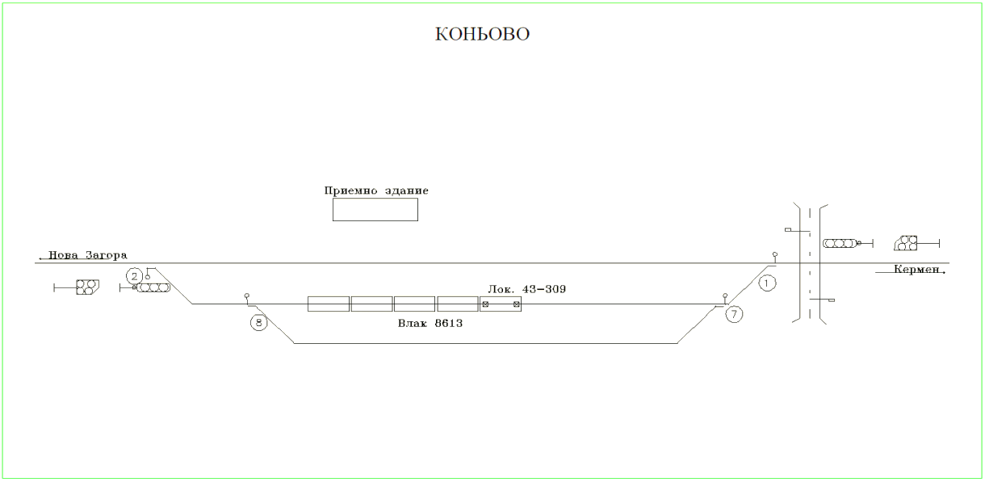
Reception building
Loc 43-309
Train 8613
Konyovo

Fig. 1. FT № 8613 scheme of reception.

1.2. Main cause of the accident:
The cause of fire in 3rd coach is a short circuit with an arc between the plus conductor feeding the Inverter that is in contact with its housing and at that moment is in contact with the minus supply wire. The plus and minus conductors for powering the 24 V inverter are mechanically abraded by the disconnection of the inverter from the mounting screws to the wall of the electrical panel and its slack on the cables, which has led to a thermal load over the insulation. The reduced dielectric strength and leakage, on one hand between the minus conductor and the inverter housing, and on the other hand between the plus conductor and the inverter housing, has developed to a short circuit causing the fire.
1.3. Summary of the main recommendations.
The recommendations issued by MTITC’s Commission for investigation are methodological and technical in order to prevent other accidents of a similar nature. They are classified as organizational, related to refreshing the knowledge of the train staff to work with the coach electric panel, building an Inverter maintenance system related to SSM’s Plan-Warning System for repair. Development and implementation of an Instruction for inverter maintenance and repair, installation of instructions for use of contacts in coach compartments and technically related to changing the place and way of inverter mounting, insertion of fuses guaranteeing reliable protection during operation of the inverter .
The recommendations are addressed to the national safety authority (Executive Agency "Railway Administration"), pointed to BDZ " Passenger Transport " Ltd railway carrier.
Recommendation № 1 proposes to train trainmasters and conductors to operate Inverters mounted in coaches.
Recommendation № 2 proposes to change the location and the way of installation of the Inverter in a horizontal surface for operation in operating conditions.
Recommendation № 3 proposes to remodel the inverter power scheme in automatic mode with separate automatic 80A fuses.
Recommendation № 4 proposes the power cables of the 24 V wiring to be protected in a corrugated casing.
Recommendation № 5 proposes to provide guidance close to 220 V contacts in coach compartments to illustrate their purpose.
Recommendation № 6 proposes to supplement the Inverter Maintenance System, which is linked to SSM’s Plan - Warning System for repair.
Recommendation № 7 offers to the personnel carrying out Inverter maintenance in coaches, to follow the relevant procedures provided by SSM.
Recommendation № 8 proposes to develop an Instruction for Operation and Maintenance of Inverters in coaches with built-in 220 V wiring.
2. Direct facts and circumstances.
2.1. Date and time of the event.
On March 30, 2018, at 19:51h the duty head of traffic at Konyovo Station receives a departure massage about FT № 8613 from duty head of traffic at Nova Zagora Station. He prepares the route for reception of FT № 8613 on second free reception and dispatch track by the station centralization (MH 68). When the train arrives in 19:59h at the station, the duty head of traffic sees smoke coming between third and fourth coaches. Shortly thereafter, a fire occurs in third coach and quickly graws and covers the entire coach. As a result of available airflows in southwest direction, the fire is rapidly transported and ignites the fourth coach. Seeing the evolving situation at the station, the duty head of traffic canceles the consent given to FT № 8632 and informs the duty head of traffic at Kermen station. He also calls 112 to send emergency medical and fire safety teams. He connects with the power dispatcher on duty and at 20:01 hours the voltage in the contact network of the whole station is switched off (Figure 2).

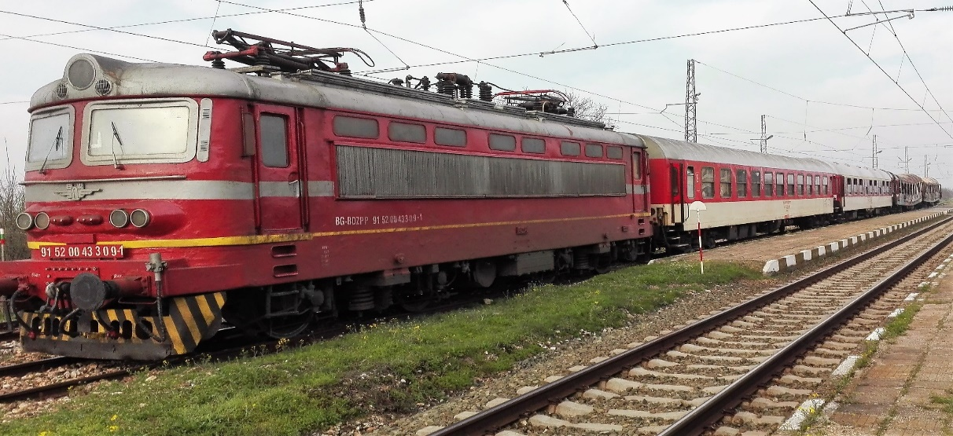
Fig. 2.
FT № 8613 conductor is in fourth coach before the train to enter Konyovo Station. Two passengers from 3rd coach inform her that they have felt a smell of a burning cable in third coach. She goes to the spot to check the submitted information and confirms it. When the train stops at the station, she informs the trainmaster who stays on the apron, close to first coach, about the situation (as evidenced by written explanations of the conductor).
The trainmaster, seeing the smoke, immediately notifies the locomotive brigade and calls 112. He also informs the officials concerned (as evidenced by his explanations).
The locomotive motorman immediately takes a fire extinguisher from the locomotive and goes to extinguish the fire in third coach. He also uses three other fire extinguishers from the station and two from the coaches brought by the trainmaster, the conductor and train passengers. After failing to extinguish the fire, he attempts to dismantle the first two coaches from the train composition and to move them to a safe distance but fails due to the switched-off voltage in the contact network (as evidenced by motorman explanations) (Figure 3) .

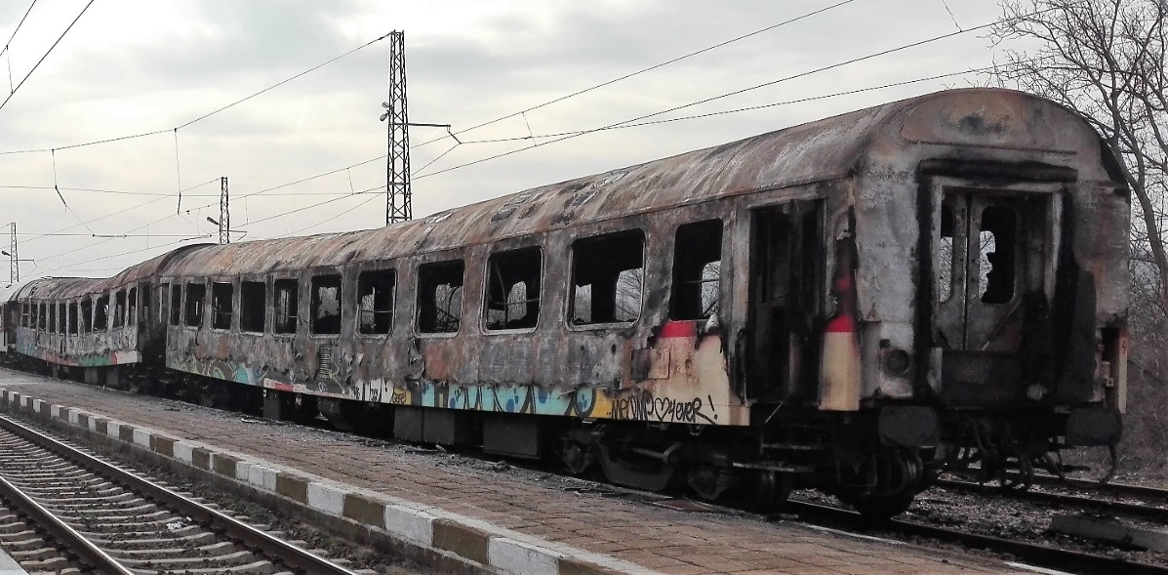
Fig. 3
2.2. Event’s location.
Konyovo Station has three reception and dispatch tracks and four arrows (Figure 4). In the area of the station between the entrance light and arrow № 1 there is a railway crossing with electrical barriers linked to the centralization. The station is located at km 151 ⁺ ⁰⁷⁹ between Nova Zagora and Kermen stations, on a single railway stretch, a part of eighth main railway Plovdiv - Stara Zagora - Burgas.

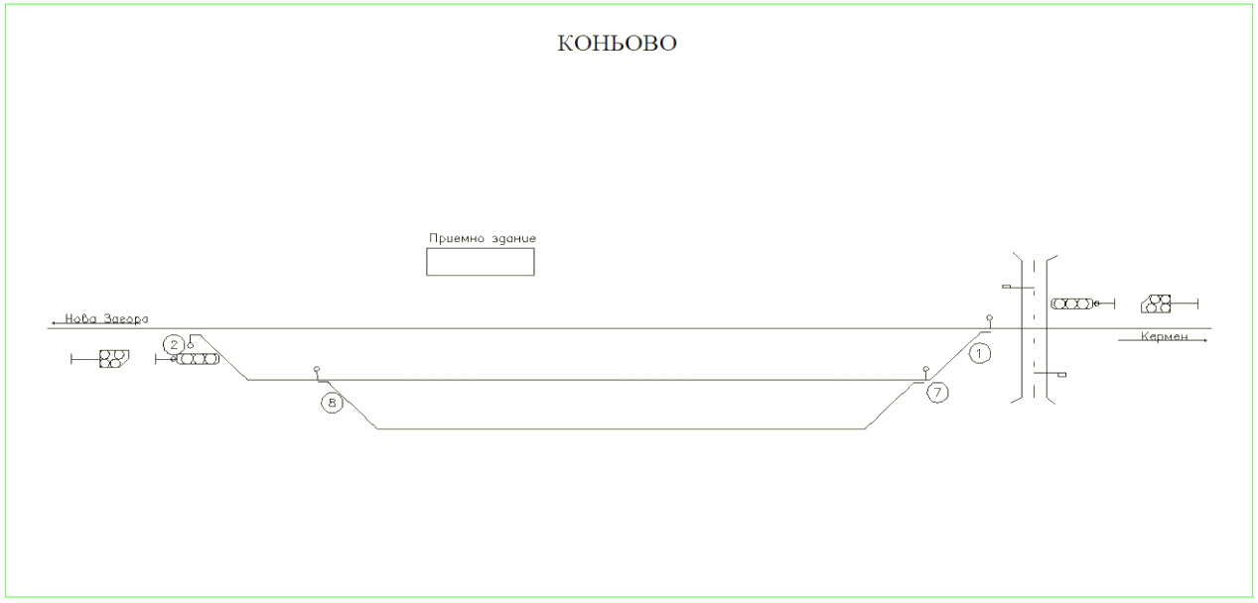
Reception building
Konyovo
Fig. 4. Konyovo station scheme

2.3. Event’s classification.
At 20:10h on March 30, 2018, the Head of "Specialized Railway Accident and Incident Investigation Unit" (SRAIIU) at the "Ministry of Transport, Information Technology and Communications" (MTITC) is informed by phone and SMS about a railway event - a fire occurred in third coach of FT № 8613 composition during its stop at Konyovo station.
The information is submitted in accordance with the requirements of "Safety Procedure FS 2.03." from September 01, 2011 of „Railway Infrastructure“ National Company (RINC).
The head of SRAIIU, clarifying in situ the situation by the collected information and the consequences of the event, classified the event as a railway accident, in relation to the requirements of Art.19 section 2 Directive 2004/49 / EC and Art. 68, para. 1, item 2 and para. 2 of Ordinance № 59, for which he informs the interested parties.
2.4. Consequences of the Event:
- there are no injured train passengers;
- because of a slight gassing during fire extinguishing the conductor and the motorman assistant, receive a medical help in situ by an emergency medical team;
- the bearing rope and second track contact wire are burnt and torn by the fire and fallen down the train composition and the railway;
- there are no damages to the track;
- no damages to the environment;
- two second-class coaches - 3rd and 4th from the composition of FT № 8613 are fully burnt.
2.5. Decision to initiate an investigation:
After the Head of SRAIIU arriving at Konyovo station and familiarization with the situation, together with the investigative authorities from Regional Office of Ministry of Interior - Nova Zagora, about 23:00 hours on March 30, 2018, they undertake a full inspection of FT № 8613. The decision for investigation is taken on the basis of the event classification, the in situ inspections and the above-mentioned norms in item 2.3.
Composition of the commission:
An investigative commission is appointed at the Ministry of Transport, Information Technology and Communications (MTITC). Chairman of the commission is the head of SRAIIU. The commission includes external experts with appropriate qualification and professional orientation to the event.
Investigation:
The head of SRAIIU in situ conducts interviews and requests written explanations from the staff serving FT № 8613 (locomotive and transport brigades) as well as from the personnel of Konyovo station (station master, duty head of traffic and pointsman) on March 30, 2018.
The Investigation Commission went on April 4, 2018 to Plovdiv Wagon Depot where, together with MoI investigating authorities and „Fire and Chemical Expertise“ Unit at the Main Directorate FS&PP (Fire Safety and Protection of Population) of Ministry of Interior, started working on establishing the circumstances and the reasons for fire occurrence in the coaches.
The Commission called and re-interviewed in Plovdiv WD the staff involved in the accident - the locomotive and transport brigades.
From April 17 till April 23, 2018 the Investigation Commission draws additional experts and carries out inspections at Nadezhda Technical Station to clarify the preceding circumstances and to establish the cause of fire. All coaches with Inverter HQ-INV1700 / 24/220 V installed in are inspected and a medium repair is carried out at „Interkom“AD - Dryanovo Wagon Factory. The parameters are shown in Table 1.
Table 1.
Height | 85 mm
Width | 210 mm
Type of entry | Supply from an accumulator
Exit peak power | 3000W
Fuses | yes
Operates by remote control | yes
Exit voltage | АС230 V
Efficiency: | 90 %
Safety functions | Accumulator Low voltage protection
 | Thermo protection
 | Short circuit protection exit
 | Overload protection
 | Extra high entry voltage protection
 | Accumulator revers polarity protection
Weight: | 5500 g
Exit signal: | Modified sine wave
Exit power: | 1700 W
Entry voltage: | 24 VDC
Exit voltage: | AC 230 V
Number of jacks: | 2
Type of jack: | F (CEE 7/4)
Length: | Length: 458 mm
During the medium repair an electrical installation for 220 V AC consumers is also installed in coach compartments. Control measurements of inverter 24 V DC voltage wiring are conducted from an external 1500 V power source. 220 V AC power consumers with 1000 and 2000 W are switched on. The inverters work normally at a power of 1000 W. At a load of 2000W, a current in the range of 80 ÷ 87 A is measured. It’s found that fuses in some of the coaches do not interrupt the circuit despite of exceeding the rated current of 80 A shown
in Table 2.
Table 2.
Coach № | I_{т}, A | t , ⁰ C | Coach№ | I_{т}, A | t , ⁰ C
 | 1000 W |  |  | 2000W
74-065-7 | 45 | 25,7 | 74-243-0 | 87 | 20.0
74-111-9 | 44 | 30 | 74-165-5 | 80 | 19,6
74-231-5 | 45 | 23,3 | 74-034-3 | Removed due to repair
74-087-1 | 45 | 22,3 | 74-213-3 | out of operation
74-060-8 | 42 | 21,3 | 74-167-1 | out of operation
74-010-3 | 42 | 24 | - | - | -

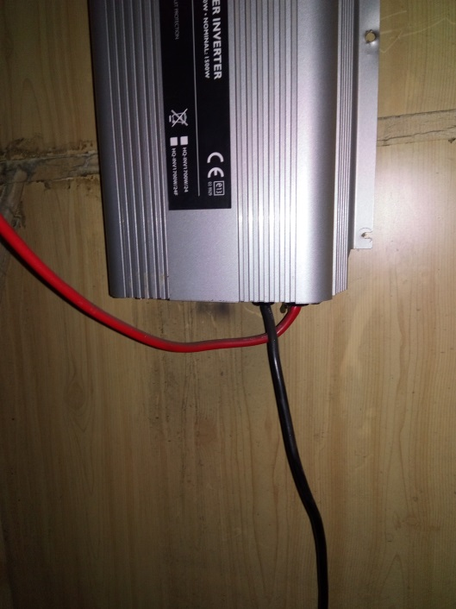
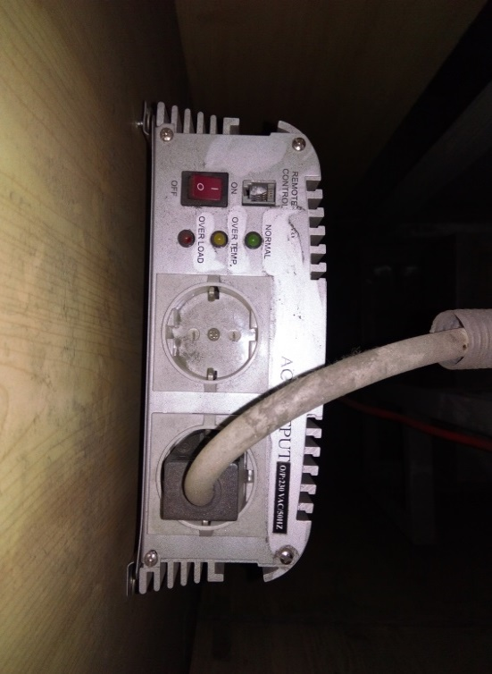
Fig. 5а
Fig. 5b

It’s found that in some of the coaches after four years of operation the self-tapping screws have begun to unscrew themselves. Others have unscrewed and are absent. According to the approved scheme of BDZ "Passenger transport" Ltd, the inverter is installed by "Intercom" AD - Dryanovo factory in vertical position to the wooden wall of the electric panel cabinet. The cabinet is made of pressed plywood with a thickness of 20 mm (Figures 5a and 5b).
The inverter is protected by fusible safety fuses TF-20, 500V,class gT – slow-acting 80A safety fuses to protect coach fluorescent lighting during continuous overload. It’s found that the power supply of the inverter is carried out by the electric board through fuses № 2 (3e1) for the positive conductor and № 5 (3e2) for the minus conductor (Figure 6a).

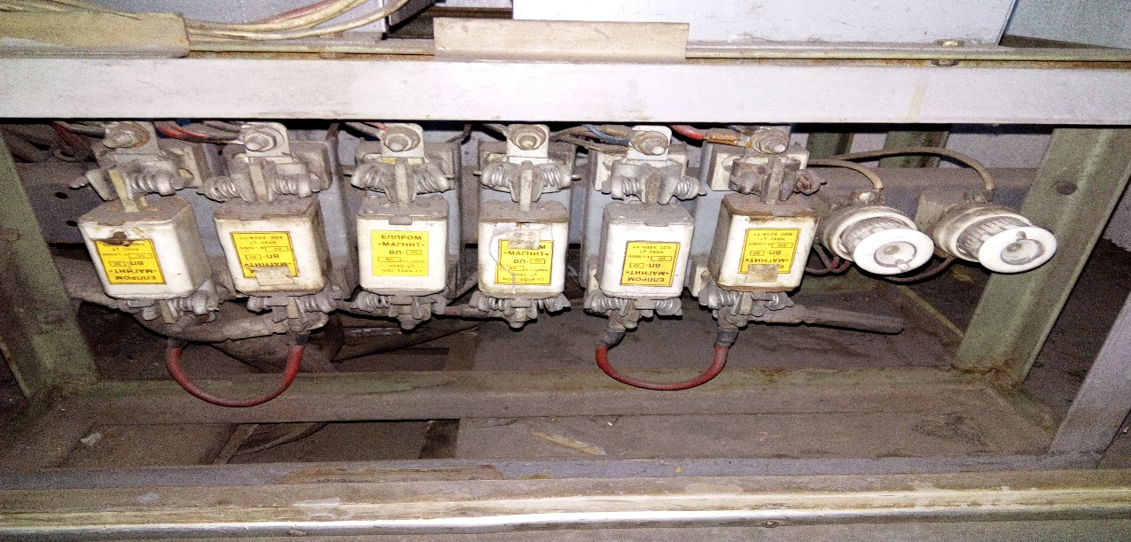
Fig. 6а.

Inverter is switched on and off by a “ЦК” – manual switch.

Fig.6б Inverter HQ-INV1700/24/220 V, and coach electric schemes of principle.
It can be assumed that the current at long current load is equal to the current in case of disturbed insulation. That's why the protection is not effective. Coach compartments’ contacts for supplying 220 V, when consumers are switched on, are protected from overloading only by the inverter electronic protection. It allows 30 minutes of overload at power up to 3000 W.
From an interview with the staff responsible for the maintenance of coach electrical equipment in Nadezhda, Plovdiv and Gorna Oryahovitsa Wagon Depots, everyone said that no inverters were reviewed unless failures are registered in their inventories.
From a random interview with conductors and trainmasters in the regions of Sofia and Plovdiv, it was found that the staff serving passenger trains are not trained to operate the inverter while the coach is in motion in order passengers to benefit the provided opportunity.
After the measurements carried out in Nadezhda WD, the investigation commission goes again to Plovdiv WD on May 05, 2018 where after analyzing and rejecting the established primary hypotheses, carries out additional experiments and identifies the circumstances in which the accident has occurred.
In order to identify exactly the main cause of fire in the coach, the investigative commission meets repeatedly in WDs and in MTITC building.
In the course of the investigation the report submitted by the Operational Group and the documents collected to it as well as the additionally requested materials and documents presented by RINC and BDZ "Passenger Transports" Ltd for implementation and observation of the Safety Management System (SMS) аre analyzed.
From the monitoring prosecutor at the Regional Prosecutor's Office - Sliven, the following certified copies of the expert reports аre provided:
1. Forensic-technical expertise of speed belt for the movement of FT № 8613 and the accuracy of the speedometer installation of electric locomotive № 43309.4;
2. Protocols from interrogations of witnesses (four passengers and the train conductor);
3. Forensic-chemical expertise, prepared by CRE department of CIPC Directorate at MD FS&PP of MoI;
4. Complex firefighting and electrical expertise, prepared by CRE department of CIPC Directorate at MD FS&PP of MoI;

The investigative commission’s chairman accepts the written standpoints of the external experts involved in the investigation commission in fulfillment of the tasks assigned to them during the investigation.
2.6. Conducting rescue and emergency-restoration actions:
For passengers’ safety, the Conductor evacuates all of them from the train in a timely manner at a safe distance.
As a result of the notification received on 112, an emergency medical team arrives at 20:15 hours at Konyovo station and helps in situ the motorman assistant and the conductor who have received light gassing while extinguishing fire in the coaches.
At 20:30 hours a specialized car of RG FS&PP - Nova Zagora arrives at Konyovo station. Steps are taken by the duty Head of traffic and the locomotive brigade to secure and ground the contact network to provide a front for burning coaches extinguishing.
At 21:30 hours the fire is localized and suppressed.
The train is moved from 2nd to 3rd track and parked there so as to recover the burnt contact network. Burnt coaches are equipped for their safe movement to Plovdiv distribution station - Plovdiv WD.
After the joint inspections and actions carried out by MoI investigative authorities and Head of SRAIIU, the train is relieved from supervision for maneuvers and movement.
3. General data established during the investigation process.
3.1. Participating officers and witnesses:
- Personnel of Konyovo station:
- Station master – RINC officer;
- Duty head of traffic – RINC officer;
- pointsman – RINC officer;
- Locomotive brigade – BDZ " Passenger transport " Ltd officers:
- Locomotive motorman of an electric locomotive № 43309.4;
- Locomotive motorman assistant of an electric locomotive № 43309.4;
- Transport brigade – BDZ " Passenger transport " Ltd officers:
- FT № 8613 Trainmaster;
- FT № 8613 Conductor;
- witnesses, 4 passengers from 3rd and 4th coaches.
3.2. Data on the Train :
- FT № 8613/8612 operates according to the schedule for trains’ movement (STM) along the route Sofia – Plovdiv – Dimitrovgrad – Stara Zagora – Karnobat – Burgas and back;
- according to the approved Train Composing Plan(TCP) for 2018 of BDZ " Passenger transport " Ltd, FT № 8613/8612 is composed by one electric locomotive,one first class coach, and three second class coaches. The plan is observed.
3.3. Data on the carrier :
- BDZ " Passenger transport " Ltd is the only licenced railway carrier for passenger transport in the Republic of Bulgaria;
- It possesses national licence for passenger transport № 151/October 21,2013;
- It possesses Safety certificate part ,,А“ BG 11 2017 0009 valid from December 31,2017 tilll December 30, 2022;
- It possesses Safety certificate part ,,В“ BG 12 2017 0009 valid from December 31,2017 tilll December 30, 2022;
- It possesses certificate of an authority, responsible for the maintenance of railway vehicles BGRA/2017/0004 valid from December 31, 2017 till December 30, 2022;
3.4. Train type, number and category:
- passenger train, № 8613, fast - regular ;
3.5. Train tractive rolling stock type and number :
- Electric locomotive № 43309.4 – regular registration in Vehicles’ register;
3.6. Train non-tractive rolling stock (coaches) type and number:
- coaches № 50522150104-0 В4, № 51521940157-4 А4, № 50522974068-1 В4, № 50522974211-7 В4 – regular registrations in Vehicles’ register;
3.7. Railway infrastructure description:
Railway and points:
- Konyovo Station has 3 tracks – 1st main track, 2nd and 3rd reception-dispatching and diverting tracks and 4 points with radius R = 300 m;
- railway on 2nd track - rail type S 49, laid on wooden sleepers with joint type "68I" with supported joins in straight 0,33 ^{о}/_{оо} profile downhill to Kermen station;
- contact network at Konyovo station - semi-compensated, not divided in sections;
3.8. Signalization, station safety installations and between-station block system
- Konyovo station is equipped with Route-relay centralization (RRC Н68) ,,Тhаles“ type.
- traffic signaling equipped with indications for common signaling;
- between-station sections Nova Zagora – Konyovo – Kermen are equipped with an automatic blockage and axis counters without duct capacitor signals;
3.9. Construction work on railway infrastructure:
- by telegram № 37 / August 02, 2017 and continued action for interruption of the traffic by telegram № 444 / November 21, 2017 of RINC until enactment of the new timetable for movement of trains from December 10, 2017 the movement of all categories of trains is suspended due to construction and repair works concerning railway, contact network and adjoining facilities in Belozem - Orizovo section. This is why the train timetable is changed. The route of all categories of fast, passenger and freight trains changes in the following direction: Sofia - Plovdiv - Dimitrovgrad - Mihaylovo - Stara Zagora - Karnobat - Burgas and back, as shown in Fig.7
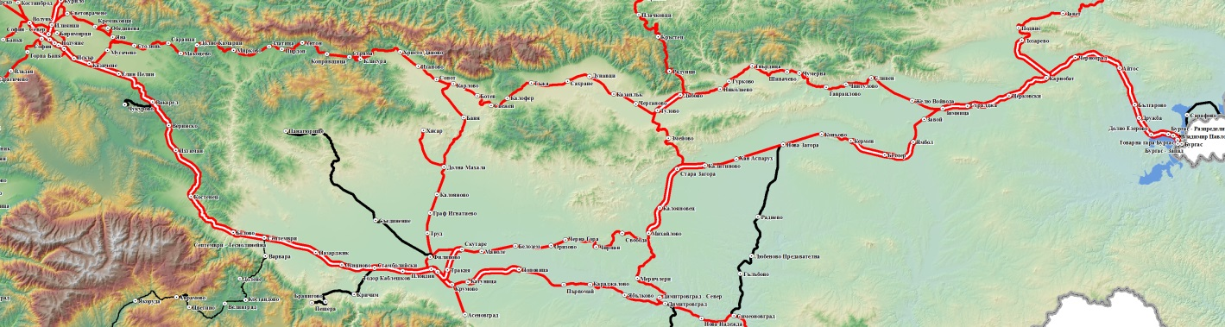

Sofia
Plovdiv
Dimitrovgrad

Konyovo
Burgas

Fig. 7
3.10. Train protection:
- № 43309.4 electric locomotive is equipped with a regular alertness device and a regular Automatic Locomotive Signalization (ALS).
- ALS is switched off and dismantled in railway section Stara Zagora – Burgas because of RINC main director’s telegram № 480/2015;
3.11. Communication system:
- Konyovo station is equipped with a universal telephone connection commutator UCС-8. Due to UCC-8 duty head of traffic performs a telephone connection with the two points posts, between-station connection with the two adjacent stations, connections with train and power dispatchers, a stationary mobile phone is also provided at the station;
- the locomotive and transport brigades have mobile phones;

3.12. Implementation of a plan for railway accidents and events.
- in implementation of the approved on February 25, 2015 ,,Plan for rescue and urgent emergency-repair works in the event of crisis situations, natural disasters, railway accidents, industrial accidents, catastrophes and terrorist acts in BDZ "Passenger Transport" Ltd“, the personnel (locomotive and transport brigades serving FT № 8613) immediately undertake the execution of their official duties concerning the occurrence of fire in rolling stock (RS) - passenger coaches (as can be seen from the explanations of staff and eyewitnesses);
- the personnel who served FT № 8613 in accordance with the approved on October 01, 2013,, Instruction on the rules and requirements for fire safety in rolling stocks in use, buildings, areas and objects of BDZ "Passenger Transport" Ltd and fire occurrence procedures“, act correctly according to Instruction’s requirements (as evidenced by the explanations of staff and eyewitnesses).
- in compliance with the approved on August 14, 2015 "Disaster Protection Plan at RINC", the station staff at Konyovo Station, after FT № 8613 stops at the station and seeing the broken out situation, immediately takes actions to shut off the voltage in the contact network, to provide the available fire extinguishers close to coaches and to alert the services and officials concerned.
4. Deaths, injuries and material damages.
4.1. No deaths;
4.2. No injured passengers;
4.3. No injured personnel;
4.4. Material damages:
For BDZ "Passenger Transport" Ltd:
- electric locomotive № 43309.4 – no damages;
- coach № 50522974068-1 – a fully burnt wagon basket with all the equipment, electric cabinet with electric panel, deformed wagon frame, costs 275 681 BGN.
- coach № 50522974211-7 – a fully burnt wagon basket with all the equipment, electric cabinet with electric panel, deformed wagon frame, costs 369 412 BGN.
- BDZ PT Ltd expenses for passengers’ transfer – 42 430,91 BGN;
- BDZ PT Ltd expenses for FT № 8613 personnel transport – 6 835,96 BGN;
For "RINC":
- expenses for railway – none;
- expenses for contact network concerning a burnt part of the contact wire and bearing rope of 2nd track at the station - 8 017,16 BGN;
- expenses for interruption of trains movement – 2 508,98 BGN;
For the environment – none;
Total damage from the accident amount to: 702 377,03 BGN.

5. External circumstances - weather and geographic conditions.
Meteorological report prepared on April 10, 2018 by the Bulgarian Academy of Sciences - Plovdiv:
- in the dark part of the day – 20:00 hours;
- air temperature +13,8º С;
- wind – 3 m/s from southwest ;
- clouds - clear.
6. Data for railway infrastructure and railway carrier staff related to the accident.
6.1. Position, place of work, sex and age.
Personnel of RINC:
- head of traffic – Konyovo station – RTMSA( Rail Traffic Management and Station Activities ) -Plovdiv, RINC, man at 48 years;
- pointsman– Konyovo station – RTMSA-Plovdiv, RINC, woman at 54 years;
Personnel of BDZ PT Ltd:
- motorman – Locomotive depot Plovdiv, BDZ PT Ltd, man at 45 years;
- motorman assistant – Locomotive depot Plovdiv, BDZ PT Ltd, man at 47 years;
- trainmaster, passenger traffic – Passenger Transport Division(PTD) Plovdiv, BDZ PT Ltd, man at 49 years;
- conductor – PTD Plovdiv , BDZ PT Ltd, woman at 48 years.
6.2. Position certificate and certificate data.
Personnel of RINC:
- Certificate № 1271/October10, 2007 for occupying position Head of traffic , RTMSA-Plovdiv;
Possessed qualification:
Head of traffic Certificate № 15878/February 08, 2001
- Certificate № 4132/July 01, 2015 for occupying position pointsman/
rail crossing guard RTMSA-Plovdiv;
Possessed qualification: Document:
pointsman Pr. № 1а/November 28,1986
rail crossing guard Cert. № 3777/June 14,1993
Personnel of BDZ PT Ltd:
- Certificate № V-68/ July01, 2014 for occupying position motorman at PTD Plovdiv /Locomotive depot Plovdiv:
Possessed qualification: Document:
motorman s. 43,44 and 45 Cert. № 9070/2008
motorman s. 46.200 Cert. № 5585-1446/2008
Operation with ALS,, ALTRACS BDZ“ Pr. № 14-76-1/2014 г.
Operation with TDRC Pr. №14-536-495/2014 г.
ЕМT motorman s. 30 and 31 Cert. № 185-185/2016 г.
- Certificate № V-36/February 04, 2013 for occupying position motorman at PTD Plovdiv /Locomotive depot Plovdiv:
Possessed qualification: Document:
Motorman of electric locomotive D. № 000757/1992
Mot. Assist. of el. and diesel locomotive D. № 055319/1989
Motorman of electric locomotive s. 61.00 Cert. № 145/1994
Operation with ALS,, ALTRACS BDZ“ Pr. № 107-74-15/2004 г.
Operation with TDRC Pr. №14-534-495/2014 г.
ЕМT motorman s. 30 and 31 Cert. № 1039-1038/2012 г.
- Certificate № IV-14/January 24, 2013 for occupying position Trainmaster PD at PC-Burgas:
Possessed qualification: Document:
Trainmaster Cert. № 14835/December10,1999
Conductor Cert. № 1630/June20,1994
License to perform trial А Cert. № 14835/December10,1999
- Certificate № IV-140/June 24, 2013 for occupying position Conductor at PC-Burgas:
Possessed qualification: Document:
Conductor Cert. № 4525/July 25,2006
6.3. Qualification certificate and certificate data.
Personnel of RINC:
- Qualification certificate № 157878/February08, 2001, acquired qualification for: Head of traffic, teaching instruction CPC-RINC, conducted study from April 10,2000 till February 08, 2001 Protocol № I-17А-35/ February 08, 2001;
- Qualification certificate № 1А/November 28,1986, acquired qualification for: Pointsman, teaching instruction RM-Plovdiv, conducted study in 1986;
- Qualification certificate № 3777/June 14, 1993, acquired qualification for: rail crossing guard, teaching instruction RVP-Sofia, conducted study in 1993;
Personnel of BDZ PT Ltd:
- Qualification certificate № 9072, acquired qualification for: Electric locomotive Motorman, teaching instruction CPO-BDZ, conducted study from March 31 till June 15, 2008, Protocol № 3053-471-454/July 28, 2008
- Certificate for locomotive driving № BG 71 2017 0829 – EA RA
- Qualification certificate № 000757/1992 acquired qualification: Electric locomotive Motorman, teaching instruction at HMTS ,,Todor Kableshkov“, Protocol № 24695 /August 08,1992
- Certificate for locomotive driving № BG 71 2017 0804 – EA RA
- Qualification certificate № 14835/December 10, 1999, acquired qualification for: Trainmaster, teaching instruction CPCC-NC BDZ, conducted study from September 01 till December 09,1999 , Protocol № I-17б-686 /December 10,1999
- Qualification certificate № 4525/July 25, 2006, acquired qualification for: Conductor, teaching instruction CPO-BDZ, conducted study from May15 till July17, 2006, Protocol № 1532-393-382 /July 25, 2006
6.4. Document for professional qualification and document data.
Personnel of RINC:
- Head of traffic – a diploma for completed secondary education № 1338/July 04,1988 at TOH – Sliven;
- Pointsman/ rail crossing guard – a diploma for completed secondary education № 1149/February10,1985 SPTU – Yambol;
Personnel of BDZ PT Ltd:
- Motorman – a diploma for completed secondary education Series А 91 № 009288 / August 30,1991
- Motorman assistant – a semi-higher education diploma
Series ТК 67 000757 / August15,1992, HMTS ,,Todor Kableshkov“ – Sofia
6.5. Certificate for passing an examination as per Ordinance № 56 from 2003
Personnel of RINC:
- Konyovo station Head of traffic–June 21,2018 ;
- Konyovo station pointsman/ rail crossing guard – June 22, 2018 ;
Personnel of BDZ PT Ltd:
- motorman –April 26, 2018 г;
- motorman assistant – April10,2014 ;
- trainmaster, passenger traffic –July 05, 2018;
- conductor – July 03, 2018 ;
6.6. Personnel break duration before staff time:
In accordance with the requirements of the normative acts - Labour Code and Ordinance № 50 / December 28, 2001 – the personnel are provided with the required rest period before their work:
Personnel of RINC:
- Konyovo station Head of traffic – rests from 19:00 hours on March 29,2018 till 19: 00 hours on March 30,2018
- Konyovo station pointsman/ rail crossing guard – rests from 19:00 hours on March 29,2018 till 19: 00 hours on March 30,2018
Personnel of BDZ PT Ltd:
- motorman - rests from 13:00 hours on March 29, 2018 till 16:40 hours on March 30, 2018 ;
- motorman assistant – rests from 08:00 hours on March 28,2018 till 16:40 hours on March 30,2018 ;
- trainmaster PT– rests from 11:10 hours on March 29,2018 till 06:10 hours on March 30,2018 for FT № 8610;
- conductor – rests from 16:15 hours on March 27,2018 till 06:10 hours on March 30,2018 for FT № 8610.
6.7. Work experience of the staff.
Personnel of RINC:
- Konyovo station Head of traffic– 25 years;
- Konyovo station pointsman/ rail crossing guard – 33 years;
Personnel of BDZ PT Ltd:
- motorman – 14 years;
- motorman assistant – 11 years;
- trainmaster PT – 8 years;
- conductor – 12 years;
6.8. Shift (travel) briefing.
Personnel of RINC:
- Personnel at Konyovo Station is briefed for duty on 30 / March 31, 2018 and they sign in the instruction book stating that they were cheerful, rested and haven’t used an alcohol and other narcotics.
Personnel of BDZ PT Ltd:
- the locomotive brigade is briefed before travel by the duty depot master at Plovdiv
locomotive depot and they sign in the instruction book stating that they were cheerful, rested and haven’t used an alcohol and other narcotics.
- the transport brigade has been briefed by the duty train crew instructor, trainmaster at Transport post in Plovdiv and they sign in the instruction book stating that they were cheerful, rested and haven’t used an alcohol and other narcotics.
7. Data from other investigations. Summary of testimony
The investigation commission has copies of testimonies provided by the monitoring prosecutor at Sliven PO. There are interrogations of three passengers who felt the smell of a burned-out cable that had boarded together at Dimitrovgrad station and travelled in 3rd coach in a middle compartment for Burgas station. The explanations of the three eyewitnesses are confined to the same established findings:
"After the train left Nova Zagora, we felt a smell of a burned cable that came from the coach corridor. After opening the toilet door, we saw smoke coming from inside and we started to announce the train conductor. We met her at the end of 4th coach corridor. "
Interview with a witness travelled in 2nd compartment of 3rd coach, carried out by the Commission:
"Once I smelled smoke, I stepped out of the compartment and walked down the corridor, where the smell was growing. Reaching the end of the 3rd coach I could not tell where the smell was coming from."
Comment between train passengers on the apron at Konyovo Station:
"The fire has most likely caused by the coach's burning electric panel."
8. System of Safety Management (SSM) .
8.1. Observing the procedures set out in SSM of RINC:
The Investigation Commission requested and took note of the provided procedures written in SSM of RINC and found that they had been met by the staff of the Railway Traffic Management and Station Activities (RTMSA) - Plovdiv. This is evident by the report of the operational group, further requested materials and station personnel statements.
8.2. Compliance with the procedures in Safety Management System (SSM) of BDZ "Passenger Transport" Ltd;
The Investigation Commission requested the procedures written in SSM of the railway carrier BDZ "Passenger Transport" Ltd, introduced by Order № 421 /June 28, 2017 and after having become acquainted with them, established the following:
- No documentation is provided for carrying out tests, analysis and risk assessment when commissioning the electrical system for supplying contacts with 220 V by an additionally installed Inverter according to the requirements of Art. 21, Item 3, Art. 30, Art. 31, item 3 of SSM;
- No documentation is provided refer to safety, maintenance and verification of compliance with TSI during reconstruction and modernization of the concerned coach series by a notified authority pursuant to Art. 38, item 2 and Art. 40 of SSM;
- No material is provided regarding the conclusion of the contract in the course of reconstruction and modernization of rail rolling stock for the activities related to safety, cited in Art. 39 of SSM;
- Based on the analysis of SSM, the Investigation Commission finds that there is no structured set of maintenance documents, including activities, procedures and tools, in accordance with the requirements of item 3 of Rolling Stock Maintenance Management;
- During the inspection of the technical documentation, it has been established that no maintenance and repair instructions for the installed 220 V installation have been developed at Company’s plan-warning system for coach maintenance.
9. Rules and norms.
9.1. The staff at the railway station Konyovo from RINC, before and during the accident, acts in compliance with the approved regulations and internal rules regulating the safety of the transport on the railway infrastructure - "Plan for disaster protection of RINC" and" Firefighting file regulating fire safety at a RINC site - RTMSA ​​- station Konyvo ":
- Konyvo station head of traffic organizes, in coordination with power dispatcher- Plovdiv, voltage shut-off at the station and sets up an organization for trains movement and the emergency means of restoration;
- the staff at the station co-operates with provision of the extinguishers available for extinguishing the burning coaches until the arrival of the specialized vehicles of FS&PP
9.2. The locomotive brigade serving the train, before and during the accident, acts in accordance with the established regulations regulating rail transports’ safety, fire prevention instruction and Crisis response plan. After the train stops at Konyovo Station and receiving the fire alert, they immediately take the following measures:
- provide the train against self-propulsion;
- remove the pantograph from the grid;
- take available fire extinguishers from the locomotive and initiate extinguishing fire occurring in 3rd coach;
- take actions to disconnect the non-burning from the burning coaches, which fails because of voltage lack the contact network.
9.3 After the train stops at the station, the conductor is first to discover fire in the coach. She immediately notifies the Trainmaster and immediately evacuates all passengers from the train at a safe place. Then begins to help with firefighting. The trainmaster brings fire extinguishers from the non-burning coaches and those provided from the station.
10. Functional condition of rolling stock and technical facilities of the railway infrastructure.
10.1. Functional condition of the railway infrastructure:
Railway and points:
- troublefree;
Safety equipment, communications, radio and power supply:
- troublefree;
Contact network:
- burnt contact wire and bearing rope of 2nd track at Konyovo station;
There are no devices for automatic recording of data from the rolling stock traffic in the railway section.
10.2. Functional condition of rolling stock.
- locomotive functional condition – fitted to operate;
- burnt coaches functional condition – unusable, adapted for movement to Plovdiv-Technical station;
- unaffected coaches functional condition – fitted to operate;
- an automatic data logger of electric locomotive № 43309.4 equipped with a speedometer-device for recording the driving speed in the range of 0 to 150 km / h. In 1st cabin of the locomotive is installed a wall-mounted tape tachograph type RT9 (registering) and in 2nd cabin - tachometer A16 (non-registering) type "Hasler". The speedometer installation registers graphically, using nibs on a paraffined paper band with perforations at the top and bottom along the strip, the following parameters:
- astronomical time - in a 24-hour digital scale;
- movement and stop time in minutes;
- speed - in km / h;
- Distance;
- air pressure in the main air tube of the pneumatic automatic brake at the value of which is judged to be triggered.
Decodification of speedometer strip of electric locomotive № 43309.4, performed by the staff of Plovdiv Locomotive depot for the movement of the railway station № 8613 in Plovdiv - Konyovo section:
- On March 30, 2018, FT № 8613 leaves Plovdiv station at 17:05h, arrives at Stara Zagora station at 19:23h and departs at 19:30. In Stara Zagora - Khan Asparuh section it moves at 128 km / h and in Khan Asparuh - Nova Zagora the train moves at a speed of 120 km / h. It leaves Nova Zagora station at 19:51h and accelerates to 128 km / h. Approximately 1000 meters before Konyvo Station, the speed begins to drop to 100 km / h and 400 meters before the station the train moves at 28 km / h. At 19:59h, the train stops at Konyovo Station. The train main airtube pressure drops to 0 bars after stopping. No other train movement is registered. The speedometer strip is downloaded at 01:19h. "
- an automatic locomotive signalization (ALS) (receiver) is installed on electric locomotive № 43309.4, which automatically records data from the rail infrastructure balizes.
According to RINC data, the railway infrastructure ALS equipment is switched off and in process of dismantling, there are no registered recordings in the locomotive device.
11. Operational System Documentation - reviews, inspections, repairs, maintenance.
11.1. Measures taken by the staff to regulate trains movement.
The Operational Control Unit (OCU) and the RTMSA ​​- Plovdiv together with BDZ PT Ltd., coordinated by Central Dispatch Management (CDM) of RINC, take timely operational actions regarding changes in the train timetable in Nova Zagora - Zimnitsa section. Various schedules are developed to change the routes for passenger and freight trains movement. Passenger trains in section Nova Zagora - Zimnitsa are cancelled and passengers are transported by buses.
11.2. Exchange of Oral Orders and Written Messages.
With the order of a train dispatcher in OCU - Plovdiv from 20:00 hours the movement of all trains and vehicles is stopped in Nova Zagora - Konyvo – Kermen section, except for the movement of emergency - restoration devices for the contact network from Nova Zagora and Yambol stations.
After partial completion of repair and restoration activities of the contact network by an order of a train dispatcher at OCU- Plovdiv, from 00:01h on March 31, 2018, it is allowed trains movement upon 1st track at Konyovo station and Nova Zagora - Konyvo - Kermen section with diesel thrust.
By an order of the train dispatcher at 04:23h on March 31, 2018, 1st track at Konyvo station is restored at a timetable speed, voltage is supplied to the contact network and on 2nd and 3rd tracks train movement is permitted with diesel thrust.
11.3. Measures taken to protect and guard the scene of accident.
From 20:30h on March 30, 2018 till 04:10h on March 31, 2018 the district of Konyovo station is detached and guarded by MoI authorities with restricted access of external persons, except for the emergency medical teams, FS&PP firefighting authorities, the investigation authorities from MoI - Nova Zagora and SRAIIU in MTITC.
12. Health and Safety work conditions.
- With reference to the requirements of Art. 13 para. 1 and Art. 14, para. 1 of Ordinance №50 / December 28, 2001 no violations are observed in the reporting of personnel working hours at RINC and BDZ, "Passenger Transport" Ltd.
- With reference to the requirements of Art. 28, para. 1 of Ordinance № 54 / June 02, 2003 for medical examinations of the personnel related to the accident, at RINC and BDZ "Passenger Transport" Ltd., no violations are found.
- With reference to the requirements of Art. 20, para. 2 of Ordinance № 54 / June 02, 2003 the officials of RINC and BDZ "PT" Ltd., related to the accident, have valid certificates for psychological examination.

13. Accidents of similar nature previously registered.
- On February 28, 2008, in Kunino - Cherven Briag section, during movement fast train № 2637, moving in the direction of Sofia - Kardam, a fire occurs in 2nd wagon-couch and subsequently the fire is transferred to 3rd wagon-couch. As a consequence of the fire, nine passengers are dead, fourteen other passengers are seriously injured. Both wagons are completely burnt out. The rolling stock and the train staff come from BDZ ,, PT "Ltd.
- In ​​Stara Zagora - Karnobat - Burgas section accidents of such a type have taken place, fire in traction rolling stock (electric locomotives) of the railway carrier BDZ „PT “Ltd.
14. Analysis and conclusions.
14.1. Description of the chain of events based on established facts.
The Commission for Investigation in MTITC collects the necessary documentation and materials. It analyzes the possible circumstances, facts and evidence that could lead to an identification of the cause of the railway accident. Detailed inspections of rolling stock, as well as in-depth analysis of materials and documents provided by the operational group, opinions of experts involved in the investigation commission, staff interviews, eyewitnesses (train passengers). The Investigation Commission conducts an interview with the management of ,,Intercom“AD – Dryanovo factory, which provides the requested documents and materials about medium repairs and installation of Inverters in the passenger wagons.
14.2. Analysis of the facts and conclusions on the causes of the accident.
Analysis of № 43309.4 electric locomotive recorder recording made in Plovdiv - Konyovo railway section during the service of FT № 8613.
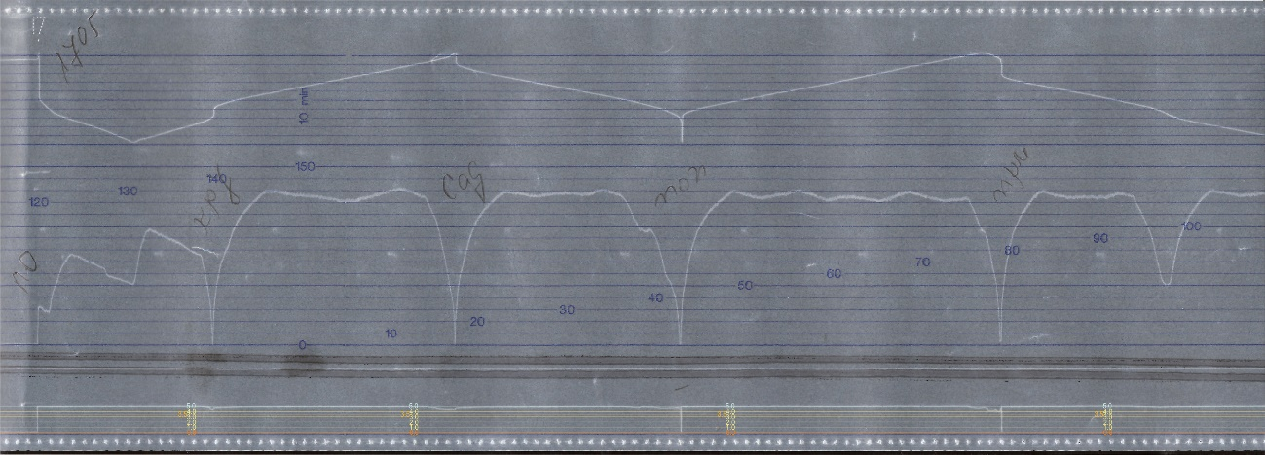
From № 43309.4 electric locomotive speed belt record it is found that in Plovdiv - Konyovo section the train moves normally, keeping the running speeds according to Schedule-Book (Figure 8).
Fig. 8
FT№ 8613 motorman drives the train, observing Schedule-Book limitations of the speed and all decreases along the track. Stopping the train in most cases is done by officially scheduled applying of brake. An exception is made at the stations Popovitsa, Parvomay and Stara Zagora, where urgent applying of brake is used. For Popovitsa and Parvomay stations there is no reason to do so because the train moves in time, but it can be attributed to motorman's discretion for particular situations.
There is nothing worth mentioning till Stara Zagora station. The train movement is normal, motorman's behavior is entirely according to the rules of train conducting.

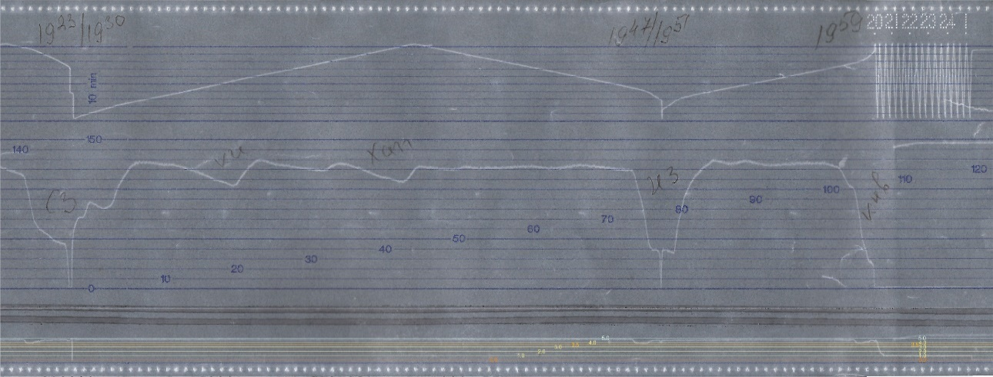
The stop at Stara Zagora station (Fig. 9) is interesting in view of the fact that it is divided into two parts: the initial stop lasts four minutes, after which the train departs, its speed is too low and therefore there is no registration in the traffic speed zone, but it is recorded on the time chart indicating that the train is in motion for several seconds. This is also confirmed by the pressure chart in main air tube, where urgent retention is noted. In all likelihood, it is either a late passenger who has appeared on the platform after the train has already started or a shipper who has jumped from the moving train and a stop signal received in time by motorman is given. At all events, this action is taken to prevent an accident. After a further three and a half minutes, the train departs from Stara Zagora Station and continues its movement along the route.
Фиг. 9
Train № 8613 transits through Kalitinovo and Khan Asparuh stations, with maximal speed in Stara Zagora - Kalitinovo and Kalitinovo - Khan Asparuh sections of 130 km / h and in the Khan Asparuh - Nova Zagora section of 125 km / h.
1500 meters before Nova Zagora station, the motorman applies the automatic train brake by letting out from main air tube 1.0 bar. The speed of 120 km / h at this point begins to decrease to 40 km / h, 500 m before it stops at the station, which testifies that the train is accepted on a diversion track. The train stops at the station at 19:47h. After a 4.5-minute stop, train № 8613 leaves Nova Zagora Station at 19:51h and for 700 m till 19:52h it moves at a speed of 40 km / h, then the speed begins to increase and reaches maximal value of 130 km / h.
2600 m before Konyvo station, at 19:57h, speed of 125 km / h begins gradually decrease of speed without using automatic train brake, i.e. the train moves in inertia along 1300 m, reaching 100 km / h. At this point, the locomotive driver applies the automatic train brake by letting out from the main air tube 1.0 bar. In this mode the train moves along 750 m and when the speed reaches 30 km / h, the motorman makes a partial loosening, increasing the pressure in main air tube (MAT) to 4.6 bar, whereby the rate of deceleration slows down. The train passes 300 meters and the motorman again performs a partial retention, reducing the pressure to 4.15 bar, decreasing train speed to zero within last 100 meters before the stop at Konyovo station. After the train is settled down, the motorman undertakes the brake loosening, but yet before the pressure has reached its nominal value (5.0 bar), his reduction is observed, initially faster and then slowly decreasing for 25 minutes reaching zero around 20:25 hours. The locomotive band is downloaded at 1:19.
14.3. Conclusions - direct and main causes of the accident additional factors related to the technical condition of the rolling stock.
As a result of the researches, measurements, analyzes of the technical documentation and coach condition, the Investigation Commission comes to the conclusion that the direct cause of fire in the coach is a short circuit, accompanied by a voltage arc, due to mechanical damage of Inverter 24V supply wires insulation where the Inverter supplies the contacts in coach compartments with 220 V.
The main reason for accident occurrence is the incorrect inverter installation in the coach:
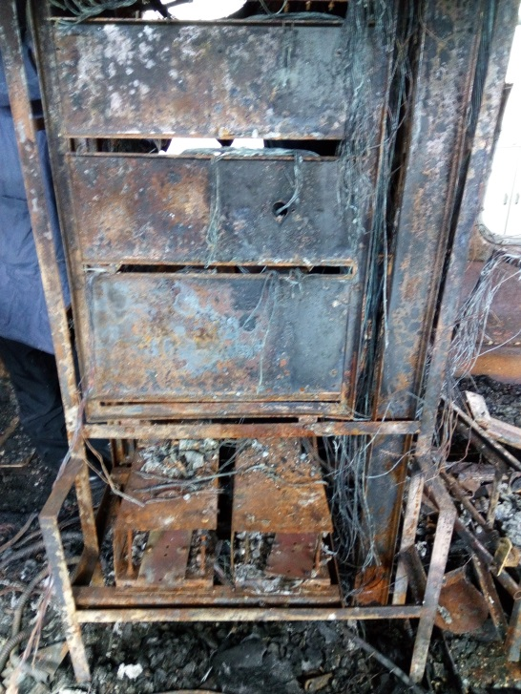
- Mounting it in vertical rather than horizontal position recommended in the product's technical passport;
Fig. 10
- Attaching it with four instead of six self-tapping screws;
- Attaching it to a wooden wall of the electrical panel with self-tapping screws that fall during the operation rather than to the metal structure of the panel;
- The supply wires of the 24V inverter are not placed in a protected corrugated hose which to keep them from mechanical damage;
- The electrical protection of the inverter's voltage supply is carried out by coach lights fuses;
- Fuses type is the slow-acting one with a large nominal, which doesn’t operate when the inverter is overloaded;
- From the installation date in 2015 until the day of Inverter’s failure in 2018, no prophylactic has been documented.
Clarifying the cause of coaches’ ignition has proved to be an extremely difficult task because of the high degree of coaches’ burning and, in this sense, the few traces that could lead to correct deductions and conclusions.
The Commission examines in detail both burnt coaches and others from the same series so that a quality and thorough analysis of all events to be made and, in that way, the direct cause of fire to be discovered. In the course of investigation, it is found that the ignition occurs in the area of ​​the electrical cabinet of 3rd coach № 50522974068-1 and the toilet.
Several versions of the ignition are considered, including damage to coach lights and heating electrical installation, intentional arson, and others. Initially, attention is focused on coach lighting installations (24V DC) and heating (1500V AC), but these hypotheses are subsequently rejected as they fail to pass the additional tests and analyzes that are made with them. The version of intentional arson in the coach and toilet also drops off. The investigating authorities from MoI and FS&PP, seize from different spots in the coach burnt remnants for exploration and preparation of an expertise in the Center for Research and Expertise (CRE) at MD FS&PP which conclusions are:
Judicial and Chemical Expertise (Reg. № 1983r-7190 / May22, 2018): "Conclusion of the Gas Chromatographic analyses and answers to the questions asked, of both samples of objects 1 and object 2 obtained for research ... no trace or presence of flammable and combustible liquids, petroleum products and their analogues "in the toilet.
Physicochemical Expertise (Reg. № 1983r-6314 / May 03,2018): "Conclusion of the gas chromatographic analyses and answers to the questions asked from the three samples of object №1, object № 3 and object № 4 ... no traces were found or presence of highly flammable and combustible liquids, petroleum products and their analogues "in the coach and the toilet.
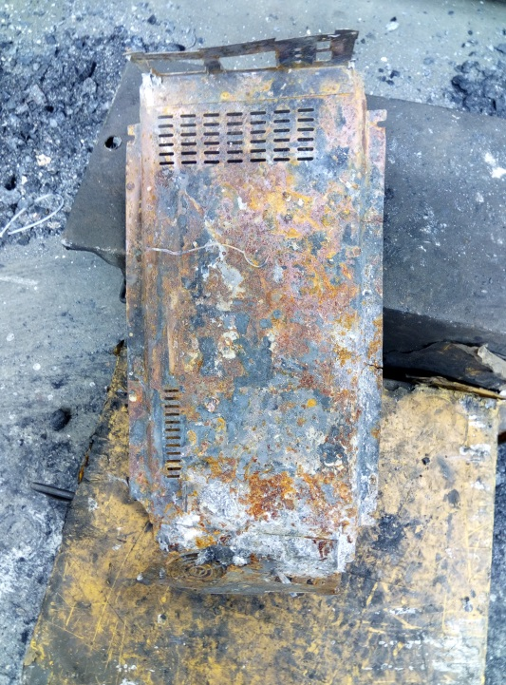
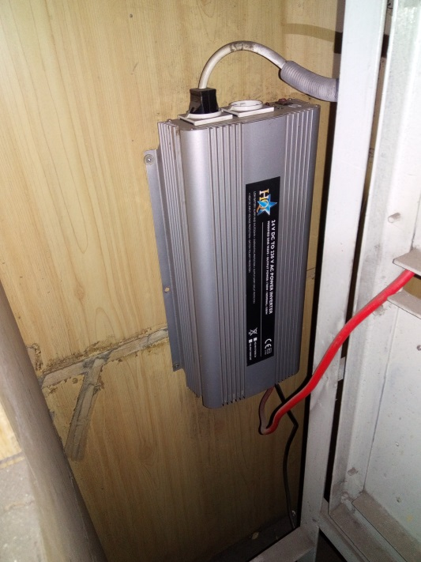
Fig. 11
Fig. 12
However, the traces of the fire, as well as the testimonies of the transport personnel (mostly of the train conductor), are directed precisely towards the already mentioned zone (Figure 10).

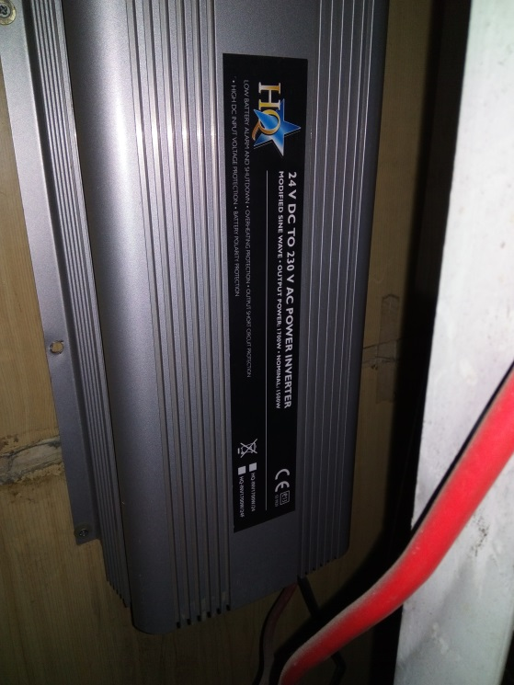
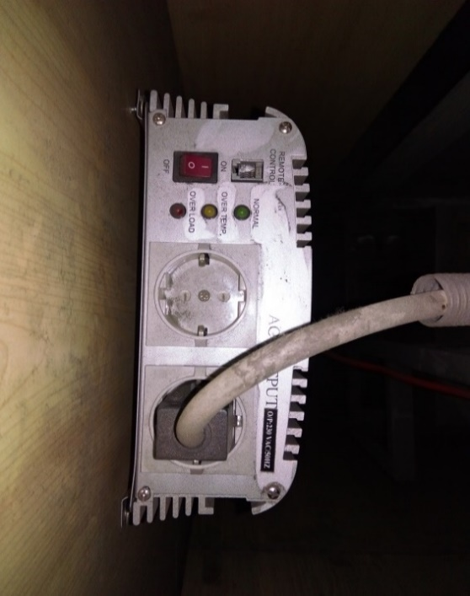
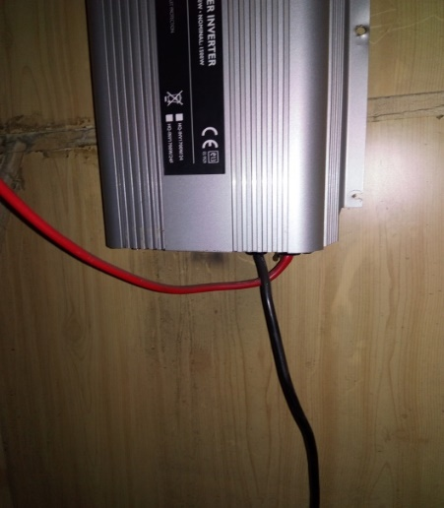
After numerous thorough inspections, the Commission discovers a metal detail, part of a device located in the area between the partition wall of the toilet and the electric cabinet of the wagon (Figure 11). It is found that the detail is a part of a device which serves to change the voltage from 24V DC to 220 V AC - Inverter (Figure 12), which supplies the contacts in coach compartment. It is fastened by self-tapping screws on the inside of the wooden wall of coach electrical board. This inverter has a nominal power of 1700W and is supplied by 24VDC coach lighting wiring. The protection is made of two 80A fusible fuses on the inlet side of the inverter (Figure 6b). Coach ignition is caused by a short circuit with an arc between the plus conductor touched to its housing and in contact with the minus supply wire. The arc is caused by the short circuit. The plus and minus cable for powering the 24 V inverter are mechanically chafed due to their slack and crossing, which in turn leads to a thermal load on their insulation. The reduced dielectric strength and leakage on one hand between the negative conductor and the inverter housing, and on the other, between the plus conductor and the inverter housing, grow into a short circuit. All this happens because the inverter's supply wires are not fastened, which in most cases leads to their crossing in the position thus assembled (Figure 13). Chafe of the wires results in damages to their insulation and leakages due to inverter’s shifting from its mounting position to the inside of coach electrical panel wall. The inverter is fastened to the wall made of extruded plywood using self-tapping screws without protection against self-unscrewing. Coach movement in a train composition is characterized with dynamic vibrations, such as tugs, bounces, swinging, galloping and winding. As a result of these oscillations, during coach exploitation, the screws begin to unscrew and separate the inverter from the wall (Figure 14). It should be noted that, in addition, screws have not been screwed in all holes when installing inverters i.e. empty mounting holes remain (Figure 15).
Fig. 15
Fig. 14
Fig. 13

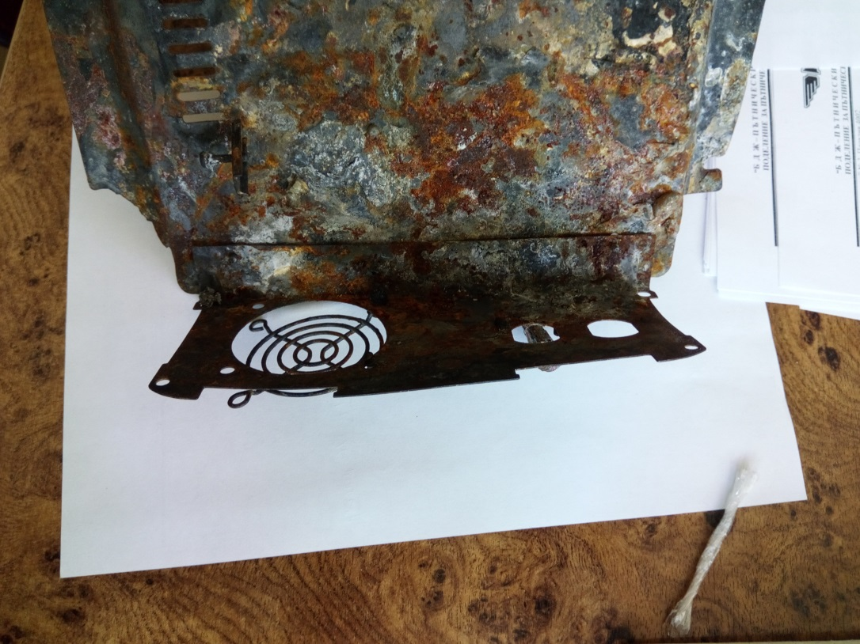
With the time, the two upper screws holding the inverter self-loosen to the extent that they are uprooted from the wall, and the inverter housing remains held only at its base by both bottom screws and at the top by the output 220V cable. Thus, the inverter travels for a long time and the bottom right screw is also unscrewed. In this position, it starts to swing around the single point of the left bottom screw and this has lasted until the left bottom corner of the housing breaks (Figure 16).
Fig. 16
Due to the unnatural position they occupy, the 24 V supply cables are moved to the back of the inverter housing and begin to rub into the housing intensively. This leads to a destruction of their insulation and leakage from the minus cable to its housing. This leakage allows continuously current through the supply wires of the inverter, whether there is consumption or not, which in turn leads to an increase in the temperature in the plus cable. In a situation of constant friction, the dielectric qualities of the insulation of the plus line are diminished to the extent that they lead to a short circuit between the 24 V input conductor and the inverter housing (which is already permanently connected to the minus conductor) and thus the circuit continuously flows current provided by coach battery. As a result, a short circuit arises with a subsequent arc, which leads to an arc welding on the inverter housing of the 24 V plus conductor (Figure 17).
The supply conductor is a multi-wire one with a cross section of 16 mm² and a homogeneous copper melt has been produced in the arc area (Figure 17). The immense rise in temperature and the occurrence of the arc ignites the Inverter at the cooling opening, where the fire ignites its components and its combustible insulation.
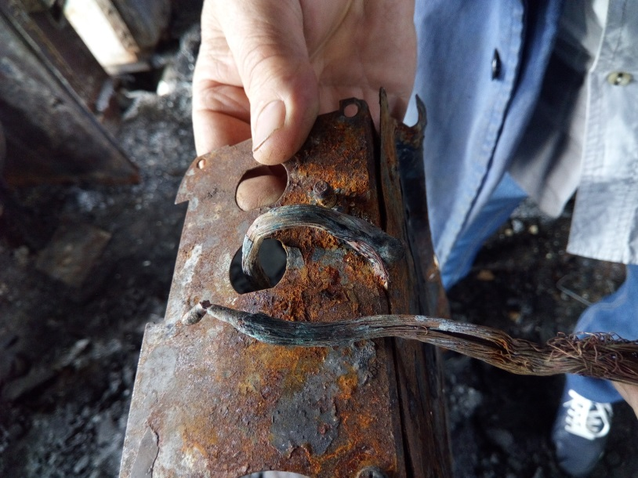
At the same time, due to the numerous vibrations of the inverter to the wall of the electrical panel, caused by the movement of the coach, a part of inverter’s housing base is detached (this part is subjected to a symmetrically varying load, leading to very rapid breaking of the material along the load line). The inverter strains by its full weight the 220 V outgoing cable and the 24 V power supply cables located at the bottom of the inverter. In this burning swinging position, it rotates and falls into the back between the frame of the apparatus cabinet and the partition wall separating the cabinet from coach's toilet. As a result of the fire in the inverter, the temperature around it increases and this leads to the ignition of the electric panel wiring insulation, the wooden floor and the partition walls made of extruded plywood, and the toilet node is lined with fiber glass. These materials are highly flammable and combustible, burning is accompanied by black smoke and unpleasant smell. For this reason, some of the passengers and the train conductor see through the open door of the toilet a black suffocant smoke coming out of the floor with a sharp smell coming from the burning insulation of the cables and from the already burning floors and walls. Subsequently, the electrical panel - the diode limiters, contactors, relays, cables, switches, capacitors, etc., is fully ignited by the high temperature which contributes to the overall coach’s blaze.
Fig. 17
15. Recommendations issued in order to avoid accidents upon the same reasons.
In accordance with the requirements of Art. 94 para. 1 and para. 3 of Ordinance № 59 from December 5, 2006 in order to improve safety in railway transport, EA "Railway Administration" orders BDZ "Passenger Transport" Ltd to implement the given safety recommendations:
Recommendation № 1 proposes to train trainmasters and conductors to operate Inverters mounted in coaches.
Recommendation № 2 proposes to change the location and the way of installation of the Inverter in a horizontal surface for operation in operating conditions.
Recommendation № 3 proposes to remodel the inverter power scheme in automatic mode with separate automatic 80A fuses.
Recommendation № 4 proposes the power cables of the 24 V wiring to be protected in a corrugated casing.
Recommendation № 5 proposes to provide guidance close to 220 V contacts in coach compartments to illustrate their purpose.
Recommendation № 6 proposes to supplement the Inverter Maintenance System, which is linked to SSM’s Plan - Warning System for repair.
Recommendation № 7 offers to the personnel carrying out Inverter maintenance in coaches, to follow the relevant procedures provided by SSM.
Recommendation № 8 proposes to develop an Instruction for Operation and Maintenance of Inverters in coaches with built-in 220 V wiring.
With reference to the implementation of Art. 94 para. 4 of Ordinance № 59 from December 5, 2006 for Railway Safety Management EA "Railway Administration" to notify in writing the head of SRAIIU in MTITC for the implementation of the given recommendations.

Sofia December 21, 2018

Chairman:
Dr. eng. Boycho Skrobanski
Head of NIB in MTITC

