REPUBLIC OF BULGARIA
MINISTRY OF TRANSPORT,
INFORMATION TECHNOLOGIES AND COMMUNICATION

9, Diakon Ignatiy Street, 1000 Sofia bskrobanski@mtitc.government.bg
тел: +359 2 940 9317 mail@mtitc.government.bg
факс: +359 2 940 9350

SPECIALIZED UNIT FOR INVESTIGATIONS OF ACCIDENTS AND INCIDENTS IN RAILWAY TRANSPORT AT MTITC

FINAL REPORT

from

investigation of a railway accident – derailment of a freight train № 30560 between stations Gavrailovo - Shivachevo on January 26, 2019

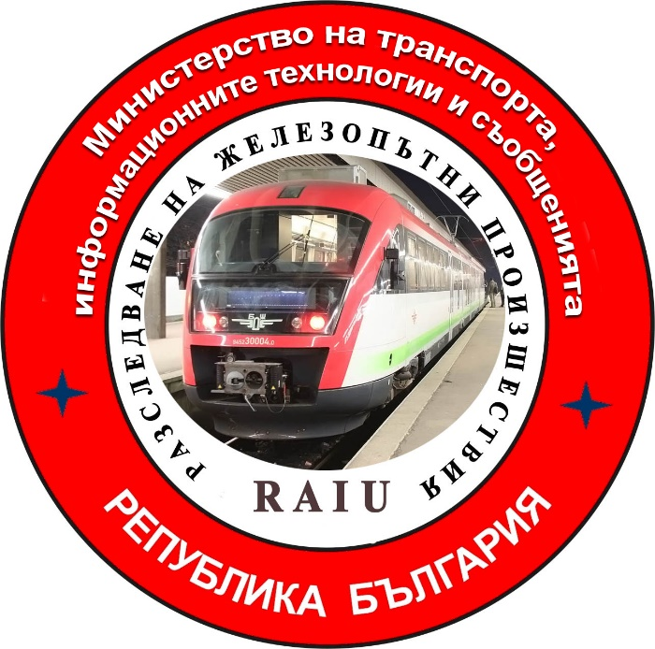

2019

FINAL REPORT

Purpose of the investigation and degree of responsibility

The Investigation of serious accidents, accidents and incidents is carried out by an independent investigation authority of the Republic of Bulgaria - "Specialized Unit for Investigation of Accidents and Incidents in Railway Transport" in the "Ministry of Transport, Information Technologies and Communications" (MTITC) and it aims:
To identify the circumstances and the reasons that led to their implementation with a view to improve safety and prevent from others without seeking personal responsibility and guilty.
The investigation is carried out in accordance with the requirements of Directive 2004/49 / EC of the European Parliament and of the Council upon safety of the Community's railways transpositioned in the Law for Railways ( LR ), Ordinance № 59 from December 5, 2006 about the management of safety in railway transport, Ordinance № H-32 from September 19, 2007 about the coordination of the actions and the exchange of information during investigations of railway accidents and incidents and the Agreement for interaction during investigations of accidents and incidents in the air, waterway and railway transport between the Prosecutor's Office of the Republic of Bulgaria, Ministry of Interior and MTITC from April 17, 2018.

CONTENTS

1. Summary…………………………………………………………………………...…..………4
2. Direct facts and circumstances …………………………………………………..…..…….…5
3. General data established during the investigation process ……………………......…..…...7
4. Deaths, injuries and material damages ………….……………………………………....…..8
5. External circumstances - weather and geographic conditions …..…………………...…....9
6. Data for railway infrastructure and railway carrier staff related to the accident ……………………………..……………………………………...…………….………….......…9
7. Data from other investigations. Summary of testimony …………………………..……...11
8. System of Safety Management (SSM) of National Company “Railway Infrastructure” RINC and “DB Cargo Bulgaria” Ltd. ……………………….……..……..……………........11
9. Rules and norms ………………………………….……………………….…..……………12
10. Functional condition of rolling stock and technical facilities of the railway infrastructure …………………..………………………….……………………..……...........12
11. Operational System Documentation - reviews, inspections, repairs, maintenance ………………………………………………………………………………....….………….…12
12. Health and Safety work conditions ………….…………………………………….…..…13
13. Accidents of similar nature previously registered:…………………………….…….......13
14. Analysis and conclusions …………………………….……………………….…..……….14
15. A description of measures already taken or measures as a result of the accident ………………………………………………...………………………………………………….23
16. Recommendations issued in order to avoid accidents upon the same reasons…………………………………………………………………………………………...24

1. Summary.
1.1. Brief description of the event.
From Burgas station on January 26, 2019, freight train (FT) № 30560 departs at 14:55 hours along Burgas - Karnobat - Zimnitsa - Tulovo - Pirdop route (Fig.1). The composition of the train is 31 wagons, 124 axles, 841 tons, including the № 86019 non-operating locomotive, serviced by electric locomotive № 86018 and a locomotive brigade of two motormen. After arriving and performing a maneuver at Karnobat station, an electric locomotive № 86012 is attached in a non-working condition to the train composition. A diesel locomotive № 56399 and three empty wagons are attached to the train composition at Zimnitsa station. From train station Zimnitsa the train departs at 16:51 hours with changed composition, 33 wagons, 3 locomotives in idle state 144 axles, 1,068 tons. At Gavrailovo Station the train arrives at 17:38 hours. At 18:17 hours, the train leaves for Shivachevo station, passing the warning signal at Shivachevo station at km 268 + 950, derailes the twenty-third empty carriage № 33 52 080 6 189-5. The wagon derails with a first axle on the first bogie, to the right according to the direction of movement and on arrow № 1 at Shivachevo station, derails the second axle. Passing without stopping on the third straight track at the railcrossing of the station, derails the second wagon bogie. After 50 meters on arrow № 2, as a result of twisting the buffers in the twenty-fourth, next empty carriage № 33 52 592 8 528-6, the same is dragged to the left and derails with the two axles of the first bogie. There was a notification from the duty head traffic at Shivachevo Station to the duty train dispatcher, who ordered the shutdown of the contact network voltage. The train is stopped in the Shivachevo - Tvarditsa railway section, at km 262 + 720.As a consequence of the derailment wagons, damages to the railway infrastructure - 6230 m railroad, damage to arrows 1 and 2 and damage to the platform between the second and third tracks at Shivachevo station are caused. Also traffic lights for third track is impacted and distorted and damages to the insurance equipment are caused.

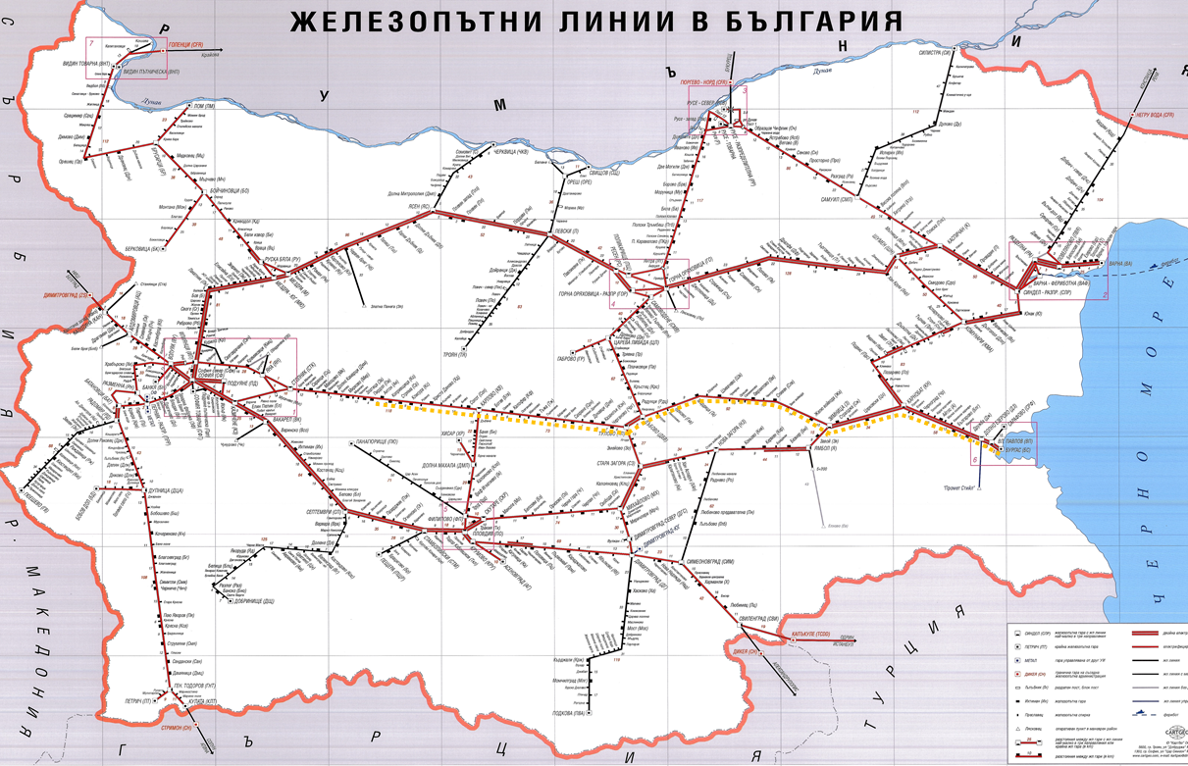
Fig. 1(Rail ways in Bulgaria)
1.2. Direct and main cause of the accident:

The derailment of a wagon № 33 52 080 6189-5 occurrs during the movement caused after breaking the bolt holding the leaf springs to the bogie from the left of the movement direction.
An imbalance of the wagon follows, which causes a jump of the right wheel of the first axle, through the right rail and falling from the outside.
With this situation of the derailed axle, the front of the spring breaks off the earring, falls out of the socket and slams into the ballast prism.
1.3. Summary of the main recommendations.
The safety recommendations are addressed to the national safety authority - the Executive Agency "Railway Administration" (EARA), the railway carrier - "DB Cargo Bulgaria" Ltd. and the Railway Infrastructure Manager - RINC.
Recommendation 1 is aimed at SE (state enterprise) RINC and "DB Cargo Bulgaria" Ltd to execute working talks with the transport safety staff to be familiar with the content of the final report.
Recommendation 2 is aimed at SE RINC to analyze the results of the submitted measurements of the rail way, carried out with the TINSA Ltd. M-120 Trace Measurement Laboratory in the Dubovo-Zimnitsa section with a deteriorated state of particular sections.
Recommendation 3 is aimed at "DB Cargo Bulgaria" Ltd. to order the staff involved in the technical maintenance of the non-tractive rolling stock it operates to increase the quality of the technical examinations carried out at the stations with technical persons in accordance with the " Risk assesment " section of SSM.

2. Direct facts and circumstances.

2.1. Date and time of the event.

From Burgas station on January 26, 2019, freight train (FT) № 30560 departs at 14:55 hours along Burgas - Karnobat - Zimnitsa - Tulovo - Pirdop route (Fig.1). The composition of the train is 31 wagons, 124 axles, 841 tons, including the № 86019 non-operating locomotive, serviced by electric locomotive № 86018 and a locomotive brigade of two motormen. The train departs from Burgas station at 14:55 hours along Burgas - Karnobat - Zimnitsa - Tulovo - Pirdop route. During the journey, the train undergoes two changes of the composition: at Karnobat station, an electric out of operation locomotive № 86012 is attached and a diesel in operation locomotive № 56399 is attached at Zimnitsa station together with three empty wagons. The train departs from Zimnitsa station at 16:51hours and arrives at at Gavrailovo station at 17:38 hours. During the movement from Zimnitsa Station to Gavrailovo station, it moves without stopping and the station staff along the route notices nothing unusual. The train has been complied schedueled speed and limitations. The train leaves Gavrail at 18:17hours for Shivachevo station. After passing the warning signal at Shivachevo station at 18:35 hours, twenty-third wagon № 33 52 080 6 189-5, derails with the first axle of the first bogie at km 268 + 950, to the right in the direction of the movement, at a speed of 75 km / h and at arrow № 1 of
Shivachevo station, derails the second axle. Implementing a non-stop route on the third main track at Shivachevo station, the train passes with the derailed wagon at a speed of 55 km / h and on arrow № 2 derails the next twenty-fourth wagon with the first bogie. After the derailment, the train continues the movement and at 18:40 hours is stopped at km 262 + 720 on the Shivachevo - Tvarditsa railway section from a subsequent disconnection of the voltage in the contact network (fig. 2).
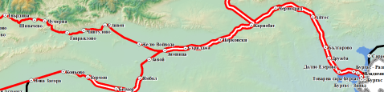
Place of derailment
Fig. 2
A senior train dispatcher from RTMSA -Plovdiv, informs the dispatcher of "DB Cargo Bulgaria" Ltd about the situation , who promptly informs the locomotive brigade that wagons has derailed from the train composition. After the inspection by the locomotive brigade, it is found that two consecutive wagons аre derailed : 23rd and 24th for which they inform the respective services.

2.2. Event’s location.
The accident occurs on the Gavrailovo - Shivachevo railway section, At km 268 + 950, derails the first wagon from FT № 30560 and at arrow № 2 of Shivachevo station, derails the second carriage. The train continues its movement on the next railway section Shivachevo - Tvarditsa, where it is stopped at km 262 + 720.
The stations are located on the third main railway line Sofia - Karlovo - Zimnitsa - Karnobat - Burgas.

2.3. Event’s classification.

On January 26, 2019, at 19:25 hours, the Head of the Special Investigation Unit for Railway Accidents and Incidents (SRAIIU) at the Ministry of Transport, Information Technology and Communications (MTITC) is informed about an occurred railway accident - derailment of two wagons from the composition of FT № 30560 in the section Gavrailovo - Shivachevo - Tvarditsa.The information is submitted in accordance with the requirements of "Safety Procedure SP 2.03." from September 01, 2011 of the National Railway Infrastructure Company (RINC). After receiving the notification, he immediately goes to the scene of accident where the primary sightings are taken to clarify the situation and the circumstances that have preceded the accident.Clarifying in situ the situation and the consequences of the event, the head of SRAIIU in MTITC on the grounds of Art.19 para 2, letter (a) of Directive 2004/49 / EC and Art. 68, para. 1, item 2 and para. 2 of Ordinance No. 59, classifies the event as a railway accident.

2.4. Consequences of the Event:

- there are no injured personnel;
- caused damages to the railway;
- caused damages to the safety appliance;
- caused damages to the apron of Shivachevo station;
- caused damages to the arrows № 1 and № 2 at Shivachevo station;
- caused damages to the railway crossing at Shivachevo station vicinities;
- caused damages to the derailed two wagons;
- no damages to the environment;

2.5. Decision to initiate an investigation:
The decision to initiate an investigation is initiated by the head of the SRAIIU on the grounds of Art. Article 19 para2 of Directive 2004/49 / EC, Art. 115k, para. 1, item 2 of the Railway Transport Act (RTA) and Art. 76, para 1, item 2 of Ordinance № 59 from December 5, 2006.
In the Ministry of Transport, Information Technology and Communications (MTITC) an independent investigation commission is assigned. The chairman of the commission is the head of SRAIIU. The Committee consists of two external experts with the relevant qualification and professional relevance to the accident.
In the course of the investigation, the report submitted by the Operational Unit and the materials and documents collected and the materials subsequently recovered are analyzed.
The Commission conducts an interview with the staff involved in the accident.
The Commission takes a piece of a hinged bolt holding the leaf bin of carriage No 33 52 080 6 189-5 as a material evidence, on the basis of which it has been appointed and drawn up a technical expertise at the Institute of Metal Science, Equipment and Technology with Hydro and Aerodynamics Center Acad A. Balevski " at the Bulgarian Academy of Sciences (BAS).
The Head of Commission has adopted the written observations of the external experts involved in the investigative commission in pursuance of the tasks assigned to them during the conducted investigations.

2.6. Conducting rescue and emergency-restoration actions:

The on duty RI BP officer - Plovdiv, after having received a notification, sends a specialized IVECO repair car from Stara Zagora to Shivachevo station at 19:50 hours. By an order of the train dispatcher from RTMSA - Plovdiv, at 20:11 hours the railway sections Gavrailovo - Shivachevo - Tvarditsa are closed for all vehicles with the exception of the restoration vehicles.
After completing the in situ inspection by the Head of SRAIIU at MTITC, the first part of the train is given permission to be withdrawn at 22:40hours to Tvarditsa station in order to ensure the commencement of restoration work of the derailed two wagons and to restore the railway infrastructure capacity.
At 00:15 hours the derailed two wagons and the second part of the train are taken to Tvarditsa Station.Emergency rehabilitation actions of the railway infrastructure are undertaken the following day, on January 27, 2019. An organization for emergency removal of breakdowns is set up, both at the railway crossing located in the railway station at km 266 + 236 and at arrows 1 and 2 in station Shivachevo, and emergency recovery of the railway in the two railway sections. Partial replacement of the crashed sleepers of the track is executed. At 15:45 hours, on January 27, 2019, with the order of the train dispatcher, the train movement in the Gavrailovo - Shivachevo - Tvarditsa sections is restored only for passenger trains with a speed of up to 25 km / h.
3. General data established during the investigation process.

3.1. Participating officers and witnesses:
RINC Personnel:
- Duty head of traffic and two pointsmen at Shivachevo and Tvarditsa stations;
- duty operator at Traction substation Tvarditsa;
„DB Cargo Bulgaria“ Ltd personnel:
- Locomotive motorman 1st person at electric locomotive № 86018;
- Locomotive motorman 2nd person at electric locomotive № 86018;
3.2. Data on rolling stock:

At a request of the carrier "DB Cargo Bulgaria" Ltd. for freight transport RINC has developed a yearly schedule for the movement of a pair of freight trains № 30560 / № 30561, carrying goods in open wagons along the route Burgas - Karnobat - Zimnica - Tulovo - Karlovo - Pirdop and vice versa.
- freight train № 30560 is composed by a traction electric locomotive № 86018, three locomotives in idle state and 33 empty wagons with a gross mass of 1068 tons, moving from Burgas station to Pirdop station.
3.3. Data on the carrier:
"DB Cargo Bulgaria" Ltd. possesses:
- License for railway transport services № 206/April 26, 2016 г.;
- Safety certificate part ,,А“ BG 11 2016 0002 and part ,,В“ BG 12 2016 0003;

3.4. Train type, number and category:
- freight train, № 30560, direct, daily travelling;
3.5. Train tractive rolling stock type and number, for FT № 30560:
- electric locomotive № 86018 – with regular registration in Vehicles’ register;
- electric locomotive № 86012 – with regular registration in Vehicles’ register;
- electric locomotive № 86019 – with regular registration in Vehicles’ register;
- diesel locomotive № 56399 – with regular registration in Vehicles’ register;
3.6. Train non-tractive rolling stock type and number:
- 26 open wagons – Тamns series, empty, with regular registration in Vehicles’ register;
- 7 open wagons – Eaos,series, empty, with regular registration in Vehicles’ register;

3.7. Railway infrastructure description:
Railway and points:
- Shivachevo railway station, 3 tracks, of which 3rd track is the main, 2nd track is deflective, reception-dispatching, and the 1st track is deaf to Tvarditsa, 3 arrows with a radius R = 300 m;
- railroad in the section Gavrailovo - Shivachevo - 6,3 ‰ climbing, curve with a radius R = 2750 m, overhanging on the rails H = 30 mm, in embankment, rails type S 49 , concrete sleepers ST-6, joint type SKL-14 with supported joins;

3.8. Signalization, station safety installations and between-station block system:
- Shivachevo station is equipped with Route-relay centralization (Н68).
- traffic signalling are equipped with indicators for speed;
- between-station sections Gavrailovo – Shivachevo – Tvarditsa are equipped with an automatic blockage without duct capacitor signals and axis counters
3.9. Contact network:
- chain compensated;
3.10. Train protection:
- electric locomotive № 86018 is equipped with sealed vigilance device;
3.11. Communication system:
Shivachevo station is equipped with an automatic telephone connection, a ftelephone connection with the two points posts, between-station connection with the two adjacent stations, connections with train and power dispatchers, a stationary and mobile phone is also provided at the station;
- the locomotive № 86018 brigade has been equipped with a service mobile phone;

3.12. Construction and repair works in the vicinity or at the place of the accident.

- between Gavrailovo and Shivachevo, till the moment of the accident following repair activities has happened:
• 1999 – renovation between Gavrailovo and Shivachevo;
• 1999 – renovation between Shivachevo and Tvarditsa;
• 2016 – partial middle size repair on the sections Gavrailovo-Shivachevo- Tvarditsa;
4. Deaths, injuries and material damages.
4.1. No deaths:
4.2 No injured personnel:
4.3. Material damages RS:
- locomotive № 86018 – no damages;
-,,DB Cargo Bulgaria“ Ltd reports about repairing of two derailed wagons at the cost of 28 872,45 BGN without VAT.
4.4. Damages to the rail infrastructure:
- RINC expenses for emergency convalescence of the movement at a speed of 25 km/h from January 26 till January 31, 2019 amounts to 64 871,97 BGN without VAT;
- By a minutes from January 29, 2019 a RINC commission has carried out a survey of the damaged railway due to the derailment from km 263 + 000 to km 268 + 950 in the section Tvarditsa - Shivachevo - Gavrailovo. The Commission has drafted a calculation comprising costs only for the non-recoverable railway infrastructure of km 263 + 000 - 266 + 985 = 3985 m in the section Tvarditsa - Shivachevo and Shivachevo station, which amounts to BGN 2 888 615.98 excluding VAT.
Cost of rehabilitation of the contact network - none;
The expenses of "BDZ - Passenger Transport" Ltd. for transhipping passengers and increasing the working time of the transport personnel amount to BGN 2 493.80 excluding VAT.
Total damages and costs of the accident amount to: 2 984 854,2 BGN excluding VAT.

5. External circumstances - weather and geographic conditions.
Meteorological conditions, with influence over the visibility:
- in the dark part of the day – 18:35 hours;
- weather – clear for seeing signals.
6. Data for railway infrastructure and railway carrier staff related to the accident..
6.1. Position, place of work, sex and age.
RINC personnel at Shivachevo station :
- ,,head of traffic” – officer of RTMSA – Plovdiv, service time 32years., man of 55 years;
- ,,pointsman” – officer of RTMSA – Plovdiv, service time 7 years., man of 48 years;
„DB Cargo Bulgaria“ Ltd. personnel:
- „locomotive motorman” 1st person at electric locomotive № 86018 – service time 15 years, man of 35 years;
- „locomotive motorman ” 2nd person at electric locomotive № 86018 – service time 33 years man of 50 ;
6.2. Position certificate and certificate data.
Personnel of RINC:
- Certificate № 1750/October 23, 2007 for occupying position Head of traffic , RTMSA-Plovdiv;
Certificate № 1756/January17, 2012 for occupying position Head of traffic , RTMSA-Plovdiv, working under art.119 from LC– pointsman;
- Certificate № 32/October 08, 2008 passed examine for pointsman at Shivachevo station;
„DB Cargo Bulgaria“ Ltd. personnel:
- 1st person, Certificate № 195/August 01, 2016 for occupying position motorman локомотивен;
- 2nd person, Certificate № 62/ August 01, 2016 for occupying position motorman/maneuverer
6.3. Qualification certificate and certificate data.
Personnel of RINC:
- Certificate № 8999/November28, 1986 acquired qualification: TORT with license: Head of Traffic, teaching structure RS-Lakatnik at EU BDZ;
- Certificate № 13708/September 17, 2011., acquired qualification for: Head of traffic, teaching instruction CPC-RINC;
Personnel of „DB Cargo Bulgaria“ Ltd:
- 1st person, Certificate № 7603/December17,2007 acquired qualification for: Electric locomotive Motorman of locomotive series 43000, 44000 and 45000 teaching structure CPO-BDZ;
- Certificate № 18708/September 17, 2016, acquired qualification for: maneuverer, teaching structure CPO-RINC;
- 2nd person, Certificate № 23536/August 18, 1990 acquired qualification for: Electric locomotive Motorman, teaching structure HMTS,,Todor Kableshkov“– Sofia;
- Certificate № 16261/May 18, 2014 acquired qualification for: maneuverer, teaching structure CPO-RINC;

6.4. Document for professional qualification.
Personnel of RINC:
- Head of traffic – a diploma for completed secondary education № 014877/June 30, 1981, secondary school ,,Heavy Industry“ Tvarditsa;
- pointsman – a diploma for completed secondary education № 043077/June 30, 1989 secondary school –„Dimitar Blagoev” Sliven;
Personnel of „DB Cargo Bulgaria“Ltd:
- locomotive motorman 1st person, a diploma for completed secondary education № 2216433/July 04, 2001, acquired qualification for technician, teaching structure SRT ,,Nikola Korchev“ – Sofia;
- minute from examine for acquiring qualification № PR 22-13-03/August 28, 2015 for operation with electric locomotive series 86000;
- minute from examine for acquiring qualification № PR 22-13-03/ August 28, 2015 for operation with electric locomotive series 88000;
- certificate № 5743-147/March 30, 2009, acquired qualification for driving electric locomotive series 46200, teaching structure CPO-BDZ;
- driving license for locomotive BG 7120170782 – EA RA;
- locomotive motorman 2nd person, a diploma № 23536/August 18, 1990 г. acquired qualification for: Electric locomotive Motorman, teaching structure HMTS,,Todor Kableshkov“– Sofia;
- minute from examine for acquiring qualification № PR 22-13-03/December 26, 2011 for operation with electric locomotive series 86000;
- minute from examine for acquiring qualification № PR 22-13-03/August 29, 2012 for operation with electric locomotive series 88000;
- certificate № 2447-846/August 31, 2006 г., acquired qualification for driving electric locomotive series 46200, teaching structure CPO-BDZ;
- driving license for locomotive BG 7120170778 – EA RA;
6.5. Certificate for successful examination according to Ordinance № 56 from 2003.
Personnel of RINC:
- Head of traffic at Shivachevo station– min. № XІ-22-39/June 21, 2018
- Pointsman at Shivachevo station– min. № XІ-22-39/June 21, 2018 ;
Personnel of „DB Cargo Bulgaria“ Ltd:
- locomotive motorman 1st person – min. № X – 17 – 109/August 17,2015;
- locomotive motorman 2nd person – min. № II – 39/August 30, 2018;
6.6. Data for the personnel, known with the railway infrastructure.
Personnel of „DB Cargo Bulgaria“ Ltd:
- locomotive motorman 1st person –December 17, 2007 without limitations on 1435 mm rails;
- locomotive motorman 2nd person – August 18,1990 without limitations on 1435 mm rails;
6.7. Break duration of the personnel concerned to the accident.

In accordance with the requirements of the normative acts - Labour Code and Ordinance № 50 / December 28, 2001 about the working time of the management and performer personnel, engaged with transportation of passengers and freights in the railway transport, they are provided the necessary break before staff time.
Personnel of RINC
- ,,Head of traffic“ Shivachevo station, rests from January 24,2019 ,07:00 hours till January 26, 2019 07:00 hours;
- ,,Pointsman” – Shivachevo station, rests from January 24,2019 07:00 hours till дата January 26,2019 07:00 hours;
Personnel of „DB Cargo Bulgaria“ Ltd:
- locomotive motorman 1st person at electric locomotive № 86018 rests from January 25,2019 10:30 hours till January 26,2019 14:00 hours;
- locomotive motorman 2nd person at electric locomotive № 86018 rests from January 25,2019 10:30 hours till January 26,2019 14:00 hours;
6.8. Shift (travel) briefing.
Personnel of RINC:
- Personnel at Shivachevo station is briefed for duty on January 26,2019 and they sign in the instruction book stating that they were cheerful, rested and haven’t used an alcohol and other narcotics.
Personnel of „DB Cargo Bulgaria “Ltd:
- the locomotive brigade is briefed before travel by Chief of transport group at Freight station Burgas and checked for presence of alcohol and they sign in the instruction book stating that they were cheerful, rested and haven’t used an alcohol and other narcotics.

7. Summary of testimony.
The Investigation Commission (IC) has held an interview with the „DB Cargo Bulgaria “Ltd and RINC personnel involved in the accident and has required their written depositions.
IC doesn’t have other testimony.
8. NC ,, Railway Infrastructure ” and „DB Cargo Bulgaria“ Ltd. System of Safety Management (SSM)
8.1. Observing the procedures set out in SSM of RINC:
The Investigation Commission requested and took note of the procedures set out in the NRIC's SSM and found that Shifachevo station shift staff at the "Railway Traffic Management and Station Activities "(RTMSA) in Plovdiv did not comply with the procedures for acting in emergency pressed cases.
8.2. Compliance with the procedures in Safety Management System (SSM) of „DB Cargo Bulgaria“ Ltd;
IC requested the SSM procedures of the carrier "DB Cargo Bulgaria" Ltd and, having become acquainted with them, established the following:
In the risk assessment under №DD 22-05-01 / 01 by the relative hazard categorization method, by calculating the risk index, it is evident that the statistically defined hazards, such as broken spring sheets and hinged bolts, are the largest - 273 . In line with the risk assessment, the hazard is defined as "Very likely," but since it did not lead to accidents, the severity of the event is defined as "Minor".
IC considers that the high number of malfunctions encountered in the spring suspension has a significant risk to the safety of rail transport and should not be underestimated. These identified failures should be considered as potential preconditions for accidents. The risk of an accident has been very probable and possibly repeated because this is not noticed and has led to an accident involving material damages.
In view of this, the Investigation Commission proposes to the railway operator to complete the hazard identification sheet and reassess its impact on safety.
9. Rules and norms:
- In "Shivachevo Station Technology", Sending trains, item 76 describes the actions of the duty head of traffic.
When the duty head of traffic has to stop and return a left train to the station, he proceeded as follows:
"- In case of emergency, bearing no delay, the disconnectors of the contact network are disconnected without an order of the duty power dispatcher. The duty head of traffic, who has made the switch off immediately notifies the duty power dispatcher. The switch on of such a disconnector shall be made only by order of the duty power dispatcher. "

10. Functional condition of rolling stock and technical facilities of the railway infrastructure.
10.1. Functional condition of rolling stock.
-locomotive functional condition – fitted to operate;
- functional condition of the two derailed wagons – damage to the wagon undercarriage (bogies and wheelsets);
- functional condition of the other wagons – fitted to operate;

10.2. Functional condition of the railway infrastructure:
Railway and points:
- damaged 6230 m railroad in the sections Gavrailovo-Shivachevo-Tvarditsa;
- damaged arrows № 1 and № 2 at Shivachevo station;
-damaged covering of the railcrossing in the vicinity of Shivachevo station at km 266⁺²³⁶;
- damaged passenger apron between 2nd and 3rd track at Shivachevo station;

Safety equipment, communications, radio and power supply:
- damaged exit traffic lights at 3rd track of Shivachevo station;
- damaged axes counters and choke-transformers at Shivachevo station;
Contact network:- troublefree;

10.3. Speed decoding of locomotive № 86018 „DB Cargo Bulgaria“ Ltd
11. Operational System Documentation reviews, inspections, repairs, maintenance and prevention.
11.1. Measures taken by staff to regulate train movements.
RTMSA – Plovdiv have undertaken timely operational changes to schedule of train movement in the Zimnitsa- Dabovo section. Variants of that schedule are developed for changing passenger and freight trains’ routes till railroad convalescence.
11.2. Exchange of Oral Orders and Written Messages.
After unsuccessful attempts by the Headof traffic at Shivachevo station to stop the train at 18:37hours, he informs the train dispatcher about the derailment of FT № 30560 and requires shutdown of the voltage in the contact network for to stop the train.
At 18:39 hours, a train dispatcher at the ROD - Plovdiv orderes the power dispatcher to turn off the tension in the section Tvarditsa - Shivachevo. The power dispatcher immediately orders the Tvarditsa traction substation duty to disconnect the voltage.
At 18:40 hours, the duty officer in Tvarditsa TS informs the power dispatcher that the voltage in Sliven - Tvarditsa section is switched off.
As it is seen from the speed report of the locomotive at 18:41 hours, the train stops in Shivachevo - Tvarditsa section at km 268 + 950.
At 18:42 hours senior dispatcher /on shift in ROD - Plovdiv, informs about the case the dispatcher of"DB Cargo Bulgaria" Ltd, who promptly contacts the locomotive brigade and informs them that there is a derailed wagon from the train composition.
At 20:11 hours with an order of the train dispatcher the Gavrailovo - Shivachevo - Tvarditsa sections are closed for all vehicles except for the means of restoration.
On January 27, 2019, after the partial completion of the repair and restoration activities on the railway track and the arrows at Shivachevo station, at 16:00 hours, the movement in Gavrailovo - Shivachevo - Tvarditsa section is restored only for traffic at a speed of 25 km / h.
Until the railway infrastructure capacity in Gavrailovo - Shivachevo - Tvarditsa section was fully restored, all freight trains for the section were redirected to other bypass routes.
On January 28, 2019, after the inspection and permission of the commission investigating the derailed two wagons, the derailed carts "DB Cargo Bulgaria" Ltd were replaced and drived for repair at "Trakcia" AD in Samuil.
12. Health and Safety work conditions.
- With reference to the requirements of Art. 28, para. 1 of Ordinance № 54 / June 02, 2003 the RINC staff and the railway operator concerned with the accident have valid certificates of psychological fitness.
- With reference to the requirements of Art. 28, para. 1 of Ordinance № 54 / June 02, 2003 there were no violations of the indicative (pre-travel) instructions of the RINC staff and the railway carrier.
- With reference to the requirements of Art. 28, para. 1 of Ordinance № 54 / June 02, 2003, the Railway Carrier Manager "DB Cargo Bulgaria" Ltd. instructed officials (Transport Group Manager) at Pirdop, Rousse, Burgas and Svilengrad stations to carry out shift (travel) briefings to motormen trainers, transportation, and alcohol check. The checks made shall be recorded on a issued travel document.

13. Accidents of similar nature previously registered :
- Admitted previous rolling stock incidents with the railway carrier "DB Cargo Bulgaria" Ltd in the Dubovo - Zimnitsa section.
1. On January 07, 2014, FT № 30562 with 33 wagons of 3154 tonnes, with train locomotive № 92-27 and auxiliary locomotive № 92-34 at 20:58 hours while transit passing the third track at Gurkovo station derail wagons № 84525383066-5 E6 15th of the Composition, 84525383046-5 E6 17th of the Composition, 845253830093 E6 18th of the Composition, 84525383048-1 E6 19th of the Composition, 33520806022-8 Т4 20th of the Composition, 33520806053 -3 T4 21st of the composition, 33520806047-5 T4 22nd of the composition and 33520806048-3 T4 23rd of the composition. Reasons - broken axle in the back of the left wheel of the fourth axle of wagon № 84525383066-5 E6, 15th of the composition due to a crack, occupying 2/3 of the section of the axle, due to fatigue of the material.
2. On July 13, 2014 FT № 90692 with 16 wagons, 732 tons, with a locomotive 86012 in the section Chumerna - Gavrailovo at 13:52 hours derails the locomotive with the first bogie at km 275 + 600. The locomotive is lifted and the section is released at 21:40 hours. Causes - broken axle in the base part because of internal corrosion.
3. On December 23, 2014 FT30561 with 25 wagons, 1112 tons, auxiliary locomotive № 92-34 and train locomotive № 92-27 at 07:04 hours on departure from fourth track at Zimnitsa station, on road № 1 at arrows 15/11 and 9 derail the two locomotives with all axles. Cause - a transverse fracture of the left tongue on p. 11, which arose in the head of the tongue rail, due to the creation of an external stress concentrator and an internal microcrawl.
4. On January 13, 2015 at 05:54 hours FT№ 30561 with 28 wagons, 1549 tons, with train locomotive № 86-019 and auxiliary locomotive head № 92-025 in the section Gavrailovo - Chumerna, derails wagon № 8452 5383027-5, 15th of the composition with the second bogie. The traffic is interrupted from 05:54 to 15:09 hours. Reasons
- a heavily hardened ballast prism with hidden slumps. The curve is supported with a H = 75 mm, less than the normal H = 95 mm.
- The staff involved in the accident by the railway operator and the railway infrastructure have no previous recorded occurrences of this type.

14. Analysis and conclusions:
The Commission for Investigation in MTITC collects the necessary documentation and materials. It analyzes the possible circumstances, facts and evidence that could lead to an identification of the cause of the railway accident. Detailed and thorough inspections of the railway track, the insurance equipment and the rolling stock were carried out. The materials and documents provided by the operational group were analyzed. The technical expertise of the Bulgarian Academy of Sciences, the opinions of the experts who participated in the investigation were analyzed. The actions of the personnel involved in the accident before and during the accident are had in mind, as well as the testimonies provided, for which the Commission found the following:
- the derailment of 23th wagon № 33 52 080 6 189-5 from freight train № 30560 occurred at 18:35 hours at km 268 + 950 with the first axle of the first bogie in the section Gavrailovo - Shivachevo and at arrow № 1 in the station Shivachevo the wagon derails also with the second bogie;
- the derailment of 24th wagon № 33 52 592 8 528-6 occurred after the train has passed without stopping at Shivachevo station, followed by a stroke of the derailed 23th wagon on the railway crossing covering, which jumped and this has led to clutch of 23rd and 24th wagons buffers and at arrow № 2, derails 24th wagon with the first bogie.
- at 18:35 hours, at the time of derailment of the wagon, the running speed is 77.4 km / h, as the allowed is 80 km / h, at 18:40 hours at the time of switching off the voltage, the train speed is 56.8 km / h as the allowed is 60 km / h;
- after the derailment of the two wagons, the train continues to move and its suspension is forced after the switching off the voltage in the contact network of Shivachevo-Tvarditsa section at km 262 + 720;
14.1. Analysis of records downloaded from the recorder of locomotive № 86018.
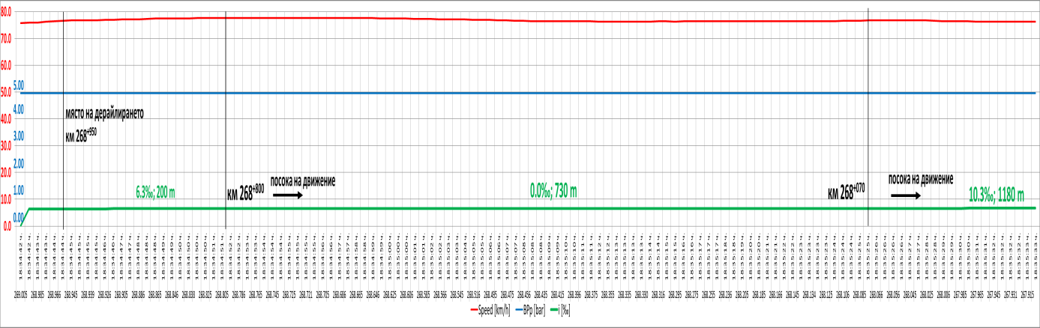
The analysis was made for the last few kilometers of train movement before its final stop after derailment.
Fig. 2
Train № 30560 is composed of:
- Locomotive 86018 fitted to operate;
- Locomotives 86019 and 86012 in the non-working state;
- Locomotive 56399 in the non-working state;
- 26 wagons Тamns 4-axes;
- 7 wagons Еaos 4-axes.
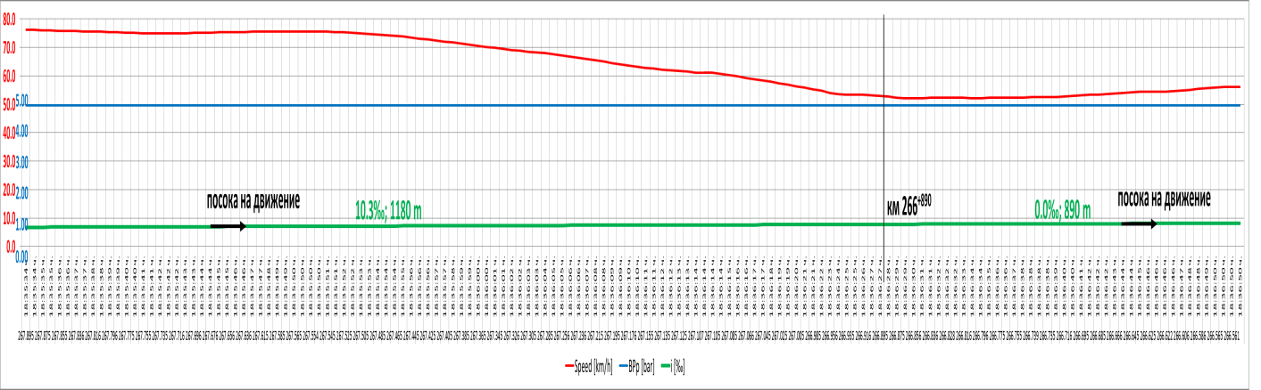
Train movement analysis starts at km 269 + 005 in the section Gavrailovo - Shivachevo. The train travels at a speed of 75.7 km / h with a slight upward trend, and given the positive slope of the road (6,3 ‰) it can be concluded that the locomotive is in the pull mode. Although at km 268 + 805 the road is at a level (0 ‰) the speed continues to fluctuate in a narrow range between 77.7 and 76.7 km / h. In the next interval of km 268 + 070, the slope changes and the road passes into climbing (10,3 ‰) for 1180 m (Fig. 2).
Fig. 3
Initially, the speed continues to maintain values between 77 and 75 km / h till km 267 + 565 at 18:35:50 hours. From that moment on, the speed begins to gradually decrease and at the end of the range of km 266 + 890 at 18:36:28 hours, is 52.7 km / h without the train brake being used; the speed decreases from the natural resistance of the train movement, i.e., the locomotive moves in inertia (fig. 3).
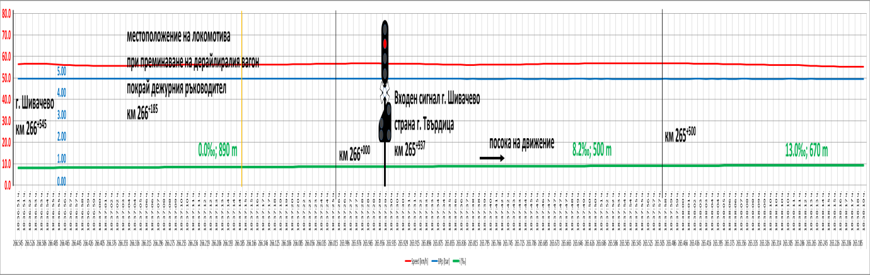
Fig. 4
The next interval is at a level and is 890 m in length from km 266 + 890 to km 266⁺⁰⁰⁰, which includes the passage through Shivachevo Station (km 266 + 545) with useful length of the longest PAK 648 m. The train passes through it, maintaining a speed of between 52.1 and 56.6 km / h. No deceleration of the train speed and activation of the ABC of the train (Fig. 4). In the range of km 266 + 000 to km 265 + 500, which is inclined at an elevation of 8,2 ‰ for 500 m, the train passes along the entrance signaling at Shivachevo station at Tvarditsa side without reaction from the motorman and therefore does not observe variations in the speed between 56.8 and 56.0 km / h and, given the slope, the locomotive is again in the pull mode. This behavior of the train does not change even at the next intervals, the first (from km 265 + 500 to 264 + 830 with a length of 670 m) is at a climbing of 13 ‰.
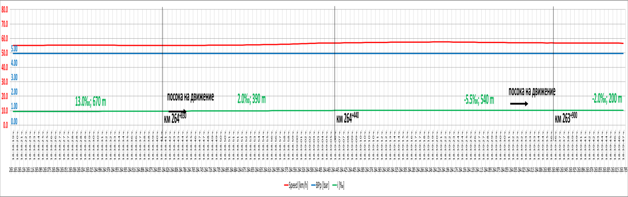
In the next interval (from km 264 + 830 to km 264 + 440 with a length of 390 m and a slope of 2 ‰) the speed again retains its values between 55.1 and 56.8 km / h, with a slight trend of increasing. In the range from km 264 + 440 to km 263 + 900 (540 m) the slope is -5.5 ‰, i.e. in a slight downhill, which again does not affect the change of speed (Fig. 5). In the range from 263 + 900 to km 263 + 700 the speed is decreasing - a trend which is observed in the next interval - from km 263 + 700 to the final stop of the train at km 262 + 720 (Figures 6 and 7). It should be noted that despite the reduction, the curve of the speed is decreasing more slowly to km 263 + 646 at 18:39:57 hours, after which it becomes steeper and over 885 m to km 262 + 761 in 18:41:19 hours in 1 min 22 sec. decreases to 19.7 km / h without using the train brake, i.e. in this interval, the locomotive has turned off his thrust and moved in inertia. The motorman activates the train brake at 18:41:19 hours, when the train is at km 262 + 766, using official retention, dropping 0.957 bar, with the pressure in MACB from 4,943 hp reaches 3.986 bar. These actions lead to speed decrease to 0 km/h and the train stops at km 262⁺⁷²⁰ , 18:41:34 hours.
Fig. 5
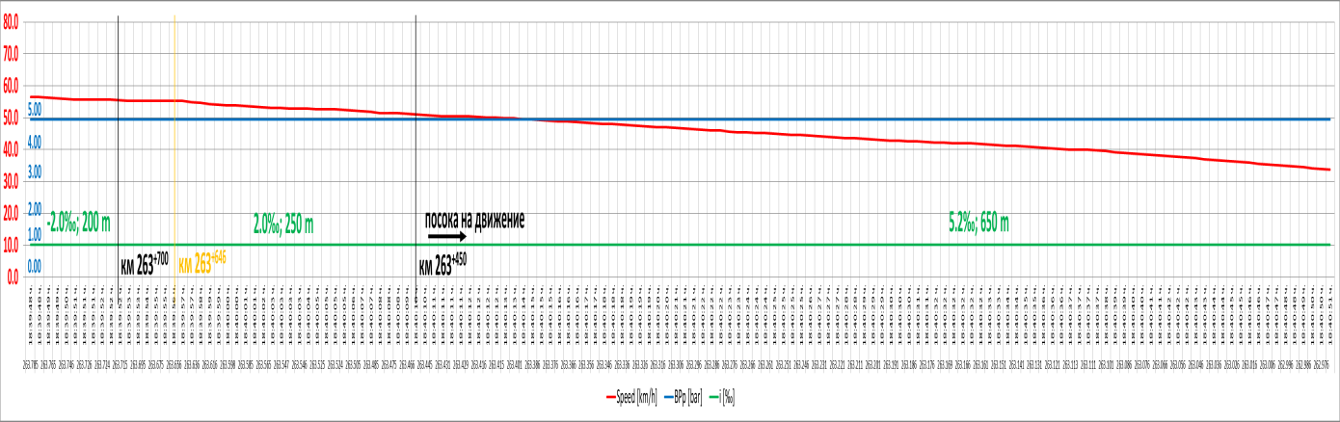
Fig. 6

From the above it follows that the motorman has not respond to the signal from the Shivachevo station (open inverse signal of the inverse entrance signal - Art. 354, para 3), and has reacted to the disconnection of the voltage in the contact network according to Art. 338, para. 1, which happens at 18:39:57 hours on km 263 + 646.
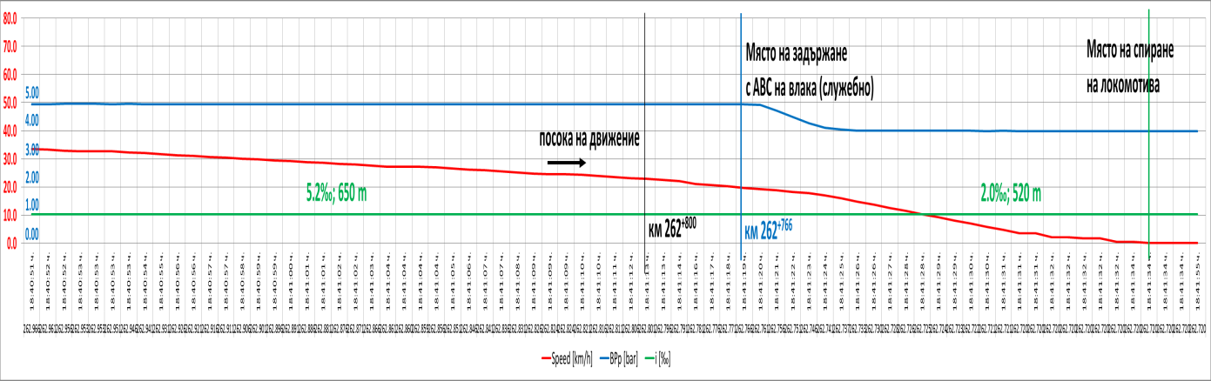
Fig. 7

According to the Shivachevo station head of traffic, he has noticed a derailed wagon in the train composition when the train passes through. The derailed wagon is at a distance of 360 m from the locomotive, therefore at that moment the locomotive is at km 266 + 185 and the return signal had pass a distance of 248 m, ranging from 18:37:14 to 18:37:30 hours for 16 sec (Figure 4). It can be assumed that this time is insufficient for the head of traffic to move to the reception building and trigger the call signal. The signal is triggered after the locomotive passes the Tvarditsa side entrance traffic lights and locomotive brigade has no visiblity to it.The train continues its travel to km 263 + 645, passing 2292 m for 2 minutes 27 seconds at a speed of between 55 and 57 km / h (Fig. 6). At this point the voltage in the contact network is switched off and the speed visibly begins to decrease without the use of the automatic train brake, i.e. due to the natural resistance of the train movements. Thus, the train travels 879 m to km 262 + 766 for 1 minute 22 sec. And at 18:41:19 hours its speed drops to 19,7 km/h (fig. 7).
At 18:41:19 hours at km 262 + 766, the motorman actuates the automatic train brake and performs partial official retention by reducing the MACB pressure from 4,943 bar to 3,986 bar for 33 m from km 262 + 766 to km 262 +733 for 6 sec. As a consequence of this action the speed starts to decrease from 19.7 km / h to 0 km / h at km 262 + 720 for 15 seconds. The train stops at km 262 + 720 at 18:41:34 hours in Shivachevo-Tvarditsa section (Figure 7).
In connection with the requirements of Art. 259 of Ordinance № 58/2006, the locomotive brigade of the leading locomotive has to immediately take measures for an official stop of the train after the voltage cut off in the contact network.
14.2. Analysis of the rail track.
To determine the causes of the derailment, a visual inspection has been carried out at and around the accident site on the technical condition of the track. The derailment position of the first leading left wheel of the first bogie of 23rd derailed wagon is at km 268 + 950, 8 meters from the beginning of the transverse, right curve, in the direction of the train movement, as slipping to the right of the left rail, there has remained a visible trace of the impact of the wheel on the railbolts of the elastic fastening on the inside of the rail and on the concrete sleepers. At 1.20 m in the direction of the train movement, the right wheel of the wheelaxis skips the head of the right track, leaving visible traces on the railbolts of the traverses on its outside.
The derailment site is in a transverse curve of 30 m length, which is a part of the curve with a radius R = 2750 m. The curve is a right one in the direction of the train movement in a slope of 6.3 ‰ downhill. By type, the construction of the railway is with rail joints. The rails are type S 49, reinforced concrete sleepers ST-6 and joints SKL-14. The irail way is well ballasted, with no visible tempered prism with a very good condition of the elastic joints and no absence of a missing one. To the main geometric features of the two rail threads are added the track gauge, longitudinal and transverse level, the position of the rails in plan, and their synchronization (lateraly and verticaly). It is evident in the minutes for the rail road condition presented by the operational group concerning the different parameters that the rail way around the derailment site complies with the requirements of the technical regulations for the construction and maintenance of the railway track as well as with the normative acts for the railway transport.

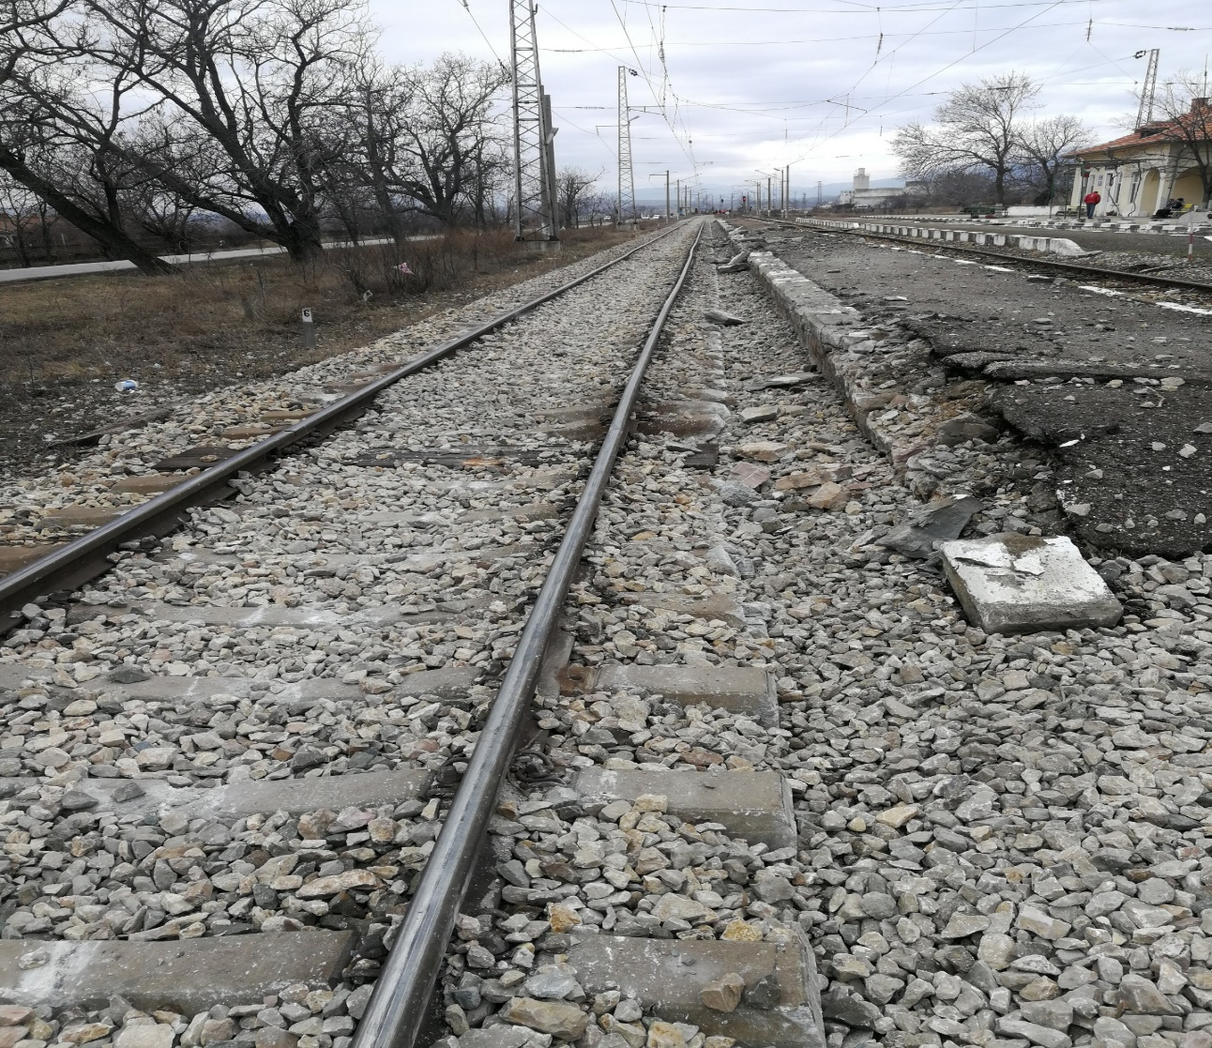
Fig. 8

The necessary control of the rail road condition is taken by Burgas railway section . The measurement of the track with the EM-120 Tramline Laboratory is done on October 16, 2018 in the section Zimnitsa - Dabovo. The result of the measurement indicates that there are no malfunctions in the derailment area endangering the safety of the trains' movement. The measurement is carried out by the notified body "TINSA" Ltd. for which data are provided with a report and conclusions about the technical condition of the railway track in the section Dabovo - Zimnitsa. From the submitted data it is evident that the railway in Dabovo - Nikolaevo, Nikolaevo - Gurkovo, Gurkovo - Tvarditsa sections is in poor technical condition, as the average arithmetic value of the ball assessment exceeds the limit for the respective speed and the class "C", recorded deficiencies of the parameters characterizing the technical condition of the track. Sections Tvarditsa - Shivachevo, Chumerna - Oreshak - Gavrailovo, Gavrailovo - Chintulovo and Chintulovo - Sliven are in a satisfactory condition. In these sections, the ball score does not exceed the limit for the corresponding speed and class "C", except for particular 200m sections. The railway from Shivachevo station to Chumerna station is in good condition, according to the criteria for class "C" and the corresponding speed category. The ball score for all 200 m sections does not exceed the limit except for km 269 + 800 to km 270 + 000 and from km 267 + 200 to km 267 + 400 total 400 m.
Despite the troubleshooting steps taken on the base of the malfunctions that EM-120 Trace Measurement Laboratory registers it can not be avoided that the large number of malfunctions are concentrated in the high-level section, including their reconciliation, prove that the railway has operated with parameters that threaten the safety of the rolling stock.
The above facts are confirmed by letters with which the manager of "DB Cargo Bulgaria" Ltd has informed the General Director of RINC and the responses confirm the deteriorated technical condition of the railway track in the above-mentioned sections in Pirdop - Burgas part of the third main railroad line.
14.3. Analysis of the facts and conclusions on the causes of the accident:
The Accident Investigation Commission has conducted a thorough inspection of the derailed wagons and has taken note of the provided technical documentation. It is found that the derailed wagons have carried out a mid term repair in 2016 at "Trakcia" AD - Samuil. Damages to bogies, springs, wheel axles, draw gears on wagons №№ 33 52 080 6 189-5 and 33 52 592 8 528-6 are results of the derailment. The reason for the derailment itself can be found in the broken hinged bolt holding the leaf spring of the first wheel axle of wagon № 33 52 080 6 189-5 during movement (Fig. 10)..
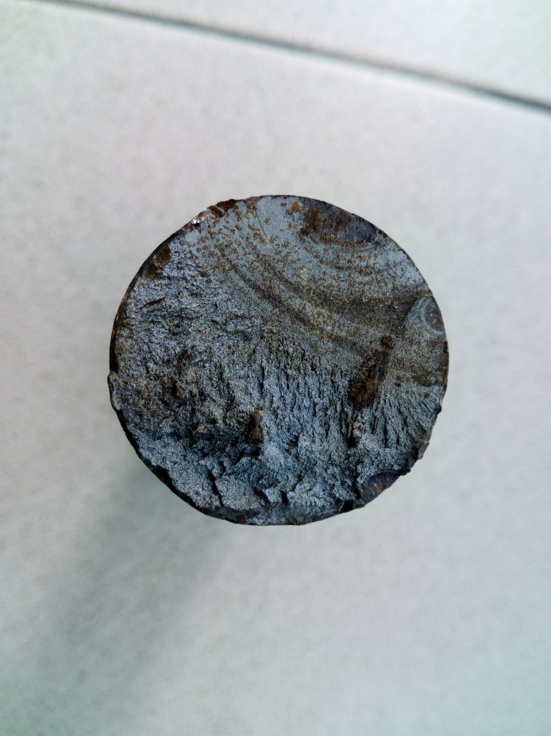
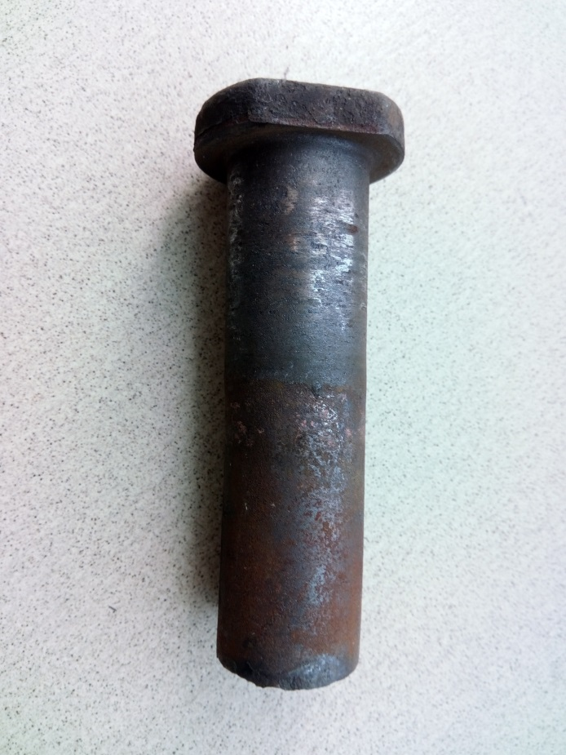
The Commission has carried out a thorough and in-depth examination of the broken hinged bolt and has found out that the reason for the bolt tear-off was material fatigue due to continuous cyclic loading in the symmetrical operating mode of the element.
Fig. 11
1
3
5
6
2
4
Fig. 10
The break up obtained at the site of rupture shows several expressive focus points on the initial centers of destruction (pos. 1, 2, 3 in Fig. 11). They are located in one plane and initialy have originated as separate sources, but subsequently two of them (pos. 1 and 2) merge and thus increase and accelerate the development of the crack. Pos. 4 shows the area of the crack and its own development with concentrically oriented to the focus lines. Here, the process of merging of both primary centers into one crack is evident too. The accelerated development of the crack with the characteristic lines focused on the center follows (pos. 5). This zone is obtained for several cycles before the final destruction. Finally, the final destruction zone (pos. 6) is observed, characterized by the break up of the material.
The Ministry of Transport, Information Technologies and Communications (MTITC) has assigned to BAS to prepare technical expertise on the basis of the spectral, metallographic and fractographic analyzes of the broken hinged bolt sample of the freight wagon № 33520806189-5 spring from the freight train №30560 composition, derailed during the movement between the stations Gavrailovo - Shivachevo on January 26, 2019.
The following tests and analyzes are performed for the purposes of technical expertise:
1. Determination of the chemical composition of the tested object metal (Test Report № 1503-1 / February 14, 2019, issued by BAS ).
2. Metallographic analysis of the tested object metal (Test Report № 1503-2 / February 22, 2019, issued by BAS).
3. Fractographic analysis of the demolished part of the tested object (Test Report № 1503-3 / February 22, 2019, issued by BAS).
The results of the conducted tests and analyzes are:
1. The chemical composition of the material of the object is determined by the optical emission spectrometry method of the "Spectrolab M3" optical spectrometer emission. The results are presented in a table 1:
Table 1
Chemical composition [% by mass]
C | Si | Mn | P | S | Cr | Ni | Al | Cu
0,497 + 0,020 | 0,335 + 0,018 | 0,725 + 0,022 | 0,015 + 0,003 | 0,012 + 0,003 | ˂ 0,499 | ˂ 0,084 | ˂ 0,0247 | 0,230 + 0,012

From the results obtained, it can be concluded that the spring hinge is made of low steel alloy , which by chemical composition corresponds to steel grade 50G bu GOST 4543-71 or steel grade C50 according to BDS EN 10027-1 "Steel marking systems . Part 1: Steel designation ».
2. The microstructure of the tested object metal is determined by the method of light microscopy, (Protocol № 1503-2 / February 22, 2019, issued by BAS).
It has found out that the microstructure of the metal is a perlite-ferrite one (Fig. 1). Percent ratio of the amount of perlite to ferrite is% P /% F = 65/35. The morphology of the perlite is a mixture of lamellate (LP) and grainy (GP) perlite in percentage% LP /% GP = 5/95. The dispersity of the lamellate perlite corresponds to a ball of 6 (medium lamellate pearlite with a distance between the plates of 1 μm). The dispersion of the granular pearlite has a ball of 2 (medium-grained grain of 0.4 μm).

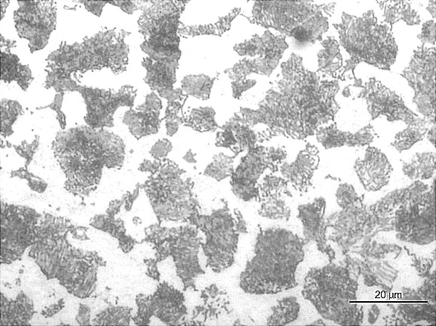 | Fig. 1 Microstructure of the studied material.

3. The fractographic studies of the object destroyed part are carried out using a "Technoval" light stereo microscope and a "JCXA 733" scanning electron microscope (CEM).
The destruction of the hinge in the accident has occurred perpendicular to its axis. For the purpose of the study, a sample containing the ruined surface is cut out from the object. It is well characterized by a large, bald area with relatively smooth relief and markedly tired furrows (Fig. 2).
Thebald (tough) rupture in this area has begun with two separate sources, indicated on Fig. 2 with A and B. The bald furrows from sources A and B are perpendicular to each other (Figures 3a, 3b). Outside of the large bald zone there is another source indicated in Fig. 2 as C. From this source, only one bald furrow (Fig. 3c) is observed. Between bald furrows the destruction is tough.
Fig. 2 General appearance of the broken surface of the hinge. The sources of bald destruction A, B and C.

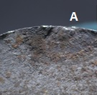 | 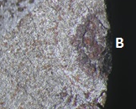 | 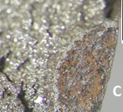
Fig. 3 Sources of bald destruction

As a result of the development of the bald destruction, the wearer section decreases, respectively bearing capacity of the hinge too, after which an accelerated spread of the crack begins by a lean mechanism. This leads to a complete rupture of the hinge. Fig. 4 shows the transition between the bald destruction zone and the zone of
fragile destruction , and in Fig. 5 the area in which the break-up occurs in a fragile mechanism. In the area of the final break-up (the last stage of demolition) an area with elements of tough demolition (fig. 6) is observed. The percentage ratio between the surfaces with bald and accelerated destruction is approximately 40:60.
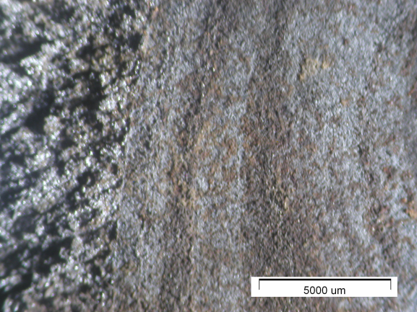 | 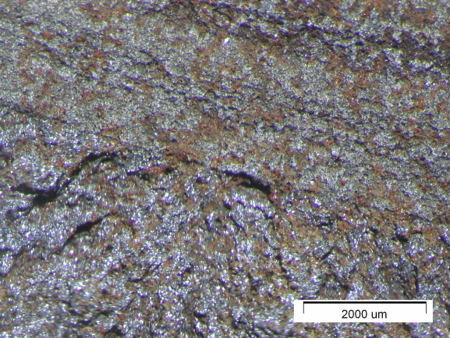
Fig. 4а Moving from a bald destruction zone to a fragile destruction zone in the area of source A | Fig. 4b Moving from a bald destruction zone to a fragile destruction zone in the area of source B

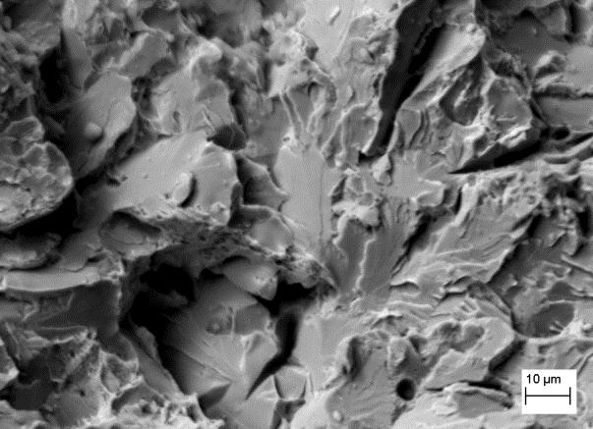 | 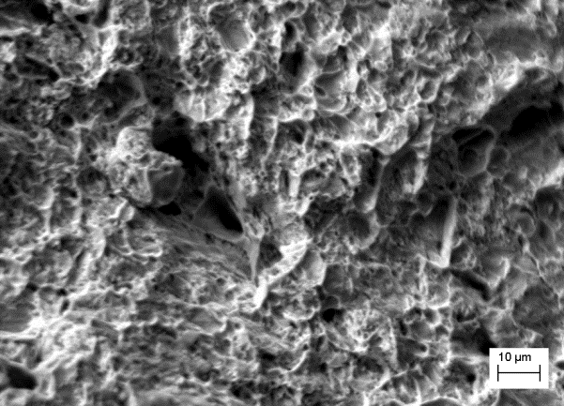
Fig. 5 Zone of fragile destruction (СЕМ) | Fig. 6 Zone of final break up (СЕМ)

Evidences that hinge breakage has begun gradually at a bald mechanism is the relatively smooth surface of the crumbles around the initial centers, the presence of bald furrows and corrosion trails on them. The most likely cause of demolition is defects and impacts on the surface of the hinge.
Conclusions from the metallographic and fractographic analyzes performed:
1. The material from which the ruptured hinge is made is low-steel alloy C50 according to the requirements of BDS EN 10027-1 for the designation of steels according to their chemical composition.
2. The microstructure of the object metal is perlite-ferrite, with a ratio of the amount of perlite to ferrite 65:35.
3. Hinge destruction has begun in a bald mechanism in three zones on the outer surface of the hinge, as the most likely cause of cracking growing is the presence of surface defects. Due to the reduction of the wearer section and the critical reduction of the bearing capacity of the hinge, the destruction has continued through an accelerated distribution of the crack in a lean mechanism. This has led to the complete destruction of the hinge.
14.4. Conclusions.
14.4.1. Direct and main causes;
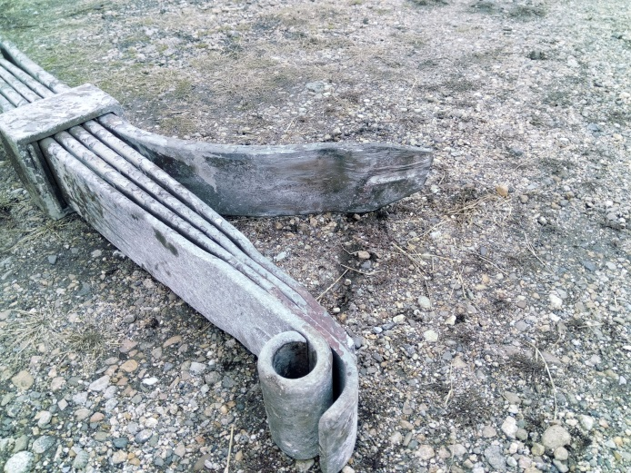
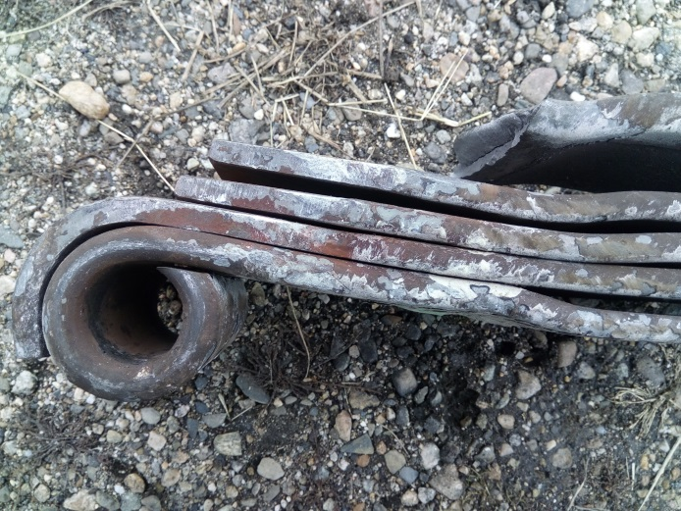
Direct causes for the derailment of the wagon is the tearing of the front hinged bolt of wagon № 33 52 080 6 189-5 left spring leaf of the first bogie first wheel axis in the train movement direction . Upon this, the left-hand wheel of the first wheel axis in the train movement direction has been released, moves upwards, bounces off the head on the left-hand rail of the track, slides from the inside of the wheel and falls on the sleepers. The released front part of the spring leaf in turn bends into the ballast prism, as the lowermost spring leaf has bent on one side, and on the other side a piece of it has broken off.; (fig. 8 and 9).
Fig. 8
Fig. 9
The derailment of first wagon bogie first axle causes the front of the wagon to tilt initially downwards and then upwards, which means that at one point the aft left buffer is stuck in the front left buffer of the next wagon and pulls it out of the holding bolts.
At the same time, both buffers jam has led to a lift of the front part of wagon № 33 52 592 8 528-6, which has caused its derailment.
14.4.2. Hidden concomitant reasons;
The concomitant causes are not the main factor for the damages that have occurred to the rolling stock, but to a certain extent have contributed to the hinge bolt destruction as described above. Such a load is obtained by additional flickering of the wagon crew while driving in a vertical longitudinal plane (galloping), and caused by unevenness along the track (hidden unilateral and chess collapses, weak track gauges, large heat gaps, etc.). In this case, the main factors attributable to the material bald destruction are the amplitude of the oscillation and the number of cycles to which the element has been subjected. Basically, both factors depend on the rail road condition where the traffic is taking place and can be considered as determining possible damages of a similar nature.
14.5. Other conclusions and observations related to violations of the normative regulations established during the investigation, but irrelevant to the reasons.
From the materials and documents provided by the Operational group and additionally requested by the Investigation Commission concerning the locomotive staff driving an electric locomotive № 86018, it was found out that they had not been trained by an accredited training institution for motormen and that the documents certifying the professional qualification for the respective series of locomotives in accordance with the requirements of Art. 18, item 6 of the Vocational Education and Training Act and Art. 44, para. 1, item 1 of Ordinance № 56 from February14, 2003.
The Railway Carrier "DB Cargo Bulgaria" Ltd has developed Safety Procedure PR 22-13 / 03, Version: 01 "Issue and renewal of additional motorman certificates" in force from September 01, 2015, a part of SSM. The procedure sets the requirements of Ordinance № 56/2003 regulating the conditions for issuance of additional certificates to the motormen for the management of a specific type of tractive rolling stock. The principle of assignment in this railway undertaking to the position motorman of the respective series of locomotives with a certificate issued by an accredited training institution is written in item 6.3. For driving a particular locomotive series, the locomotive motorman needs to undergo theoretical and practical training in an accredited training institution for locomotive motormen . After training, the locomotive motorman is attached to an experienced one who has already acquired a professional qualification for this series of locomotives.
Training for the acquisition of professional qualification for the respective series of locomotives and the issue of the relevant document shall be carried out in accordance with Art. 9 of the Vocational Education and Training Act.

15. A description of measures already taken or measures as a result of the accident.
After the accident occurs, urgent partial repairs to restore traffic have been undertaken only for passenger trains at a speed of 25 km / h until the railway infrastructure was fully restored.The National Railway Infrastructure Company on January 29, 2019 has carried out a check on the site of derailment on the compromised railway from km 263 + 000 to km 268 + 950 in the section Tvarditsa - Shivachevo - Gavrailovo and Shivachevo station. The Commission has undertaken emergency measures to restore the track and to bring it into a proper technical condition, in accordance with technical and regulatory requirements.
An emergency renewal of 3985m railroad happens for healing and speeding up with the aim to restore the full capacity of the railway infrastructure. From February 21, 2019, the train movement is restored in the section at a speed of 25 km / h.
16. Recommendations issued in order to avoid accidents upon the same reasons.
In connection with the requirements of Art. 94 para. 1 and para. 3 of Ordinance № 59 from December 5, 2006 about safety management in railway transport, in order to improve safety in railway transport, EA "Railway Administration" in the capacity of National Safety Authority to recommend to "DB Cargo Bulgaria" Ltd and RINC SЕ to implement the safety recommendations.
1. The managers of "DB Cargo Bulgaria" Ltd and SE RINC in the working talks with the transport safety personnel should be familiar with the content of the final report.
2. SE RINC to analyze the results of the measurements on the railway track, carried out by "TINSA" Ltd M-120 Laboratory in the Dubovo-Zimnitsa section, with a deteriorated state in particular sections.
3. "DB Cargo Bulgaria" Ltd shall instruct the personnel engaged in the technical maintenance of the non-tractive rolling stock that it operates to increase the quality of the technical examinations carried out at the stations with technical persons in accordance with the prepared "Risk Assessment" part of SSM.In connection with the requirements of Art. 94 para. 4 of Ordinance № 59 from December 5, 2006 about the safety management in the railway transport EA "Railway Administration", "DB Cargo Bulgaria" Ltd and RINC shall notify in written the head of SRAIIU in MTITC for the actions undertaken to implement the given recommendations for safety.

Sofia, May 20, 2019

Chairman:
Dr. eng. Boycho Skrobanski
Head of NIB in MTITC

