MINISTRY OF TRANSPORT,
INFORMATION TECHNOLOGIES AND COMMUNICATION

9, Diakon Ignatiy Street, 1000 Sofia bskrobanski@mtitc.government.bg
tel: +359 2 940 9317 mail@mtitc.government.bg
fax: +359 2 940 9350

SPECIALIZED UNIT FOR INVESTIGATIONS OF ACCIDENTS AND INCIDENTS IN RAILWAY TRANSPORT

FINAL REPORT

from

a railway accident investigation - a collision between diesel locomotive № 07065 and Rail Maintenance Car-33 in Kaspichan station on October 14, 2019

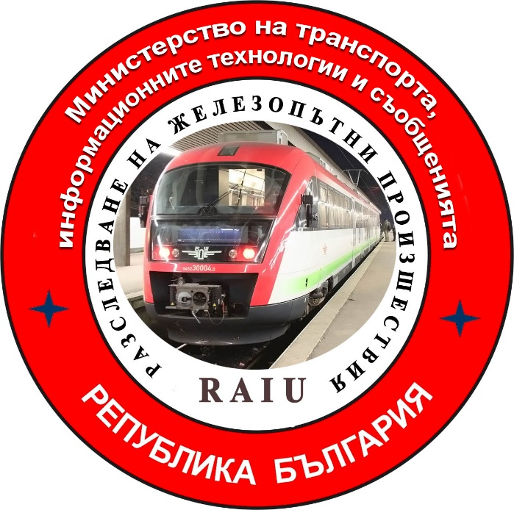

2020
FINAL REPORT

Purpose of the investigation and degree of responsibility

The Investigation of serious accidents, accidents and incidents is carried out by an independent investigation authority of the Republic of Bulgaria - "Specialized Unit for Investigation of Accidents and Incidents in Railway Transport" in the "Ministry of Transport, Information Technologies and Communications" (MTITC) and it aims:
To identify the circumstances and the reasons that led to their implementation with a view to improve safety and prevent from others without seeking personal responsibility and guilty.
The investigation is carried out in accordance with the requirements of Directive 2004/49 / EC of the European Parliament and of the Council upon safety of the Community's railways transpositioned in the Law for Railways ( LR ), Ordinance № 59 from December 5, 2006 about the management of safety in railway transport, Ordinance № H-32 from September 19, 2007 about the coordination of the actions and the exchange of information during investigations of railway accidents and incidents and the Agreement for interaction during investigations of accidents and incidents in the air, waterway and railway transport between the Prosecutor's Office of the Republic of Bulgaria, Ministry of Interior and MTITC from April 17, 2018.

CONTENTS
1. Summary………………………………………………………………………...…..………4
2. Direct facts and circumstances ……………..……………………….…………..…..……..6
3. General data established during the investigation process …….……………..…...……..9
4. Deaths, injuries and material damages ………………………………………………......10
5. External circumstances - weather and geographic conditions ……….………….…..….11
6. Data for railway infrastructure and railway carrier staff related to the accident…......11
7. Data from other investigations. Summary of testimony …………………………..……..14
8. System of Safety Management (SSM) of NRIC and BDZ FT EOOD …………………..16
9. Rules and norms ………………………………..………………………….…..…………...16
10. Functional condition of rolling stock and technical facilities of the railway
infrastructure ………………………..………….......…………………..……..……...17
11. Operational System Documentation …………………………………..…………………17
12. Health and Safety work conditions …………………………..…………………….…….18
13. Accidents of similar nature previously registered …………………………………........19
14. Analysis and conclusions ……………………………………………..……….…..………19
15. Recommendations issued in order to avoid accidents upon the same reasons …….….25

- Summary.
1.1. Brief description of the event
On October 14, 2019, at 19:05 hrs, a request was submitted in Regional Operational Dispatch Unit (RODU) by the Senior Dispatcher “Operational Management of the Transport” ( OMT ) in Gorna Oryahovitsa Freight Transport Unit (FTU) at BDZ Freight Transport EOOD to appoint the movement of diesel locomotive № 07065 after its attachment to Rail Maintenance Car -33 at Kaspichan station to leave for Sindel-distribution station.
The head of traffic / senior train dispatcher at RODU Gorna Oryahovitsa orders the head of traffic/ train dispatcher of the Shumen - Varna section to cancel the movement of Rail Maintenance Car-33 and to appoint both vehicles for movement as train № 20997. At 19:15 hrs the train dispatcher has instructed the duty heads of traffic at stations Caspichan, Provadia and Sindel to appoint the train № 20997 movement.
At 19:10 hrs, the head of traffic on duty at the Kaspichan station orders the switchmen at Post № 1 and № 2 for the forthcoming exit of diesel locomotive № 07065 from the Kaspichan outfit post (OP). The same will be let to pass on 14th track and stationed on 4-th track in the Kaspichan station, occupied by Rail Maintenance Car-33, and after they are attached, they will leave for Sindel-distribution station.
At 18:35 hrs in the Kaspichan OP, the last shift depot master informs the new shift one that diesel locomotive № 07065 has to leave the station and to depart for Sindel-distribution station.
The locomotive brigade arrives at 19:00 hrs in the Kaspichan OP, inspects the locomotive, a travel briefing is conducted and at 19:15 hrs the locomotive is let to move to Post № 1 for entering the station.
After receiving the verbal permission from the head traffic on duty, the switchman at Post № 1 exchanges a telephone gram with the depot master on duty in the Kaspichan OP for the exit of locomotive № 07065 on 14-th track at the station. The switchman at Post № 2, after noticing the incoming locomotive on 14 th track, prepares the route for the withdrawal track and stops it after switch № 19. The switchman prepares the route to 4-th track and sends a "Forward" signal. The locomotive takes the prepared route to 4-th track to the station without stopping in front of Post № 2.
The locomotive drivers has not seen the motor tractor on 4-th track, has not seen any signals, has not reduced the speed of the locomotive, and subsequently strikes the motor tractor.
Because of the impact, the motorman of the tractor loses balance and falls off the platform between 4-th and 5-th tracks. He receives a number of serious injuries since the fall. The other motorman of the tractor manages to grasp and only gets slightly injured.
An emergency alert is issued to 112 by phone. No injuries are reported from the locomotive drivers in diesel locomotive № 07065.

1.2. Main cause of the accident
The main reason for the accident is the peculiarity in the control of locomotive № 07065 from the rear cabin, which limits the visibility of the locomotive drivers, thus they have not seen the Rail Maintenance Car-33 which has been stopped on 4-th track and subsequently they have hit at the speed of 21 km/h.
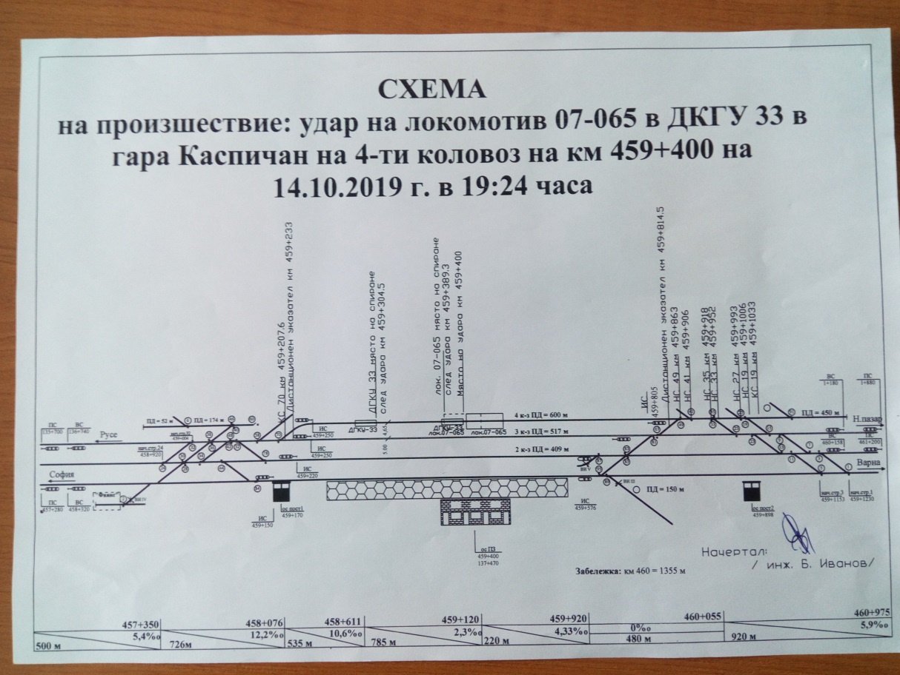
1.3. Summary of the main recommendations
Fig. 1
Legend:
- the location of locomotive 07065 at the moment of impact;
- the location of locomotive 07065 after the impact;
- the location of Rail Maintenance Car-33 at the moment of impact;
- the location of Rail Maintenance Car-33 after the impact.
The recommendations that have been given aim to improve the safety management systems in the railway enterprises.
1. It is proposed to the railway enterprises BDZ Freight Transport EOOD and SE NRIC to familiarize the personnel directly engaged in Rail Maintenance Car, operation, station and maneuvering activities with the contents of the report by an extraordinary briefing.
2. It is proposed to BDZ Freight Transport EOOD to issue a motorman license indicating the railway infrastructure for which he has been certified and the rolling stock entitled to drive in accordance with the requirements of Directive 2007/59 / EC.
3. It is proposed to SE NRIC to update "Instruction № 13 / June 29.2006 for joint work between Kaspichan Station and Kaspichan OP" when moving locomotives from the post to the station and vice versa.
4. It is proposed to BDZ Freight Transport EOOD to supplement the "Rules for the management of the transport activity in the transport planning and operational management" in Section VII "Operational interaction in the transport management " with a text obliging the operational sector in OMT to pass the operational decisions to the immediate contractors.
2. Direct facts and circumstances.
2.1. Date and time of the event
On October 14, 2019, at 19:05 hrs the Head of Movement/Senior Train Dispatcher at Regional Operational Movement Unit (RODU) - Gorna Oryahovitsa at NRIC receives request № 16 from the Senior Dispatcher/ Shift Operational Management of the Transport at the "Freight transport “ unit Gorna Oryahovitsa (FTU-GO) at BDZ“ Freight Transport” EOOD diesel locomotive № 07065 to be assigned to movement. The head of traffic / senior train dispatcher in RODU Gorna Oryahovitsa orders the head of traffic/ train dispatcher in the section Shumen-Varna to cancel the movement of Rail Maintenance Car-33 and to plan both vehicles' movement as of train № 20997. The locomotive is to be composed with Rail Maintenance Car-33 at Kaspichan station and both vehicles to leave for Sindel-distribution station as a single stock due to the lack of bandwidth in the section.
At 19:15 hrs, the head of traffic/train dispatcher receives the timetable for train № 20997, which he has ordered to the heads of traffic on duty at Kaspichan, Provadia and Sindel stations.
At 19:10 hrs, the head of traffic on duty at Kaspichan station orders the switchmen at Post №1 and № 2 for the forthcoming exit of diesel locomotive № 07065 from the Kaspichan outfit post. It is to be let to pass on 14-th track and to be stationed on 4-th track and composed with Rail Maintenance Car-33, after which they have to depart at 19:45 hrs as train № 20997 to Sindel train station.
At 16:00 hrs, the locomotive dispatcher at FTU-GO orders the depot master on duty at the Kaspichan OP that the locomotive brigade for locomotive No 07065 must report at 19:00 hrs the acceptance of the locomotive. The new depot master in Kaspichan OP has been informed by the last shift one, at 18:35 hrs, that locomotive No 07065 has to leave the station by 19:30 hrs and to leave for Sindel-distribution station.
The locomotive drivers arrives at 19:00 hrs. They accept the locomotive after an inspection and a held travel briefing.
At 19:15 hrs the locomotive is let to move to Post № 1 for tracking into the station. This is followed by an oral permission from the duty head of traffic for the diesel locomotive No 07065 to pass along 14-th track. At 19:20 hrs, the post switchmen exchange telephoned telegram for letting locomotive № 07065 to pass on 14-th track. The switchman at Post № 2, after noticing the incoming locomotive on 14-th track, prepares the route for the withdrawal track and passes them a "Forward" signal. After the passing of point № 27, the locomotive stops after point № 19. The post switchman prepares the route to 4-th track and passes the signal “Forward”. The locomotive beeps a caution signal and proceeds along the prepared route to 4-th track to the station. The forward-facing cab is dark and the locomotive is signaled by a red light, and the train head signalling is from the rear cabin to the side of the station Provadia (as seen in the explanations of the post switchman on Post № 2). As they pass Post № 2, the locomotive does not stop to ask where they are going. Post № 2's switchman has not signaled, "Stop" to alert them for the motor vehicle on 4-th track. The locomotive continues its movement towards the station at a speed of about 21 km/h and at the same speed hits the Rail Maintenance Car-33.
According to the testimony of the depot master on duty at the Kaspichan OP, the locomotive driver and the assistant locomotive motorman, no one has explained the maneuver at the station. They were not informed that there was another vehicle on the track that they needed to attach to, and that 4-th track was dimly lit.
The Rail Maintenance Car-33 motormen, seeing the locomotive on 4-th track, signal the Rail Maintenance Car for a train queue and one of them exits the cab, steps on the Rail Maintenance Car for descent and hitch to a locomotive. At that moment, seeing that the locomotive is not slowing down, he begins to shriek and shout, but the locomotive crew does not notice that, does not slow down and hits the Rail Maintenance Car. The Rail Maintenance Car has stayed with its hand brake applied and after the subsequent impact from the locomotive it moves to 95.5 m. No derailment occurs.
At about 20:00 hrs a car of emergency medical care arrives at Kaspichan station. It takes the injured motormen of the motor tractor to NMB - Shumen. One of the motormen is hospitalized and discharged from the hospital, the other motorman of the Rail Maintenance Car is left for treatment at the hospital.
2.2. Event’s location
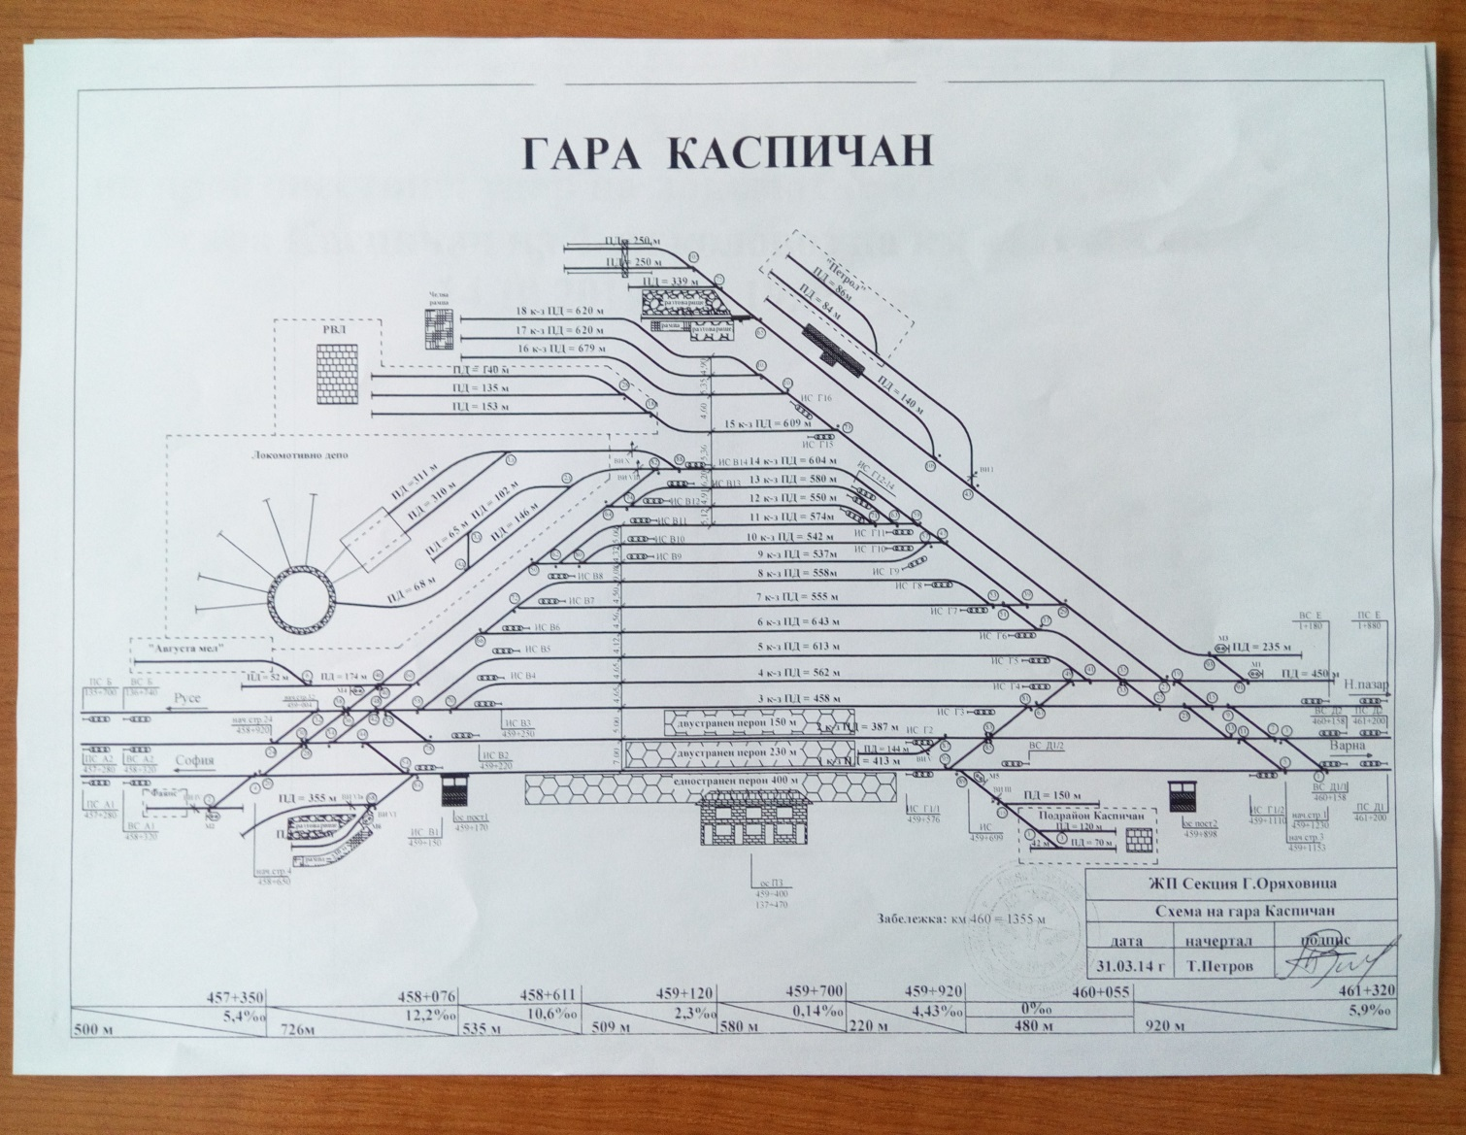
The event takes place on 4th track in Kaspichan station. Kaspichan Station is a hub for the 2nd and 9-th main railways and is located at 459 + 400 km. The station has 14 tracks. In the station there is an outfit post for locomotives of BDZ Freight Transport EOOD (Fig. 2).
Fig. 2. Scheme of the tracks at Kaspichan station
2.3. Event’s classification
On October 14. 2019, at 19:26 hrs in connection with the requirements of Art. 115k, para. 2 of the Railway Transport Act (RTA) the Head of the Specialized Unit for investigation of Railway Accidents and Incidents (SUIRAI) at the Ministry of Transport, Information Technology and Communications (MTITC) is notified.
On October 15, 2019, after analyzing the collected operational information on the spot, at the Kaspichan station, the head of SUIRAI categorizes the event as a railway accident, in accordance with Art. 19 (2) (a) of Directive 2004/49 / EC and Art. 68, para. 1, item 2 and para. 2 of Ordinance № 59, for which he notifies the interested parties.
2.4. Consequences of the Event
- two Rail Maintenance Car-33 motormen are injured ;
- the motorman and the assistant motorman of locomotive No 07065 are not injured;
- no damage to the railway infrastructure;
- Rail Maintenance Car-33 sustains serious damage;
- diesel locomotive No 07065 has no damage;
- no damage to the environment.
2.5. Decision to initiate an investigation
The decision to initiate an investigation is taken by the head of the SUIRAI at MTITC on the grounds of Art. 115k, para. 1, item 2 of the RTA and Art. 76, para. 2, item 1 of Ordinance № 59.
Composition of the commission
An investigative commission is appointed at the Ministry of Transport, Information Technology and Communications (MTITC). Chairman of the commission is the head of SUIRAI. The commission includes external experts with appropriate qualification and professional orientation to the event.
Investigation
The Chairman of the Investigation Committee at MTITC has allowed the Head of the Operational Group in Gorna Oryahovitsa to extend the deadline for submitting the materials in order to collect all the necessary documents and prepare a report under Ordinance № 59.
In the period November 06 - 07. 2019, at the Regional Inspectorate for "Transport Safety" in Gorna Oryahovitsa, the Investigation Commission accepts from the 2nd Category Operational Group, a report with the documents and materials collected therein. The Commission interviews the shift staff involved in the implementation of the NRIC and BDZ FT accident and requests their written evidence.
In the period January 14 ÷ 17. 2020, the Investigation Commission leaves for the City of Novi Pazar and together with the competent investigative body of MoI PD - Novi Pazar, analyzes the circumstances that has led to the accident, both in terms of safety and Criminal Procedure Code (CPC).
With the permission of the supervising prosecutor at the District Prosecutor's Office - Novi Pazar, the investigative body at the MoI PD - Novi Pazar provides copies of the collected materials under CPC to the MTITC Commission.
On January 15.2020, the Commission carries out inspections at Kaspichan Station in the interval 19 ÷ 20:00 hrs - the time of occurrence of the accident in order to establish the light at the station and the possibility of communication and reception of signals by the staff in Post No 1 and No 2. An interview is conducted with the night watch staff at the station and with the depot master on duty at the Kaspichan outfit post.
When the seriously injured second motorman of the motor tractor has recovered, the Commission interviewed him in the Shumen railway section, requesting his affidavit.
It is found that both enterprises (NRIC and BDZ FT) are operating with an outdated "Instruction for joint work between the Kaspichan railway station and Kaspichan outfit post from October 29.2006" in Kaspichan station.
The Investigation Commission conducts a speedometer tape decoding and movement analysis of diesel locomotive No 07065 since its exit from OP Kaspichan until the moment of the impact and its stopping. The speed of movement at the moment of impact with the motor tractor is determined as well as the exact time of impact.
In the course of the investigation, the report submitted by the Operational Group and the documents collected thereto are analyzed, and materials and documents submitted by NRIC and BDG Freight Transport EOOD related to the investigation are additionally requested.
The investigative commission’s chairman accepts the written standpoints of the external experts involved in the investigation commission in fulfillment of the tasks assigned to them during the investigation.
2.6. Conducting rescue and emergency-restoration actions
At 19:26 hrs, the diesel locomotive No 07065 motorman signals to 112 by phone asking medical assistance to the injured Rail Maintenance Car-33 motormen due to the accident.
At 20:00 hrs a specialized car of the NMB - Shumen arrives at Kaspichan station. After the injured motormen receive first medical care they are taken for treatment to the NMB - Shumen.
After the medical examinations at NMB - Shumen it is found that:
- the motor tractor's motorman has received fractures on four ribs, on the left shoulder and on the thumb of the right hand, as well as abrasion wounds on the body. He is left for treatment for 15 days. The motorman assistant is given medical care and is discharged from the hospital the same day.
No rescue and emergency-restoration actions have been taken. With the permission of the competent investigating authorities under the CPC, the locomotive is released and departs in the direction of Sindel Distribution Station. Due to the damage inflicted on Rail Maintenance Car-33, it is left at Kaspichan station to be moved to a repair point.
3. General data established during the investigation process.
3.1. Participating officers
NRIC personnel:
- head of traffic on duty/ Senior Train Dispatcher at RODU Gorna Oryahovitsa;
- head of traffic on duty / Train Dispatcher at RODU Gorna Oryahovitsa;
- head of traffic on duty at Kaspichan station;
- post switchman at Post № 1;
- post switchman at Post № 2;
- Rail Maintenance Car motorman;
- Rail Maintenance Car motorman assistant.
BDZ “Freight Transport” EOOD personnel:
- shift work senior dispatcher at ,,Freight Transport Unit“ Gorna Oryahovitsa (FTU-GO) at BDZ “Freight Transport” EOOD last shift;
- shift work senior dispatcher at ,,Freight Transport Unit“ Gorna Oryahovitsa (FTU-GO) at BDZ “Freight Transport” EOOD new shift;
- motorman of diesel locomotive № 07065;
- motorman assistant of diesel locomotive № 07065;
- duty depot master on shift – October 14. 2019, at OP Kaspichan.
- duty depot master on shift – October 14/15.2019, at OP Kaspichan.
3.2. Data on the carrier
- BDZ "Freight Transport" EOOD is a state railway company licensed to carry out freight transport in the Republic of Bulgaria;
- it holds a national cargo license No 203 / January 24, 2019;
- it holds a safety certificate Part "A" BG 11 2017 0008 valid from December 31. 2017 to December 30.2022;
- it holds a safety certificate Part "B" BG 12 2017 0008 valid from December 31. 2017 to December 30.2022;
- it holds a certificate of an entity responsible for the maintenance of railway vehicles BGRA / 2017/0003 valid from December 31. 2017 to December 30.2022 ;
3.3. Tractive rolling stock type and number
- diesel locomotive № 07065 - regular registration in Vehicles’ register;
3.6. Railway infrastructure description
Railway of 4-th track in Kaspichan station:
- with fishplates, rail type S 49, laid on CT-4 sleepers, in straight, with profile –4,33 ^{о}/_{оо} uphill towards Mutnitsa station;
3.7. Signalization, station safety installations and between-station block system
- Kaspichan Station is equipped with Route Relay Centralization (WSSB GS -2);
- the second railway line sections Mutnitsa - Kaspichan - Provadia are two-road sections equipped with a Semiautomatic Blockage (SAB);
- the ninth railway line section Kaspichan - Pliska is a one-road section equipped with Semiautomatic Blockage (SAB);
3.8. Train protection
- diesel locomotive № 07065 is equipped with a regular and plumbed alertness device;
3.11. Communication system
- Kaspichan station is equipped with a station hub, a railway telephone, a train-to-dispatcher radio connection (TDRC), a maneuver radio system and a mobile connection. The head of traffic on duty establishes a telephone connection through the station hub with the points posts in the station, with the adjacent stations, with the train dispatcher and the power dispatcher;
- the locomotive brigade in locomotive No 07065 and in Rail Maintenance Car-33 have official mobile phones;
4. Deaths, injuries and material damages.
4.1. No deaths;
4.2. Injured personnel; – two Rail Maintenance Car-33 motormen;
4.4. Material damage;
For BDZ “Freight Transport” EOOD
- diesel locomotive № 07065 – no damage;
For NC “Railway Infrastructure”
- railway – no damage;
- damage to motor tractor Rail Maintenance Car-33 – 31 474,00 BGN;
For the environment – none
Total damage from the accident amount to: 16 140,50 €.
5. External circumstances - weather and geographic conditions.
Meteorological report for October 14. 2019 by MS - Shumen for Kaspichan;
- in the dark part of the day – 19:00 ÷19:30 hrs;
- air temperature +15º С;
- wind speed 7 км/ч;
- clouds – clear.
6. Data for railway infrastructure and railway carrier staff related to the accident.
6.1. Position, place of work, sex and age
NC “Railway Infrastructure” personnel
- driver -senior – Railway section - Shumen, man at 55 years;
- driver -assistant – Railway section - Shumen, man at 48 years;
- duty head of traffic – Kaspichan station – RTMSA – Gorna Oryahovitsa, man at 44 years;
- pointsman/post at post № 1 – Kaspichan station – RTMSA – Gorna Oryahovitsa, man at 42 years;
- pointsman/post at post № 2 – Kaspichan station – RTMSA – Gorna Oryahovitsa, man at, 54 years;
- head of traffic/train dispatcher –Sh – Va – RTMSA – Gorna Oryahovitsa, man at 54 years;
- head of traffic/senior train dispatcher – RTMSA – Gorna Oryahovitsa, man at 45 years;
BDZ “Freight Transport” EOOD personnel
- locomotive driver – Locomotive depot Rousse, man, 53 years;
- locomotive, assistant driver – Locomotive depot Rousse, man, 55 years;
- depot master last shift – OP Kaspichan at Locomotive depot Rousse, man, 49 years;
- depot master new shift – OP Kaspichan at Locomotive depot Rousse, man, 52 years;
- shift work senior dispatcher at ,,Freight Transport Unit“ G.Oryahovitsa, man, 60 years;
6.2. Position certificate and certificate data
NC “Railway Infrastructure” personnel
- Rail Maintenance Car -senior – Certificate № 142/February 28.2018, for occupying position Rail Maintenance Car;
- Rail Maintenance Car -assistant – Certificate № 143/ February 28.2018, for occupying position Rail Maintenance Car;
- duty head of traffic – Certificate № 2969/March 16. 2015, for occupying position Head of traffic;
- pointsman/post at post № 1 – Certificate № 3410/October 30.2017, for occupying position post pointsman;
- pointsman/post at post № 2 – Certificate № 2591/December 29.2011, for occupying position post pointsman;
BDZ “Freight Transport” EOOD personnel
- locomotive driver – Certificate № 12/October 21.2013, for occupying position locomotive motorman train work ;
- locomotive, assistant driver – Certificate № 62/October 16.2018, for occupying position locomotive motorman assistant;
- depot master new shift OP Kaspichan – Certificate № 20/January 13.2016, for occupying position, locomotive instructor/depot master;
6.3. Qualification certificate and certificate data
NC “Railway Infrastructure” personnel
- driver -senior – Qualification certificate № 1416/September 28.1990, acquired qualification for motorman of a motor tractor, RVP – Sofia at F BDZ;
Locomotive driver license BG 7120160210 – EA RA;
Additional certificate № BG7120160210 valid through February 29.2020, issued by SE NRIC and SP in accordance with Ordinance 2007/59/ЕО;
- driver -assistant – Certificate № 8727/May 07.2008, acquired qualification: motorman of heavy road machinery, teaching structure PTC at NRIC;
Locomotive driver license BG 7120174146 – EA RA;
Additional certificate № BG7120171146 valid through February 29.2020, issued by SE NRIC and SP in accordance with Ordinance 2007/59/ЕО;
- duty head of traffic – Qualification certificate № 10279/May 07.2009, acquired qualification: head of traffic, teaching structure PTC at NRIC;
- pointsman/post at post № 1 – Qualification certificate № 12139/April 27.1990, acquired qualification: maneuver and post pointsman, teaching structure CPPKK-G.Oryahovitsa at F BDZ;
- pointsman/post at post № 2 – Qualification certificate № 14701/November 25.1996, acquired qualification: pointsman/crossing guard, teaching structure CPPKK-G.Oryahovitsa at F BDZ;
BDZ “Freight Transport” EOOD personnel
- locomotive driver – Certificate № 664-664/July 03.2012, acquired qualification: locomotive motorman on diesel locomotive series 07, teaching structure PTC BDZ;
Locomotive driver license BG 71 2018 1605 – EA RA;
- locomotive driver -assistant – Qualification certificate № 20741, acquired qualification for locomotive motorman-assistant, PTC BDZ, conducted training from January 22. till June 06.2018.
- depot master new shift OP Kaspichan – Diploma № 22897/July 20.1989, acquired qualification: locomotive motorman on diesel locomotive, teaching structure HMTS ,,Todor Kableshkov“ Sofia;
Certificate № 124/July 06.1992, for retraining from a diesel locomotive motorman to an electric locomotive motorman, teaching structure CPPKK at F BDZ;
6.4. Document for professional qualification
NC “Railway Infrastructure” personnel
- driver -senior – Qualification certificate № 028683/June 30.1981, STS in agricultural mechanization in Byala, Varna district;
- driver -assistant – Diploma for secondary education № 051361/June 28.2007, SOU ,,St.St. Ciril I Metodii“, Sindel – Avren municipality;
- head of traffic – Diploma for a college education № 22841/August 20.1988;
- pointsman/post at post № 1– Diploma for secondary education № 6461-051/June 24.2004, PGEE –„Konstantin Fotinov” Burgas;
- pointsman/post at post № 2 – Diploma for secondary education № 001032/July 28.1995, SSRPS Gorna Oryahovitsa.
BDZ “Freight Transport” EOOD personnel
- locomotive driver – Diploma for secondary education SPTU in MSS Targovishte, № 000945/July 30.1984;
- locomotive driver -assistant – Diploma for secondary education № 014644/June 30.1983, TMT ,,Hr. Botev“Shumen;
- depot master new shift OP Kaspichan – Diploma № 22897/July 20.1989, acquired qualification: locomotive motorman on diesel locomotives, teaching structure HMTS ,,Todor Kableshkov“ Sofia;
6.5. Certificate for passing an examination as per Ordinance № 56 from 2003.
NC “Railway Infrastructure” personnel
- driver, senior – pr. XІ-28-28/June 22.2018;
- driver, assistant – pr. XІ-28-56/December12.2016;
- head of traffic Kaspichan station– pr.XІ-26-37/June 01.2018;
- post pointsman at post № 1 at Kaspichan station – pr.XІ-26-29/May 18.2018;
- post pointsman at post № 2 at Kaspichan station – pr.XІ-26-32/May 23.2018;
BDZ “Freight Transport” EOOD personnel:
- locomotive driver – pr.XІ-28-22/June 06.2018;
- locomotiveq assistant driver – pr.230/August 01.2018;
- depot master last shift OP Kaspichan – pr.XІ-28-21/June 06.2018;
- depot master new shift OP Kaspichan – pr.XІ-28-23/June 07.2018;
6.6. Personnel break duration before time staff
In accordance with the requirements of the normative acts - Labour Code and Ordinance № 50 / December 28, 2001 – the personnel participating in the accident is provided with the required rest period before their work:
NC “Railway Infrastructure” personnel
- driver -senior – rests from 13:00 hrs on October 13.2019 till 13:00 hrs on October 14.2019;
- driver -assistant – rests from 13:00 hrs on October 12.2019 till 13:00 hrs on October 14.2019;
- head of traffic Kaspichan station – rests from 18:55 hrs on October 13.2019 till 18:55 hrs on October 14.2019;
- post pointsman at post № 1 at Kaspichan station – rests from 18:55 hrs on October 13.2019 till 18:55 hrs on October 14.2019;
- post pointsman at post № 2 at Kaspichan station – rests from 18:55 hrs on October 13.2019 till 18:55 hrs on October 14.2019;
BDZ “Freight Transport” EOOD personnel
- locomotive driver – rests from 19:20 hrs on October 13.2019 till 19:00 hrs on October 14.2019;
- locomotive driver -assistant – rests from 19:20 hrs on October 13.2019 till 19:00 hrs on October 14.2019;
- depot master new shift OP Kaspichan – rests from 19:00 hrs on October 13.2019 till 19:00 hrs on October 14.2019;
6.7. Work experience of the staff
NC “Railway Infrastructure” personnel
- driver -senior – 29 years;
- driver -assistant – 3 years;
- head of traffic Kaspichan station – 22 years;
- post pointsman at post № 1 at Kaspichan station – 25 years;
- post pointsman at post № 2 at Kaspichan station – 20 years;
BDZ “Freight Transport” EOOD personnel
- locomotive driver – 33 years;
- locomotive driver -assistant – 2 years;
- depot master new shift OP Kaspichan – 39 years;
6.8. Shift (travel) briefing
NC “Railway Infrastructure” personnel
- The Kaspichan station staff on duty on October 14/15. 2019, is briefed and the same by personal signature in the instruction book declare that they are cheerful, rested and haven’t used alcohol and other narcotics. They are informed about the forthcoming maneuver of diesel locomotive No 07065 from Kaspichan OP on 4th track at the station to be hitched to Rail Maintenance Car-33, then to leave as train No 20997 for Sindel-distribution station;
BDZ “Freight Transport” EOOD personnel
- The locomotive drivers of locomotive № 07065 is briefed by the depot master on duty at Kaspichan OP and, by their signatures in the instruction book, they declare that they are cheerful, rested and haven’t used alcohol and other narcotics. During the briefing, the locomotive drivers has not been aware of the conditions of the forthcoming maneuver with the locomotive in the station (as seen in the briefing);
7. Data from other investigations. Summary of testimony
The investigation commission doesn’t have testimony.
8. System of Safety Management (SSM).
8.1. Observing the procedures set out in SSM of NRIC
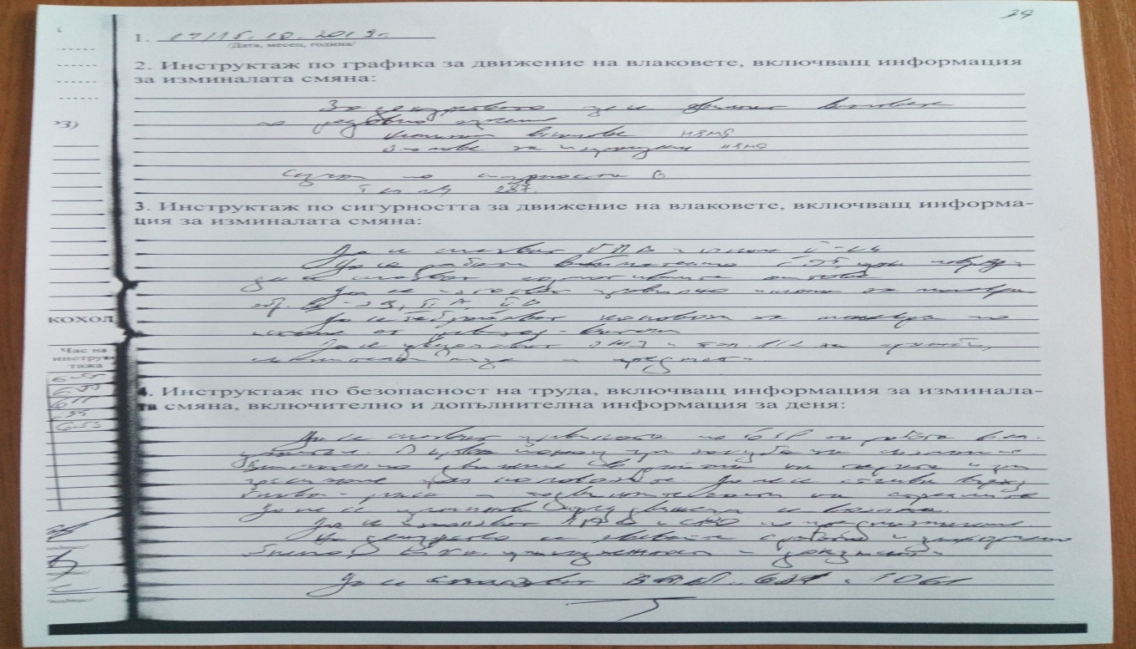
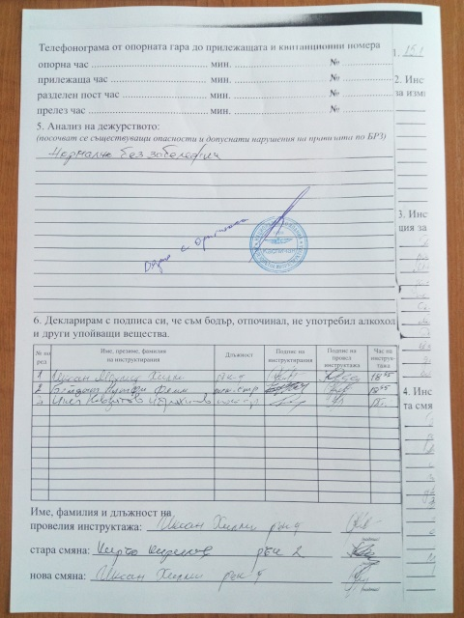
The Investigation Commission requested and got acquainted with the procedures laid down in SSM, which are relevant to the staff of the "Railway Traffic Management and Station Activities" (RTMSA) - Gorna Oryahovitsa. The same have been observed by the shift personnel at Kaspichan station with admitted gaps in communication with the locomotive brigade of locomotive No 07065. After the exit of the locomotive from OP Kaspichan, the movement of the locomotive is regulated by the verbal permission of the duty head of traffic in Kaspichan station and the exchanged telephoned telegrams between the depot master and post pointsmen at posts №№ 1 and 2 at the Kaspichan station, regulated by the Rules for trains movement and maneuvering (RTMM). During the maneuver at Kaspichan station, the station staff has not explained to the locomotive brigade of locomotive № 07065 the forthcoming maneuver and its hitching to Rail Maintenance Car-33 located on 4-th track of Kaspichan station ( Fig. 3).
Fig. 3. Kaspichan station Instruction book for the duty on October 14/15. 2019
8.2. Compliance with the procedures in Safety Management System (SSM) of BDZ "Freight Transport" EOOD
The Investigation Commission requested the procedure laid down in SSM of the railway carrier BDZ "Freight Transport" EOOD and after acquainted with it, found the following:
During the inspection of the technical documentation of locomotive No 07065 no violations of the current “Regulations for factory and depot repair and maintenance of diesel locomotives” are found and registered. The locomotive brigade, after coming on a shift in Kaspichan OP, has adhered to the technology for adopting the locomotive for operation and briefing by the duty depot master at OP.
On November 12, 2019, at the Locomotive Depot Plovdiv, the Investigation Commission carried out tests on both locomotive motorman-taps for the direct brake type Zb3 of locomotive
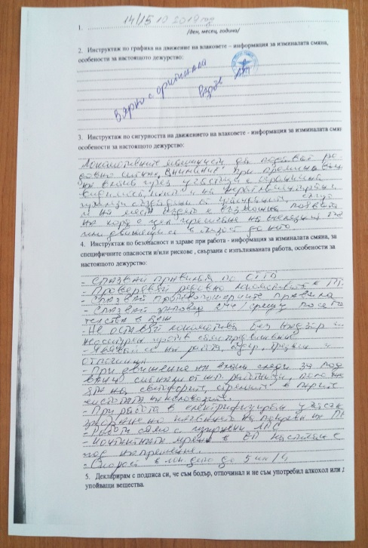
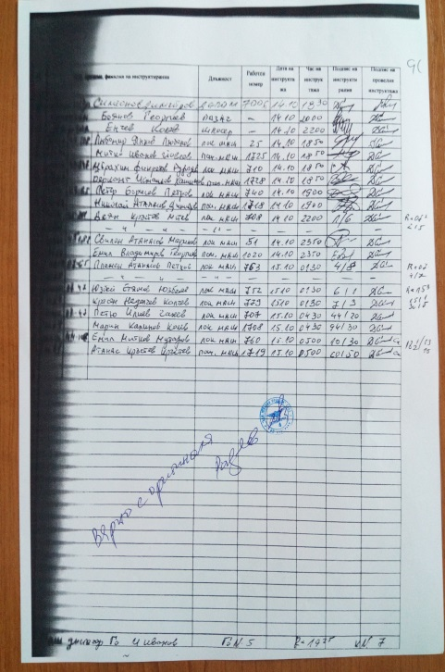
№ 07065 by the "Stand for testing and diagnostics of brakes" at Locomotive Depot - Plovdiv.
Fig. 4. Kaspichan OP Instruction book for the duty on October 14/15. 2019

On the same date, control tests are carried out in the laboratory of the Locomotive Depot - Plovdiv on both speedometers RT 9 and A 16 of locomotive No 07065 both cabins.
The results of the tests carried out are documented in protocols dated November 12. 2019, which certifies the correctness of the abovementioned apparatus.
In connection with the requirements of "BDZ TP Transportation Management Regulations", the Investigation Commission identifies communication gaps in the transport management. There are no written texts regulating the exchange of information from a locomotive dispatcher to a depot master for the appointment of locomotive movement on the railway infrastructure. This is evident from the Book for conducting daily briefings of locomotive brigades in Kaspichan OP, which does not contain a text setting out the conditions for the movement of locomotive 07065 to Sindel-distribution station (Fig. 4)
9. Rules and norms.
9.1. The NRIC shift staff at Kaspichan Station have admitted gaps during the accident fulfilling their obligations arising from the requirements of Art. 475, para. 2 and Para 3 of RTMM, relevant to the provisions of item 97 in the Kaspichan Station Technology.
9.2. The drivers servicing Rail Maintenance Car-33 from NRIC's Shumen Railway Section on October 14. 2019 admits gaps in compliance with Art. 36, para. 1 in connection with Art. 33, para. 1 of the OTM motorman's Instruction Manual.
9.3 As evidenced by the materials collected, the locomotive brigade servicing diesel locomotive No 07065, after leaving Kaspichan OP and moving on 4th track at Kaspichan station, has admitted gaps in the implementation of the requirements of Art. 429 of Ordinance № 58 / August 2, 2006 and Art. 248, Vol. 4, Art. 250, para. 1, Vol. 1, Art. 412, Vol. 1, Art. 474, para. 2 of RTMM, and Art. 20, para. 3 of the Instruction for Operation of the Locomotive Brigade in Normal Operation, part of BDZ "Freight Transport" EOOD motorman's manual.
- Functional condition of rolling stock and technical facilities of the railway infrastructure.
10.1. Functional condition of the railway infrastructure
Railway and points:
- troublefree;
Safety equipment, communications, radio and power supply:
- troublefree;
Contact network:
- troublefree;
10.2. Functional condition of rolling stock
- the functional state of locomotive № 07065 - operational;
- the functional state of Rail Maintenance Car-33 - unserviceable;
11. Operational System Documentation.
11.1. Measures taken by the staff to regulate trains movement..
According to the accident on 4th track at Kaspichan station, no intervention of the staff for the regulation of the traffic has been necessary as it has not violated the timetable of the trains' movement.
11.2. Exchange of Oral Orders and Written Messages
On October 14, 2019, at 19:05 hrs after the acceptance of duty the NRIC senior train dispatcher, receives an application № 16/October 14, 2019, from BDZ TP - G. Oryahovitsa senior dispatcher to appoint diesel locomotive № 07065 movement from Kaspichan station to Sindel Distribution station.
Head of traffic/ senior train dispatcher at RODU Gorna Oryahovitsa orders to the head of traffic/ train dispatcher in the section Shumen - Varna to cancel the movement of Rail Maintenance Car-33 and to assign both vehicles for movement as train № 20997. The locomotive is to be hitched to Rail Maintenance Car-33 at Kaspichan station, and both vehicles have to leave for Sindel Distribution Station as a single stock due to lack of capacity in the section.
The senior train dispatcher orders the NRIC train dispatcher in the Shumen - Varna section to cancel the movement of Rail Maintenance Car-33 and prepares a new timetable for the movement of both vehicles as train № 20997.
At 19:15, a timetable is delivered to the train dispatcher by telephone message 172, who brings it to the attention of the duty heads of traffic at Kaspichan, Provadia and Sindel station.
At 19:10 after the acceptance of the duty, the duty head of traffic at Kaspichan station verbally orders the pointsmen at Post №1 and № 2 for the forthcoming exit of the diesel locomotive № 07065 from the Kaspichan Outfit Point. It will be let to pass on 14-th track and parked on 4-th track at the side to Varna station, on Rail Maintenance Car-33 and after they are hitched, they will leave as train № 20997 at 19:45 hrs for Sindel-distribution station.
The duty depot master (daily shift) at 16:00 hrs is ordered by BDZ TP locomotive dispatcher, the locomotive brigade for locomotive No 07065 to report at 19:00 hrs at Kaspichan Outfit Point for acceptance of the locomotive.
The new shift depot master in OP Kaspichan is notified on this from the last shift and at 18:35 hrs is informed by the duty senior dispatcher at BDZ TP Gorna Oryahovitsa that locomotive № 07065 should exit the station by 19:30 hrs, otherwise it would lose the route to Sindel-distribution Station, but does not notify him of the conditions for locomotive's movement.
The locomotive drivers arrives at 19:00 hrs and after inspection and a briefing, accepts the locomotive.
At 19:00 hrs, after receiving the verbal permission from the duty head of traffic, the Post switchman at Post № 1 exchanges a telephone telegram with the depot master for the locomotive № 07065 exit on 14-th track at the station for composing train № 20997. After an oral permission from the duty head of traffic locomotive № 07065 to be passed on 14-th track, the post pointsmen exchange telephone messages for locomotive 07065 passage.
At 19:15 hrs, the depot master in Kaspichan OP gives over the locomotive to Post № 1 at Kaspichan station for an entering track to the station.
At 19:20 hrs after the route is arranged, the pointsman at Post № 2 signals the driver to move to the towing track. The post pointsman prepares the route for 4-th track and sends a "Forward" signal.
As evidenced by the testimony and actions of the duty depot master, the motorman and the assistant motorman of diesel locomotive № 07065, no one has informed them where they were going, and that there was a vehicle on 4-th track to which they should hitch.
11.3. Measures taken to protect and guard the scene of accident
From 21:00 hrs to 23:00 hrs on October 14, 2019, the accident area at Kaspichan Station is cut off from the bodies of MoI PD - Novi Pazar for carrying out investigative actions under the Criminal Procedure Code with the exception of the team for emergency medical care. The access for external persons is limited.
12. Health and Safety work conditions.
With reference to the requirements of Art. 13 para. 1 and Art. 14, para. 1 of Ordinance №50 / December 28, 2001 no violations are observed in the reporting of personnel working hours at NRIC and BDZ, "Freight Transport" EOOD.
With reference to the requirements of Art. 28, para. 1 of Ordinance № 54 / June 02, 2003 for medical examinations of the personnel related to the accident, at NRIC and BDZ "Freight Transport" EOOD, no violations are found.
With reference to the requirements of Art. 20, para. 2 of Ordinance № 54 / June 02, 2003 the officials of NRIC and BDZ "FT" EOOD, related to the accident, have valid certificates for psychological examination.

13. Accidents of similar nature previously registered.
Registered accidents of similar nature in the period 2018 - 2019 with locomotives of the railway carrier BDZ Freight Transport EOOD during maneuvers with other personnel.
- on February 14.2018, while performing a maneuver at Locomotive Depot Sofia, electric locomotive No 43548 collides with EMТ;
- on June 19, 2019, while performing a maneuver at Russe-distribution station, diesel locomotive No 51008 strikes in the rib electrical locomotive No 45155 moving on an authorized maneuver signal to a locomotive depot;
- on February 03.2019, in parking maneuver of two hitched locomotives No 44123 / No 44068 at Sindel-distribution station from 6th to 12th track they hit a group of standing wagons;
14. Analysis and conclusions.
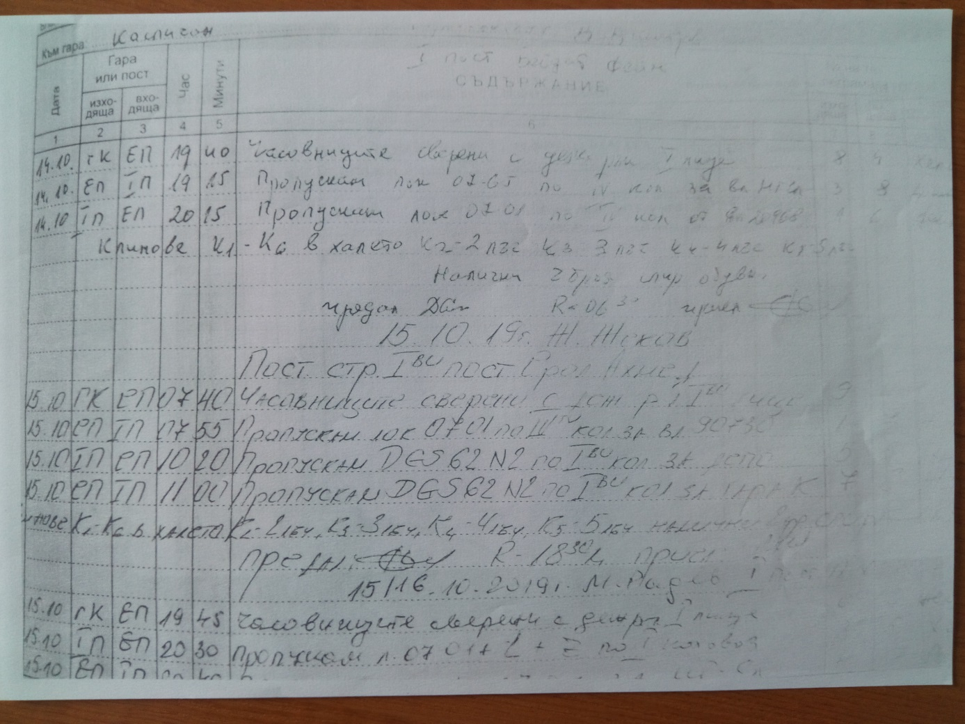
14.1. Description of the chain of events by defining conclusions
Fig. 5.

Fig. 6.

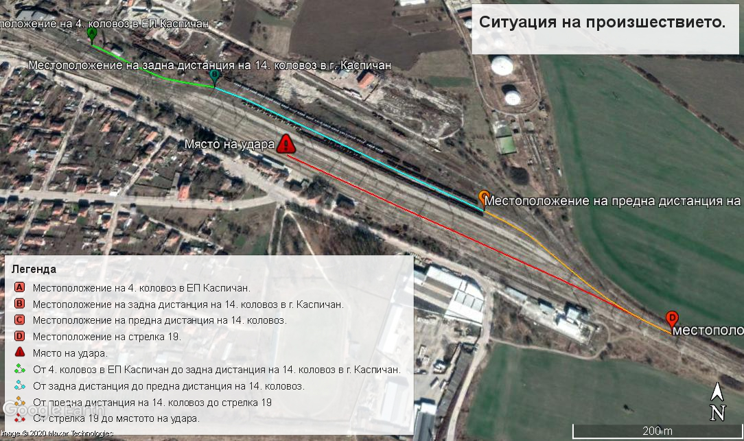
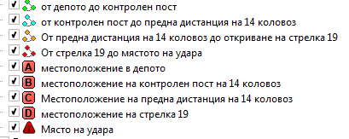
Fig. 7.

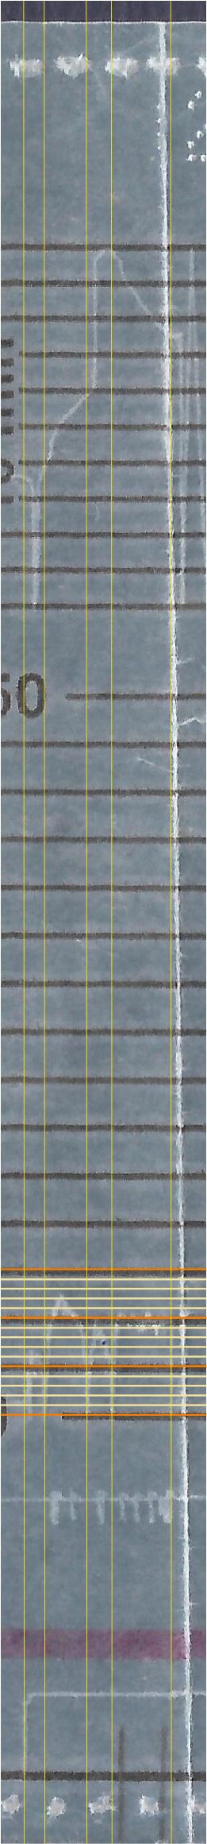
The MTITC Investigation Commission gathered the necessary documentation and materials. Analyzed the facts and evidence that could lead to clarification of the circumstances for establishing the cause of the impact of locomotive No 07065 to Rail Maintenance Car-33. They made several inspections of the locomotive, Rail Maintenance Car, the place of the event at Kaspichan station in the light and dark part of the day, close to the time of the accident. They analyzed the materials and documents provided by the Operational Group and discussed the opinions of the experts included in the Commission. Conducted an interview and requested written testimony from staff involved in the accident. Required additional documents and materials regarding the repair of the locomotive. Analyzed the documents and materials provided by the competent investigative bodies of the Regional Police Department of Novi Pazar.
Fig. 8.
- Markers;
- Positions.
Notes:
- On the graph, the nib registering the speed diverges in terms of the nib registering the time.
- The strap is stretched for greater perspicuity.

1
2
3
4
5
1
2
4
3
5
6
2
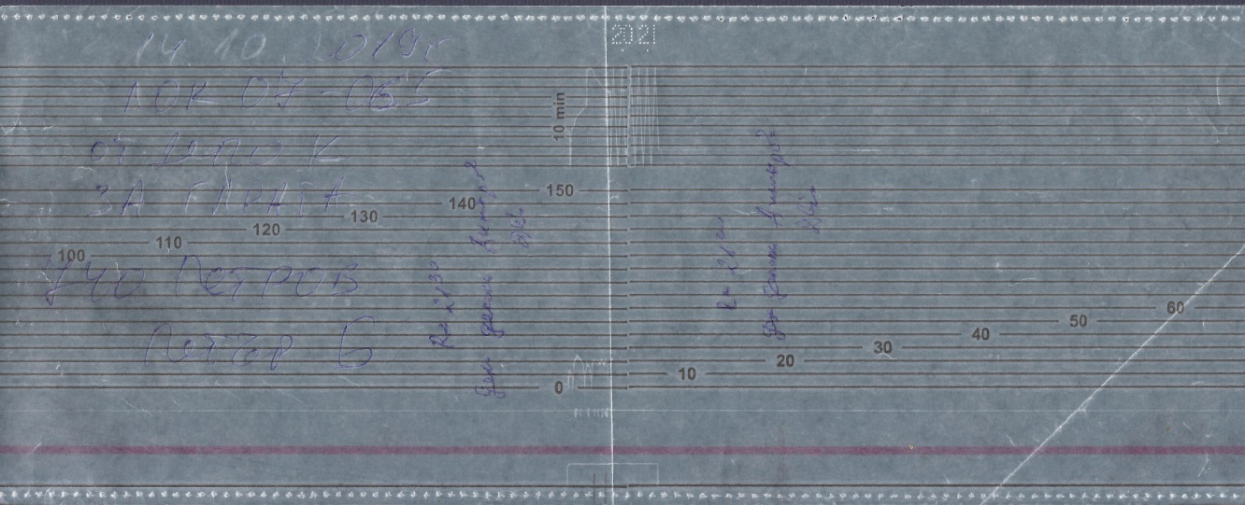
The Investigation Commission analyzed the recording of Diesel Locomotive № 07065 Recorder at Kaspichan Station during the maneuver from its exit from Kaspichan OP until its stop on 4-th track. Locomotive № 07065 has been located on fourth track at Kaspichan Outfit Point (OP) and has been accepted by the Locomotive Brigade between 19:00 and 19:13 hrs. The locomotive exits the Kaspichan EP (Fig. 7, from marker A to marker B) at 19:13 hrs, reaches a speed of 13 km/h and after a distance of 220 meters (Fig. 8, from marker 1 to marker 2) stops at 19:14 hrs after the detection of arrow № 88 (leading to OP) and the output signal of 14-th track in west direction (direction Sofia and Rousse), ready to move in either direction (Sofia or Varna) (Fig. 8, pos. 1, from marker 1 to marker 2). At 19:15 hrs it is handed over by the depot master of OP Kaspichan to post № 1 of Kaspichan station for its exit on a station track (Fig. 5, Fig. 6). After a stay of 30 seconds (Fig. 8, pos. 2) and a signal from the post switchman at post № 1 and at 19:14 hrs locomotive № 07065 moves along 14th track to its exit signal in the direction of post № 2 (Fig. 7 from position B to position C), reaching up to 24 km/h and traveling 450 meters (Fig. 8 from marker 2 to marker 3). At 19:15 hrs, the locomotive stops and stands at a forward distance on 14th track for 3.5 minutes (fig.8, pos. 3). About 20 seconds before 19:20 hrs, it moves off (Fig. 7, from marker C to marker D), accelerates to 20 km/h and stops 20 seconds after 19:20 hrs, traversing 270 meters (Fig. 8, from marker 3) to marker 4) to turn point № 27 and change the direction of movement. After a stand of about 20 seconds - a time that is not enough to change the cabin, (Fig. 8, pos. 4) the locomotive re-starts (Fig. 8, from marker 4 to marker 5), and very quickly (for about 50 meters) reaches a speed of 21 km/h, at which it moves aproxiately 100 meters, then decreases to 19 km/h and traverses at about 50 meters, accelerates again to 21 km/h, traverses 50 meters, decreases to 18 km/h, traverses 100 meters, accelerates to 21 km/h, traverses 100 meters, decreases to 16 km/ h, accelerates to 20 km/h (Fig. 8, pos. 5) and after passing 120 metes at 19:23 hrs drops sharply from 20 kmh to 0 km/h, the chart speed is strictly vertical with no trace of heel due to a retention of the brake of the locomotive (fig. 8, pos. 6), i.e. this is the moment of the impact of the locomotive in the standing Rail Maintenance Car-33. This is evidence that the motorman of locomotive № 07065 has not taken any action to reduce the speed and has not held any of the brakes of the locomotive, in other words, he has not seen the stopped Rail Maintenance Car on 4-th train track until the last moment. This can only be due to the complete lack of visibility in the direction of movement, i.e. or there has been a total darkness over the station, which is not the case according to the witnesses, or both motormen have not been in the forward-facing cabin and have not seen at all the standing on 4-th track Rail Maintenance Car-33.
Fig. 9.
Място на прегъване на
скоростомерната лента
The speed tape of locomotive № 07065 is folded exactly at the stop point of the locomotive, which made it extremely difficult for the experts to decipher and analyze the locomotive‘s movement (Fig. 9).
14.2. Analysis of the facts and conclusions on the causes of the accident
The Investigation Commission conducted a thorough and in-depth analysis of the whole series of events, interviewed the persons involved in the accident, examined and analyzed the documents that has recorded the actions of the individual participants and came to the following conclusions:
- The application of BDZ FT for the appointment of the movement of locomotive № 07065 together with Rail Maintenance Car-33 is submitted by the day shift Senior dispatcher at FTU Gorna Oryahovitsa (Fig. 10);
- The shift work senior dispatcher at RODU Gorna Oryahovitsa accepts the request at 19:05 hrs and after receiving permission from the Head of Unit at FTU Gorna Oryahovitsa starts to draw up a schedule for the movement of the vehicles and at 19:15 hrs, by telegram № 172, submits it to the train dispatcher in the section Shumen - Varna, explaining him the situation (Fig. 11);
- The train dispatcher notifies the stations in the section Kaspichan, Provadia, Sindel distribution for the vehicles' movement, by introducing them to telegram № 172;
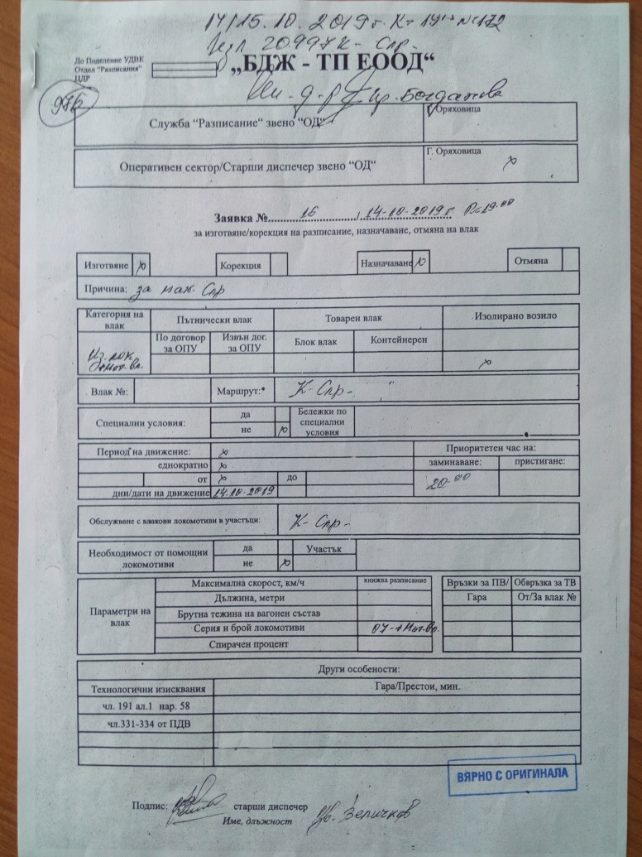
- The duty head of traffic at Kaspichan station, after being acquainted with telegram № 172, notifies the post pointsmen and gives them verbal instructions for the movement of locomotive № 07065 from Kaspichan OP to 4th track of Kaspichan station;
Fig. 10.
- The depot master on duty is not informed by the new shift senior dispatcher at FTU Gorna Oryahovitsa that locomotive № 07065 would depart for Sindel distribution station composed with Rail Maintenance Car-33, and therefore the locomotive brigade is not informed too.
- The lighting at Kaspichan station has been switched on and the visibility onto 4th train track has been normal for the dark part of the day;
- The duty pointsmen of posts №№ 1 and 2 are notified of the movement of locomotive № 07065, but have not taken the necessary actions to notify the locomotive brigade - verbally and through appropriate signals;
- The locomotive brigade is informed that they should report to work in Kaspichan OP and then leave with an isolated locomotive for the Sindel-distribution station, and they are not informed that will be hitched to Rail Maintenance Car -33;
- Although the locomotive brigade passes once by post № 1 and twice by post № 2 at Kaspichan station, they do not attempt to find out where locomotive № 07065 will be parked, in which direction, from which track and in what conditions it will leave;
- When reversing the direction of movement of the locomotive at point № 19 (post № 2), the
motormen do not change the cabin to control the locomotive and start the movement through points № 19, 27, 33, 35, 41, 49 and on 4th track at Kaspichan station, driving locomotive № 07065 from the rearward-facing cab, signaling it with two ordinary rearward buffer lights and one red forward light;
Fig. 11.
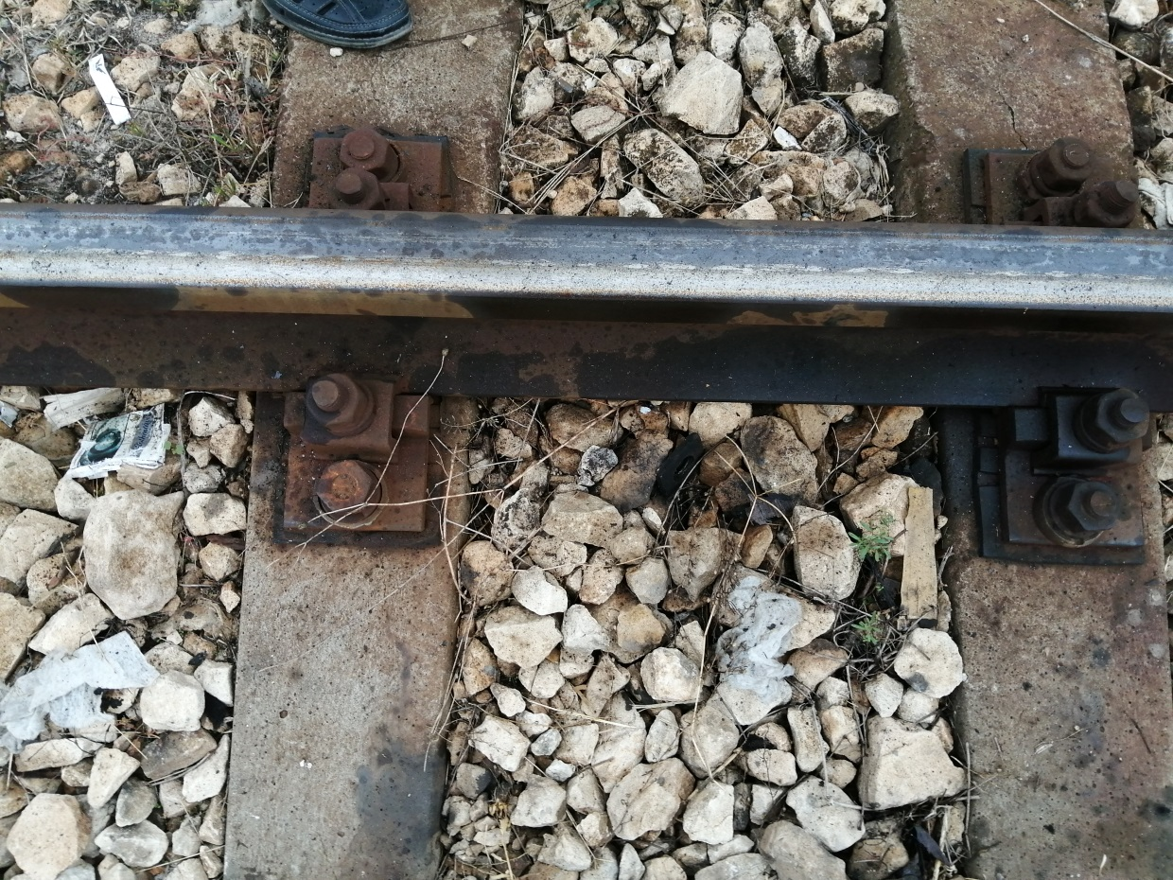
- Rail Maintenance Car-33 is parked on 4-th track of Kaspichan station, opposite the reception building. The machine has stood on a hand brake applied (confirmed by the tracks left by the wheels of the vehicle sliding on the rails after the impact - Fig. 12), as according to its motormen, Rail Maintenance Car-33 has been parked with over-buffer lights on, but according to oral indications to other duty officers this is not true;
Fig. 12.
- The motorman assistant of Rail Maintenance Car-33, seeing the approach of the locomotive and having been informed that both vehicles will travel together to Sindel-distribution station, exits the control cabin of his machine and stands on the platform under the crane system, getting ready to hitch to the approaching locomotive. After finding that locomotive № 07065 is not slowing down, he starts shouting and waving his hands instead of giving a stop signal with an electric torch and a pocket whistle;
14.3. Conclusions
Direct and main causes of the accident
The immediate cause of the accident, the collision of a diesel locomotive No 07065 appointed to hitch Rail Maintenance Car-33 on fourth track of Kaspichan station on October 14.2019, is the control of the locomotive from the rearward-facing cab at a speed of 21 km/h.
The main reason for the impact of locomotive № 07065 in Rail Maintenance Car-33 is the movement of the locomotive without to stop against the tractor.
The concomitant reasons leading to the main reason are the lack of communication between the individual officials providing the operational management of the movement of the trains in both railway companies, as well as the failure the locomotive 07065 motormen and the motorman assistant of Rail Maintenance Car-33 to comply with the maneuvering technology.
The main conclusion reached by the Investigation Commission is that the accident has occurred as a result of the non-fulfillment of staff obligations related to the operation and management of the traffic at NRIC and BDZ FT.
Reasons related to applying the safety management system
In “Rules for management of the transport activity in BDZ FT EOOD in planning and operational management of the transport” in Section VII “Operational interaction in the management of transport” there is no written text that to oblige the operational sector in OMT to pass the operational decisions to the immediate contractors.
The Investigation Commission did not find in the current "Instruction № 13/June 29.2006, on joint work between Kaspichan station and Kaspichan OP" the texts regulating communication between the staff when moving locomotives from Kaspichan OP to the area of Kaspichan station and vice versa.
15. Recommendations issued in order to avoid accidents upon the same reasons.
In connection with the requirements of Art. 94, para. 1 of Ordinance № 59 of December 5, 2006, aiming to improve the safety in railway transport, the Investigation Commission proposes to EA Railway Administration, railway company BDZ “Freight Transport” EOOD and NRIC to implement the given safety recommendations:
With recommendation №1 it is proposed to the railway enterprises BDZ Freight Transport EOOD and SE NRIC to familiarize the personnel directly engaged in OMT, operation, station and maneuvering activities with the contents of the report by an extraordinary briefing.
With recommendation №2 it is proposed to BDZ Freight Transport EOOD to issue a motorman license indicating the railway infrastructure for which he has been certified and the rolling stock entitled to drive in accordance with the requirements of Directive 2007/59 / EC.
With recommendation №3 it is proposed to SE NRIC to update "Instruction № 13 / June 29.2006 for joint work between Kaspichan Station and Kaspichan OP" when moving locomotives from the post to the station and vice versa.
With recommendation №4 it is proposed to BDZ Freight Transport EOOD to supplement the "Rules for the management of the transport activity in the transport planning and operational management" in Section VII "Operational interaction in the transport management” with a text obliging the operational sector in OMT to pass the operational decisions to the immediate contractors.
In connection with the requirements of Art. 91, para. 3 and Art. 94, para. 4 of Ordinance № 59 of December 5, 2006, on railway safety management, I submit a final report with recommendations given therein. The addressees shall, in writing, inform the Head of the SUIRAI at MTITC about the actions undertaken.

Sofia January 31, 2020

Chairman:
Dr. Eng. Boycho Skrobanski
Head of NIB in MTITC

I, the undersigned Galina Krasimirova Grozeva in my capacity of official translator, hereby certify that the above document, consisting of 25 (twenty five) pages is a true and complete translation into English of the attached official document, originally composed in Bulgarian. In testimony thereof I have hereunto set my hand and affixed the official seal of the company.
Translator:
Galina Krasimirova Grozeva

