14 May 2019

Explained, the economic ties between Europe and Asia
Asia and Europe are now leading trade partners, with $1.5 trillion of annual merchandise trade, overtaking each continent’s trade with the United States. A new study gathering an unprecedented range of bilateral data between country pairs pinpoints the economic, social and political ties between 51 Asian and European countries.
While the eyes of the world are on the US-China trade war, Asia and Europe are working to deepen their relationship. The two continents have made mutual connectivity between people, businesses and institutions a top political priority, and are moving quickly to build and strengthen ties, with a firm commitment to work towards the Sustainable Development Goals (SDGs).
Sustainable connectivity is the new name of the game. It has become a focal point of the Asia-Europe Meeting (ASEM), a high-level intergovernmental cooperation forum between 30 European and 21 Asian countries, including Australia and New Zealand. The European Union has also put forward sustainable connectivity in its recently adopted strategy, “Connecting Europe and Asia – Building blocks for an EU Strategy”.
So how are Asia and Europe connected today? Here’s what the data tells us.

Asia-Europe trade
Trade between ASEM countries accounts for about half of all world merchandise trade. Although intra-regional trade (i.e. within Europe or within Asia) is four times higher than cross-regional trade, the Asian and European regions trade more between them than between any other regions in the world.
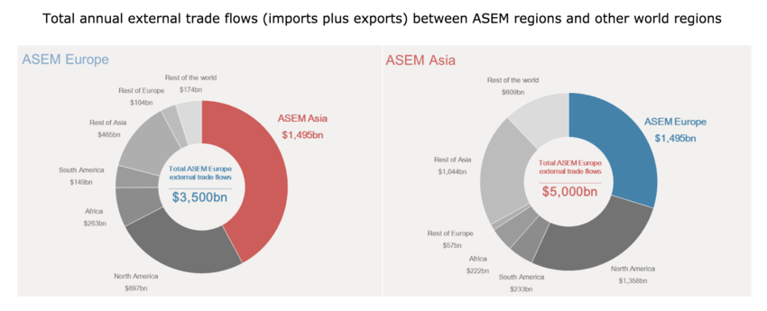
Source: Comtrade, 2016
Two major hubs stand out: Germany and China. These countries together are responsible for one quarter of the overall trade in the ASEM group, and are the main trade bridges between the two continents. Nearly one third of European goods shipped to Asia come from Germany ($202 billion), with China as the largest customer.
In the other direction, over half of China’s exports to Europe are delivered to Germany, The Netherlands and the UK ($178 billion). Russia, with its geographically central position, is the third largest trader in the ASEM group of countries. The country exports twice as much to Europe than to Asia.
Important Asia-Europe trade flows of more than $100 billion also exist between Europe and Japan, and Korea and India. Within Europe, Switzerland comes second in exports to Asia, particularly to China and India, surpassing Germany in the latter.
On the institutional side, trade relations between European and Asian countries are being strengthened. 2019 saw a new trade agreement between the EU and Japan coming into force. Such trade agreements offer an excellent opportunity to include provisions on sustainable development. The EU-Japan agreement is the first of its kind to include a specific provision on the Paris Agreement.
Diplomatic relationships are strong, and data shows that links via trade agreements and embassies are associated with a greater intensity of bilateral trade. Top traders such as China and Germany have embassies in all 50 ASEM partner countries.

Cross-border investment
Foreign direct investment (FDI) between Asia and Europe reaches close to $90 billion annually (2015-2017). This is nearly the same size as FDI flows within Europe.
The FDI landscape is dominated by two major foreign investors in each region. Over half of European investment in Asia comes from the UK and Germany, exceeding $32 billion. In fact, the UK invests twice as much in Asia than in Europe, with India receiving the greatest share. Likewise, China and Japan are the main Asian investors in Europe, collectively amounting to $12 billion.
Overall, India and China attract around half the total European foreign investment. However, some Asian countries are more appealing to foreign investors from Europe than from Asia. This is the case for Korea, Mongolia, Singapore and Russia.
But there is more to Asia-Europe relations than economic ties.

Movement of people
Asia and Europe are also bringing people and societies closer together, with around 13 million people having migrated between the two regions. Germany, the UK and Australia host the largest number of cross-bloc migrants (around 2.5 million each).
Large movements of migrants from the UK to Australia and from Russia and Kazakhstan to Germany are associated with historical, cultural and language ties. Russia is the main country of origin of migrants to Europe, followed by India.
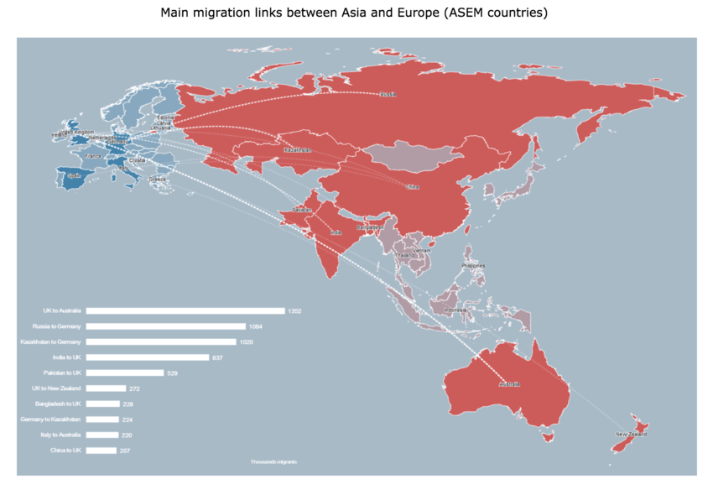
Source: UN-DESA, 2017
International graduate student mobility provides access to quality education abroad, as well as the opportunity to improve language skills and explore different cultures and societies. Around 1,000 students move between the two continents every day – or about 400,000 every year.
The UK is the top destination for Asian students, with nearly three quarters coming from China, India and Malaysia. Chinese students represent almost half of Asian students in Europe. Australia is the favourite destination for European students, followed by Japan.
Asia is presently open without a visa to more than two thirds of European passport holders and Europe to one third of Asian nationalities, as visa openness policies enable students and researchers to travel easily.

Working together in research
More than 200,000 collaborations between Asian and European research institutions take place every year in the form of co-authorship of scientific publications. Cross-bloc collaboration represents close to one third of research collaborations in ASEM countries.
Researchers from institutions in Australia, New Zealand and India collaborate around twice as much with European countries than with Asian countries, and Russian researchers collaborate three times more with European ones. Cross-bloc collaboration is stronger on the Asian side than on the European side, since European countries also have a strong internal collaboration network supported by large EU-funded research programmes.
Countries such as China, Australia, the UK, Germany, Russia and France provide an intercontinental bridge for scientists. The most collaborations are between the UK and China, and the UK and Australia (more than 10,000 each), followed by Germany and China (around 7,000).
Researchers in small Asian nations find key research partners in European countries. For example, research collaborations between Laos and the UK represent around 20% of Laos’ research outputs. The same trend is seen between Mongolia and Germany, and Myanmar and the UK.

Sustainable connectivity - the way forward
While Asia-Europe connectivity is vital for peace, stability, economic prosperity and inclusive development, it’s only half the story. Sustainable connectivity needs to contribute to achieving the SDGs, part of the 2030 Agenda for Sustainable Development.
Data shows that Asia-Europe connectivity is aligned with most of the SDGs, in particular the ones linked to the social dimension of sustainability. This means that connectivity is associated with better living conditions, more inclusive societies and greater levels of education, among others.
However, better connected countries are also associated with larger impacts on the environment, which translates into higher greenhouse gas emissions and domestic material consumption. Policy-makers are faced with the challenge of minimizing the environmental impact of connectivity, and ensuring that its benefits are inclusive for all members of society.
