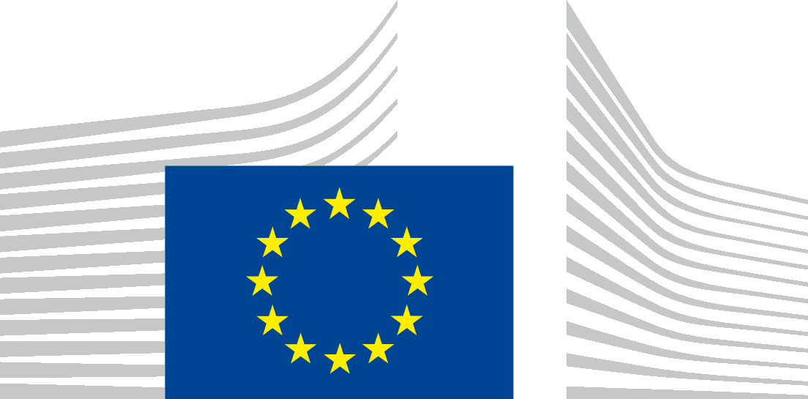 | EUROPEAN COMMISSION  Directorate-General for Communications Networks, Content and Technology  Media and Data

BIG DATA ACTIVITIES - QUESTIONNAIRE TO THE MEMBER STATES

The questionnaire below is intended to gather country-specific information. Whenever more than one government body has the required competences to provide the relevant answers, we would be grateful if you could provide a comprehensive reply including input from all the actors involved.

We are also looking forward to receiving the key references and contact data that will help us facilitate future coordination and collaboration in the field of Big Data activities in the EU.

You are invited to send your replies to the following e-mail address: CNECT-G3@ec.europa.eu

Thank you for your support to this initiative!

1. Big Data developments

- Do you notice the impact of Big Data technologies in your country's economy?

If yes, please outline the main developments, challenges or opportunities related to data-driven technologies in your country.

- Are such developments, challenges or opportunities relevant for any economic sectors in particular?

2. Data Value Chain Strategy

- Have you adopted or are you preparing to adopt a national 'Data Value Strategy', i.e. a set of measures (budgetary, policy or legal) aimed at supporting data-driven innovation in your country?

- If yes, please outline its main elements, providing the relevant reference documents and links.
- If not, please provide the main reasons.
3. Framework conditions

- Are you taking steps to identify and improve the main framework conditions (e.g. privacy regulations, data ownership, copyright, software development, access to capital, infrastructures) which impact the development of a data-driven economy?

- If yes, please outline its main elements, providing the relevant reference documents and links.

- If not, please provide the main reasons.

4. Data skills

- Does your economy experience a shortage of workers with appropriate data skills (data analysts, data scientists) in your country?

- If yes, please outline the main remedial actions, providing the relevant reference documents and links.

- If not, please provide the main possible reasons for not experiencing such shortages.

5. Existence of 'data champions' and national competence centres for data

- In your market, are there companies / research institutions / industrial sectors that play a particularly important role in the functioning of the data-driven economy (i.e. that are successful data-driven innovators and can be considered as best practice)?

- If so, please provide examples.

- If not, please provide your assessment why this is not the case

6. Cross-border cooperation

- Are you involved in cross-border cooperation with the authorities of other member states, focussing on data-related research or on other activities referred to in the questions above (data value chain strategy, framework conditions, data skills, etc.)?

- If yes, please outline its main elements, providing the relevant reference documents and links.

- If not, please provide the main reasons.

7. Role of the Commission

- What do you think should be the main focus of the Commission in the development of research and economic policies aimed at strengthening of data-driven economy in the EU?

8. Other issues

- Should you have any other suggestions or comments on issues related to data-based economy or data-related research, feel free to let us know.

9. Main contacts in my country

- Government contact point for data-driven innovation

- Contact for data research and innovation funding

- Main national and/or regional competence centres for data-driven innovation

Thank you in advance for your feedback!

